TECHNICAL ANALYSIS REPORT
Quantum Machine Learning
Circuit and input analysis, optimization evidence,
and a fully classical no-circuit comparison
MSE802 Quantum Computing • Assessment 2 • Task 4
Local implementation: Python 3.11, Qiskit 2.5.1, Aer 0.17.2
Prepared 24 July 2026

Executive summary
The course-supplied quantum machine-learning starter was converted into a local, deterministic workflow that retains its four-qubit basis encoder, recursive RY-RY-CX classifier, one-bit output, mean absolute-error objective, and SPSA training approach. The final notebook identifies exactly where data enters the circuit, explains the quantum model independently of its optimizer, records every optimization iteration and cumulative time, and validates one fixed parameter vector on exact statevector, Aer, and real Quokka backends.
Key result Both implementations classify all four supplied images correctly at the shared 0.5 threshold. The quantum model's full-dataset probability MAE is 0.2754; the classical model's is 0.0246. The classical path is faster and uses no quantum circuit or shots. Because the dataset has four samples and one test item, this is not evidence of generalisation or quantum advantage.

Assessment coverage
Requirement | Implemented evidence | Primary location
Analyse circuit/input/problem | Pixel-qubit map, basis encoding, pair tree, gates, output and diagnostics | Sections 1–2 / notebook
Iteration metric and time plots | 61 trace points: initial point plus 60 SPSA updates | Section 3 / CSV / PNGs
No-quantum local version | Two classical orientation features plus logistic regression | Section 4 / classical_ml.py
Compare efficiency/effectiveness | Shared split, threshold, accuracy, MAE, timings, circuits and shots | Section 5 / benchmark JSON
Notebook and Word report | Executed notebook and rendered report with retained evidence | Task 4 submission folder

Deliverable map
- Executed analysis: Task_4_Quantum_ML.ipynb.
- Comprehensive report: Task_4_Quantum_ML_Report.docx.
- Machine-readable evidence: backend validation, optimization trace, classical baseline, and quantum/classical benchmark.
- Review visuals: input dataset, circuit, two optimization plots, and the four-panel comparison.

1. Problem formulation and data
The task is binary classification of non-uniform 2 x 2 binary images generated inside the starter notebook [1]. Vertical stripe patterns are label 0 and horizontal bar patterns are label 1. Removing the all-zero and all-one cases leaves four images. Each row-major flattened pixel vector x = (x0,x1,x2,x3) contains exactly two ones.
Figure 1. Complete generated Task 4 dataset and labels.
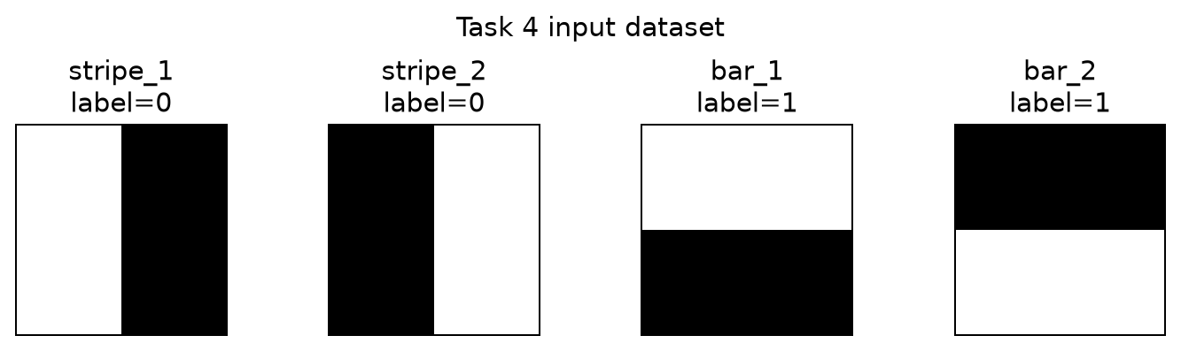

1.1 Deterministic split
The starter's 75/25 random split is retained but isolated in a NumPy Generator with seed 802. Training indices are [3, 0, 2], with labels [1, 0, 1]; test index [1] has label 0. The training set therefore contains both classes. A single-item test partition is useful for reproducibility but statistically weak.
Sample | Flattened pixels | Class | Split
stripe_1 | [1, 0, 1, 0] | 0 | Training
stripe_2 | [0, 1, 0, 1] | 0 | Test
bar_1 | [1, 1, 0, 0] | 1 | Training
bar_2 | [0, 0, 1, 1] | 1 | Training

1.2 Reproducibility boundary
Local source modules replace Colab file upload, a hard-coded HTTP endpoint, and mutable global randomness. Dependencies are locked, backend configuration is read from an ignored environment file, and saved Quokka responses contain no credential. Remote evidence is retained rather than regenerated during ordinary notebook execution.

2. Quantum circuit and input analysis

2.1 Exact data-input location
The data enters only through the basis-encoding loop. Pixel xi = 1 appends X to qubit qi; a zero leaves that qubit in |0>. The six angles are trainable model parameters, not sample features. Qubit and classical-bit labels follow Qiskit's documented circuit conventions [2].
for qubit, pixel in enumerate(sample):
if pixel > 0.5:
circuit.x(qubit)

2.2 Recursive parameterized model
A post-order recursion yields pairs (q0,q1), (q2,q3), then (q1,q3). Each block applies RY(theta_k) to the first qubit, RY(theta_k+1) to the second, and CX from first to second. RY is a single-qubit Y-axis rotation [3]; CX makes the second branch conditional on the first. Three blocks require six angles. The final prediction is P(c0=1), obtained by measuring q3 into c0.
Figure 2. Example classifier for stripe_1 at zero trainable angles.
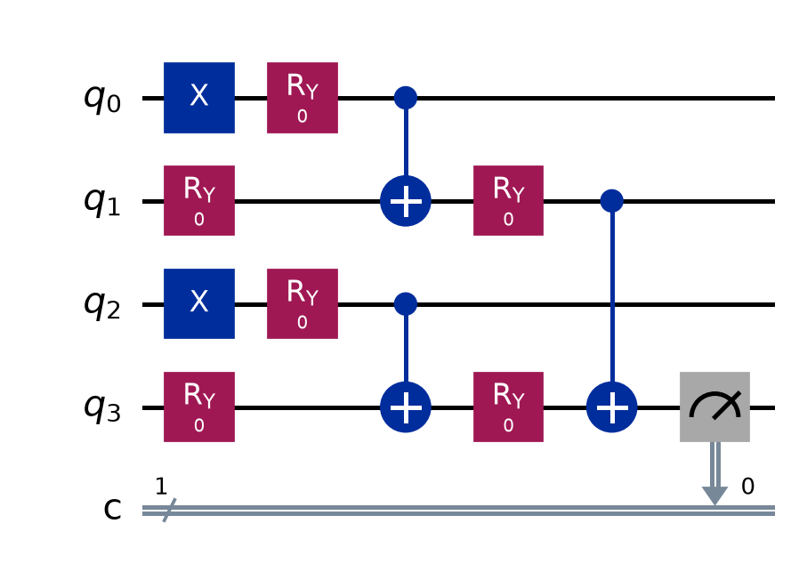

2.3 Zero-angle diagnostic
At zero angles the RY gates are identities and the three CX operations form a parity tree. Output q3 becomes x0 XOR x1 XOR x2 XOR x3. Every supplied image has even parity, so exact statevector evaluation returns P(1)=0 for all four samples. This demonstrates that the untrained circuit cannot separate the classes; learned rotations are essential.

2.4 Backend portability check
One circuit constructor supports exact statevector probability, local shot-based Aer, and Quokka submission through OpenQASM 2. Qiskit documents qasm2.dumps as its circuit-to-string interoperability route [5]. AerSimulator is a configurable circuit simulator [4]. The real Quokka check uses a fixed angle vector and 256 shots per sample; it is validation, not training.
Sample | Exact P(1) | Aer P(1) | Quokka P(1) | |Aer–Quokka|
stripe_1 | 0.0853 | 0.0859 | 0.0977 | 0.0117
stripe_2 | 0.4400 | 0.4492 | 0.4609 | 0.0117
bar_1 | 0.4215 | 0.4180 | 0.4219 | 0.0039
bar_2 | 0.1829 | 0.2070 | 0.1914 | 0.0156
Backend finding The maximum absolute Aer–Quokka difference is 0.015625, equal to four counts out of 256. This is small relative to finite-shot uncertainty and does not indicate a systematic backend disagreement for the checked circuit.

3. Optimization evidence

3.1 Objective and protocol
The starter objective is training mean absolute error: average over samples of |P_theta(c0=1 | xi) - yi|. Seeded SPSA performs 60 updates on local Aer with 256 shots per circuit. Each update evaluates a positive perturbation, a negative perturbation, and the updated parameter vector. SPSA estimates a multivariate search direction from simultaneous perturbations [7]. This report uses it as the supplied classical optimizer and does not treat it as part of the quantum circuit analysis.
Measure | Recorded value | Interpretation
Training MAE | 0.5638 → 0.2904 | Lower is better
Best point | 0.2904 at iteration 60 | All points retained
Objective calls | 181 | Initial plus three per update
Circuit executions | 543 | Three training samples per objective
Training shots | 139,008 | 256 shots per circuit
Wall time | 1.430 s | Machine-dependent local timing

3.2 Per-iteration metric
Figure 3. Training mean absolute error at iteration 0 and 60 SPSA updates.
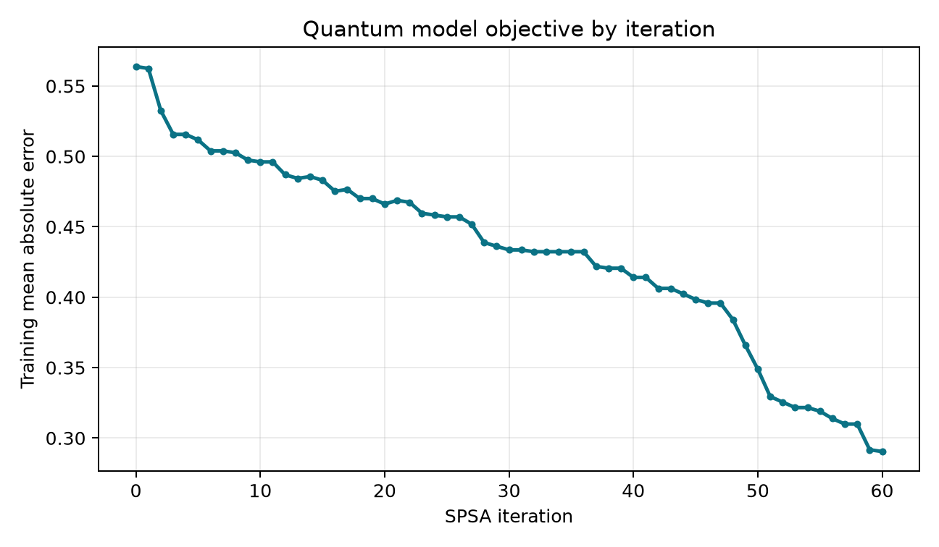
The saved metric decreases from 0.5638 to 0.2904. Small flat or rising steps would be expected for a sampled stochastic search; retaining the complete CSV prevents selective reporting. In this seeded run the final point is also the best recorded point.

3.3 Per-iteration cumulative time
Figure 4. Cumulative local Aer training time for the same trace.
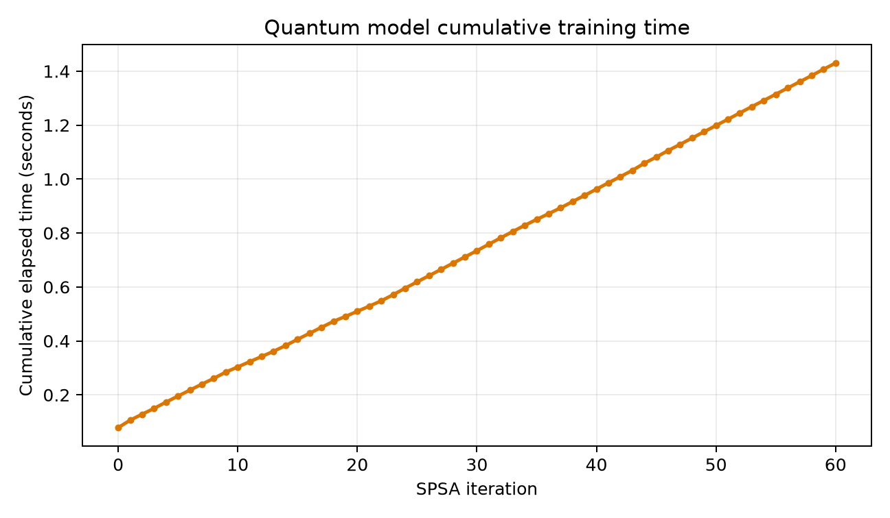
Cumulative time is monotonic and approximately linear because every update has the same objective-call structure. The absolute slope is specific to this machine; the retained circuit and shot counts are the more portable resource measure.

4. Fully classical no-circuit version

4.1 Modification
The local baseline is deliberately isolated in mse802/classical_ml.py. It imports NumPy and scikit-learn only and does not import Qiskit, create QASM, construct a quantum circuit, run a simulator, call Quokka, or consume shots. It converts each image to the mean change between rows and the mean change between columns, then fits balanced logistic regression on the same training indices. Scikit-learn documents LogisticRegression as its regularized classifier implementation [6].
Sample | Vertical change | Horizontal change | Label | P(class 1)
stripe_1 | 0.0 | 1.0 | 0 | 0.0246
stripe_2 | 0.0 | 1.0 | 0 | 0.0246
bar_1 | 1.0 | 0.0 | 1 | 0.9754
bar_2 | 1.0 | 0.0 | 1 | 0.9754
No-quantum check The evidence records quantum_circuits = 0, quantum_shots = 0, and quantum_backend = null. An automated source check also rejects Qiskit, QuantumCircuit, QuokkaClient, or qasm2 references in the classical module.

4.2 Why the baseline works
For a vertical stripe, rows are identical but adjacent columns differ, giving [vertical change, horizontal change] = [0,1]. A horizontal bar gives [1,0]. These features expose the data-generation rule directly, so all four points are linearly separable. This makes the baseline strong but also unusually tailored to the tiny synthetic dataset.

4.3 Effectiveness
The classical model obtains training, test, and full-dataset accuracy of 1.0, 1.0, and 1.0. Its full-dataset MAE is 0.0246. These values show correct operation on the supplied points, not performance on a broad image distribution.

5. Quantum/classical comparison

5.1 Fair comparison protocol
Both models use seed 802, the same three training indices and one test index, the same labels, and the same 0.5 decision threshold. Accuracy captures the thresholded decision; MAE retains probability confidence. Efficiency includes training wall time, median warmed four-sample inference time, and quantum resource counts. Quokka network/queue time is excluded because optimization was intentionally local.
Figure 5. Shared effectiveness and local efficiency benchmark.
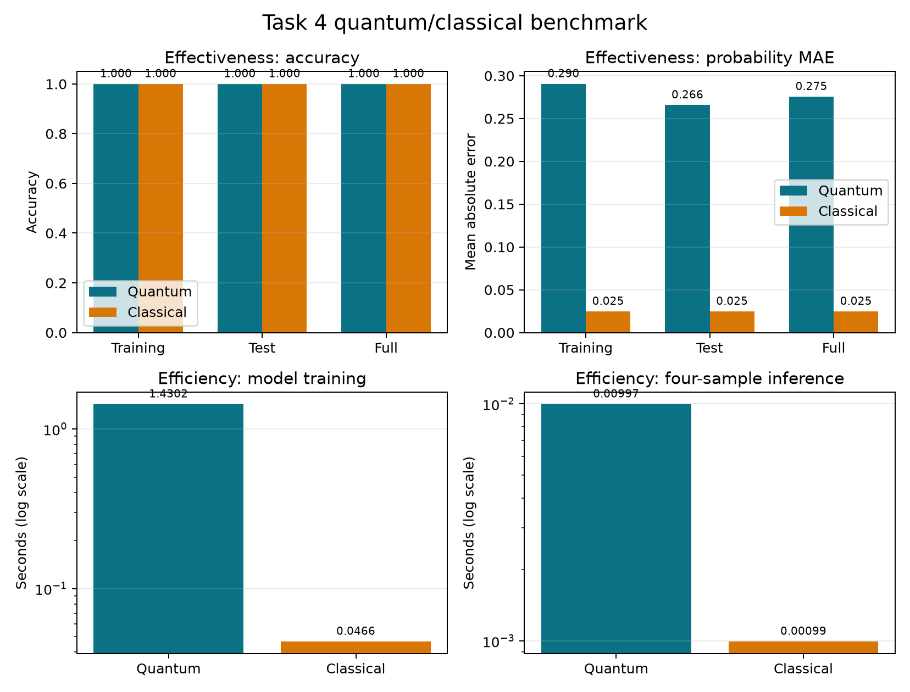
Measure | Quantum | Classical | Finding
Training accuracy | 1.000 | 1.000 | Tie
Test accuracy | 1.000 | 1.000 | One correct test item each
Full accuracy | 1.000 | 1.000 | Tie
Full MAE | 0.2754 | 0.0246 | Classical lower
Training time | 1.4302 s | 0.0466 s | Classical faster locally
Circuits / shots | 543 / 139,008 | 0 / 0 | Classical uses no quantum resource

5.2 Interpretation
At threshold 0.5 both pipelines make the same four correct decisions. The classical probabilities are substantially closer to their labels and its runtime/resource requirements are lower. For this narrowly defined problem, the classical approach is therefore more effective by MAE and more efficient. The quantum implementation remains useful as an auditable demonstration of basis encoding, parameterized RY-CX blocks, finite-shot training, and portable execution across local and remote backends.
Claim boundary No quantum advantage is claimed. A four-sample benchmark with one test item cannot establish generalisation, scalability, or hardware performance.

6. Verification, limitations, and conclusion

6.1 Verification
Check | Result
Dataset and split | Exact four images; deterministic [3,0,2] / [1] split
Circuit schedule | Pairs (0,1), (2,3), (1,3); six parameters; q3 readout
Zero-angle diagnostic | Exact output probability 0 for all four images
Backend check | Four real Quokka records; maximum difference retained
Optimization | 61 ordered trace rows; nondecreasing cumulative time
No-circuit baseline | No quantum imports/circuits/shots; all points classified
Repository tests | 29 tests passed at report generation
Notebook | Executed top-to-bottom from a fresh kernel

6.2 Limitations
- The dataset has four synthetic samples and the test result is one decision.
- The classical features directly encode the known generation rule and may not transfer to richer images.
- Aer is ideal unless a noise model is added; the Quokka run checks only one fixed vector at 256 shots per sample.
- SPSA results depend on hyperparameters, initialization, finite shots, and seed; only one fully retained run is reported.
- Wall-clock timings are machine-specific and exclude remote network/queue delay.

6.3 Conclusion
The completed Task 4 workflow meets the assessment requirements with an explicitly analysed quantum circuit, reproducible backend validation, complete iteration/time evidence, a genuinely no-circuit local version, and a common efficiency/effectiveness benchmark. The retained notebook, source modules, raw records, CSV traces, figures, and automated tests make every reported value reviewable. Within the severe data limitations, the classical solution is the practical winner; the quantum solution demonstrates the intended circuit and execution concepts without overstating its result.

References
[1] MSE802 Quantum Computing, “Quantum_ML_AS2.ipynb,” course-supplied Assessment 2 starter notebook, 2026.
[2] IBM Quantum, “Quantum circuit model,” Qiskit SDK documentation. https://quantum.cloud.ibm.com/docs/api/qiskit/circuit (accessed 24 July 2026).
[3] IBM Quantum, “RYGate,” Qiskit SDK API documentation. https://quantum.cloud.ibm.com/docs/api/qiskit/1.3/qiskit.circuit.library.RYGate (accessed 24 July 2026).
[4] Qiskit Development Team, “AerSimulator,” Qiskit Aer documentation. https://qiskit.github.io/qiskit-aer/stubs/qiskit_aer.AerSimulator.html (accessed 24 July 2026).
[5] IBM Quantum, “OpenQASM 2 and the Qiskit SDK.” https://quantum.cloud.ibm.com/docs/guides/interoperate-qiskit-qasm2 (accessed 24 July 2026).
[6] scikit-learn developers, “LogisticRegression,” scikit-learn API. https://scikit-learn.org/stable/modules/generated/sklearn.linear_model.LogisticRegression.html (accessed 24 July 2026).
[7] J. C. Spall, “Multivariate stochastic approximation using a simultaneous perturbation gradient approximation,” IEEE Transactions on Automatic Control, vol. 37, no. 3, pp. 332–341, 1992.
[8] M. A. Nielsen and I. L. Chuang, Quantum Computation and Quantum Information, 10th anniversary ed. Cambridge: Cambridge University Press, 2010.

Appendix A — Evidence inventory
Artefact | Purpose
Task_4_Quantum_ML.ipynb | Executed end-to-end analysis
task4_backend_validation.json | Real fixed-vector Quokka comparison
task4_quantum_optimization*.json/.csv/.png | Training parameters, trace and plots
task4_classical_baseline.json | No-circuit model evidence
task4_quantum_classical_benchmark.* | Common protocol, results and figure
task4_example_circuit.qasm/.png | Exact circuit representation
SOURCE_NOTE.md / README.md | Provenance and reproduction instructions
Task_4_Quantum_ML_Report.docx | Comprehensive assessment report

