TECHNICAL INVESTIGATION REPORT
Quantum Tic-Tac-Toe
Code completion, gameplay dynamics,
quantum-circuit generation, and gate analysis
MSE802 Quantum Computing • Assessment 2 • Task 3
Local implementation: Python 3.11, Qiskit 2.5.1, Aer 0.17.2
Prepared 24 July 2026

Executive summary
The supplied Quantum Tic-Tac-Toe notebook was completed and converted from a Google Colab-only prototype into a local, reproducible Jupyter application. Every move now produces an explicit Qiskit gate, all eight winning triples are implemented, measurement order is handled correctly, SWAP uses a reliable two-cell interaction, and Replay creates a clean nine-qubit circuit.
Key result Four saved games and seven Task 3 automated tests confirm the gate semantics, measurement mapping, score calculation, clean reset, and interface flow. The complete project test suite contains 14 passing tests.

Assessment coverage
Requirement | Implemented evidence | Location
Complete missing code | Not, O, X, SWAP, eight wins, measurement, reset | mse802/tictactoe.py
Play multiple games | Four seeded games with move logs and resolved boards | task3_game_evidence.json
Analyse code and gameplay | Sections 2–6 plus executed notebook | This report / Task 3 notebook
Explain circuit generation | State preparation, move-to-gate mapping, copied measurement circuit | Sections 3–4
Describe every gate | Reset, H, RY, X, SWAP, barrier, measurement | Section 4

Deliverable map
- Executed notebook: Task_3_Quantum_Tic_Tac_Toe.ipynb.
- Game implementation: mse802/tictactoe.py; interface: mse802/tictactoe_ui.py.
- Reproducible evidence: four QASM files, four circuit PNGs, summary PNG, and JSON.
- Automated checks: tests/test_tictactoe.py.

1. Purpose and completed architecture
The educational purpose is to make circuit construction visible through a familiar game. The pre-measurement board is not classical ownership data: it is a nine-qubit state assembled by the player's sequence of reversible gates. Measurement ends a round, converts each qubit to O or X, and evaluates the classical winning lines.

1.1 Adaptation of the starter
The starter mixed package installation, game rules, simulator calls, and a Colab-specific grid in one notebook. The local version separates those concerns:
- The notebook explains and demonstrates the assessment work.
- Board owns the quantum circuit, validated moves, measurement, and scoring.
- TicTacToeWidget owns only portable controls and presentation.
- Evidence and notebook-builder scripts make generated artefacts repeatable.
- Pytest exercises the model independently of manual interaction.

1.2 Runtime flow
Stage | State change | Observable result
New round | Reset then H on q0…q8 | Nine unresolved |+⟩ cells
Choose move | Append X, RY, or SWAP | Move log and circuit update
Measure | Copy circuit; measure qi → ci | One c8…c0 bitstring
Post-process | Reverse string; 0→O, 1→X | Board cells 0…8
Score | Evaluate eight triples | Separate X and O line counts
Replay | Discard old circuit; prepare new board | No stale gate or score
Design decision Measurement is appended to a circuit copy. The unmeasured move circuit remains available for inspection, and repeated UI drawing cannot accidentally add measurement instructions.

2. Quantum state and circuit generation

2.1 Initial board
A new round creates QuantumCircuit(9, 9). Each qubit is reset to |0⟩ and then receives H, producing |+⟩ = (|0⟩ + |1⟩)/√2. Before any move, the joint state is |+⟩⊗9 and every board pattern has probability 1/512 under ideal independent measurement. Reset is retained from the starter even though a new simulator circuit begins in |0⟩; it makes the preparation intention explicit.

2.2 How gameplay generates a circuit
Board.apply_move validates the selected cell and dispatches the operation to a Qiskit circuit method. Gates are appended in click order, so later actions act on the quantum state produced by earlier actions. The move history is metadata for review; only the circuit determines the measured outcome.
O → circuit.ry(-π/2, cell)
X → circuit.ry(+π/2, cell)
Not → circuit.x(cell)
SWAP→ circuit.swap(first_cell, second_cell)

2.3 Measurement and Qiskit ordering
The measurable copy maps qi to ci for i = 0…8 and executes exactly one shot on AerSimulator. Qiskit prints bit n−1 at the left of a string and bit 0 at the right [2]. Therefore c8…c0 is reversed before assigning the first character to board cell 0. The implementation maps 0 to O and 1 to X, matching the starter comments that O rotates toward |0⟩ and X toward |1⟩.
Failure prevented Without the reversal, moves on cell 0 would appear on cell 8. The automated bit-order test fixes both endpoint cells and verifies the seven middle cells.

3. Quantum gates and instructions
This section covers every instruction used to generate or resolve the game circuit. Quantum gates are unitary and reversible; reset and measurement are non-unitary operations.
Instruction | Action in this game | Key characteristic
reset | Prepare every square as |0⟩ | Non-unitary initialization
H | Create unresolved |+⟩ square | Equal 0/1 amplitudes
RY(−π/2) | Set an untouched |+⟩ square to O | Y-axis rotation to |0⟩
RY(+π/2) | Set an untouched |+⟩ square to X | Y-axis rotation to |1⟩
Pauli-X | Not: exchange 0 and 1 amplitudes | X² = I; bit flip
SWAP | Exchange two complete cell states | |a,b⟩ → |b,a⟩ [3]
barrier | Visually separate preparation/resolution | No state change
measure | Resolve qi into classical ci | Born-rule probabilistic collapse

3.1 Hadamard and open squares
H = (1/√2)[[1, 1], [1, −1]]. Acting on |0⟩ gives |+⟩. An untouched cell is therefore genuinely unresolved, not an empty classical value. A one-shot measurement returns O or X with equal ideal probability.

3.2 RY rotations for O and X
RY(θ) = [[cos(θ/2), −sin(θ/2)], [sin(θ/2), cos(θ/2)]]. Substitution gives RY(−π/2)|+⟩ = |0⟩ and RY(+π/2)|+⟩ = |1⟩. These identities make O and X deterministic on a fresh square. Repeated rotations still compose as quantum operations; the interface intentionally does not pretend a text label is the current measured state.

3.3 Pauli-X as Not
X = [[0, 1], [1, 0]] exchanges |0⟩ and |1⟩. Thus Not converts a prepared O to X and X to O. On an untouched |+⟩ cell, X|+⟩ = |+⟩, so Not has no observable effect—exactly the gameplay description in the starter.

3.4 SWAP, barrier, and measurement
SWAP is a two-qubit Clifford gate with mapping |a,b⟩ → |b,a⟩ [3]. It exchanges the full amplitudes of two cells, not their interface labels. The local UI collects two different cells before appending one SWAP; selecting the same cell cancels the operation.
Barriers group the initial preparation and final resolution visually. They do not change amplitudes and may constrain compiler reordering. Measurement is different: it returns a classical bit according to squared amplitudes and ends the quantum portion of the round. AerSimulator is a configurable noisy-circuit simulator; this assessment uses its default ideal CPU simulation [4].
Figure 1. Game 3 measured circuit: preparation, SWAP/Not moves, and resolution.
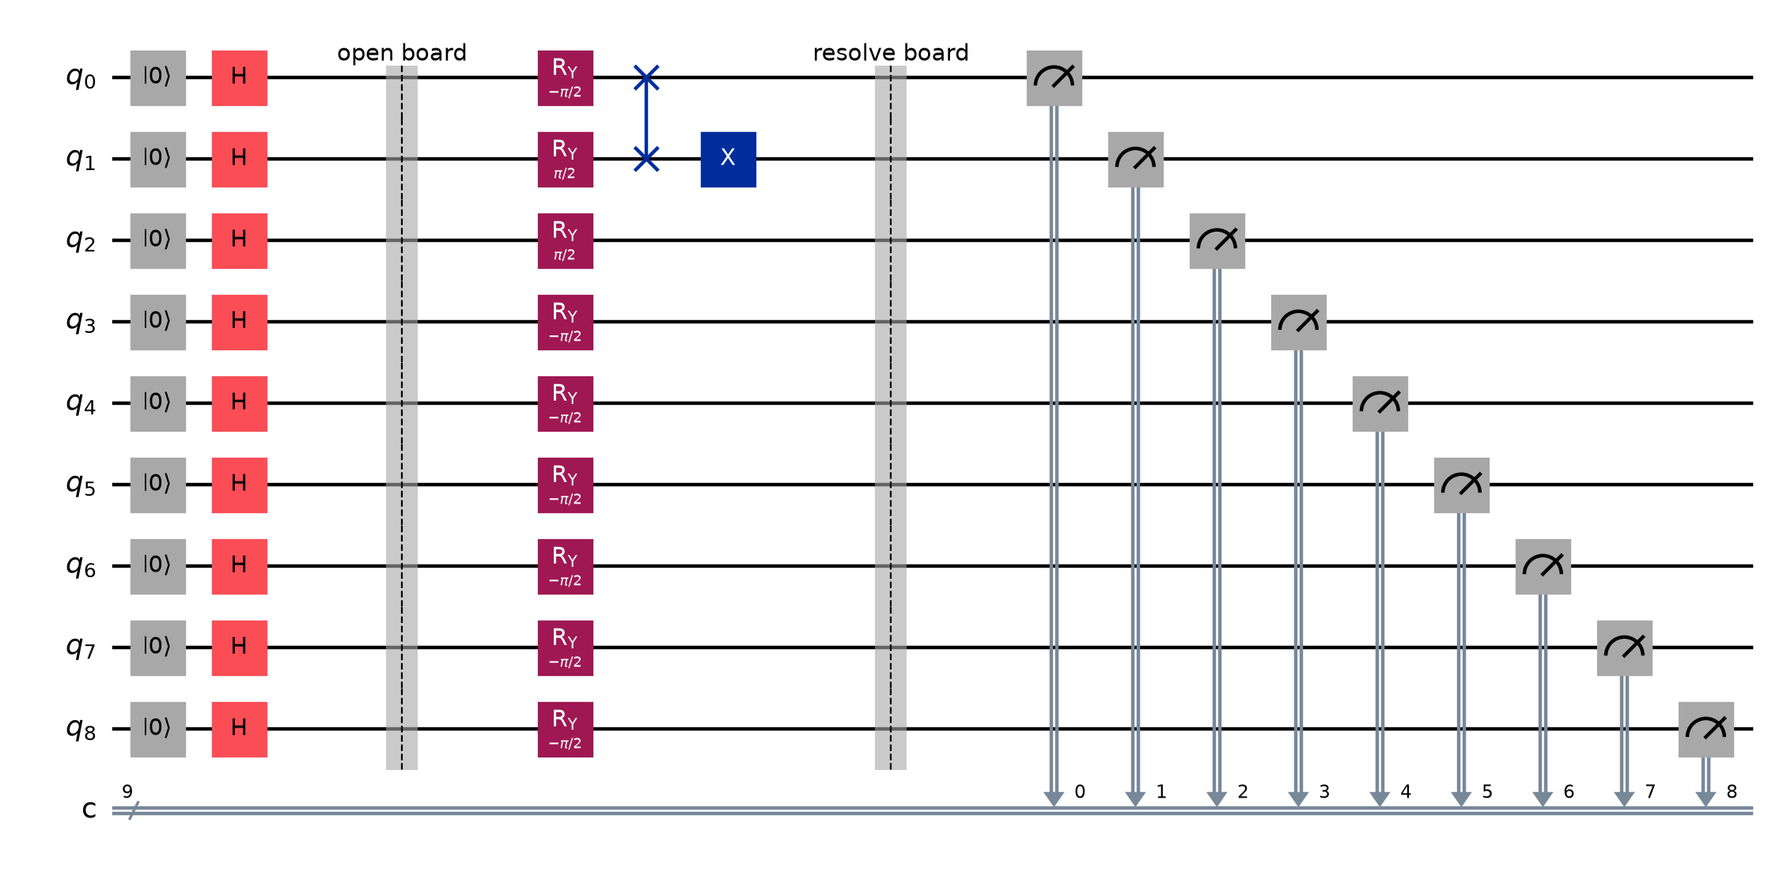

3.5 Gate-order implications
Gate order matters. In Game 3, cell 0 is prepared O and cell 1 X; SWAP makes cell 0 X and cell 1 O; Not then turns cell 1 into X. Preparing cell 2 as X completes the top row. Moving Not before SWAP would flip a different logical state and could change the winner.

4. Gameplay dynamics and scoring

4.1 Interaction
The player chooses a move and clicks a board cell. For SWAP, the first click is highlighted and the second click completes the gate. Measure resolves all cells in one shot. Replay resets the circuit, history, score, pending SWAP selection, button labels, and button colours.

4.2 Winning conditions
The eight triples are rows (0,1,2), (3,4,5), (6,7,8); columns (0,3,6), (1,4,7), (2,5,8); and diagonals (0,4,8), (2,4,6). The scorer counts all completed lines independently for both symbols. Unlike ordinary alternating Tic-Tac-Toe, a quantum resolution can produce simultaneous or multiple wins.
Game | Resolved board (rows separated by /) | X lines | O lines
Game 1 Rows | OOO/XXX/XXX | 2 | 1
Game 2 Not | XOO/OXO/OOX | 1 | 0
Game 3 Swap | XXX/OOO/OOO | 1 | 2
Game 4 Open | OOO/XOX/OOX | 0 | 3

4.3 Why labels are provisional
Before measurement, a button label records operations such as O, N, or S; it does not calculate a classical owner. This is essential for superposition and gate composition. After measurement, buttons display only resolved O/X values and the score reports completed lines.
Interpretation The game is an educational circuit builder, not a claim of quantum advantage. Its value is the direct connection between a user action, a gate, and a measurable state transition.

5. Multiple-game evidence
Figure 2. Four submitted one-shot game outcomes.
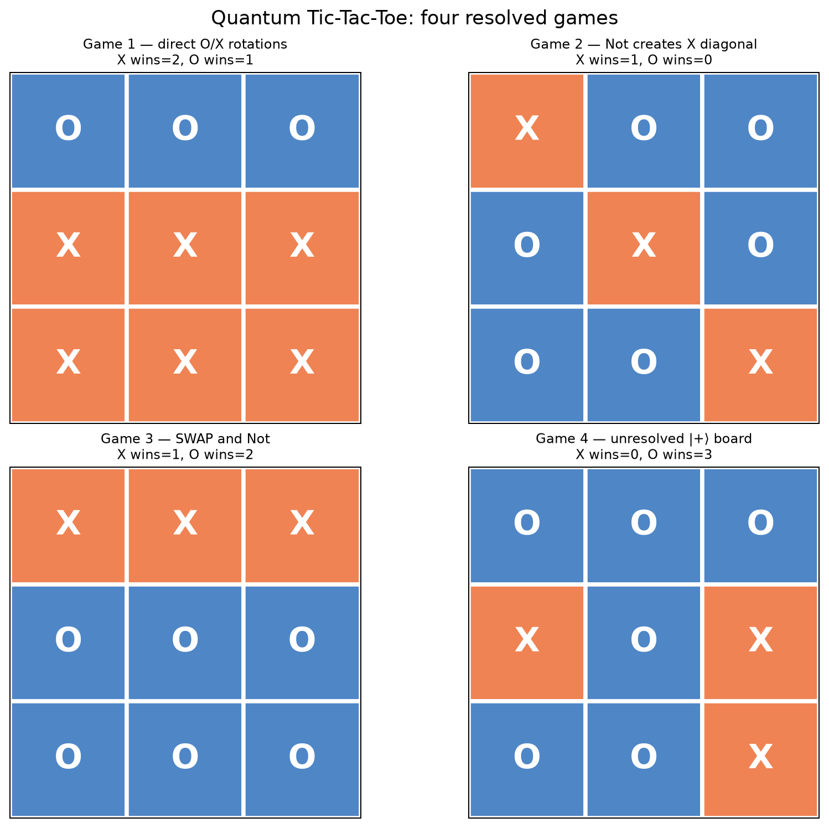

5.1 Games 1–3: analytical checks
Game 1 resolves as OOO/XXX/XXX, yielding one O row and two X rows. Game 2 starts O everywhere and applies Not on 0, 4, and 8, yielding XOO/OXO/OOX and one X diagonal. Game 3 resolves XXX/OOO/OOO after SWAP and Not, yielding one X row and two O rows. All three results exactly match the gate algebra.

5.2 Game 4: probabilistic resolution
Game 4 appends no player gate. Seed 805 produced OOOXOXOOX, with 0 X lines and 3 O lines. The seed makes the saved run reproducible, but it does not make this board a deterministic physical prediction. A new seed can produce any of 512 ideal board strings.

6. Verification and engineering quality

6.1 Automated checks
Check | Assertion
Gate dispatch | O/X/Not/SWAP append ry/ry/x/swap in order
Deterministic semantics | O→0, X→1, and O+Not→1
State exchange | SWAP exchanges prepared O and X cells
Winning triples | Exactly eight unique triples; all-X board scores eight
Bit order | c8…c0 reverses to cells 0…8
Measurement isolation | Stored game circuit receives no measure gate
UI flow | Two-click SWAP and Replay reset behave correctly
At evidence generation, all seven Task 3 tests passed and the complete repository suite reported 14 passed. The notebook was also executed from top to bottom without a cell error. Seeds 802–805 are stored with the game records.

6.2 Reproducibility
- Dependencies are locked by pyproject.toml and uv.lock.
- The notebook is generated by scripts/build_task3_notebook.py.
- Game artefacts are regenerated by scripts/generate_task3_evidence.py.
- QASM retains the exact measured circuit for each saved game.
- JSON retains versions, backend, seeds, moves, depth, operations, and outcomes.

6.3 Limitations
Aer is ideal unless a noise model is supplied, so the evidence does not measure hardware error. One shot is correct for resolving one game but is insufficient for estimating probabilities. Most played circuits contain no entangling gate: SWAP exchanges states but does not itself create entanglement from product inputs. Finally, repeated O/X rotations are allowed as quantum operations even when their classical-looking labels may suggest simple ownership.

7. Conclusion
The completed application meets the Task 3 requirements as a local, interactive, and auditable quantum program. The circuit is generated directly from gameplay; its preparation, moves, measurement, endianness conversion, and scoring are explicit. Multiple saved games demonstrate deterministic rotation, Not, SWAP, simultaneous wins, and an unresolved superposition board. Automated tests and retained QASM/JSON evidence support the analysis rather than relying on screenshots alone.

References
[1] MSE802 Quantum Computing, “Quantum_Tic_Tac_Toe__AS2.ipynb,” course-supplied Assessment 2 starter notebook, 2026.
[2] IBM Quantum, “Bit-ordering in the Qiskit SDK,” IBM Quantum Documentation. https://quantum.cloud.ibm.com/docs/en/guides/bit-ordering (accessed 24 July 2026).
[3] IBM Quantum, “SwapGate,” Qiskit SDK API documentation. https://quantum.cloud.ibm.com/docs/api/qiskit/qiskit.circuit.library.SwapGate (accessed 24 July 2026).
[4] Qiskit Development Team, “AerSimulator,” Qiskit Aer 0.17 documentation. https://qiskit.github.io/qiskit-aer/stubs/qiskit_aer.AerSimulator.html (accessed 24 July 2026).
[5] M. A. Nielsen and I. L. Chuang, Quantum Computation and Quantum Information, 10th anniversary ed. Cambridge: Cambridge University Press, 2010.

Appendix A — Evidence inventory
Artefact | Purpose
Task_3_Quantum_Tic_Tac_Toe.ipynb | Executed explanation and interactive game
game_1_rows … game_4_open (.qasm/.png) | Exact circuits and diagrams
task3_game_evidence.json | Machine-readable moves, metrics, and results
task3_four_game_summary.png | Visual comparison of resolved boards
SOURCE_NOTE.md | Starter provenance and adaptation boundary
Task_3_Quantum_Tic_Tac_Toe_Report.docx | Comprehensive assessment report

