Lab 9 - Stored Programs: User Defined Functions

Task 2

Create a function to clean up and make the film descriptions URL safe. For example, URLs cannot contain spaces and certain special characters.

1. Alter the table film by adding the following column and write the query to do so as your answer: urlsafe VARCHAR(255) (1 mark)  
     
   ALTER TABLE film ADD urlsafe VARCHAR(255);  
   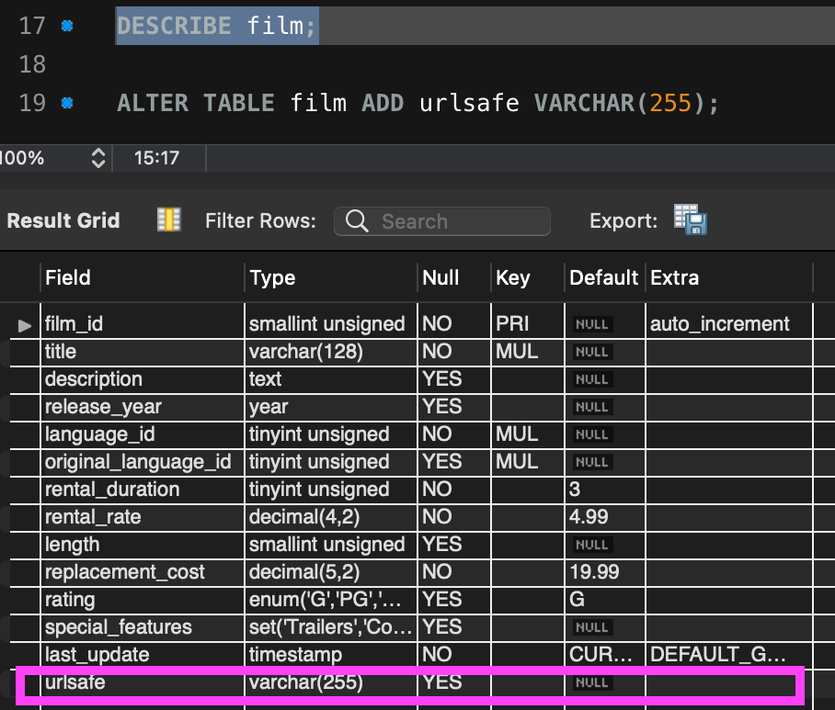
2. Create a user defined function, named clean_string, to strip out spaces. The user defined function will accept a string(varchar) as an argument. (4 marks)  
   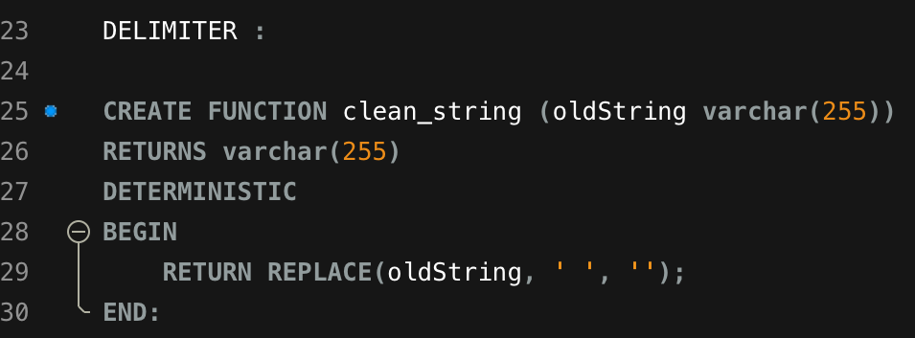
3. Test your function by running and copy the result of running this as your answer: select clean_string(" this is a test"); (1 mark)  
   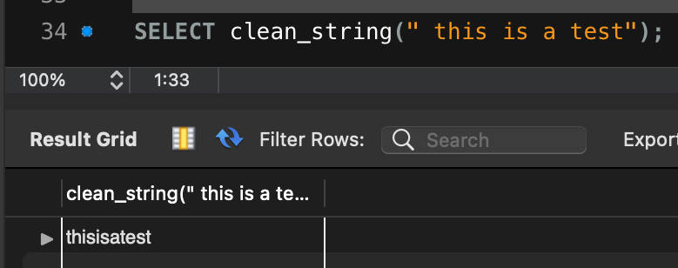
4. Test your function by running a string through that has other characters present such as a period or a semi colon. (1 mark)  
   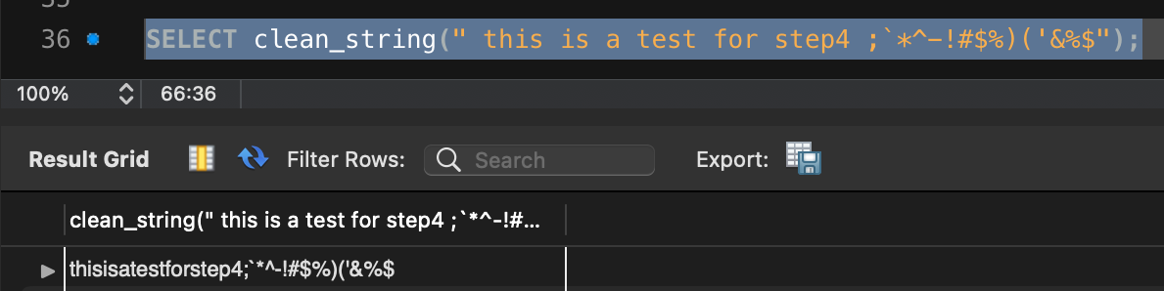
5. Alter your function to strip out the following characters in addition to spaces: .;!@#$%* (2 marks)  
     
   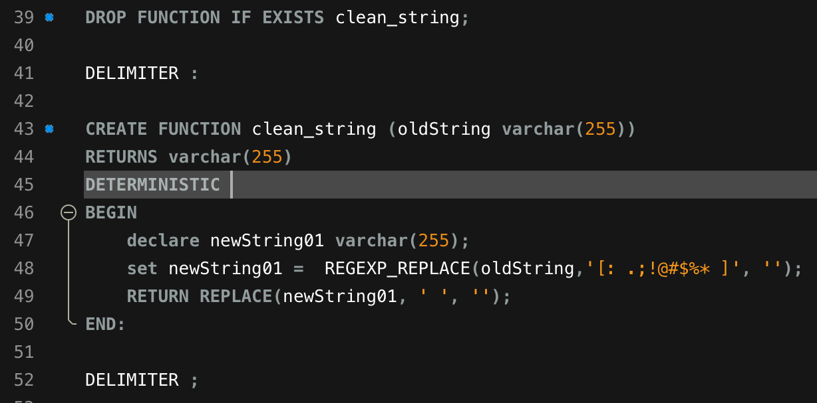
6. Now run your function against the description field of the film table for the first 5 rows and copy the result as your answer. (1 mark)  
   the result (below)  
   'AEpicDramaofaFeministAndaMadScientistwhomustBattleaTeacherinTheCanadianRockies'  
   'AAstoundingEpistleofaDatabaseAdministratorAndaExplorerwhomustFindaCarinAncientChina'  
   ' AAstoundingReflectionofaLumberjackAndaCarwhomustSinkaLumberjackinABaloonFactory'  
   ' AFancifulDocumentaryofaFrisbeeAndaLumberjackwhomustChasea\n\nMonkeyinASharkTank'  
   'AFast-PacedDocumentaryofaPastryChefAndaDentistwhomustPursueaForensicPsychologistinTheGulfofMexico'  
     
   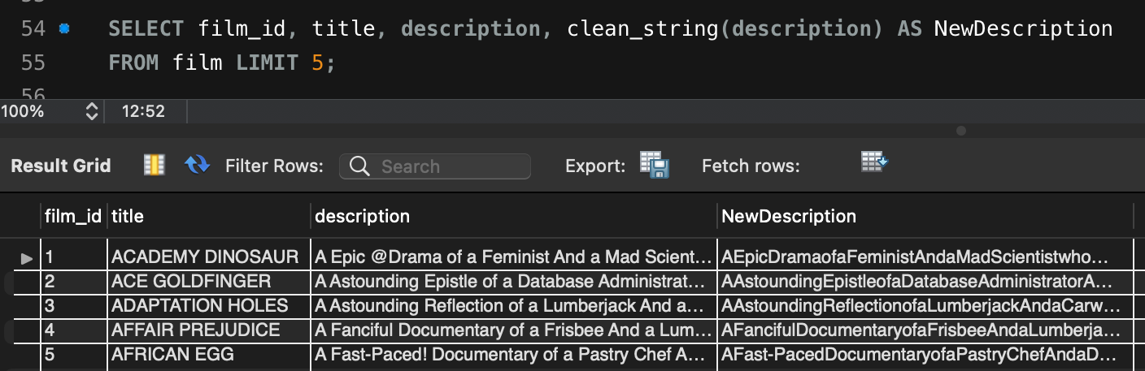

• Last Name, first name – Lab 9.sql

Include delimiter statements when submitting the lab.