Week11-Transactions

2022/07/27

Miku Abe (041047851)

1. Start two connections to your database server (note that both connections can be made with the same user i.e. root). On the first instance/connection, execute the following. Red text will indicate the first instance; blue text will indicate the second.
2. Write a query that calculates the number of records in the example1 table and provide this query. (1 mark)  
   
3. Execute the query from 1. How many records are stored in the example1 table? (1 mark)  
     
   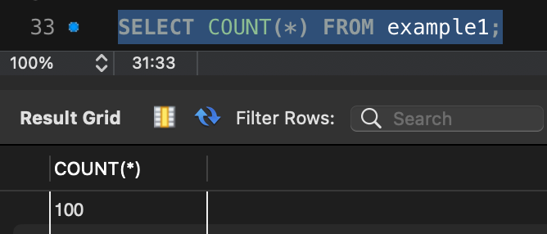
4. Execute the query below.  
   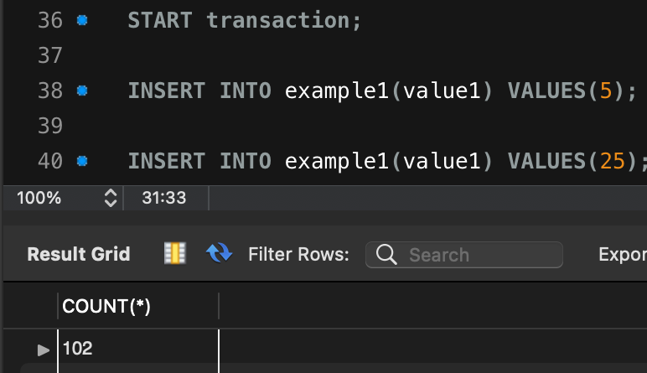
5. Execute the insert statements from 1 again. How many records are stored in the example1 table? (1 mark)  
     
   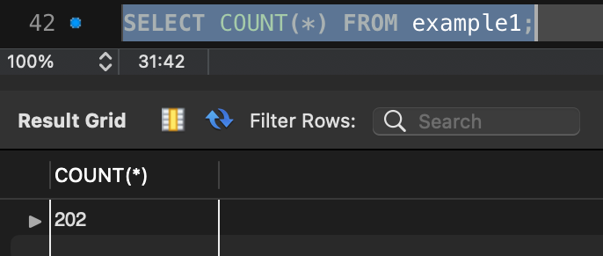
6. Switch to the second instance/connection. Set the default database to transtest.
7. How many records are stored in the example1 table? Why? Which letter of ACID does it demonstrate? (1 mark)  
     
   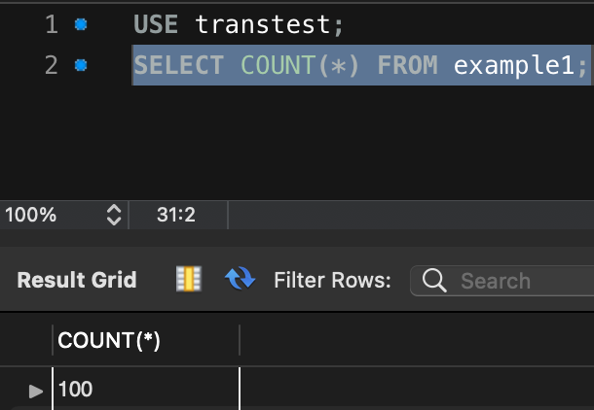  
     
   Because connection 1 starts transaction then not commit yet, connection 2 cannot see any change. Atomicity and Isolation are applied.
8. Switch to the first instance/connection and ensure safe updates is disabled.  
   Or go to Edit --> Preferences --> SQL Editor and uncheck “Safe Updates” at the bottom of the window. If you did not have this setting set, you will have to restart your connection to the first instance for this change to take effect.
9. Run the following command:
10. How many records are stored in the example1 table in the first instance? (1 mark)  
      
    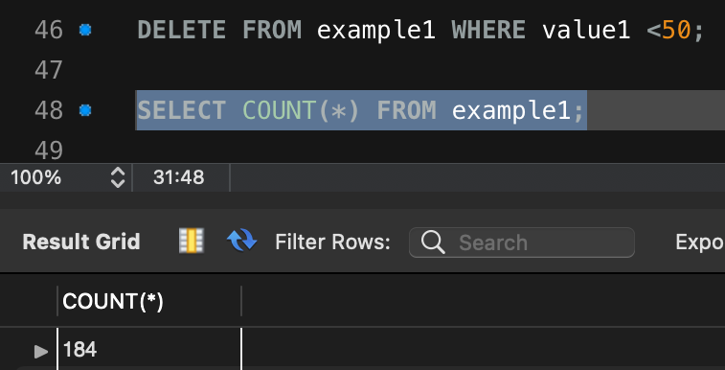
11. Commit the transaction from the first instance then switch to the second instance/connection.
12. How many records are stored in the example1 table in the second instance? Explain. (1 mark)  
      
    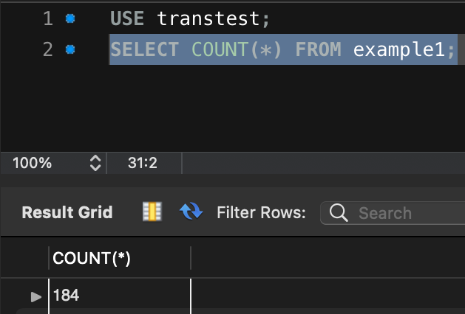  
      
    Since connection 1 commits its transaction, the change is set to the database permanently. Durability is applied.
13. Switch back to the first instance/connection and run the following:
14. How many records are stored in the example1 table in the first instance? (1 mark)   
      
    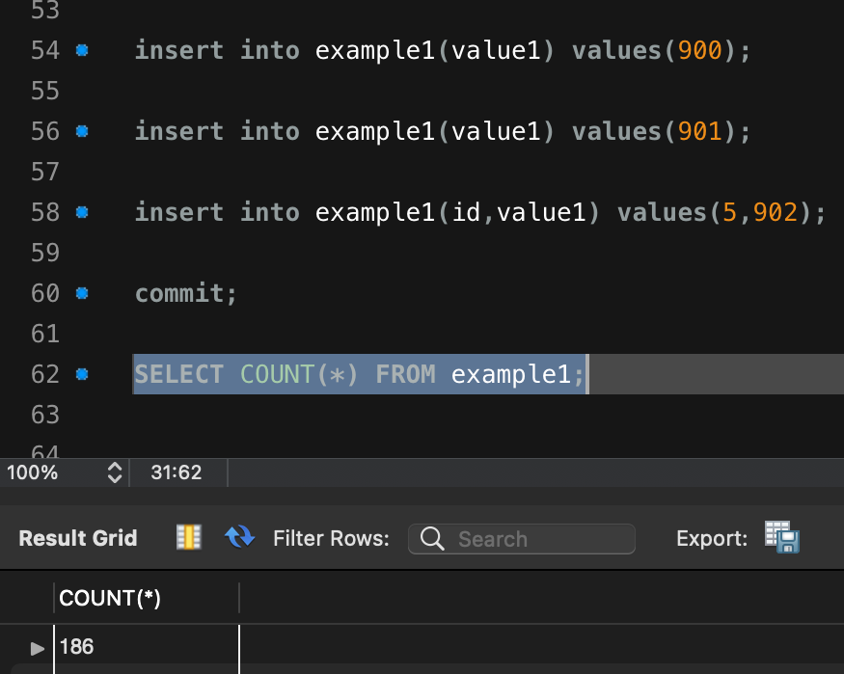  
    Because the first and second insert statement are applied, only two rows are added.
15. Switch to the second instance/connection.
16. What is the number of records in the example1 table in the second instance? (1 mark)   
       
      
    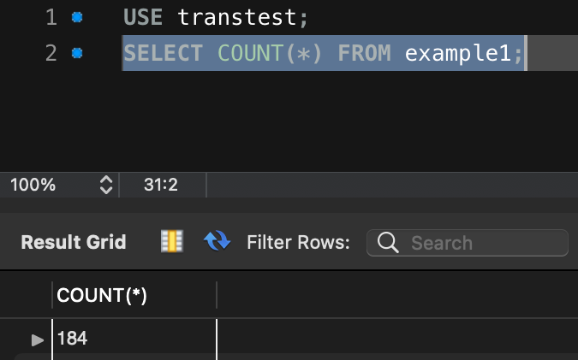  
    Because transaction in connection 1 isn’t committed yet, the changes have not affected the table.
17. Which letter of ACID does it demonstrate? (1 mark)  
      
    A(Atomicity) and I(Isolation) are applied
18. Switch back to the first instance and run
19. How many records are stored in the example1 table in the first instance? (1 mark)   
      
    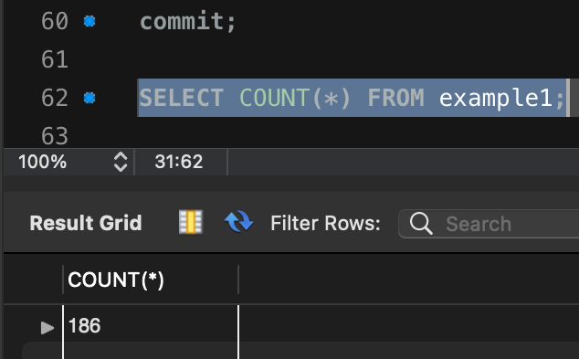
20. Switch to the second instance/connection.
21. How many records are stored in the example1 table in the second instance? Explain. (1 mark)  
      
    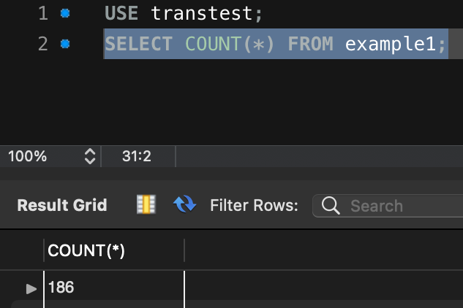  
    Since connection 1 committed its transaction, the permanent changes applied to the table then connection 2 can see the results.
22. Switch to the first instance/connection. Execute the entire transaction below:
23. How many records are stored in the example1 table in the first instance? (1 mark)  
    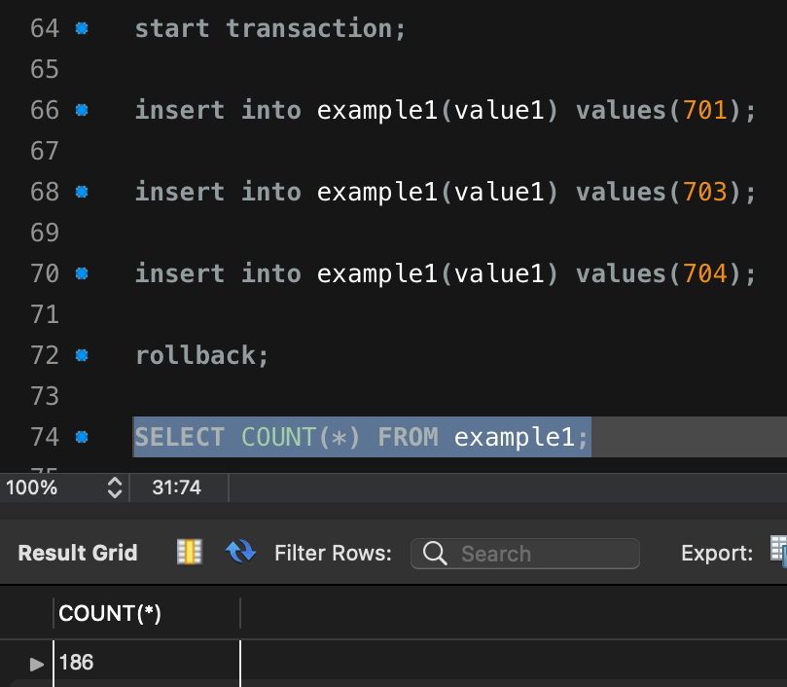
24. Switch to the second instance/connection.
25. How many records are stored in the example1 table in the second instance? Explain. (1 mark)  
      
    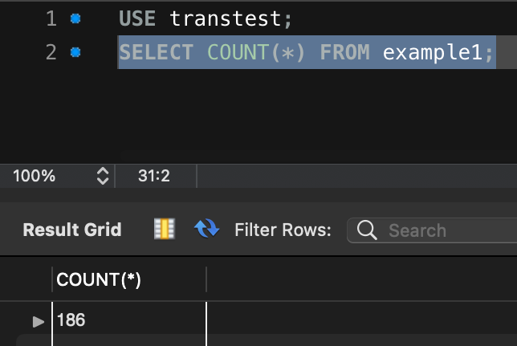  
    Since connection 1 starts transaction and rollback it instead of commit, the changes connection 1 made are canceled. connection 2 can see the results which looks like nothing happened.
26. Switch to the first instance/connection and run:
27. How many records are stored in the example1 table in the first instance? (1 mark)  
      
    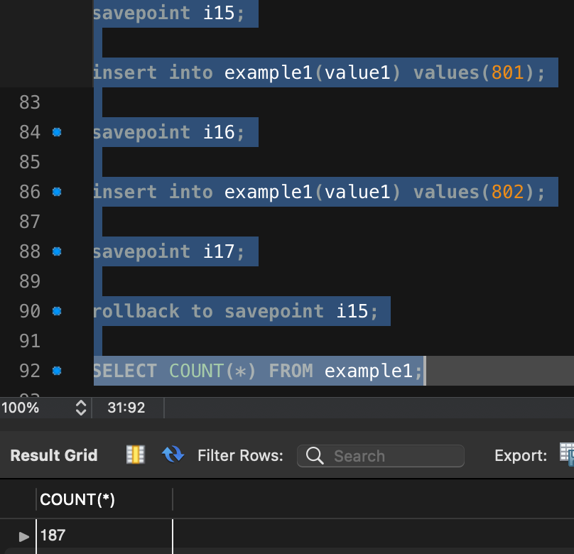
28. Switch to the second instance/connection.
29. How many records are stored in the example1 table in the second instance? (1 mark)  
      
      
    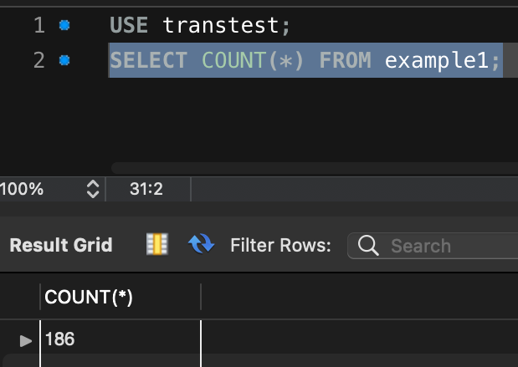
30. Switch to the first instance/connection and run the following:
31. How many records are stored in the example1 table in the first instance? (1 mark)  
      
      
    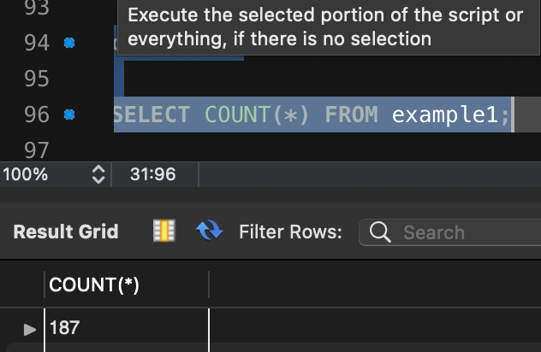
32. Switch to the second instance/connection.
33. How many records are stored in the example1 table in the second instance? Explain (1 mark)  
      
    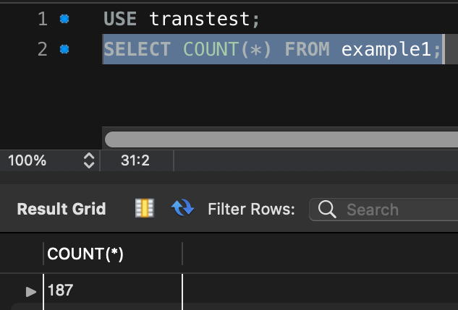  
      
    Since connection 1 starts transaction and committed it, the changes connection 1 made are set to the table. connection 2 can see the results.