
PROJECT REPORT · FUNCTIONAL PROTOTYPE

Melo
  - Pause. Breathe. Say It Better.
A bounded mental-wellness and healthy-communication prototype
for students before they press Send
HKIIT × TP Melo Team
5 August 2026

Executive summary
Core proposition Melo creates a small, usable pause between a strong feeling and an impulsive message. It helps a student name the context, breathe, and turn the draft into a calmer message with a concrete next step.
Melo is a functional React Native and Expo prototype for emotional regulation and healthier communication. It is intentionally narrower than an open-ended therapy chatbot: the primary flow starts with a message the user is about to send and ends with a version they can copy or share. A friendly virtual companion supports the pause without diagnosing the user or replacing professional care.

What the prototype demonstrates
- A four-stage Guided Rewrite: draft, emotional context, twelve-second breathing pause, and Before/After review.
- A bounded Melo Chat with device-local history, model attribution, optional model-level image input and five validated character expressions.
- Bring Your Own Key provider settings with no supplied credits, key or active default model.
- English, Traditional Chinese and Simplified Chinese interface switching, plus written Cantonese as a message-output option.
- A resilient offline fallback for Guided Rewrite that stays visibly labelled and is never presented as AI output.

Evidence boundary
This report describes implemented behaviour and observed test results. It does not claim clinical effectiveness, measured user outcomes, production security, full accessibility compliance or successful provider use on a teammate’s physical phone.

1. Problem and product proposition
Students often communicate while feeling overwhelmed, angry, disappointed or anxious. The underlying concern may be valid, but wording written at the emotional peak can turn a solvable issue into a damaged friendship, family relationship or group-project dynamic.

Design challenge
The product must interrupt an impulsive action without becoming another complicated form, a moral judgement or a clinical claim. It also has to remain demonstrable when Wi-Fi or a model provider is unavailable.

Product response
- Start from the real draft rather than from an abstract wellness questionnaire.
- Ask only for context that changes the rewrite: emotion, recipient, tone and output language.
- Insert one brief regulation action before generation.
- Return a usable message, explain the communication change, and make Copy or Share immediate.
- Keep the boundary visible: support communication, not diagnosis or therapy.
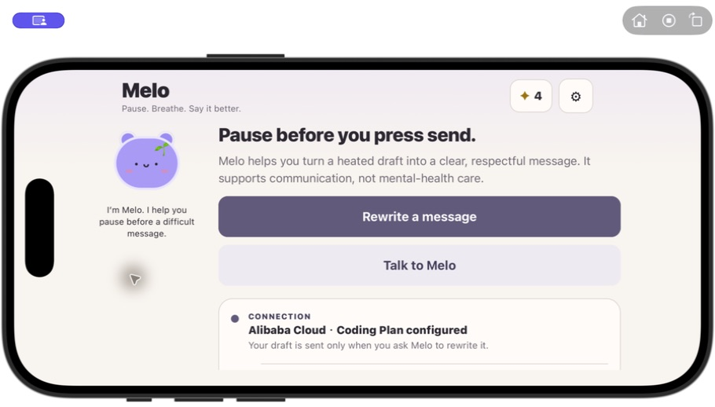
Figure 1. Melo Home keeps the primary action clear and the provider status secondary.

2. Core user journey
- Enter the draft. The user types or pastes the message they are about to send.
- Add context. Emotion, recipient, tone and message language shape the output.
- Pause with Melo. A twelve-second breathing interaction interrupts the impulse; a demo control can skip the remainder after the experience is visible.
- Review and act. Before/After presentation makes the change legible, while Copy, Share, retry and start-again controls support the next action.

Why the flow is bounded
Each stage asks for one kind of decision. The system does not require an account, long onboarding, a mood diary or a diagnostic score before helping with the immediate communication moment. Interface language remains independent from message-output language, which supports students communicating across Hong Kong, Singapore and other multilingual contexts.
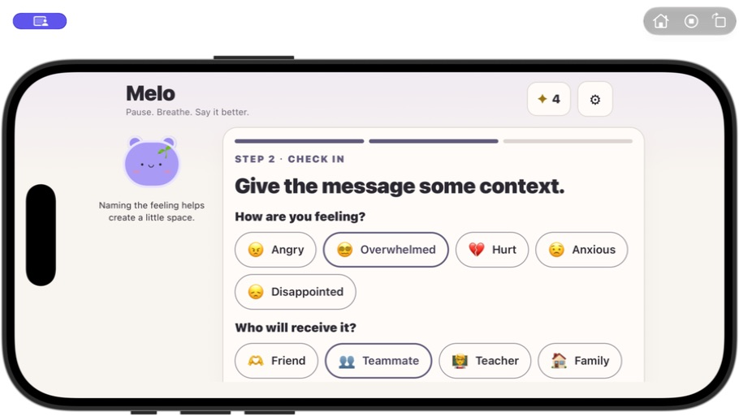
Figure 2. Context choices are compact, visible and directly tied to the rewrite.

3. Interaction design and the Melo companion
Melo is part of the regulation loop rather than decorative branding. The same character listens on Home, helps the user name an emotion, breathes during the pause, celebrates a completed healthy-communication action and appears beside replies in Chat. The project uses Melo’s calm purple face as its brand mark so the app icon, report and presentation share one recognisable identity.

Positive reinforcement without pressure
- One completed Guided Rewrite earns one Calm Star.
- Simple accessories unlock at 3, 7 and 15 stars.
- There is no daily streak punishment, hunger, sickness, death or message that blames the user for leaving.
- Tapping Melo on Home produces a short local expression and bounce without a provider request.

Visual and responsive system
The current interface uses warm ivory surfaces, muted plum as the primary accent and restrained lavender-to-white transitions. The layout centres content on wide screens, adapts to tablet portrait and landscape, preserves safe areas, and supports Reduce Motion.
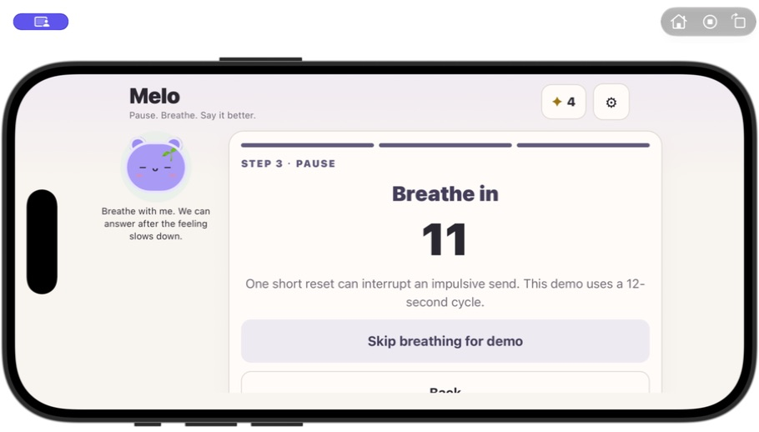
Figure 3. The breathing pause makes the wellness action part of the working flow.

4. Melo Chat: familiar interaction, explicit limits
Melo Chat uses a familiar message-bubble composer but keeps Melo’s defined personality and a narrow support role. It listens, reflects, validates without overclaiming, and helps the user choose one manageable next step. It does not fabricate an assistant reply when the model request is missing or fails.

Bounded context and truthful attribution
- The newest 24 messages are retained only on the current device or browser.
- At most the latest 8 conversation messages are sent with Melo’s system instructions for one provider turn.
- Every successful assistant bubble preserves the exact provider and Model ID that generated it.
- Changing settings later does not rewrite attribution stored on older bubbles.
- The model may select only calm, listening, thinking, encouraging or concerned; unrecognised values fall back safely.

Optional image input
Image attachment is enabled only when the user marks the exact selected model as image-capable. Images are resized and normalised locally before the request; the app never assumes vision support from a provider name alone.
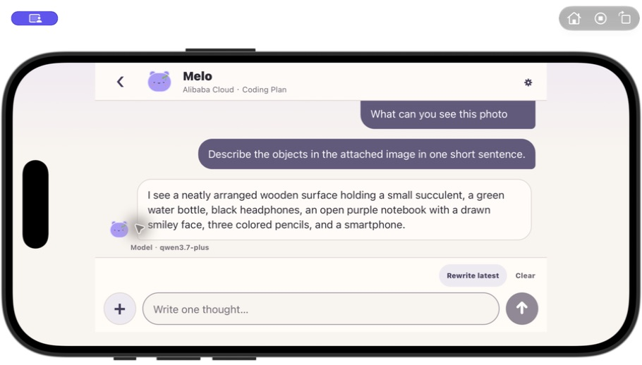
Figure 4. A real configured provider reply keeps a quiet Model ID note under the bubble.

5. Technical implementation and model choice
The client is built with React Native, Expo SDK 54 and TypeScript. A shared OpenAI-compatible Chat Completions transport serves Guided Rewrite and Melo Chat, while provider-specific presets remain separate from the product logic. The same codebase targets iOS, Android and Web.

Bring Your Own Key by design
- Melo supplies no API key, model access, credits or active default provider/model.
- Users choose OpenAI, Google AI Studio, DeepSeek, Kimi, MiniMax, Z.ai BigModel, Alibaba Cloud or a custom compatible endpoint, then enter the exact Model ID.
- Alibaba Cloud adds two explicit selectors: plan and region/server. Pay-as-you-go, Coding Plan and Token Plan map only to compatible endpoint choices.
- Changing provider, Alibaba plan or region clears the previous key to reduce accidental endpoint/key mismatch.
- Client requests time out after 65 seconds and distinguish local configuration, network, timeout, HTTP and invalid-response failures without displaying secret material.
Provider truth A provider badge appears only after a readable model response. A deterministic local rewrite is always labelled Offline fallback; Melo Chat never invents a local assistant conversation.
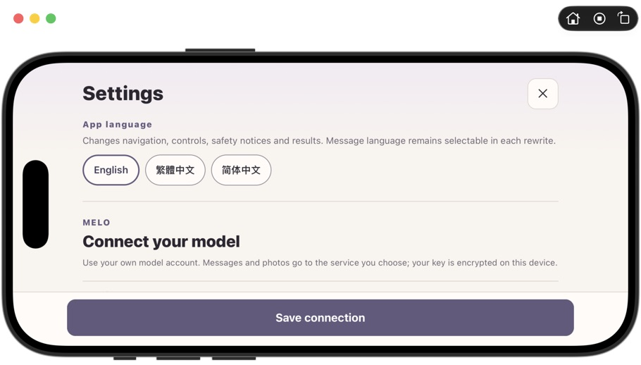
Figure 5. Settings use progressive disclosure for language, service, plan/server and technical connection details.

6. Safety, privacy and product boundaries

Safety boundary
A small multilingual keyword guard stops the normal rewrite or Chat provider flow for obvious high-risk phrases and directs the user toward immediate real-world support. This is a prototype guard, not a clinical risk model; it can miss or misclassify text.

Data handling in the prototype
- Offline Guided Rewrite keeps the draft in current application state and makes no provider request.
- AI Guided Rewrite sends the selected draft and context directly to the user-selected provider.
- Native provider settings and bounded Chat text use Expo SecureStore; Web settings use browser session storage and Web Chat uses local storage.
- Native Chat storage uses a this-device-only accessibility class. There is no account, cloud history or cross-device synchronisation.
- The user can clear local Chat history. Raw provider bodies, keys, authorisation headers and draft text are not copied into diagnostic logs.

Production requirements
A production release would require a trusted backend, consent and retention controls, secure secret management, provider moderation, rate limiting, regional support-resource localisation and professional safety, privacy and accessibility review. Direct client-to-provider calls remain a prototype trade-off.
Positioning rule Describe Melo as a virtual wellness companion for emotional regulation and healthier communication. Do not describe it as an AI therapist, diagnosis tool, counselling replacement or emergency service.

7. Validation evidence
The following gates were checked on 5 August 2026. They establish source, build, simulator and authorised-provider evidence; they do not replace a physical-device acceptance test on a teammate’s own network.
Gate | Status | Observed evidence
TypeScript | Passed | npm run typecheck completed without error.
Regression suite | Passed | 59 of 59 deterministic tests passed across provider truth, settings, localisation, fallback, safety, Chat and persistence.
Expo Doctor | Passed | 18 of 18 Expo SDK 54 checks passed.
Production export | Passed | Web, iOS and Android exports completed successfully.
Responsive simulator QA | Passed | Phone, iPad portrait/landscape and short-landscape Chat layouts were exercised without visible clipping.
Authorised provider UI | Passed | iOS Simulator Guided Rewrite, multi-turn Chat and a synthetic image turn returned labelled provider output.
Physical phone | Open gate | A teammate’s Expo Go run and complete provider flow on their own network still need visible confirmation.

Failure behaviour was tested
A deliberately delayed response succeeded after nine seconds, while an HTTP 500 path was presented as Offline fallback with the status shown safely. A Chat request that reached the configured time limit added no assistant message and offered Retry or Configure model service.

Authorised provider evidence and claim boundary
The screenshot below shows the real Guided Rewrite UI after an explicitly authorised Alibaba Cloud Coding Plan request in the iOS Simulator. The service badge is part of the saved result rather than a decorative label, and the generated wording differed when the selected tone changed.
What this proves The configured simulator path reached the shared provider adapter and returned a readable response that Melo labelled as AI. It does not prove physical-device connectivity, clinical benefit, or that every supported provider preset has completed the same end-to-end account test.
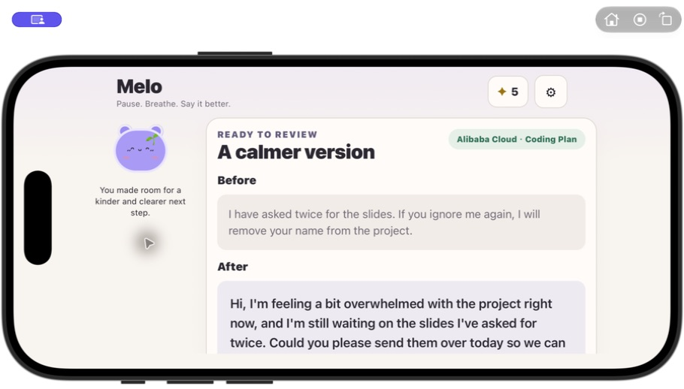
Figure 6. Authorised Alibaba Cloud Coding Plan result, visibly attributed to the selected service.

8. Intended value and evaluation plan
Melo’s intended value is practical rather than clinical: reduce blame, make the user’s feeling understandable, and end with a clear request or next step. The output can immediately be copied or shared. Any real impact claim should be established through later user research rather than inferred from the working prototype.

Proposed evaluation
- Task completion: can a first-time student finish the four-stage flow without explanation?
- Message quality: do blinded reviewers rate the rewrite as clearer, less blaming and more actionable than the original?
- Perceived agency: does the result still express the user’s real concern rather than erase it?
- Trust: can users correctly tell whether the result came from a provider or Offline fallback?
- Accessibility and localisation: can users complete the flow in all three interface languages and across phone/tablet orientations?

Current limitations and next steps
- Confirm Expo Go and the complete authorised-provider flow on a teammate’s physical phone.
- Add an explicit Test Connection action before users enter the main flow.
- Improve the high-risk support screen and localise real support resources.
- Expand accessibility review, automated UI coverage and large-text testing.
- Move provider calls behind a trusted backend before any production deployment.
- Address Expo 54 transitive build-tool advisories through a planned SDK migration rather than a blind major-version update.

Conclusion
Closing statement Melo does not replace human connection. It creates one small pause that can protect that connection.

Evidence sources
Primary repository: https://github.com/miku233333/mobile-Team-A
Reviewed materials: README.md, README.zh-Hant.md, PITCH.md, package.json, app.json, src/components, src/config, src/services, src/theme.ts and the deterministic tests in tests/.
Screenshots in this report were captured from the local Melo prototype on 5 August 2026 using synthetic, non-private content.

