



**index.php**

**<?php include('includes/config.php'); ?>**

**<?php session_start(); ?>**

**<!DOCTYPE html>**

**<html lang="en">**

**<head>**

**<meta charset="UTF-8">**

**<meta http-equiv="X-UA-Compatible" content="IE=edge">**

**<meta name="viewport" content="width=device-width, initial-scale=1.0">**

**<link href="https://cdn.jsdelivr.net/npm/bootstrap@5.2.0-beta1/dist/css/bootstrap.min.css" rel="stylesheet" integrity="sha384-0evHe/X+R7YkIZDRvuzKMRqM+OrBnVFBL6DOitfPri4tjfHxaWutUpFmBp4vmVor" crossorigin="anonymous">**

**<link rel="stylesheet" href="style.css">**

**<title>College Management System - Home</title>**

**</head>**

**<body style="background: linear-gradient(-450deg, #8cc5d0, transparent);">**

**<!-- Navbar -->**

**<nav class="navbar navbar-expand-lg bg-light" style="background: linear-gradient(450deg, #8cc5d0, transparent);">**

**<div class="container-fluid">**

**<a href="index.php" class="navbar-brand">**

**<img id="college-logo" src="images/logo.svg" alt="College Logo" draggable="false" height="30" />**

**<span class="mx-4 h3">College Management System</span>**

**</a>**

**<button class="navbar-toggler" type="button" data-bs-toggle="collapse" data-bs-target="#navbarSupportedContent" aria-controls="navbarSupportedContent" aria-expanded="false" aria-label="Toggle navigation">**

**<span class="navbar-toggler-icon"></span>**

**</button>**

**<div class="collapse navbar-collapse" id="navbarSupportedContent">**

**<ul class="navbar-nav me-auto mb-2 mb-lg-0 mx-4">**

**<!-- <li class="nav-item">**

**<a class="nav-link active" aria-current="page" href="index.php">Home</a>**

**</li>**

**<li class="nav-item">**

**<a class="nav-link" href="#">About Us</a>**

**</li>**

**<li class="nav-item">**

**<a class="nav-link" href="#">Courses</a>**

**</li>**

**<li class="nav-item">**

**<a class="nav-link" href="#">Events</a>**

**</li> -->**

**</ul>**

**<?php if (!isset($_SESSION['signIn']) and !isset($_SESSION['student'])) { ?>**

**<form class="d-flex float-right" role="search">**

**<a class="btn btn-outline-success me-4" href="signIn.php">Sign In</a>**

**<a class="btn btn-outline-primary me-4" href="signUp.php">Sign Up</a>**

**</form>**

**<?php } else { ?>**

**<form class="d-flex" role="search">**

**<a class="btn btn-outline-primary me-5" href= <?php if(isset($_SESSION['student'])){echo "./student/dashboard.php";} else {echo "./admin/dashboard.php";}?>>Dashboard</a>**

**</form>**

**<form class="d-flex" role="search">**

**<a class="btn btn-outline-danger" href="actions/logout.php">Log Out</a>**

**</form>**

**<?php } ?>**

**</div>**

**</div>**

**</div>**

**</nav>**

**<!-- Body -->**

**<div class="container-fluid my-5">**

**<div class="row">**

**<!-- Left Side -->**

**<div class="col-lg-6 my-5">**

**<h1 class="display-3 my-5">Welcome to College Mangement Website!</h1>**

**<p class="my-4">The prestigious WURI Rankings 2022 has ranked us 2nd in India among the Top Ivy League**

**universities. In our very first attempt, we have secured a global band of 101-200. Join with us now!</p>**

**<?php if (!isset($_SESSION['signIn']) and !isset($_SESSION['student'])) { ?>**

**<a href="signIn.php" class="btn btn-lg btn-outline-success my-3 mx-5 col-lg-6">Sign In </a>**

**<a href="signUp.php" class="btn btn-lg btn-outline-primary my-3 mx-5 col-lg-6">Sign Up </a>**

**<?php } ?>**

**</div>**

**<!-- Right Side -->**

**<?php if (!isset($_SESSION['signIn']) and !isset($_SESSION['student'])) { ?>**

**<div class="col-lg-6 my-5">**

**<div class="w-50 mx-auto">**

**<h4>Student registration and inquiry form</h4>**

**<form action="#" method="POST" class="my-5">**

**<div class="input-group mb-4">**

**<span class="input-group-text" id="fullName">Full Name</span>**

**<input type="text" class="form-control" placeholder="Your Full Name" aria-label="fullName" aria-describedby="fullName" required>**

**</div>**

**<div class="input-group mb-4">**

**<span class="input-group-text" id="userName">User Name</span>**

**<input type="text" class="form-control" placeholder="Your User Name" aria-label="userName" aria-describedby="userName" required>**

**</div>**

**<div class="input-group mb-4">**

**<span class="input-group-text" id="email">Email</span>**

**<input type="email" class="form-control" placeholder="Your Email" aria-label="email" aria-describedby="email" required>**

**</div>**

**<div class="input-group mb-4">**

**<span class="input-group-text" id="phNumber">Number</span>**

**<input type="tel" class="form-control" placeholder="Your Phone Number" aria-label="phNumber" aria-describedby="phNumber" required>**

**</div>**

**<div class="input-group mb-4">**

**<span class="input-group-text" id="pWord">Password</span>**

**<input type="password" class="form-control" placeholder="Enter your password" aria-label="pWord" aria-describedby="pWord" required>**

**</div>**

**<div class="input-group mb-4">**

**<span class="input-group-text" id="confPass">Confirm Password</span>**

**<input type="password" class="form-control" placeholder="Confirm your password" aria-label="confPass" aria-describedby="confPass" required>**

**</div>**

**<div class="input-group mb-4 gender-details">**

**<input type="radio" name="gender" id="male">**

**<input type="radio" name="gender" id="female">**

**<input type="radio" name="gender" id="others">**

**<input type="radio" name="gender" id="undefined">**

**<div class="category">**

**<label for="male">**

**<span class="dot one"></span>**

**<span class="gender">Male</span>**

**</label>**

**<label for="female">**

**<span class="dot two"></span>**

**<span class="gender">Female</span>**

**</label>**

**<label for="others">**

**<span class="dot three"></span>**

**<span class="gender">Others</span>**

**</label>**

**<label for="undefined">**

**<span class="dot four"></span>**

**<span class="gender">Prefer not to say</span>**

**</label>**

**</div>**

**</div>**

**<div class="input-group mb-4">**

**<select class="form-select form-select-lg mb-3" aria-label=".form-select-lg example">**

**<option hidden="true">Choose your department</option>**

**<option value="BCA">BCA</option>**

**<option value="BBA">BBA</option>**

**</select>**

**</div>**

**<div class="input-group mb-4">**

**<input type="submit" class="btn btn-lg btn-outline-primary col-12" value="Register">**

**</div>**

**</form>**

**</div>**

**</div>**

**</div>**

**</div>**

**<?php } ?>**

**<section class="py-5">**

**<div class="text-center mb-5">**

**<h2 class="font-weight-bold">Our Courses</h2>**

**<p class="text-muted">Lorem ipsum, dolor sit amet consectetur adipisicing elit. Quod, tempore. Tempore repellendus ut voluptatem neque dicta officia earum, expedita ullam.</p>**

**</div>**

**<div class="container">**

**<div class="row">**

**<?php**

**$query = mysqli_query($con, "SELECT * FROM courses ORDER BY id DESC LIMIT 0, 8");**

**while($course = mysqli_fetch_object($query)) {**

**?>**

**<div class="col-lg-3 mb-4">**

**<div class="card">**

**<div><img src="dist/uploads/<?php echo $course->course_image; ?>" class="img-fluid rounded-top" alt="Course Picture"></div>**

**<div class="card-body">**

**<b><?php echo $course->course_name; ?></b>**

**<p class="card-text">**

**<b>Duration: <?php echo $course->duration; ?></b>**

**<b>Price: <?php echo $course->price ?></b>**

**</p>**

**<button class="btn btn-primary">Enroll Now</button>**

**</div>**

**</div>**

**</div>**

**<?php } ?>**

**</div>**

**</div>**

**</section>**

**<script src="https://cdn.jsdelivr.net/npm/bootstrap@5.2.0-beta1/dist/js/bootstrap.bundle.min.js" integrity="sha384-pprn3073KE6tl6bjs2QrFaJGz5/SUsLqktiwsUTF55Jfv3qYSDhgCecCxMW52nD2" crossorigin="anonymous"></script>**

**</body>**

**</html>**

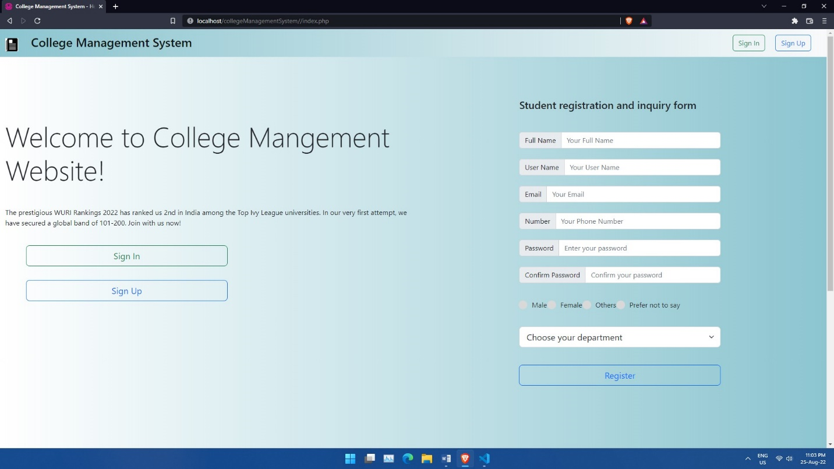

**config.php**

**<?php**

**$con = mysqli_connect('localhost', 'root', '', 'college_management_system');**

**if(!$con) {**

**echo "Database Connection Failed...";**

**exit;**

**}**

**include('functions.php');**

**?>**

**functions.php**

**<?php**

**function get_classes($con)**

**{**

**$query = mysqli_query($con, "SELECT * FROM classes");**

**$output = array();**

**while ($classes = mysqli_fetch_object($query)) {**

**$output[] = $classes;**

**}**

**return $output;**

**}**

**function get_post(array $args = [])**

**{**

**global $con;**

**if (!empty($args)) {**

**$condition = "WHERE 0 ";**

**foreach ($args as $k => $v) {**

**$v = (string)$v;**

**$condition_ar[] = "$k = '$v'";**

**}**

**if ($condition_ar > 0) {**

**$condition = "WHERE " . implode(" AND ", $condition_ar);**

**}**

**};**

**$sql = "SELECT * FROM posts $condition";**

**$query = mysqli_query($con, $sql);**

**return mysqli_fetch_object($query);**

**}**

**function get_posts(array $args = [], string $type = 'object')**

**{**

**global $con;**

**$condition = "WHERE 0 ";**

**if (!empty($args)) {**

**foreach ($args as $k => $v) {**

**$v = (string)$v;**

**$condition_ar[] = "$k = '$v'";**

**}**

**if ($condition_ar > 0) {**

**$condition = "WHERE " . implode(" AND ", $condition_ar);**

**}**

**};**

**$sql = "SELECT * FROM posts $condition";**

**$query = mysqli_query($con, $sql);**

**return data_output($query, $type);**

**}**

**function get_metadata($item_id, $meta_key = '', $type = 'object')**

**{**

**global $con;**

**$query = mysqli_query($con, "SELECT * FROM metadata WHERE item_id = $item_id");**

**if (!empty($meta_key)) {**

**$query = mysqli_query($con, "SELECT * FROM metadata WHERE item_id = $item_id AND meta_key = '$meta_key'");**

**}**

**return data_output($query, $type);**

**}**

**function data_output($query, $type = 'object')**

**{**

**$output = array();**

**if ($type == 'object') {**

**while ($result = mysqli_fetch_object($query)) {**

**$output[] = $result;**

**}**

**} else {**

**while ($result = mysqli_fetch_assoc($query)) {**

**$output[] = $result;**

**}**

**}**

**return $output;**

**}**

**function get_user_data($user_id, $type = 'object')**

**{**

**global $con;**

**$query = mysqli_query($con, "SELECT * FROM accounts WHERE id = $user_id");**

**return data_output($query, $type);**

**}**

**signUp.php**

**<?php include('includes/config.php'); ?>**

**<?php**

**if (isset($_POST['signUpBtn'])) {**

**$user_name = $_POST['signUpName'];**

**$email = $_POST['signUpEmail'];**

**$user_type = $_POST['signUpType'];**

**$password = $_POST['signUpPass'];**

**$conf_password = $_POST['signUpConfPass'];**

**$passed_checks = 1;**

**$query = mysqli_query($con, "SELECT * FROM accounts");**

**while ($account = mysqli_fetch_object($query)) {**

**if ($account->email == $email) {**

**echo "<script>alert('The given email is already in use');</script>";**

**$passed_checks = 0;**

**}**

**}**

**if ($password != $conf_password) {**

**echo "<script>alert('The password does not match. Try again');</script>";**

**$passed_checks = 0;**

**}**

**if ($passed_checks != 0) {**

**mysqli_query($con, "INSERT INTO accounts (user_type, email, password, user_name) VALUES ('$user_type', '$email', '$password', '$user_name')");**

**header('location: index.php');**

**}**

**}**

**?>**

**<!DOCTYPE html>**

**<html lang="en">**

**<head>**

**<meta charset="UTF-8">**

**<meta http-equiv="X-UA-Compatible" content="IE=edge">**

**<meta name="viewport" content="width=device-width, initial-scale=1.0">**

**<link href="https://cdn.jsdelivr.net/npm/bootstrap@5.2.0-beta1/dist/css/bootstrap.min.css" rel="stylesheet" integrity="sha384-0evHe/X+R7YkIZDRvuzKMRqM+OrBnVFBL6DOitfPri4tjfHxaWutUpFmBp4vmVor" crossorigin="anonymous">**

**<title>College management system - Register</title>**

**</head>**

**<body>**

**<!-- Sign In Page -->**

**<section class="vh-100 d-flex" style="background: linear-gradient(-450deg, #8cc5d0, transparent);">**

**<div class="col-3 m-auto">**

**<div class="card">**

**<div class="card-body shadow">**

**<h3 class="my-3 mx-3">Register here</h3>**

**<form action="" method="POST">**

**<div class="input-group my-5">**

**<span class="input-group-text" id="name">Name</span>**

**<input type="text" class="form-control" name="signUpName" placeholder="Your Name" aria-label="name" aria-describedby="name" required>**

**</div>**

**<div class="input-group my-5">**

**<span class="input-group-text" id="email">Email</span>**

**<input type="email" class="form-control" name="signUpEmail" placeholder="Your Email" aria-label="email" aria-describedby="email" required>**

**</div>**

**<div class="input-group my-5">**

**<span class="input-group-text" id="type">choose your type</span>**

**<select name="signUpType" class="form-control" name="signUpType" aria-label="type" aria-describedby="type" required>**

**<option value="student">Student</option>**

**<option value="counsellor">Counsellor</option>**

**<option value="teacher">Teacher</option>**

**<option value="parent">Parent</option>**

**<option value="librarian">Librarian</option>**

**</select>**

**</div>**

**<div class="input-group mb-5 ">**

**<span class="input-group-text" id="pWord">Password</span>**

**<input type="password" class="form-control" name="signUpPass" placeholder="Enter your password" aria-label="pWord" aria-describedby="pWord" required>**

**</div>**

**<div class="input-group mb-5 ">**

**<span class="input-group-text" id="pWord">Confirm Password</span>**

**<input type="password" class="form-control" name="signUpConfPass" placeholder="Confirm your password" aria-label="pWord" aria-describedby="pWord" required>**

**</div>**

**<div class="input-group mb-4">**

**<input type="submit" class="btn btn-lg btn-outline-primary col-12" name="signUpBtn" value="Sign Up">**

**</div>**

**</form>**

**<div class="d-flex justify-content-center">**

**<span>Already registered?&nbsp;</span> <a href="signIn.php" style="text-decoration: none;">&nbsp;Login here&nbsp;</a> <span>or&nbsp;</span><a href="index.php" style="text-decoration: none;">Return to home</a>**

**</div>**

**</div>**

**</div>**

**</div>**

**</section>**

**<script src="https://cdn.jsdelivr.net/npm/bootstrap@5.2.0-beta1/dist/js/bootstrap.bundle.min.js" integrity="sha384-pprn3073KE6tl6bjs2QrFaJGz5/SUsLqktiwsUTF55Jfv3qYSDhgCecCxMW52nD2" crossorigin="anonymous"></script>**

**</body>**

**</html>**

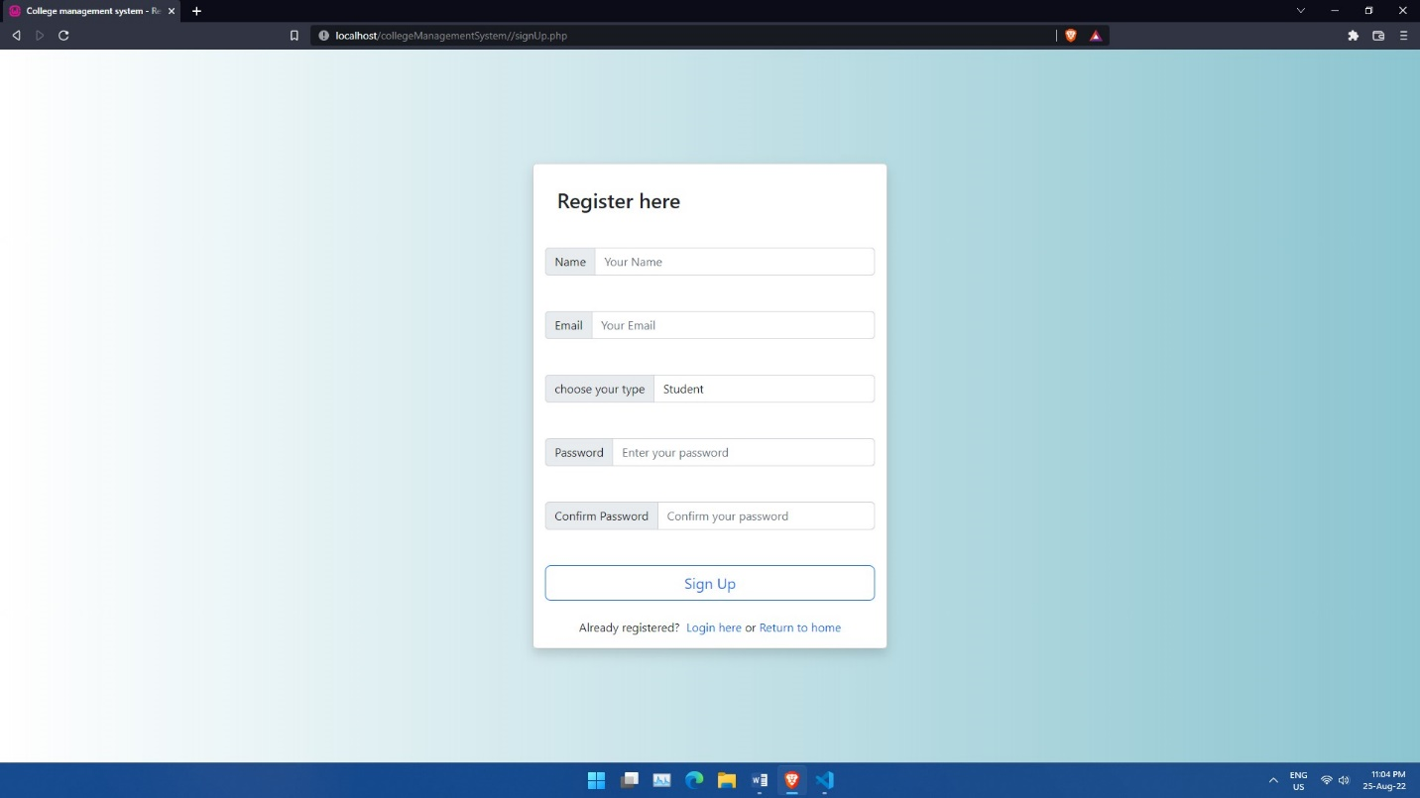

**signIn.php**

**<!DOCTYPE html>**

**<html lang="en">**

**<head>**

**<meta charset="UTF-8">**

**<meta http-equiv="X-UA-Compatible" content="IE=edge">**

**<meta name="viewport" content="width=device-width, initial-scale=1.0">**

**<link href="https://cdn.jsdelivr.net/npm/bootstrap@5.2.0-beta1/dist/css/bootstrap.min.css" rel="stylesheet"**

**integrity="sha384-0evHe/X+R7YkIZDRvuzKMRqM+OrBnVFBL6DOitfPri4tjfHxaWutUpFmBp4vmVor" crossorigin="anonymous">**

**<title>College management system - Login</title>**

**</head>**

**<body>**

**<!-- Sign In Page -->**

**<section class="vh-100 d-flex" style="background: linear-gradient(-450deg, #8cc5d0, transparent);">**

**<div class="col-3 m-auto">**

**<div class="card">**

**<div class="card-body shadow">**

**<h3 class="my-3 mx-3">Sign In to continue</h3>**

**<form action="actions/login.php" method="POST">**

**<div class="input-group my-5">**

**<span class="input-group-text" id="email">Email</span>**

**<input type="email" class="form-control" name="signInEmail" placeholder="Your Email" aria-label="email"**

**aria-describedby="email" required>**

**</div>**

**<div class="input-group mb-5 ">**

**<span class="input-group-text" id="pWord">Password</span>**

**<input type="password" class="form-control" name="signInPass" placeholder="Enter your password"**

**aria-label="pWord" aria-describedby="pWord" required>**

**</div>**

**<div class="input-group mb-4">**

**<input type="submit" class="btn btn-lg btn-outline-primary col-12" name="signInBtn" value="Sign In">**

**</div>**

**</form>**

**<div class="d-flex justify-content-center">**

**<span>New here?&nbsp;</span> <a href="signUp.php" style="text-decoration: none;">&nbsp;Register here&nbsp;</a> <span>or&nbsp;</span><a href="index.php" style="text-decoration: none;">Return to home</a>**

**</div>**

**</div>**

**</div>**

**</div>**

**</section>**

**<script src="https://cdn.jsdelivr.net/npm/bootstrap@5.2.0-beta1/dist/js/bootstrap.bundle.min.js"**

**integrity="sha384-pprn3073KE6tl6bjs2QrFaJGz5/SUsLqktiwsUTF55Jfv3qYSDhgCecCxMW52nD2"**

**crossorigin="anonymous"></script>**

**</body>**

**</html>**

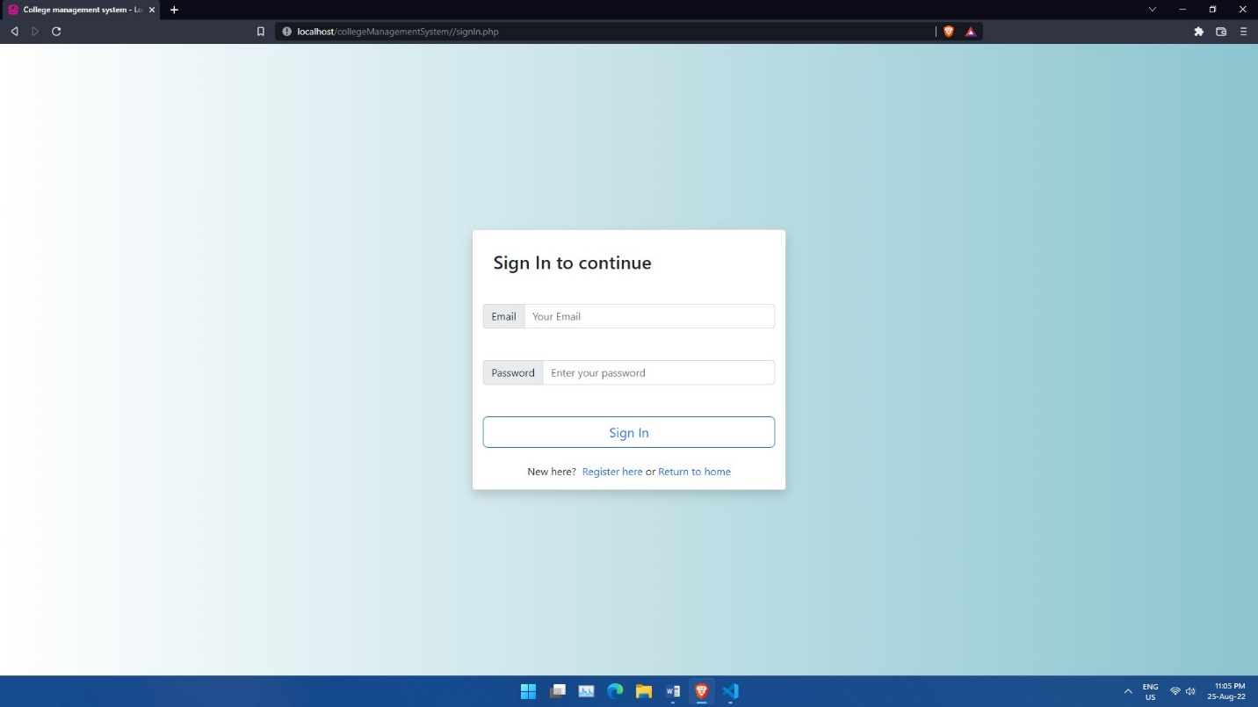

**login.php**

**<?php**

**if (isset($_POST['signInBtn'])) {**

**$email = $_POST['signInEmail'];**

**$password = $_POST['signInPass'];**

**}**

**if ($email === 'admin@example.com' and $password === '123') {**

**session_start();**

**$_SESSION['signIn'] = true;**

**header('location: ../admin/dashboard.php');**

**} elseif ($email === 'student@example.com' and $password === '123') {**

**session_start();**

**$_SESSION['student'] = true;**

**header('location: ../student/dashboard.php');**

**} else {**

**echo "<script>alert('Invalid email or password')</script>";**

**}**

**?>**

**logout.php**

**<?php**

**session_start();**

**session_destroy();**

**header('location: ../index.php');**

**?>**

**dashboard.php**

**<?php include('header.php'); ?>**

**<?php include('side_bar.php'); ?>**

**<!-- Content Header (Page header) -->**

**<div class="content-header">**

**<div class="container-fluid">**

**<div class="row mb-2">**

**<div class="col-sm-6">**

**<h1 class="m-0">Dashboard</h1>**

**</div><!-- /.col -->**

**<div class="col-sm-6">**

**<ol class="breadcrumb float-sm-right">**

**<li class="breadcrumb-item"><a href="#">Admin</a></li>**

**<li class="breadcrumb-item active">Dashboard</li>**

**</ol>**

**</div><!-- /.col -->**

**</div><!-- /.row -->**

**</div><!-- /.container-fluid -->**

**</div>**

**<!-- /.content-header -->**

**<!-- Main content -->**

**<section class="content">**

**<div class="container-fluid">**

**<!-- Info boxes -->**

**<div class="row">**

**<div class="col-12 col-sm-6 col-md-3">**

**<div class="info-box">**

**<span class="info-box-icon bg-info elevation-1"><i class="fas fa-graduation-cap"></i></span>**

**<div class="info-box-content">**

**<span class="info-box-text">Total Students</span>**

**<span class="info-box-number">**

**5000**

**</span>**

**</div>**

**<!-- /.info-box-content -->**

**</div>**

**<!-- /.info-box -->**

**</div>**

**<!-- /.col -->**

**<div class="col-12 col-sm-6 col-md-3">**

**<div class="info-box mb-3">**

**<span class="info-box-icon bg-danger elevation-1"><i class="fas fa-users"></i></span>**

**<div class="info-box-content">**

**<span class="info-box-text">Total Teachers</span>**

**<span class="info-box-number">100</span>**

**</div>**

**<!-- /.info-box-content -->**

**</div>**

**<!-- /.info-box -->**

**</div>**

**<!-- /.col -->**

**<!-- fix for small devices only -->**

**<div class="clearfix hidden-md-up"></div>**

**<div class="col-12 col-sm-6 col-md-3">**

**<div class="info-box mb-3">**

**<span class="info-box-icon bg-success elevation-1"><i class="fas fa-book-open"></i></span>**

**<div class="info-box-content">**

**<span class="info-box-text">Total Courses</span>**

**<span class="info-box-number">4</span>**

**</div>**

**<!-- /.info-box-content -->**

**</div>**

**<!-- /.info-box -->**

**</div>**

**<!-- /.col -->**

**<div class="col-12 col-sm-6 col-md-3">**

**<div class="info-box mb-3">**

**<span class="info-box-icon bg-warning elevation-1"><i class="fas fa-question"></i></span>**

**<div class="info-box-content">**

**<span class="info-box-text">New Inquiries</span>**

**<span class="info-box-number">10</span>**

**</div>**

**<!-- /.info-box-content -->**

**</div>**

**<!-- /.info-box -->**

**</div>**

**<!-- /.col -->**

**</div>**

**<!-- /.row -->**

**</div>**

**<!--/. container-fluid -->**

**</section>**

**<!-- /.content -->**

**<?php include('footer.php'); ?>**

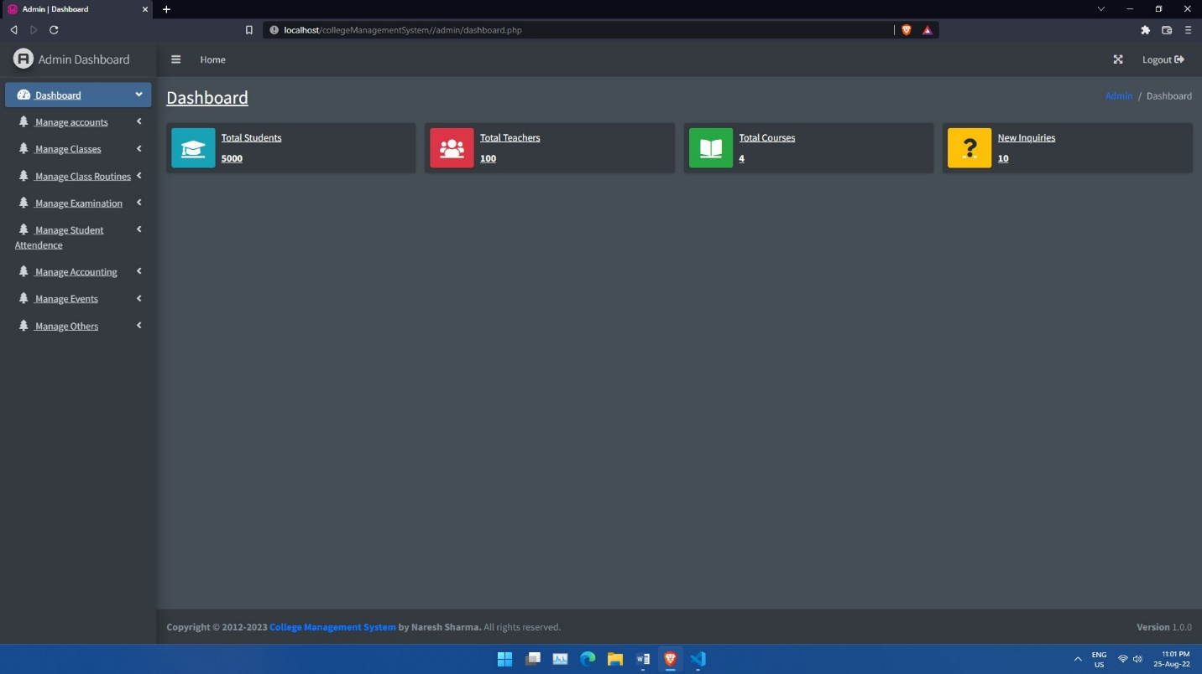

**user_accounts.php**

**<?php include('../includes/config.php'); ?>**

**<?php**

**if (isset($_POST['user_submit'])) {**

**$user_name = $_POST['user_name'];**

**$user_type = $_POST['user_type'];**

**$user_email = $_POST['user_email'];**

**$user_pass = md5(123);**

**$check_email = mysqli_query($con, "SELECT * FROM accounts WHERE email='$user_email'");**

**if (mysqli_num_rows($check_email) > 0) {**

**echo "<script>alert('Email already exists')</script>";**

**} else {**

**mysqli_query($con, "INSERT INTO accounts (user_name, user_type, email, password) VALUES ('$user_name', '$user_type', '$user_email', '$user_pass')") or die(mysqli_error($con));**

**header("location: user_accounts.php?user=$user_type&action=add-new");**

**}**

**}**

**?>**

**<?php include('header.php'); ?>**

**<?php include('side_bar.php'); ?>**

**<!-- Content Header (Page header) -->**

**<div class="content-header">**

**<div class="container-fluid">**

**<div class="row mb-2">**

**<div class="col-sm-6">**

**<h1 class="m-0">Manage Accounts</h1>**

**<a href="user_accounts.php?user=<?php echo $_REQUEST['user']; ?>&action=add-new" class="btn btn-lg btn-primary mt-4">Add New</a>**

**</div><!-- /.col -->**

**<div class="col-sm-6">**

**<ol class="breadcrumb float-sm-right">**

**<li class="breadcrumb-item"><a href="#">Accounts</a></li>**

**<li class="breadcrumb-item active"><?php echo $_REQUEST['user'] ?></li>**

**</ol>**

**</div><!-- /.col -->**

**</div><!-- /.row -->**

**</div><!-- /.container-fluid -->**

**</div>**

**<!-- /.content-header -->**

**<!-- Main content -->**

**<section class="content">**

**<div class="container-fluid">**

**<?php if (isset($_GET['action']) && $_GET['action']) { ?>**

**<div class="card">**

**<div class="card-body">**

**<form action="" method="POST" class="form-group">**

**<input type="text" placeholder="Enter full name" name="user_name" class="form-control bg-white mb-4">**

**<input type="email" placeholder="Enter email" name="user_email" class="form-control bg-white mb-4">**

**<input type="hidden" name="user_type" value="<?php echo $_REQUEST['user']; ?>">**

**<input type="submit" class="btn btn-lg btn-success" name="user_submit" value="Register <?php echo $_REQUEST['user']; ?>">**

**</form>**

**</div>**

**</div>**

**<?php } else { ?>**

**<div class="table-responsive bg-white">**

**<table class="table table-bordered">**

**<thead>**

**<tr>**

**<th>Sr no.</th>**

**<th>Name</th>**

**<th>Email</th>**

**<th>Actions</th>**

**</tr>**

**</thead>**

**<tbody>**

**<?php**

**$user_query = "SELECT * FROM accounts WHERE user_type='" . $_REQUEST['user'] . "'";**

**$user_result = mysqli_query($con, $user_query);**

**$count = 1;**

**while ($users = mysqli_fetch_object($user_result)) {**

**?>**

**<tr>**

**<td><?php echo $count; ?></td>**

**<td><?php echo $users->user_name; ?></td>**

**<td><?php echo $users->email; ?></td>**

**<td>**

**<a href="user_accounts_updates.php?id=<?php echo $users->id ?>" class="btn btn-primary">Edit</a>**

**<a href="user_accounts_delete.php?id=<?php echo $users->id ?>" class="btn btn-danger">Delete</a>**

**</td>**

**</tr>**

**<?php $count++;**

**} ?>**

**</tbody>**

**<thead>**

**<tr>**

**<th>Sr no.</th>**

**<th>Name</th>**

**<th>Email</th>**

**<th>Actions</th>**

**</tr>**

**</thead>**

**</table>**

**</div>**

**<?php } ?>**

**</div>**

**<!--/. container-fluid -->**

**</section>**

**<!-- /.content -->**

**<?php include('footer.php'); ?>**

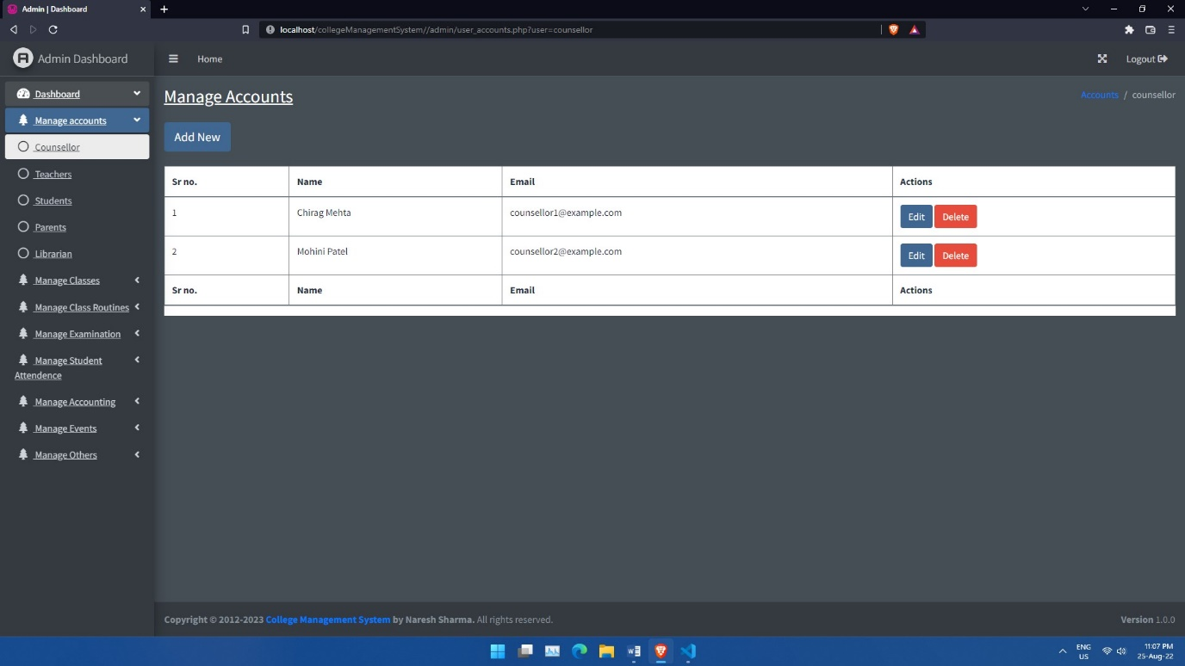

**user_accounts_updates.php**

**<?php include('../includes/config.php'); ?>**

**<?php**

**$id = $_GET['id'];**

**$id_query = mysqli_query($con, "SELECT * FROM accounts WHERE id = $id");**

**$account = mysqli_fetch_object($id_query);**

**?>**

**<?php**

**if (isset($_POST['user_submit'])) {**

**$user_name = $_POST['user_name'];**

**$user_email = $_POST['user_email'];**

**$user_type = $_POST['user_type'];**

**mysqli_query($con, "UPDATE accounts SET user_name = '$user_name', email = '$user_email' WHERE id = $id") or die(mysqli_error($con));**

**header("location: user_accounts.php?user=$user_type");**

**}**

**?>**

**<?php include('header.php'); ?>**

**<?php include('side_bar.php'); ?>**

**<!-- Content Header (Page header) -->**

**<div class="content-header">**

**<div class="container-fluid">**

**<div class="row mb-2">**

**<div class="col-sm-6">**

**<h1 class="m-0">Manage Accounts</h1>**

**<a href="user_accounts.php?user=<?php echo $account->user_type; ?>&action=add-new" class="btn btn-lg btn-primary mt-4">Add New</a>**

**</div><!-- /.col -->**

**<div class="col-sm-6">**

**<ol class="breadcrumb float-sm-right">**

**<li class="breadcrumb-item"><a href="#">Accounts</a></li>**

**<li class="breadcrumb-item active"><?php echo $account->user_type; ?></li>**

**</ol>**

**</div><!-- /.col -->**

**</div><!-- /.row -->**

**</div><!-- /.container-fluid -->**

**</div>**

**<!-- /.content-header -->**

**<!-- Main content -->**

**<section class="content">**

**<div class="container-fluid">**

**<div class="card">**

**<div class="card-body">**

**<form action="" method="POST" class="form-group">**

**<input type="text" placeholder="Enter full name" name="user_name" value="<?php echo $account->user_name; ?>" class="form-control bg-white mb-4">**

**<input type="email" placeholder="Enter email" name="user_email" value="<?php echo $account->email; ?>" class="form-control bg-white mb-4">**

**<input type="hidden" name="user_type" value="<?php echo $account->user_type; ?>">**

**<input type="submit" class="btn btn-lg btn-success" name="user_submit" value="Update <?php echo $account->user_type; ?>">**

**</form>**

**</div>**

**</div>**

**</div>**

**<!--/. container-fluid -->**

**</section>**

**<!-- /.content -->**

**<?php include('footer.php'); ?>**

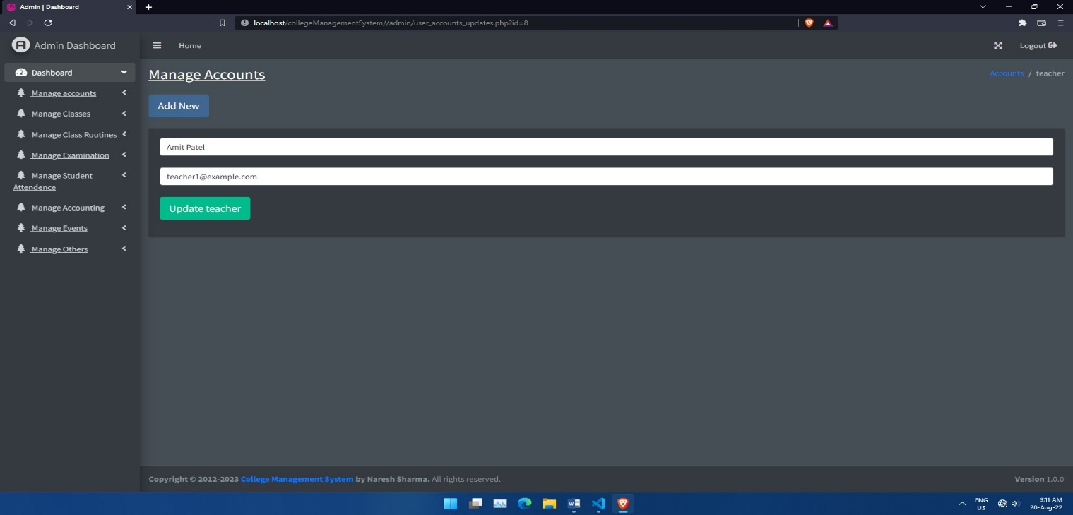

**user_accounts_delete.php**

**<?php include('../includes/config.php'); ?>**

**<?php**

**$id = $_GET['id'];**

**$id_query = mysqli_query($con, "SELECT * FROM accounts WHERE id = $id");**

**$account = mysqli_fetch_object($id_query);**

**mysqli_query($con, "DELETE FROM accounts WHERE id = $id");**

**header("location: user_accounts.php?user=$account->user_type");**

**?>**

**classes.php**

**<?php include('../includes/config.php'); ?>**

**<?php**

**if (isset($_POST['submit'])) {**

**$title = $_POST['title'];**

**$description = $title." Description";**

**$type = 'class';**

**$added_date = date('Y-m-d');**

**$status = 'publish';**

**$query = mysqli_query($con, "INSERT INTO posts (title, description, type, publish_date, status) VALUES('$title', '$description', '$type', '$added_date', '$status')") or die('oops! Something went wrong...');**

**$item_id = mysqli_insert_id($con);**

**$section_ids = $_POST['section'];**

**foreach($section_ids as $section_id) {**

**$meta_query = mysqli_query($con, "INSERT INTO metadata (item_id, meta_key, meta_value) VALUES ($item_id, 'section', '$section_id')");**

**}**

**}**

**?>**

**<?php include('header.php'); ?>**

**<?php include('side_bar.php'); ?>**

**<!-- Content Header (Page header) -->**

**<div class="content-header">**

**<div class="container-fluid">**

**<div class="row mb-2">**

**<div class="col-sm-6">**

**<h1 class="m-0">Manage Classes</h1>**

**</div><!-- /.col -->**

**<div class="col-sm-6">**

**<ol class="breadcrumb float-sm-right">**

**<li class="breadcrumb-item"><a href="#">Admin</a></li>**

**<li class="breadcrumb-item active">Classes</li>**

**</ol>**

**</div><!-- /.col -->**

**</div><!-- /.row -->**

**</div><!-- /.container-fluid -->**

**</div>**

**<!-- /.content-header -->**

**<!-- Main content -->**

**<section class="content">**

**<div class="container-fluid">**

**<?php if (isset($_REQUEST['action'])) { ?>**

**<div class="card">**

**<div class="card-header py-2">**

**<h3 class="card-title">**

**Add New Class (Year)**

**</h3>**

**</div>**

**<div class="card-body">**

**<div class="table-responsive bg-white">**

**<form action="" method="POST">**

**<div class="form-group px-5 py-3">**

**<label for="title">Title</label>**

**<input type="text" name="title" class="form-control bg-white mb-4" placeholder="Enter class title" required>**

**<label for="section">Section (Semester)</label>**

**<?php**

**$query = mysqli_query($con, "SELECT * FROM posts WHERE type = 'section'");**

**$count = 1;**

**while ($sections = mysqli_fetch_object($query)) {**

**?>**

**<div>**

**<label for="<?php $count ?>">**

**<input type="checkbox" id="<?php $count ?>" value="<?php echo $sections->id; ?>" name="section[]" class="mb-1"><?php echo $sections->title; ?>**

**</label>**

**</div>**

**<?php $count++;**

**} ?>**

**</div>**

**<input type="submit" name="submit" class="btn btn-success mx-5 mb-2 col-3" value="Add Class">**

**</form>**

**</div>**

**</div>**

**<!-- /.row -->**

**</div>**

**<?php } else { ?>**

**<!-- Info boxes -->**

**<div class="card">**

**<div class="card-header">**

**<h3 class="card-title">**

**Classes**

**</h3>**

**<div class="card-tools">**

**<a href="?action=add-new" class="btn btn-sm btn-outline-success"><i class="fa fa-plus mr-2"></i>Add New</a>**

**</div>**

**</div>**

**<div class="card-body">**

**<div class="table-responsive bg-white">**

**<table class="table table-bordered">**

**<thead>**

**<tr>**

**<th>Sr no.</th>**

**<th>Class (Year)</th>**

**<th>Sections</th>**

**<th>Actions</th>**

**</tr>**

**</thead>**

**<tbody>**

**<tbody>**

**<?php**

**$args = array('type' => 'class', 'status' => 'publish');**

**$classes = get_posts($args);**

**$count = 1;**

**foreach ($classes as $class) {**

**?>**

**<tr>**

**<td><?php echo $count; ?></td>**

**<td><?php echo $class->title; ?></td>**

**<td>**

**<?php**

**$class_meta = get_metadata($class->id, 'section');**

**foreach ($class_meta as $meta) {**

**$section = get_post(array('id' => $meta->meta_value));**

**echo $section->title, "<br>";**

**}**

**?>**

**</td>**

**<td>**

**<a href="classes_updates.php?id=<?php echo $class->id ?>" class="btn btn-primary">Edit</a>**

**<a href="classes_delete.php?id=<?php echo $class->id ?>" class="btn btn-danger">Delete</a>**

**</td>**

**</tr>**

**<?php $count++;**

**} ?>**

**</tbody>**

**<thead>**

**<tr>**

**<th>Sr no.</th>**

**<th>Class (Year)</th>**

**<th>Sections</th>**

**<th>Actions</th>**

**</tr>**

**</thead>**

**</table>**

**</div>**

**</div>**

**<!-- /.row -->**

**</div>**

**<?php } ?>**

**<!--/. container-fluid -->**

**</section>**

**<!-- /.content -->**

**<?php include('footer.php'); ?>**

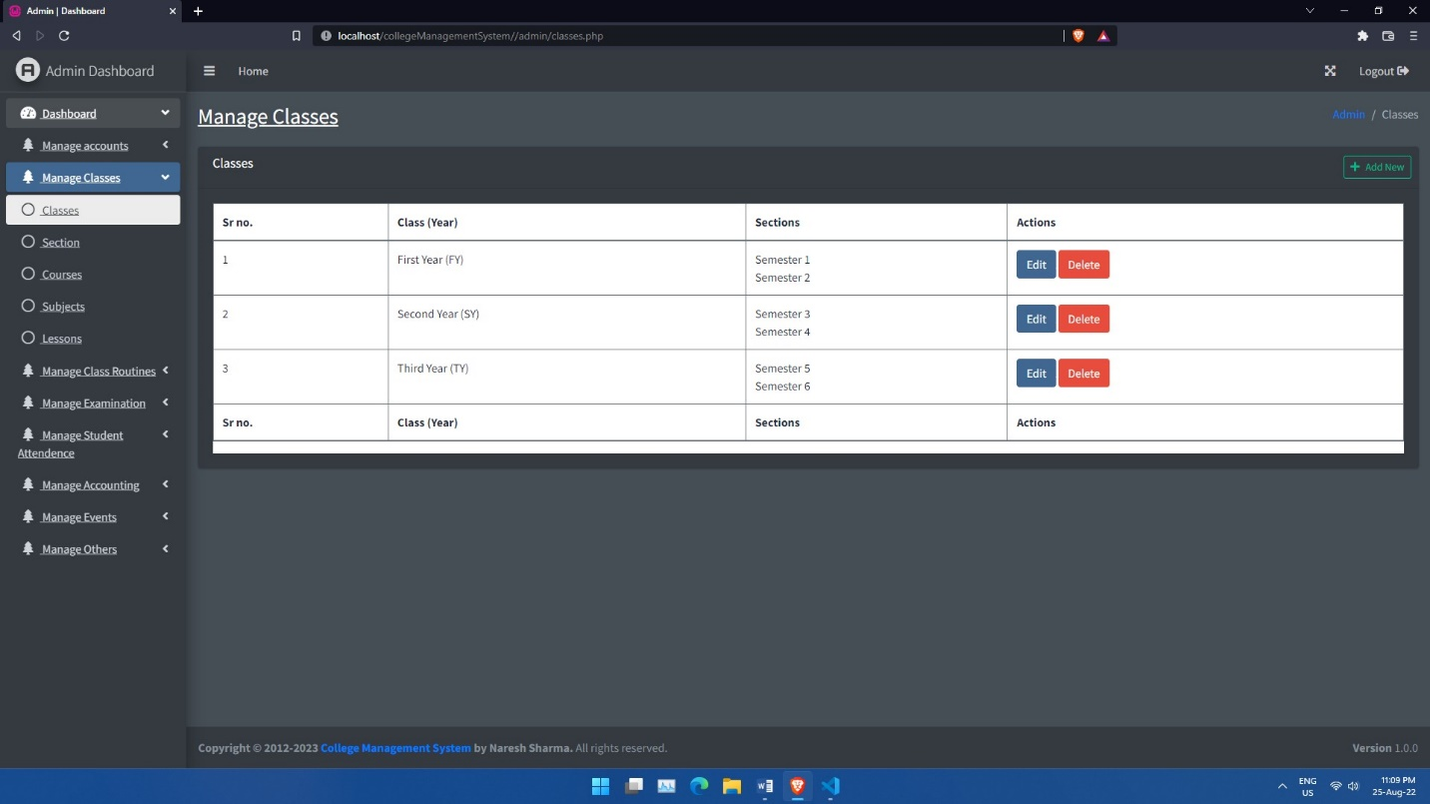

**sections.php**

**<?php include('../includes/config.php'); ?>**

**<?php include('header.php'); ?>**

**<?php include('side_bar.php'); ?>**

**<?php**

**if (isset($_POST['submit'])) {**

**$title = $_POST['title'];**

**$description = $title . " Description";**

**$type = 'section';**

**$date_added = date('Y-m-d');**

**$status = 'publish';**

**$query = mysqli_query($con, "INSERT INTO posts (title, description, type, publish_date, status) VALUES('$title', '$description', '$type', '$date_added', '$status')");**

**if ($query) {**

**echo "<script>alert('Data inserted successfully');</script>";**

**} else {**

**echo "<script>alert('Some error occured');</script>";**

**}**

**}**

**?>**

**<!-- Content Header (Page header) -->**

**<div class="content-header">**

**<div class="container-fluid">**

**<div class="row mb-2">**

**<div class="col-sm-6">**

**<h1 class="m-0">Manage Sections (Semesters)</h1>**

**</div><!-- /.col -->**

**<div class="col-sm-6">**

**<ol class="breadcrumb float-sm-right">**

**<li class="breadcrumb-item"><a href="#">Admin</a></li>**

**<li class="breadcrumb-item active">Sections</li>**

**</ol>**

**</div><!-- /.col -->**

**</div><!-- /.row -->**

**</div><!-- /.container-fluid -->**

**</div>**

**<!-- /.content-header -->**

**<!-- Main content -->**

**<section class="content">**

**<div class="container-fluid">**

**<div class="row">**

**<div class="col-lg-8">**

**<div class="card">**

**<div class="card-header">**

**<h3 class="card-title">**

**Sections (Semesters)**

**</h3>**

**</div>**

**<div class="card-body">**

**<div class="table-responsive bg-white">**

**<table class="table table-bordered">**

**<thead>**

**<tr>**

**<th>Sr no.</th>**

**<th>Title</th>**

**<th>Actions</th>**

**</tr>**

**</thead>**

**<tbody>**

**<?php**

**$args = array('type' => 'section', 'status' => 'publish');**

**$sections = get_posts($args);**

**$count = 1;**

**foreach ($sections as $section) {**

**?>**

**<tr>**

**<td><?php echo $count; ?></td>**

**<td><?php echo $section->title; ?></td>**

**<td>**

**<a href="sections_updates.php?id=<?php echo $section->id; ?>" class="btn btn-primary">Edit</a>**

**<a href="sections_delete.php?id=<?php echo $section->id; ?>" class="btn btn-danger">Delete</a>**

**</td>**

**</tr>**

**<?php $count++;**

**} ?>**

**</tbody>**

**<thead>**

**<tr>**

**<th>Sr no.</th>**

**<th>Title</th>**

**<th>Actions</th>**

**</tr>**

**</thead>**

**</table>**

**</div>**

**</div>**

**</div>**

**</div>**

**<div class="col-lg-4">**

**<div class="card">**

**<div class="card-header py-2">**

**<h3 class="card-title">**

**Add New Section (Semester)**

**</h3>**

**</div>**

**<div class="card-body">**

**<div class="table-responsive bg-white">**

**<form action="" method="POST">**

**<div class="form-group px-5 py-3">**

**<label for="title">Title</label>**

**<input type="text" name="title" class="form-control bg-white" placeholder="Enter section (Semester) title" required>**

**</div>**

**<input type="submit" name="submit" class="btn btn-success mx-5 mb-2 col-3" value="Add Section">**

**</form>**

**</div>**

**</div>**

**</div>**

**</div>**

**</div>**

**</div>**

**</section>**

**<!-- /.content -->**

**<?php include('footer.php'); ?>**

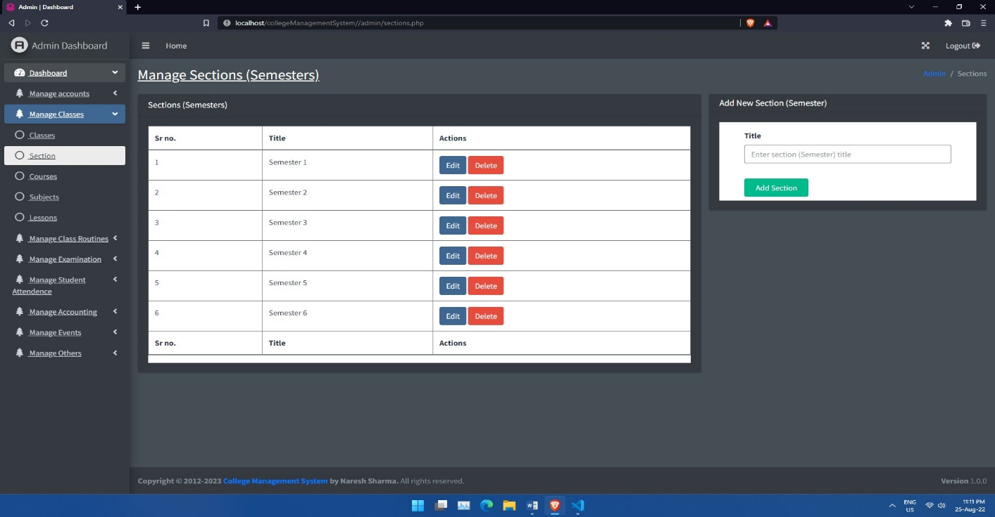

**courses.php**

**<?php include('../includes/config.php'); ?>**

**<?php**

**if (isset($_POST['submit'])) {**

**$name = $_POST['name'];**

**$category = $_POST['category'];**

**$duration = $_POST['duration'];**

**$price = $_POST['price'];**

**$image = $_FILES["thumbnail"]["name"];**

**$date_added = date('Y-m-d');**

**$target_dir = "../dist/uploads/";**

**$target_file = $target_dir . basename($_FILES["thumbnail"]["name"]);**

**$uploadOk = 1;**

**$imageFileType = strtolower(pathinfo($target_file, PATHINFO_EXTENSION));**

**// Check if image file is a actual image or fake image**

**if (isset($_POST["submit"])) {**

**$check = getimagesize($_FILES["thumbnail"]["tmp_name"]);**

**if ($check !== false) {**

**$uploadOk = 1;**

**} else {**

**echo "File is not an image.";**

**$uploadOk = 0;**

**}**

**}**

**// Check if file already exists**

**if (file_exists($target_file)) {**

**echo "Sorry, file already exists.";**

**$uploadOk = 0;**

**}**

**// Check file size**

**if ($_FILES["thumbnail"]["size"] > 50000000) {**

**echo "Sorry, your file is too large.";**

**$uploadOk = 0;**

**}**

**// Allow certain file formats**

**if (**

**$imageFileType != "jpg" && $imageFileType != "png" && $imageFileType != "jpeg"**

**&& $imageFileType != "gif"**

**) {**

**echo "Sorry, only JPG, JPEG, PNG & GIF files are allowed.";**

**$uploadOk = 0;**

**}**

**// Check if $uploadOk is set to 0 by an error**

**if ($uploadOk == 0) {**

**echo "Sorry, your file was not uploaded.";**

**// if everything is ok, try to upload file**

**} else {**

**if (move_uploaded_file($_FILES["thumbnail"]["tmp_name"], $target_file)) {**

**$query = mysqli_query($con, "INSERT INTO courses (course_name, category, duration, price, course_image, date_added) VALUES ('$name', '$category', '$duration', $price, '$image', '$date_added')") or die(mysqli_error($con));**

**header('location: courses.php');**

**} else {**

**echo "Sorry, there was an error uploading your file.";**

**}**

**}**

**}**

**?>**

**<?php include('header.php'); ?>**

**<?php include('side_bar.php'); ?>**

**<!-- Content Header (Page header) -->**

**<div class="content-header">**

**<div class="container-fluid">**

**<div class="row mb-2">**

**<div class="col-sm-6">**

**<h1 class="m-0">Manage Courses</h1>**

**</div><!-- /.col -->**

**<div class="col-sm-6">**

**<ol class="breadcrumb float-sm-right">**

**<li class="breadcrumb-item"><a href="#">Admin</a></li>**

**<li class="breadcrumb-item active">Courses</li>**

**</ol>**

**</div><!-- /.col -->**

**</div><!-- /.row -->**

**</div><!-- /.container-fluid -->**

**</div>**

**<!-- /.content-header -->**

**<!-- Main content -->**

**<section class="content">**

**<div class="container-fluid">**

**<?php if (isset($_REQUEST['action'])) { ?>**

**<div class="card">**

**<div class="card-header py-2">**

**<h3 class="card-title">**

**Add New Course**

**</h3>**

**</div>**

**<div class="card-body">**

**<div class="table-responsive bg-white">**

**<form action="" enctype="multipart/form-data" method="POST">**

**<div class="form-group px-5 py-3">**

**<label for="name">Course name</label>**

**<input type="text" name="name" class="form-control bg-white mb-4" placeholder="Enter course name" required>**

**<label for="category">Course Category</label>**

**<select name="category" class="form-control bg-white mb-4">**

**<option value="">Select Category</option>**

**<option value="web-designing">Business and Management</option>**

**<option value="programming">Computer Science and IT</option>**

**</select>**

**<label for="price">Course price (Per Year)</label>**

**<input type="number" name="price" class="form-control bg-white mb-4" placeholder="Enter course price" required>**

**<label for="thumbnail">Thumbnail</label>**

**<input type="file" name="thumbnail" class="form-control bg-white mb-4" required>**

**<label for="duration">Course duration (In Years)</label>**

**<input type="text" name="duration" class="form-control bg-white mb-4" placeholder="Enter course duration" required>**

**</div>**

**<input type="submit" name="submit" class="btn btn-success mx-5 mb-2 col-3" value="Add Course">**

**</form>**

**</div>**

**</div>**

**<!-- /.row -->**

**</div>**

**<?php } else { ?>**

**<!-- Info boxes -->**

**<div class="card">**

**<div class="card-header">**

**<h3 class="card-title">**

**Courses**

**</h3>**

**<div class="card-tools">**

**<a href="?action=add-new" class="btn btn-sm btn-outline-success"><i class="fa fa-plus mr-2"></i>Add New</a>**

**</div>**

**</div>**

**<div class="card-body">**

**<div class="table-responsive bg-white">**

**<table class="table table-bordered">**

**<thead>**

**<tr>**

**<th>Sr no.</th>**

**<th></th>**

**<th>Name</th>**

**<th>Category</th>**

**<th>Duration (In Years)</th>**

**<th>Price (Per year)</th>**

**<th>Added Date</th>**

**<th>Actions</th>**

**</tr>**

**</thead>**

**<tbody>**

**<tbody>**

**<?php**

**$course_query = mysqli_query($con, "SELECT * FROM courses");**

**$count = 1;**

**while ($course = mysqli_fetch_object($course_query)) {**

**?>**

**<tr>**

**<td><?php echo $count; ?></td>**

**<td><img src="../dist/uploads/<?php echo $course->course_image; ?>" alt="Course Image" height="100" width="100" class="border"></td>**

**<td><?php echo $course->course_name; ?></td>**

**<td><?php echo $course->category; ?></td>**

**<td><?php echo $course->duration; ?></td>**

**<td><?php echo $course->price; ?></td>**

**<td><?php echo $course->date_added; ?></td>**

**<td>**

**<a href="courses_updates.php?id=<?php echo $course->id; ?>" class="btn btn-primary">Edit</a>**

**<a href="courses_delete.php?id=<?php echo $course->id ?>" class="btn btn-danger">Delete</a>**

**</td>**

**</tr>**

**<?php $count++;**

**} ?>**

**</tbody>**

**<thead>**

**<tr>**

**<th>Sr no.</th>**

**<th></th>**

**<th>Name</th>**

**<th>Category</th>**

**<th>Duration (In Years)</th>**

**<th>Price (Per year)</th>**

**<th>Added Date</th>**

**<th>Actions</th>**

**</tr>**

**</thead>**

**</table>**

**</div>**

**</div>**

**<!-- /.row -->**

**</div>**

**<?php } ?>**

**<!--/. container-fluid -->**

**</section>**

**<!-- /.content -->**

**<?php include('footer.php'); ?>**

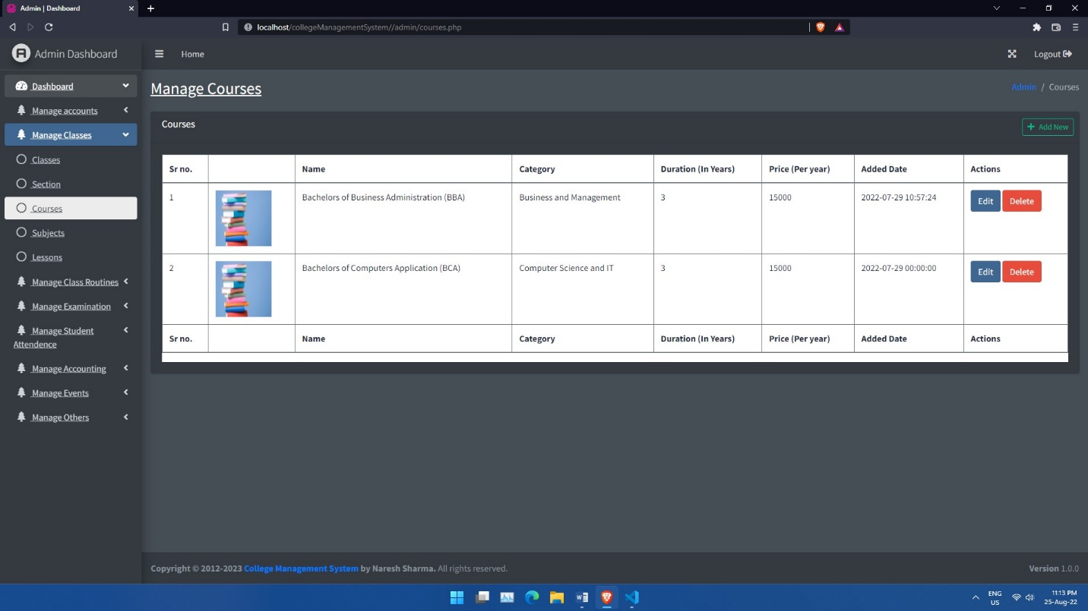

**subjects.php**

**<?php include('../includes/config.php'); ?>**

**<?php**

**if (isset($_POST['submit_subject'])) {**

**$title = $_POST['input_subject'];**

**$class = $_POST['select_class'];**

**$section = $_POST['select_section'];**

**$description = $title . " Description";**

**$type = 'subject';**

**$date_added = date('Y-m-d');**

**$status = 'publish';**

**$query = mysqli_query($con, "INSERT INTO posts (title, description, type, publish_date, status) VALUES ('$title', '$description', '$type', '$date_added', '$status')");**

**if ($query) {**

**$item_id = mysqli_insert_id($con);**

**$metadata = array(**

**'class_id' => $class,**

**'section_id' => $section,**

**);**

**foreach ($metadata as $key => $value) {**

**mysqli_query($con, "INSERT INTO metadata (item_id, meta_key, meta_value) VALUES ('$item_id', '$key', '$value')");**

**}**

**echo "<script>alert('Data inserted Successfully');</script>";**

**} else {**

**echo "<script>alert('Some error occured!');</script>";**

**}**

**}**

**?>**

**<?php include('header.php'); ?>**

**<?php include('side_bar.php'); ?>**

**<!-- Content Header (Page header) -->**

**<div class="content-header">**

**<div class="container-fluid">**

**<div class="row mb-2">**

**<div class="col-sm-6">**

**<h1 class="m-0">Manage Subjects</h1>**

**</div><!-- /.col -->**

**<div class="col-sm-6">**

**<ol class="breadcrumb float-sm-right">**

**<li class="breadcrumb-item"><a href="#">Admin</a></li>**

**<li class="breadcrumb-item active">Subjects</li>**

**</ol>**

**</div><!-- /.col -->**

**</div><!-- /.row -->**

**</div><!-- /.container-fluid -->**

**</div>**

**<!-- /.content-header -->**

**<!-- Main content -->**

**<section class="content">**

**<div class="container-fluid">**

**<!-- Info boxes -->**

**<div class="row">**

**<div class="col-lg-4">**

**<div class="card">**

**<div class="card-header py-2">**

**<div class="card-title">**

**Add New Subject**

**</div>**

**</div>**

**<div class="card-body bg-white">**

**<form action="" class="form-group" method="POST">**

**<label for="select_class">Select Class</label>**

**<select name="select_class" id="select_class" class="form-control bg-white mb-4" id="select_class" required>**

**<option value="">Select Class (Year)</option>**

**<?php**

**$args = array('type' => 'class', 'status' => 'publish');**

**$classes = get_posts($args);**

**foreach ($classes as $class) {**

**?>**

**<option value="<?php echo $class->id; ?>"><?php echo $class->title; ?></option>**

**<?php } ?>**

**</select>**

**<div class="form-group" id="section-container" style="display:none">**

**<label for="select_section">Select Section (Semester)</label>**

**<select require name="select_section" id="select_section" class="form-control bg-white" required>**

**<option value="">-Select Section-</option>**

**</select>**

**</div>**

**<label for="input_subject">Enter Subject Name</label>**

**<input type="text" name="input_subject" placeholder="Enter subject" id="input_subject" class="form-control bg-white mb-5" required>**

**<input type="submit" name="submit_subject" class="btn btn-success col-12" value="Add Subject">**

**</form>**

**</div>**

**</div>**

**</div>**

**<div class="col-lg-8">**

**<div class="card">**

**<div class="card-header py-2">**

**<h3 class="card-title">**

**Subjects**

**</h3>**

**</div>**

**<div class="card-body">**

**<div class="table-responsive bg-white">**

**<table class="table table-bordered">**

**<thead>**

**<tr>**

**<th>Sr no.</th>**

**<th>Name</th>**

**<th>Added Date</th>**

**<th>Actions</th>**

**</tr>**

**</thead>**

**<tbody>**

**<tbody>**

**<?php**

**$count = 1;**

**$args = array(**

**'type' => 'subject',**

**'status' => 'publish'**

**);**

**$subjects = get_posts($args);**

**foreach ($subjects as $subject) {**

**?>**

**<tr>**

**<td><?php echo $count; ?></td>**

**<td><?php echo $subject->title; ?></td>**

**<td><?php echo $subject->publish_date; ?></td>**

**<td>**

**<a href="subjects_updates.php?id=<?php echo $subject->id; ?>" class="btn btn-primary">Edit</a>**

**<a href="subjects_delete.php?id=<?php echo $subject->id; ?>" class="btn btn-danger">Delete</a>**

**</td>**

**</tr>**

**<?php $count++;**

**} ?>**

**</tbody>**

**<thead>**

**<tr>**

**<th>Sr no.</th>**

**<th>Name</th>**

**<th>Added Date</th>**

**<th>Actions</th>**

**</tr>**

**</thead>**

**</table>**

**</div>**

**</div>**

**<!-- /.row -->**

**</div>**

**</div>**

**</div>**

**</div>**

**<!--/. container-fluid -->**

**</section>**

**<!-- /.content -->**

**<?php include('footer.php'); ?>**

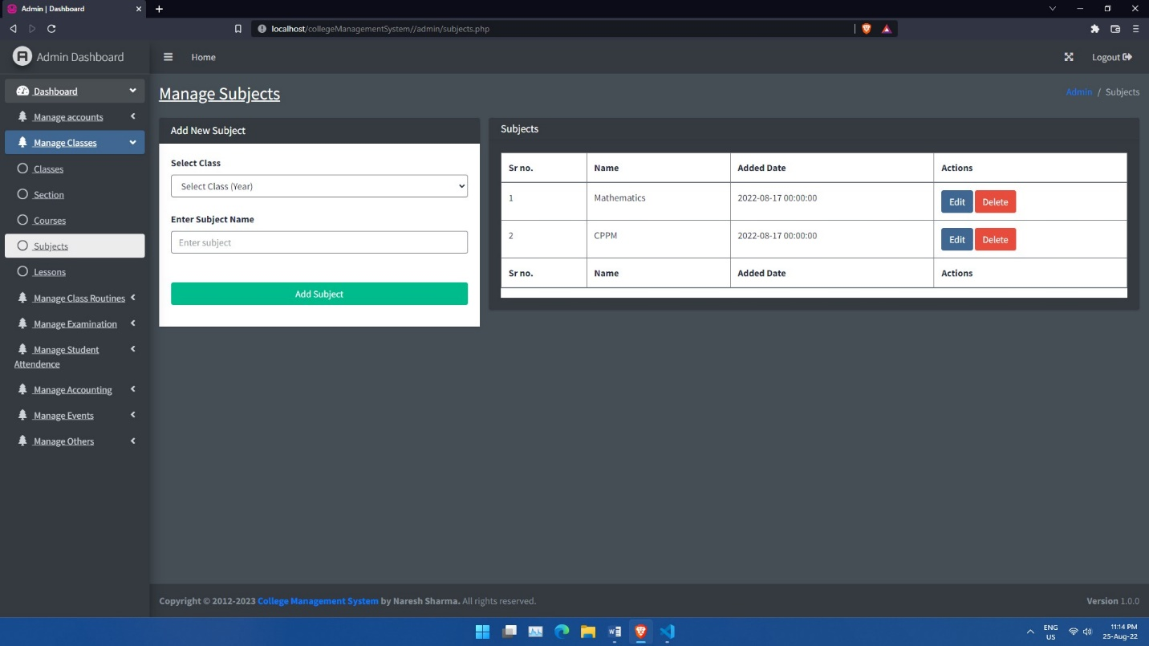

**periods.php**

**<?php include('../includes/config.php'); ?>**

**<?php**

**if (isset($_POST['submit'])) {**

**$title = $_POST['title'];**

**$from = $_POST['from'];**

**$to = $_POST['to'];**

**$type = 'period';**

**$description = $title . " Description";**

**$status = 'publish';**

**$date_added = date('Y-m-d');**

**$query = mysqli_query($con, "INSERT INTO posts (title, status, type, description, publish_date) VALUES ('$title', '$status', '$type', '$description', '$date_added')");**

**if ($query) {**

**$post_id = mysqli_insert_id($con); // Returns the id of last inserted row**

**mysqli_query($con, "INSERT INTO metadata (meta_key, meta_value, item_id) VALUES ('from', '$from', '$post_id')");**

**mysqli_query($con, "INSERT INTO metadata (meta_key, meta_value, item_id) VALUES ('to', '$to', '$post_id')");**

**// header('location: ./periods.php');**

**echo "<script>alert('Data inserted successfully');</script>";**

**} else {**

**echo "<script>alert('Some error occoured');</script>";**

**}**

**}**

**?>**

**<?php include('header.php'); ?>**

**<?php include('side_bar.php'); ?>**

**<!-- Content Header (Page header) -->**

**<div class="content-header">**

**<div class="container-fluid">**

**<div class="row mb-2">**

**<div class="col-sm-6">**

**<h1 class="m-0">Manage Periods</h1>**

**</div><!-- /.col -->**

**<div class="col-sm-6">**

**<ol class="breadcrumb float-sm-right">**

**<li class="breadcrumb-item"><a href="#">Admin</a></li>**

**<li class="breadcrumb-item active">Periods</li>**

**</ol>**

**</div><!-- /.col -->**

**</div><!-- /.row -->**

**</div><!-- /.container-fluid -->**

**</div>**

**<!-- /.content-header -->**

**<!-- Main content -->**

**<section class="content">**

**<div class="container-fluid">**

**<div class="row">**

**<div class="col-lg-8">**

**<div class="card">**

**<div class="card-header">**

**<h3 class="card-title">**

**Periods**

**</h3>**

**</div>**

**<div class="card-body">**

**<div class="table-responsive bg-white">**

**<table class="table table-bordered">**

**<thead>**

**<tr>**

**<th>Sr no.</th>**

**<th>Title</th>**

**<th>From</th>**

**<th>To</th>**

**<th>Actions</th>**

**</tr>**

**</thead>**

**<tbody>**

**<?php**

**$args = array('type' => 'period', 'status' => 'publish');**

**$periods = get_posts($args);**

**$count = 1;**

**foreach ($periods as $period) {**

**?>**

**<tr>**

**<td><?php echo $count; ?></td>**

**<td><?php echo $period->title; ?></td>**

**<td>**

**<?php**

**$from = get_metadata($period->id, 'from')[0]->meta_value;**

**echo date('h:i A', strtotime($from));**

**?>**

**</td>**

**<td>**

**<?php**

**$to = get_metadata($period->id, 'to')[0]->meta_value;**

**echo date('h:i A', strtotime($to));**

**?>**

**</td>**

**<td>**

**<a href="periods_updates.php?id=<?php echo $period->id ?>" class="btn btn-primary">Edit</a>**

**<a href="periods_delete.php?id=<?php echo $period->id ?>" class="btn btn-danger">Delete</a>**

**</td>**

**</tr>**

**<?php $count++;**

**} ?>**

**</tbody>**

**<thead>**

**<tr>**

**<th>Sr no.</th>**

**<th>Title</th>**

**<th>From</th>**

**<th>To</th>**

**<th>Actions</th>**

**</tr>**

**</thead>**

**</table>**

**</div>**

**</div>**

**</div>**

**</div>**

**<div class="col-lg-4">**

**<div class="card">**

**<div class="card-header py-2">**

**<h3 class="card-title">**

**Add New Period**

**</h3>**

**</div>**

**<div class="card-body">**

**<div class="table-responsive bg-white">**

**<form action="" method="POST">**

**<div class="form-group px-5 py-3">**

**<label for="title">Title</label>**

**<input type="text" name="title" class="form-control bg-white" placeholder="Enter title" required>**

**<label for="title">From</label>**

**<input type="time" name="from" class="form-control bg-white" required>**

**<label for="title">To</label>**

**<input type="time" name="to" class="form-control bg-white" required>**

**</div>**

**<input type="submit" name="submit" class="btn btn-success mx-5 mb-2 col-3" value="Add Period">**

**</form>**

**</div>**

**</div>**

**</div>**

**</div>**

**</div>**

**</div>**

**</section>**

**<!-- /.content -->**

**<?php include('footer.php'); ?>**

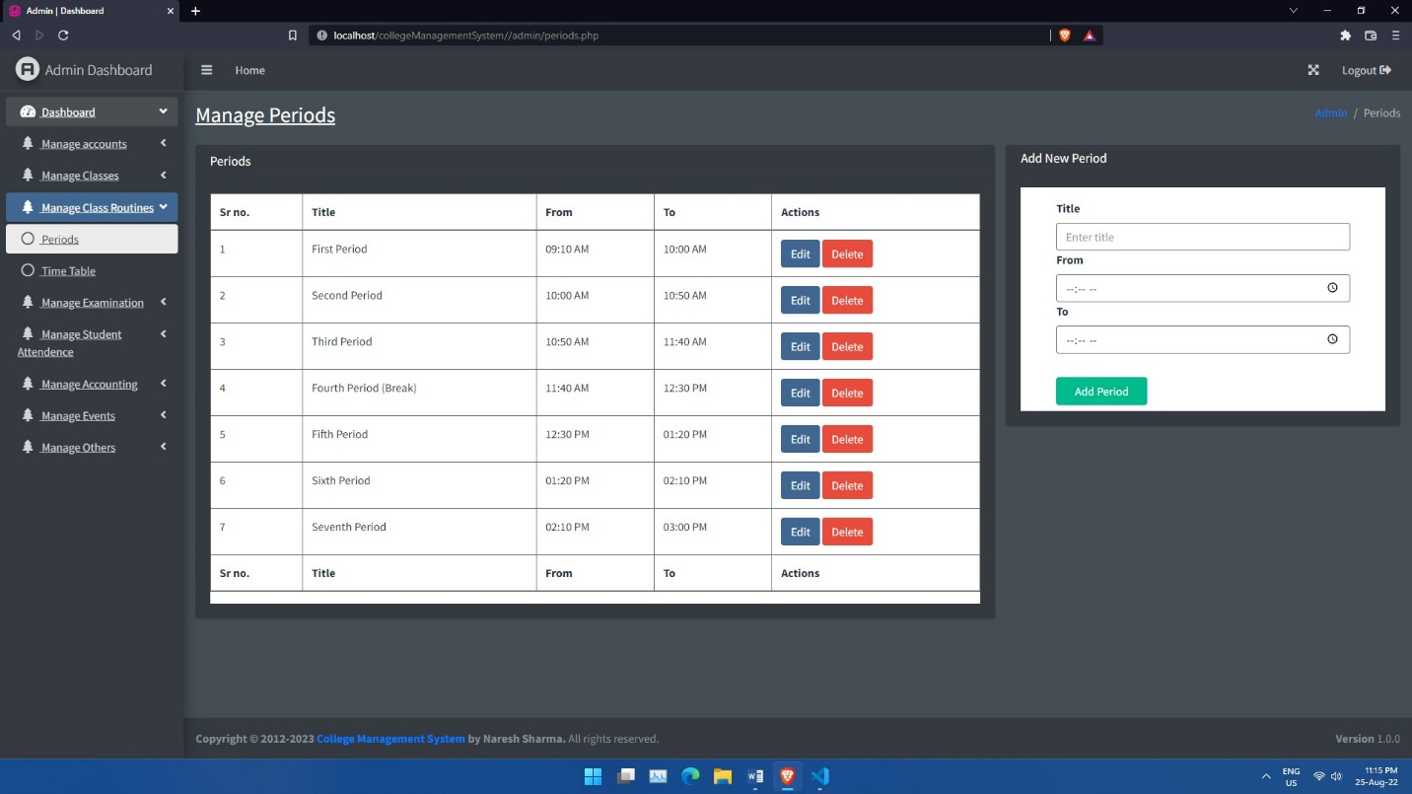

**Time_table.php**

**<?php include('../includes/config.php'); ?>**

**<?php**

**if (isset($_POST['submit'])) {**

**$class = $_POST['select_class'];**

**$section = $_POST['select_section'];**

**$teacher = $_POST['select_teacher'];**

**$period = $_POST['select_period'];**

**$day = $_POST['select_day'];**

**$subject = $_POST['select_subject'];**

**$date_added = date('Y-m-d');**

**$status = 'publish';**

**$type = 'time_table';**

**$title = $day . " Time table";**

**$metadata = array(**

**'class_id' => $class,**

**'section_id' => $section,**

**'teacher_id' => $teacher,**

**'period_id' => $period,**

**'day_name' => $day,**

**'subject_id' => $subject,**

**);**

**$query = mysqli_query($con, "INSERT INTO posts (type, status, publish_date) VALUES ('$type', '$status', '$date_added')");**

**$item_id = mysqli_insert_id($con);**

**if ($query) {**

**foreach ($metadata as $key => $value) {**

**mysqli_query($con, "INSERT INTO metadata (item_id, meta_key, meta_value) VALUES ('$item_id', '$key', '$value')");**

**}**

**echo "<script>alert('Data inserted Successfully');</script>";**

**} else {**

**echo "<script>alert('Some error occured!');</script>";**

**}**

**}**

**?>**

**<?php include('header.php'); ?>**

**<?php include('side_bar.php'); ?>**

**<!-- Content Header (Page header) -->**

**<div class="content-header">**

**<div class="container-fluid">**

**<div class="row mb-2">**

**<div class="col-sm-6">**

**<h1 class="m-0">**

**Manage Time Table**

**<a href="?action=add" class="mx-5 btn btn-lg btn-primary">Add New</a>**

**</h1>**

**</div><!-- /.col -->**

**<div class="col-sm-6">**

**<ol class="breadcrumb float-sm-right">**

**<li class="breadcrumb-item"><a href="#">Admin</a></li>**

**<li class="breadcrumb-item active">Time Table</li>**

**</ol>**

**</div><!-- /.col -->**

**</div><!-- /.row -->**

**</div><!-- /.container-fluid -->**

**</div>**

**<!-- /.content-header -->**

**<!-- Main content -->**

**<section class="content">**

**<div class="container-fluid">**

**<?php if (isset($_GET['action']) && $_GET['action'] == 'add') { ?>**

**<div class="card">**

**<div class="card-body">**

**<form action="" class="form-group" method="POST">**

**<div class="row">**

**<div class="col-6">**

**<label for="select_class">Select Class (Year)</label>**

**<select name="select_class" id="select_class" class="form-control bg-white mb-4" id="select_class" required>**

**<option value="">Select Class (Year)</option>**

**<?php**

**$args = array('type' => 'class', 'status' => 'publish');**

**$classes = get_posts($args);**

**foreach ($classes as $class) {**

**?>**

**<option value="<?php echo $class->id; ?>"><?php echo $class->title; ?></option>**

**<?php } ?>**

**</select>**

**</div>**

**<div class="col-6">**

**<div class="form-group" id="section-container">**

**<label for="select_section">Select Section (Semester)</label>**

**<select require name="select_section" id="select_section" class="form-control bg-white" required>**

**<option value="">Select Section (Semester)</option>**

**</select>**

**</div>**

**</div>**

**<div class="col-6">**

**<div class="form-group" id="teacher-container">**

**<label for="select_teacher">Select Teacher</label>**

**<select require name="select_teacher" id="select_teacher" class="form-control bg-white" required>**

**<option value="">Select Teacher</option>**

**<?php**

**$query = mysqli_query($con, "SELECT * FROM accounts WHERE user_type = 'teacher'");**

**while ($teachers = mysqli_fetch_object($query)) {**

**?>**

**<option value="<?php echo $teachers->id; ?>"><?php echo $teachers->user_name; ?></option>**

**<?php } ?>**

**</select>**

**</div>**

**</div>**

**<div class="col-6">**

**<div class="form-group" id="period-container">**

**<label for="select_period">Select Period</label>**

**<select require name="select_period" id="select_period" class="form-control bg-white" required>**

**<option value="">Select Period</option>**

**<?php**

**$args = array('type' => 'period', 'status' => 'publish');**

**$periods = get_posts($args);**

**foreach ($periods as $period) {**

**?>**

**<option value="<?php echo $period->id; ?>"><?php echo $period->title; ?></option>**

**<?php } ?>**

**</select>**

**</div>**

**</div>**

**<div class="col-6">**

**<div class="form-group" id="day-container">**

**<label for="select_day">Select Day</label>**

**<select require name="select_day" id="select_day" class="form-control bg-white" required>**

**<option value="">Select Day</option>**

**<?php**

**$days = ['monday', 'tuesday', 'wednesday', 'thursday', 'friday'];**

**foreach ($days as $day) {**

**?>**

**<option value="<?php echo $day; ?>"><?php echo ucwords($day); ?></option>**

**<?php } ?>**

**</select>**

**</div>**

**</div>**

**<div class="col-6">**

**<div class="form-group" id="subject-container">**

**<label for="select_subject">Select Subject</label>**

**<select require name="select_subject" id="select_subject" class="form-control bg-white" required>**

**<option value="">Select Subject</option>**

**<?php**

**$args = array('type' => 'subject', 'status' => 'publish');**

**$subjects = get_posts($args);**

**foreach ($subjects as $subject) {**

**?>**

**<option value="<?php echo $subject->id; ?>"><?php echo $subject->title; ?></option>**

**<?php } ?>**

**</select>**

**</div>**

**</div>**

**<input type="submit" class="btn btn-lg btn-success mt-4 col-12" name="submit" value="Add">**

**</div>**

**</form>**

**</div>**

**</div>**

**<?php } else { ?>**

**<div class="card">**

**<div class="card-body">**

**<form action="" class="form-group" method="POST">**

**<div class="row">**

**<div class="col-lg-6">**

**<label for="select_class">Select Class</label>**

**<select name="select_class" id="select_class" class="form-control bg-white mb-4" id="select_class" required>**

**<option value="">Select Class (Year)</option>**

**<?php**

**$args = array('type' => 'class', 'status' => 'publish');**

**$classes = get_posts($args);**

**foreach ($classes as $class) {**

**?>**

**<option value="<?php echo $class->id; ?>"><?php echo $class->title; ?></option>**

**<?php } ?>**

**</select>**

**</div>**

**<div class="col-lg-6">**

**<div class="form-group" id="section-container" style="display:none">**

**<label for="select_section">Select Section (Semester)</label>**

**<select require name="select_section" id="select_section" class="form-control bg-white">**

**<option value="">Select Section (Semester)</option>**

**</select>**

**</div>**

**</div>**

**</div>**

**</form>**

**</div>**

**</div>**

**</div>**

**<div class="card">**

**<div class="card-body">**

**<table class="table table-bordered bg-white">**

**<thead>**

**<tr>**

**<th>Timing</th>**

**<th>Monday</th>**

**<th>Tuesday</th>**

**<th>Wednesday</th>**

**<th>Thursday</th>**

**<th>Friday</th>**

**</tr>**

**</thead>**

**<tbody>**

**<?php**

**$args = array('type' => 'period', 'status' => 'publish');**

**$periods = get_posts($args);**

**foreach ($periods as $period) {**

**?>**

**<tr>**

**<td><?php**

**$from = get_metadata($period->id, 'from')[0]->meta_value;**

**echo date('h:i A', strtotime($from));**

**?> - <?php**

**$to = get_metadata($period->id, 'to')[0]->meta_value;**

**echo date('h:i A', strtotime($to));**

**?></td>**

**<?php**

**$days = ['monday', 'tuesday', 'wednesday', 'thursday', 'friday'];**

**foreach ($days as $day) {**

**$query = mysqli_query($con, "SELECT * FROM posts AS p INNER JOIN metadata AS md ON (md.item_id = p.id) INNER JOIN metadata AS mp ON (mp.item_id = p.id) WHERE p.type = 'time_table' AND p.status = 'publish' AND md.meta_key = 'day_name' AND md.meta_value = '$day' AND mp.meta_key = 'period_id' AND mp.meta_value = $period->id");**

**if (mysqli_num_rows($query) > 0) {**

**while ($time_table = mysqli_fetch_object($query)) {**

**?>**

**<td>**

**<p>**

**<b>Sub: </b>**

**<?php**

**$subject_id = get_metadata($time_table->item_id, 'subject_id')[0]->meta_value;**

**echo get_post(array('id' => $subject_id))->title;**

**?>**

**<br>**

**<b>Teacher: </b> <?php**

**$teacher_id = get_metadata($time_table->item_id, 'teacher_id')[0]->meta_value;**

**echo get_user_data($teacher_id)[0]->user_name;**

**?>**

**</p>**

**</td>**

**<?php }**

**} else { ?>**

**<td>**

**Unscheduled**

**</td>**

**<?php }**

**} ?>**

**</tr>**

**<?php } ?>**

**</tbody>**

**</table>**

**</div>**

**</div>**

**<?php } ?>**

**</div>**

**</section>**

**<!-- /.content -->**

**<?php include('footer.php'); ?>**

