**1) Take user input in the Textbox control and print in another textbox control.**

**CODE:-**

**Public Class Form1**

**Private Sub Button1_Click(sender As Object, e As EventArgs) Handles Button1.Click**

**TextBox2.Text = TextBox1.Text**

**End Sub**

**End Class**

**Output:**

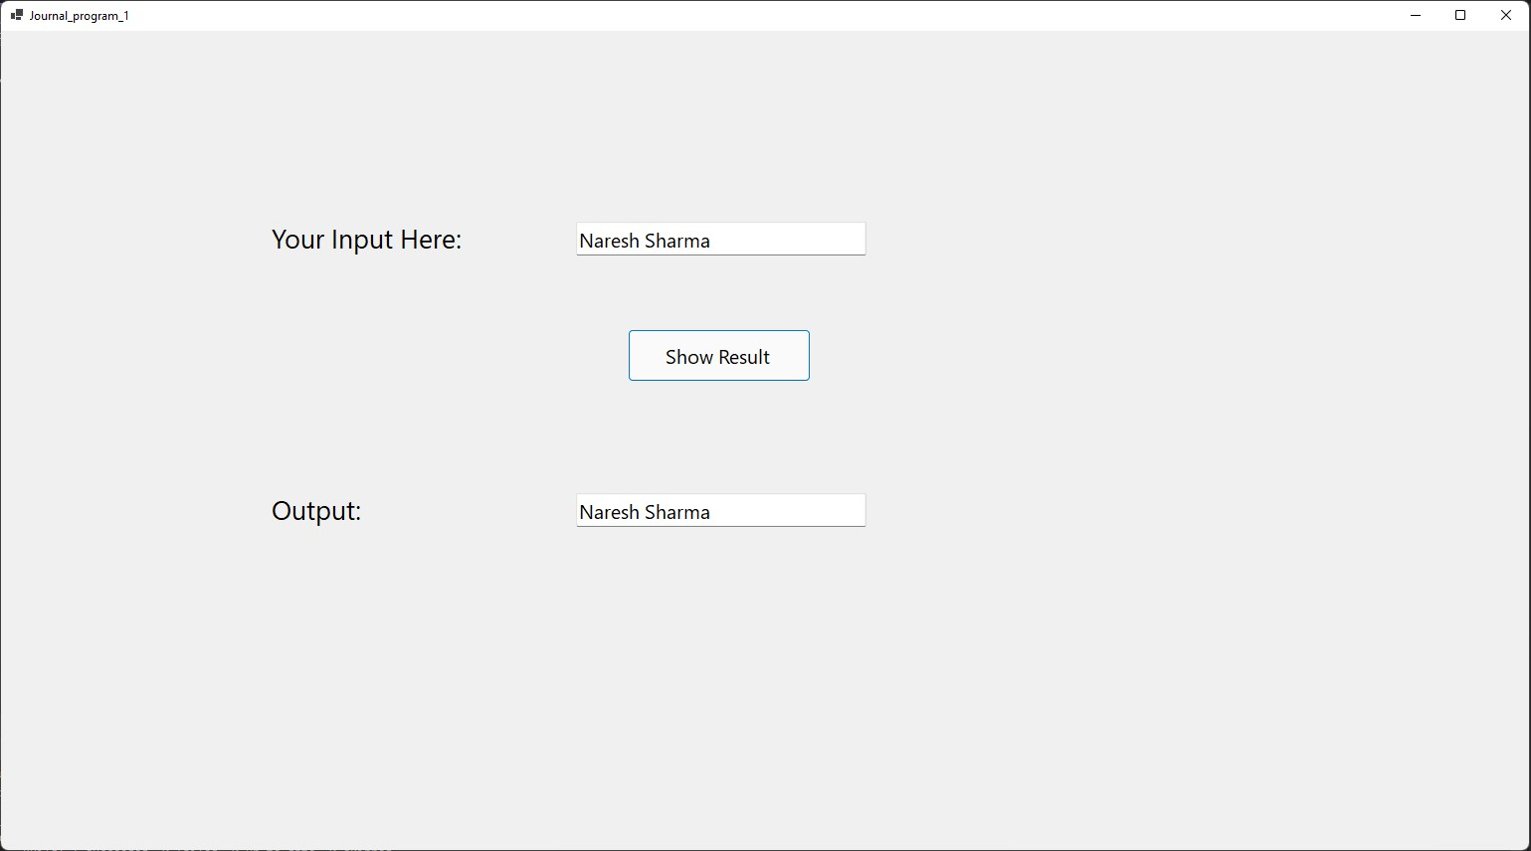

**2) Addition of Textbox controls and print answer in label control. (Sum of two numbers.**

**CODE:-**

**Public Class Form1**

**Private Sub Button1_Click(sender As Object, e As EventArgs) Handles Button1.Click**

**Label2.Text = String.Format("The Sum of {0} and {1} is {2}", TextBox1.Text, TextBox2.Text, CInt(TextBox1.Text) + CInt(TextBox2.Text))**

**End Sub**

**End Class**

**Output:**

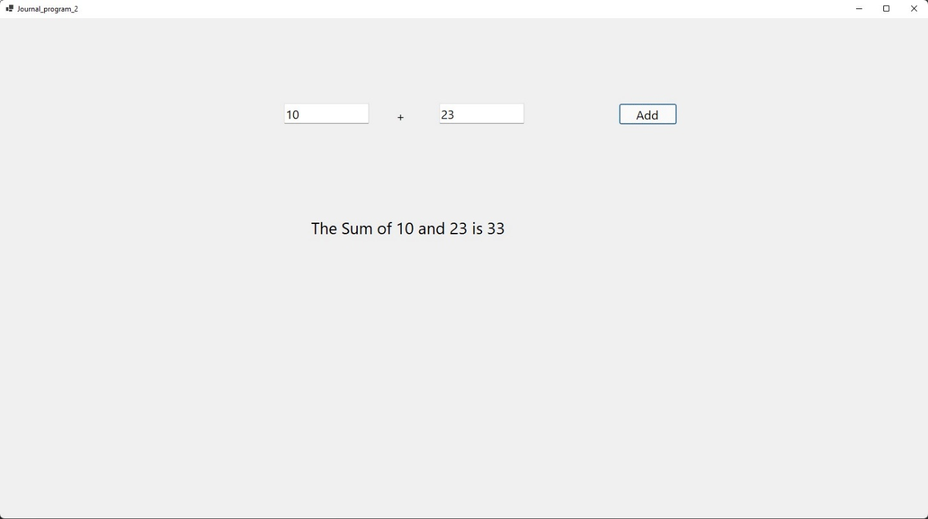

**3) Arithmetic Operators like Celsius to Fahrenheit, Rupee to dollar, pound, Euro.**

**CODE:-**

**Public Class Form1**

**Private Sub Button1_Click(sender As Object, e As EventArgs) Handles Button1.Click**

**If TextBox1.Text = vbNullString Then**

**Label3.Text = "Please enter some integer value in celsius"**

**Else**

**Label3.Text = (CInt(TextBox1.Text) * 1.8) + 32 & " Farenheit"**

**End If**

**End Sub**

**Private Sub Button2_Click(sender As Object, e As EventArgs) Handles Button2.Click**

**If TextBox2.Text = vbNullString Then**

**Label7.Text = "Please enter some integer value in rupees"**

**Label10.Text = "Please enter some integer value in rupees"**

**Label11.Text = "Please enter some integer value in rupees"**

**Else**

**Label7.Text = (CInt(TextBox2.Text) * 0.0133) & " Dollar"**

**Label10.Text = (CInt(TextBox2.Text) * 0.0099) & " Pound"**

**Label11.Text = (CInt(TextBox2.Text) * 0.0119) & " Euro"**

**End If**

**End Sub**

**End Class**

**Output:**

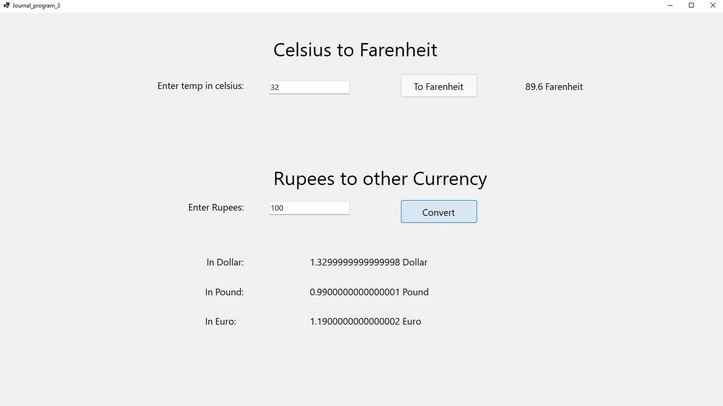

**4) Create simple calculator using 2 textboxes and 1** **textboxes for answer. Take 5 buttons for perform +, -, x, / and** **Clear the values.**

**CODE:-**

**Public Class Form1**

**Private Sub Button5_Click(sender As Object, e As EventArgs) Handles Button5.Click**

**TextBox1.Clear()**

**TextBox2.Clear()**

**TextBox3.Clear()**

**End Sub**

**Private Sub Button1_Click(sender As Object, e As EventArgs) Handles Button1.Click**

**If TextBox1.Text = vbNullString Then**

**TextBox3.Text = "No Values!"**

**Else**

**TextBox3.Text = CInt(TextBox1.Text) + CInt(TextBox2.Text)**

**End If**

**End Sub**

**Private Sub Button2_Click(sender As Object, e As EventArgs) Handles Button2.Click**

**If TextBox1.Text = vbNullString Then**

**TextBox3.Text = "No Values!"**

**Else**

**TextBox3.Text = CInt(TextBox1.Text) - CInt(TextBox2.Text)**

**End If**

**End Sub**

**Private Sub Button3_Click(sender As Object, e As EventArgs) Handles Button3.Click**

**If TextBox1.Text = vbNullString Then**

**TextBox3.Text = "No Values!"**

**Else**

**TextBox3.Text = CInt(TextBox1.Text) * CInt(TextBox2.Text)**

**End If**

**End Sub**

**Private Sub Button4_Click(sender As Object, e As EventArgs) Handles Button4.Click**

**If TextBox1.Text = vbNullString Then**

**TextBox3.Text = "No Values!"**

**Else**

**TextBox3.Text = CInt(TextBox1.Text) / CInt(TextBox2.Text)**

**End If**

**End Sub**

**End Class**

**Output:**

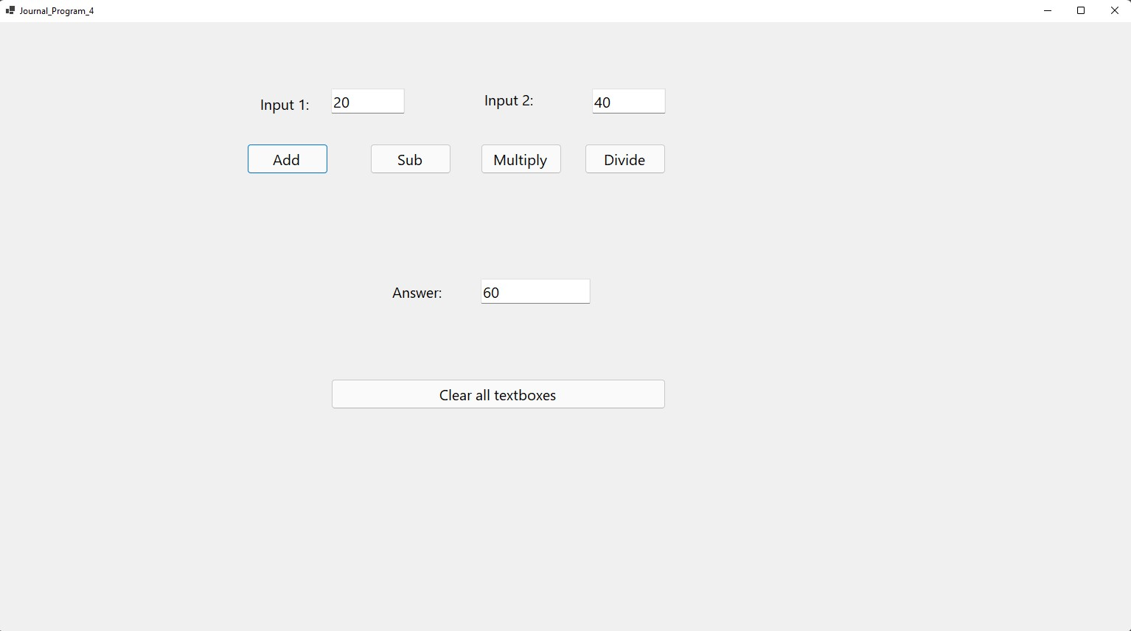

**5) Assignment**

**Code:**

**Public Class Form1**

**Private Sub Button1_Click(sender As Object, e As EventArgs) Handles Button1.Click**

**Dim n As Integer**

**n = 20**

**n += 2**

**n -= 4**

**n *= 3**

**n /= 3**

**n ^= 2**

**MsgBox(String.Format("The value of n is: {0}", n))**

**End Sub**

**End Class**

**Output**

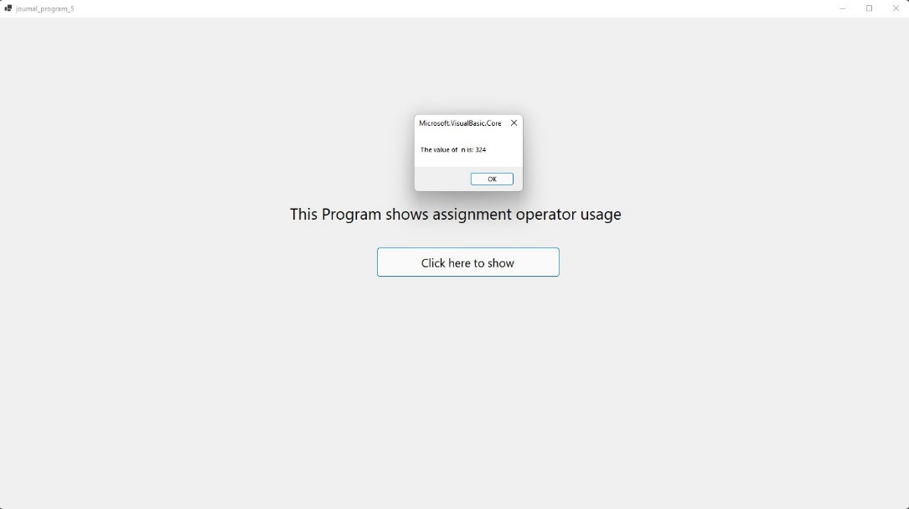

**6) Relational/Comparison**

**CODE:-**

**Public Class Form1**

**Private Sub Button1_Click(sender As Object, e As EventArgs) Handles Button1.Click**

**Dim n As Integer = 20**

**If n = 20 Then**

**MsgBox(String.Format("The number is {0}", n))**

**Else**

**MsgBox(String.Format("The number is not {0}", n))**

**End If**

**End Sub**

**End Class**

**Output:**

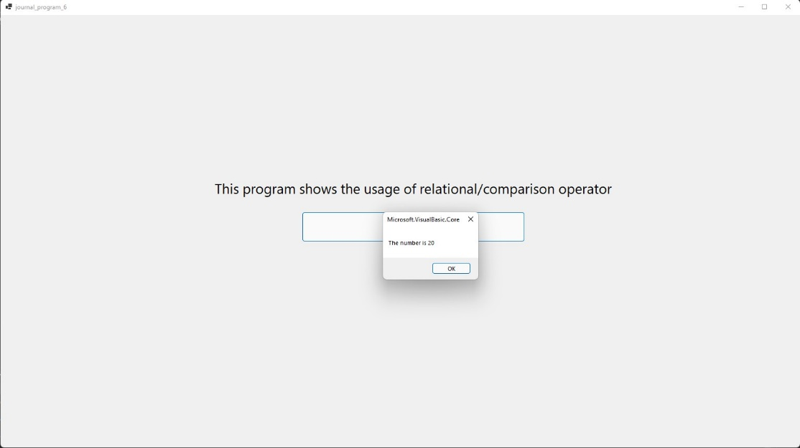

**7) Concatenation Operators**

**CODE:-**

**Public Class Form1**

**Private Sub Button1_Click(sender As Object, e As EventArgs) Handles Button1.Click**

**Dim myString1 As String = "Naresh "**

**Dim myString2 As String = "Sharma "**

**MsgBox("My name is " & myString1 + myString2)**

**End Sub**

**End Class**

**Output:**

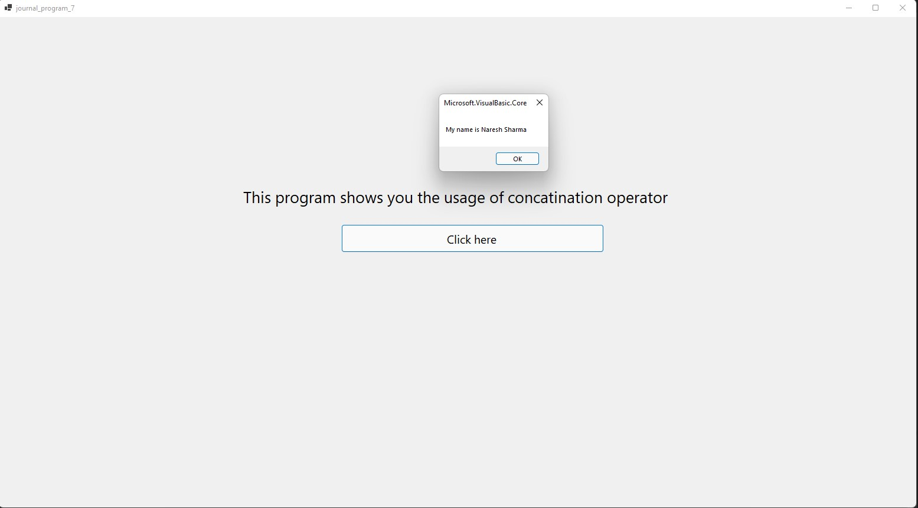

**8) Like operator**

**CODE:-**

**Public Class Form1**

**Private Sub Button1_Click(sender As Object, e As EventArgs) Handles Button1.Click**

**Dim example As String = "Lion" Like "Lion"**

**MsgBox(example)**

**End Sub**

**End Class**

**Output:**

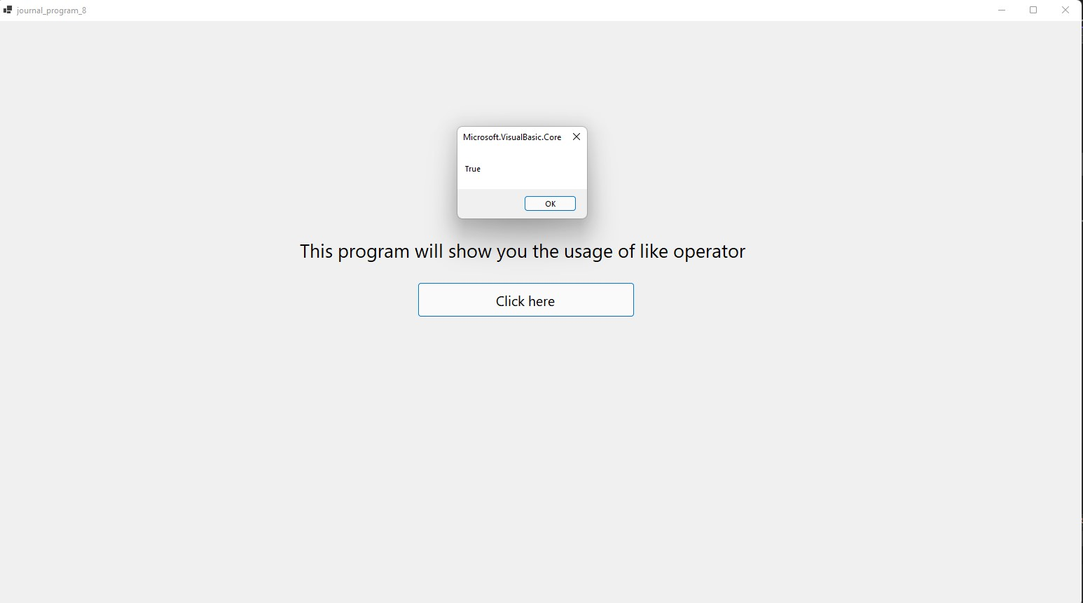

**9) The number is Numeric or not (If Else block)**

**CODE:-**

**Public Class Form1**

**Private Sub Button1_Click(sender As Object, e As EventArgs) Handles Button1.Click**

**If TextBox1.Text = vbNullString Then**

**Label2.Text = "Please input something!"**

**Else**

**If IsNumeric(TextBox1.Text) Then**

**Label2.Text = "The input is numeric"**

**Else**

**Label2.Text = "The input is not numeric"**

**End If**

**End If**

**End Sub**

**End Class**

**Output:**

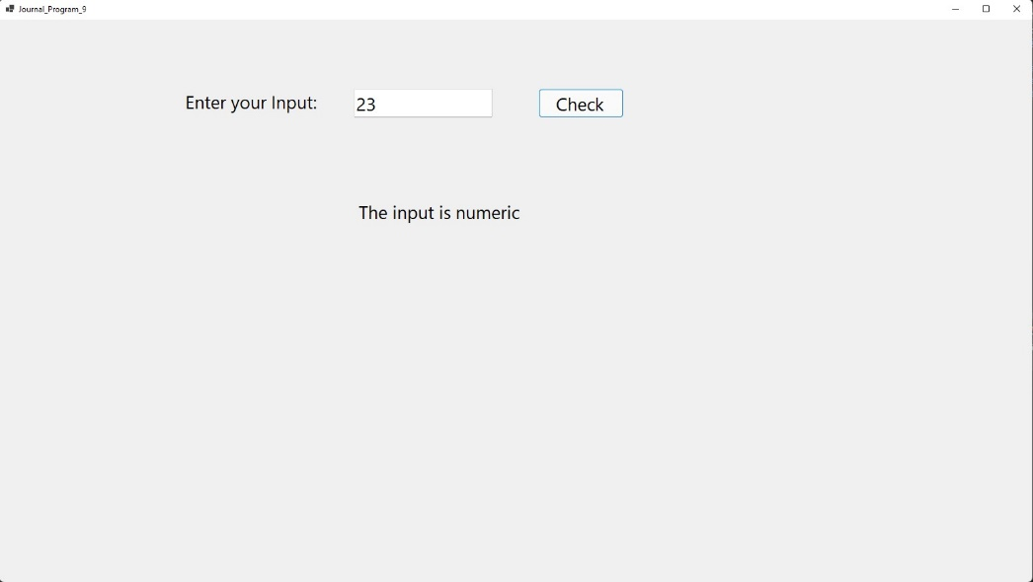

**10) Enter age and display category (Like Sr. or Gr.KG, Secondary, Primary, Higher)**

**CODE:-**

**Public Class Form1**

**Private Sub Button1_Click(sender As Object, e As EventArgs) Handles Button1.Click**

**If TextBox1.Text = vbNullString Then**

**Label2.Text = "Please Enter your age first"**

**Else**

**If CInt(TextBox1.Text) <= 0 Then**

**Label2.Text = "Please Enter proper age"**

**ElseIf CInt(TextBox1.Text) <= 5 Then**

**Label2.Text = "You are still a kid"**

**ElseIf CInt(TextBox1.Text) <= 7 Then**

**Label2.Text = "You are in Jr. Kg or Sr. Kg"**

**ElseIf CInt(TextBox1.Text) <= 13 Then**

**Label2.Text = "You are in primary section"**

**ElseIf CInt(TextBox1.Text) <= 15 Then**

**Label2.Text = "You are in higher section"**

**ElseIf CInt(TextBox1.Text) <= 17 Then**

**Label2.Text = "You are in higher secondary section"**

**ElseIf CInt(TextBox1.Text) > 18 Then**

**Label2.Text = "You are in college and adult"**

**End If**

**End If**

**End Sub**

**End Class**

**Output:**

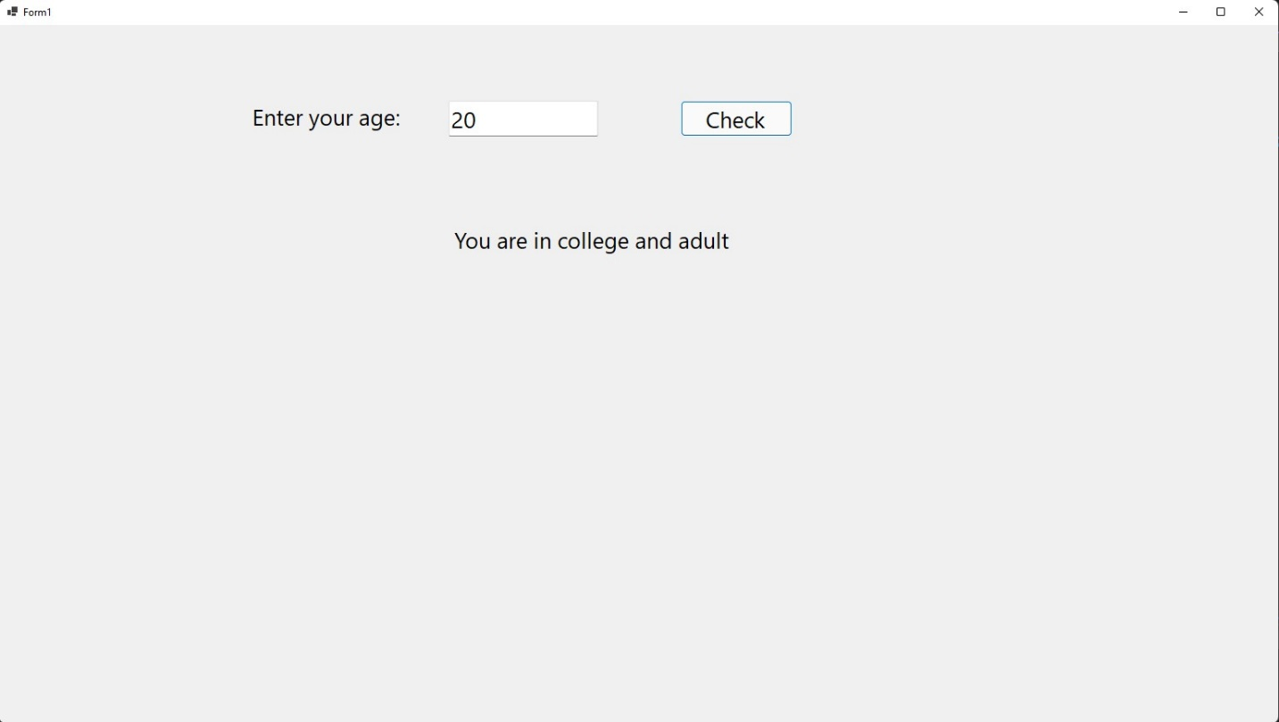

**11) Write an Application of find the number is odd or even.**

**CODE:-**

**Public Class Form1**

**Private Sub Button1_Click(sender As Object, e As EventArgs) Handles Button1.Click**

**Dim num As Integer = TextBox1.Text**

**If num Mod 2 = 0 Then**

**Label2.Text = String.Format("{0} is an even number", num)**

**Else**

**Label2.Text = String.Format("{0} is an odd number", num)**

**End If**

**End Sub**

**End Class**

**Output:**

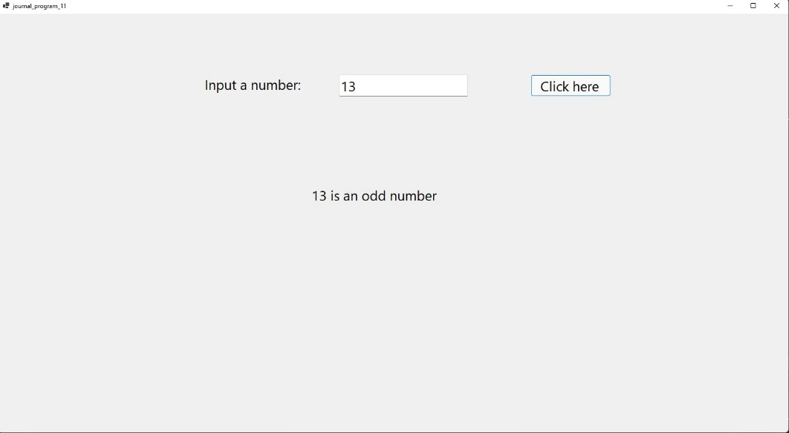

**12) DateTimePicker and selected date should be display in label.**

**CODE:-**

**Public Class Form1**

**Private Sub Button1_Click(sender As Object, e As EventArgs) Handles Button1.Click**

**Dim dt As DateTime = DateTimePicker1.Value**

**Label2.Text = dt**

**End Sub**

**End Class**

**Output:**

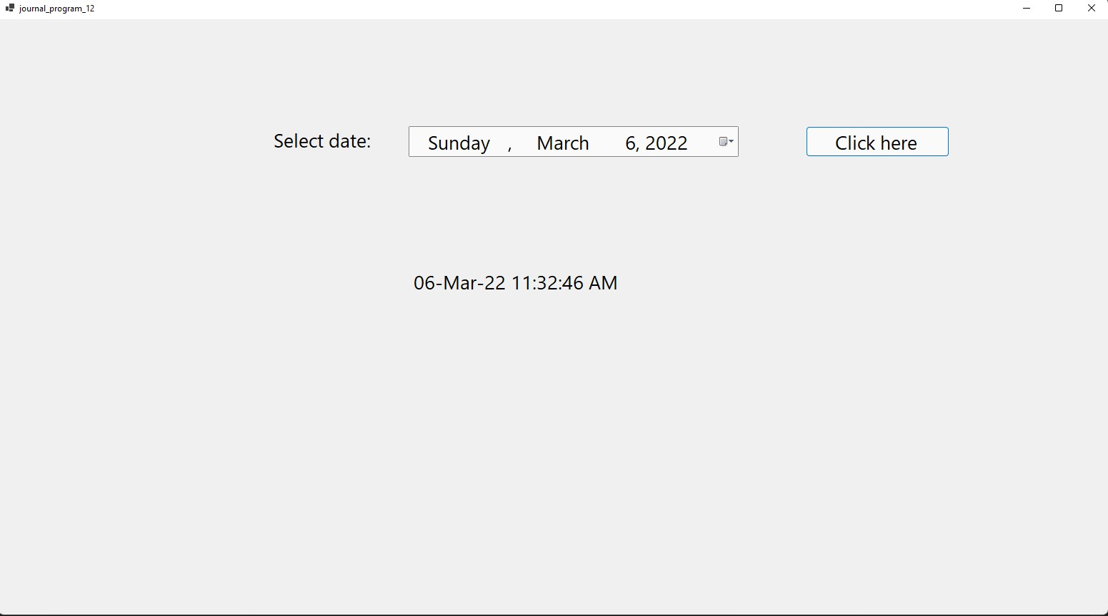

**13) Enter the number and prints its 1 to N. (input one text box print n number other textbox) and in textbox enter only digit.**

**CODE:-**

**Public Class Form1**

**Private Sub Form1_Load(sender As Object, e As EventArgs) Handles MyBase.Load**

**Dim i As Integer**

**Dim num As Integer = InputBox("Enter a number")**

**For i = 1 To num**

**TextBox1.Text &= i & " "**

**Next**

**End Sub**

**End Class**

**Output:**

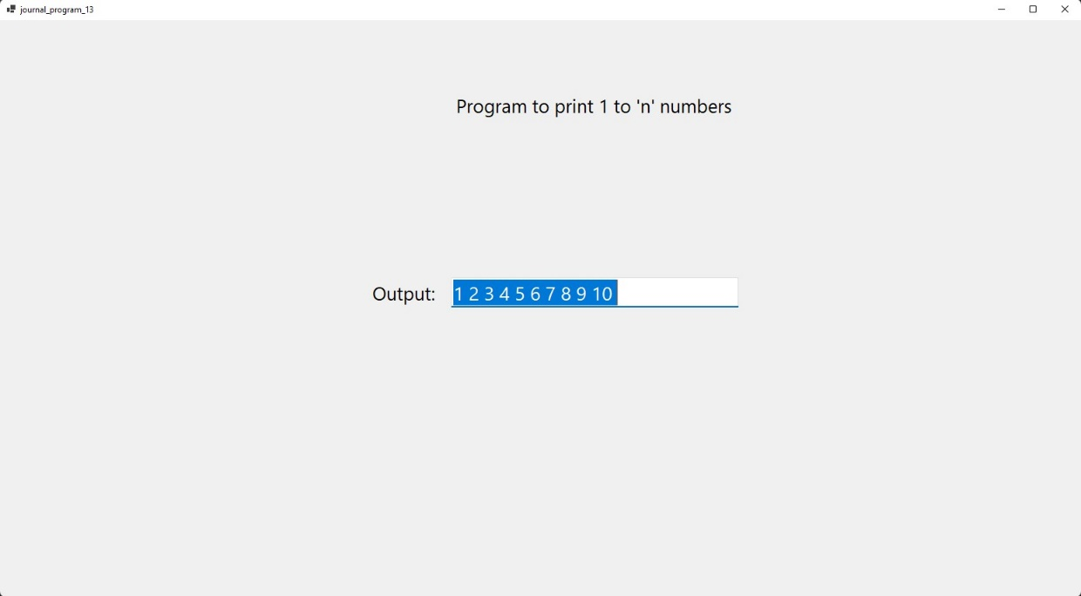

**14) Make a Table (5*5=25)**

**CODE:-**

**Public Class Form1**

**Private Sub Button1_Click(sender As Object, e As EventArgs) Handles Button1.Click**

**Dim n, result**

**Dim str As String**

**For n = 1 To 10**

**str = 5 & "*" & n & "="**

**result = 5 * n**

**TextBox1.Text = TextBox1.Text & str & result & vbNewLine**

**Next**

**End Sub**

**End Class**

**Output:**

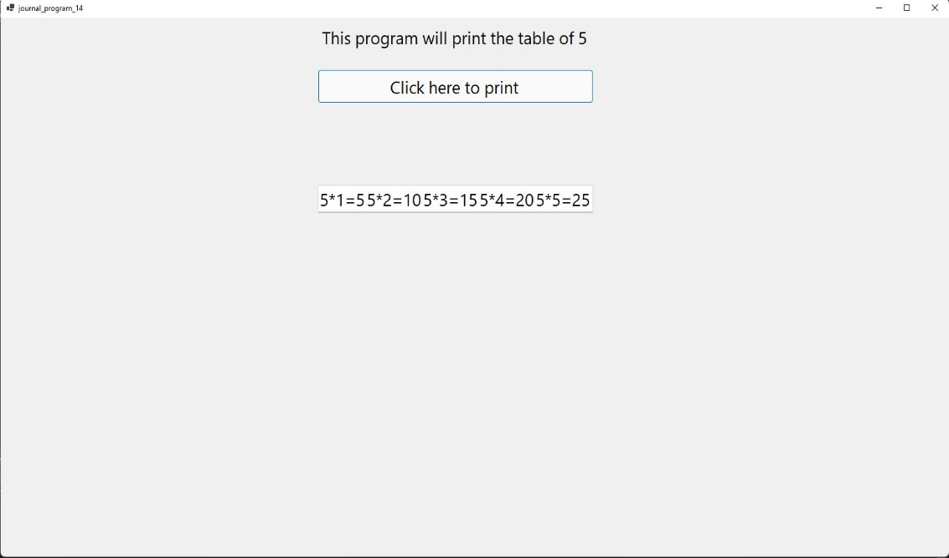

**15) Find 1 to 5 Factorial & ans is display in listbox and listbox type combobox.**

**Code:**

**Public Class Form1**

**Private Sub Form1_Load(sender As Object, e As EventArgs) Handles MyBase.Load**

**ListBox1.Items.Add("Answer will be displayed here!")**

**End Sub**

**Private Sub Button1_Click(sender As Object, e As EventArgs) Handles Button1.Click**

**Dim i As Integer**

**Dim fact As Integer = 1**

**For i = 1 To 5**

**fact = fact * i**

**Next**

**ListBox1.Items.Remove("Answer will be displayed here!")**

**ListBox1.Items.Add(String.Format("The factorial of 5 is {0}", fact))**

**End Sub**

**End Class**

**Output:**

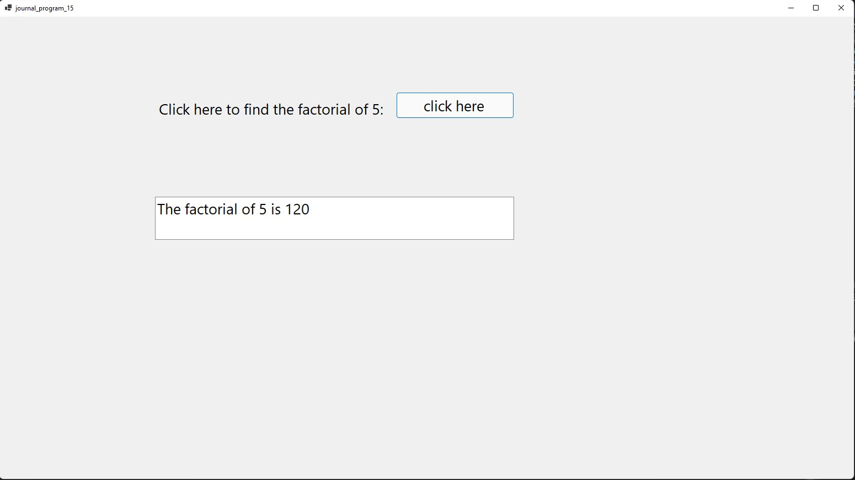

**16) Count number of Textboxes on form.**

**CODE:-**

**Public Class Form1**

**Private Sub Button1_Click(sender As Object, e As EventArgs) Handles Button1.Click**

**Dim ctrl As New Control**

**Dim count As Integer = 0**

**For Each ctrl In Me.Controls**

**If TypeOf ctrl Is TextBox Then**

**count = count + 1**

**End If**

**Next**

**MsgBox(String.Format("Total number of textboxes are: {0}", count))**

**End Sub**

**End Class**

**Output:**

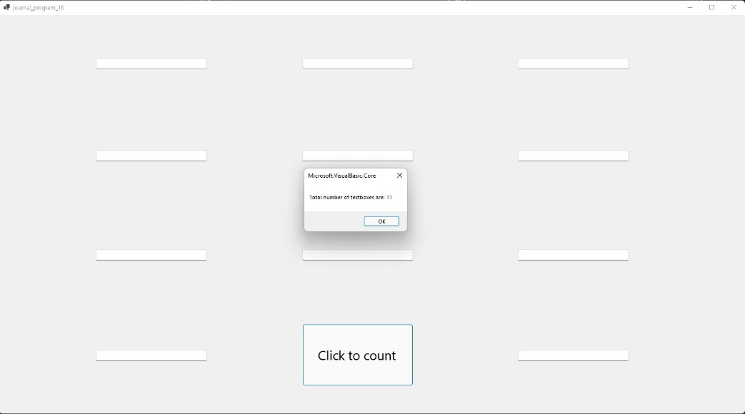

**17) Example of MsgBox and MassageBox.show.**

**CODE:-**

**Public Class Form1**

**Private Sub Button1_Click(sender As Object, e As EventArgs) Handles Button1.Click**

**MsgBox("Naresh Sharma", , "MsgBox Example")**

**MessageBox.Show("My name is Naresh Sharma", "MessageBox.Show Example", MessageBoxButtons.OK, MessageBoxIcon.Information)**

**End Sub**

**End Class**

**Output:**

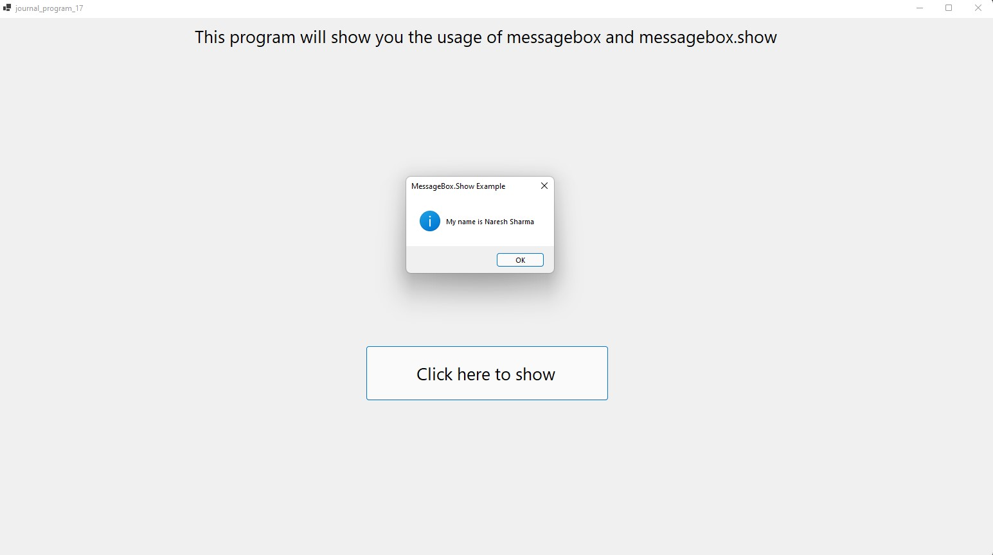

**18) Accept the name from Input Box and Display name in the message box.**

**CODE:-**

**Public Class Form1**

**Private Sub Button1_Click(sender As Object, e As EventArgs) Handles Button1.Click**

**Dim name As String**

**name = InputBox("Enter your name", "Program 18")**

**MessageBox.Show(String.Format("My name is {0}", name), "My Name", MessageBoxButtons.OK, MessageBoxIcon.Information)**

**End Sub**

**End Class**

**Output:** 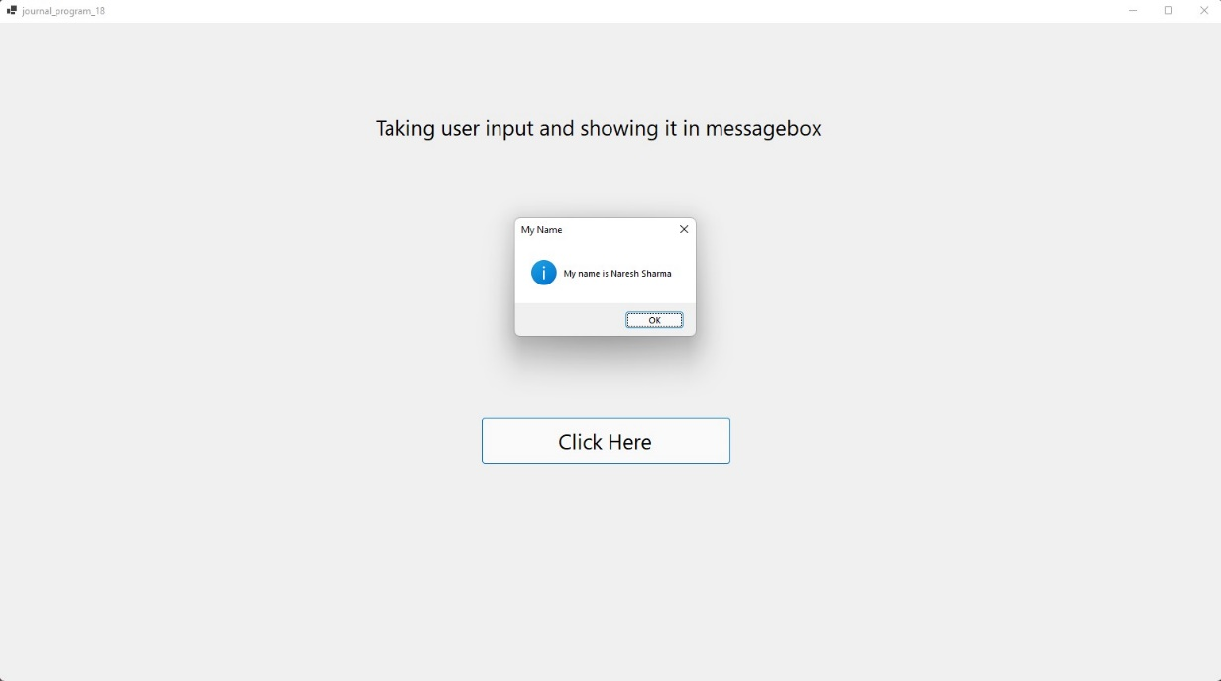

**19) Function procedures (Demo)**

**Code:**

**Public Class Form1**

**Private Function add(ByVal a As Integer, ByVal b As Integer) As Integer**

**Dim c As Integer**

**c = a + b**

**Return c**

**End Function**

**Private Sub Button1_Click(sender As Object, e As EventArgs) Handles Button1.Click**

**Dim result As Integer = add(22, 32)**

**MsgBox(String.Format("The addition of 22 and 32 is {0}", result))**

**End Sub**

**End Class**

**Output:**

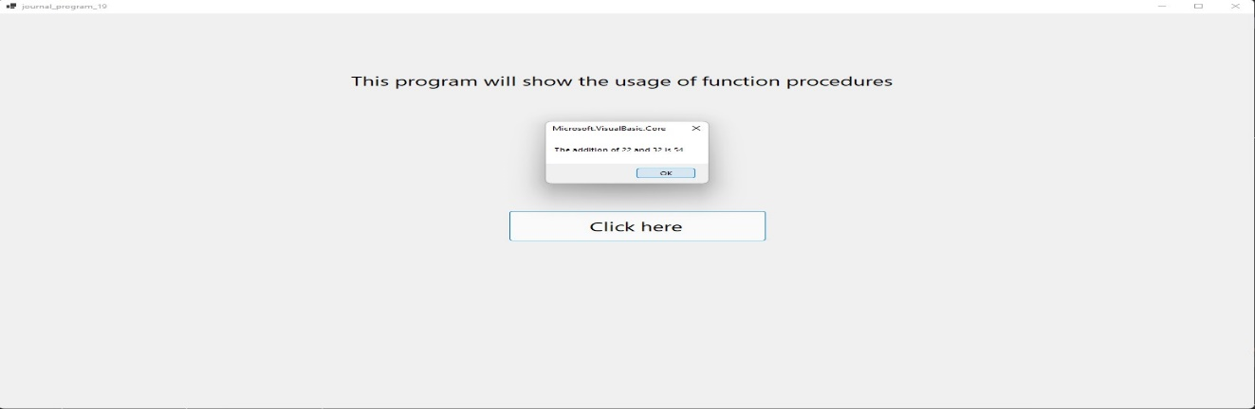

**20) Swapping of 2 values**

**CODE:-**

**Public Class Form1**

**Private Sub swap(ByRef a As Integer, ByRef b As Integer)**

**Dim temp As Integer**

**temp = a**

**a = b**

**b = temp**

**End Sub**

**Private Sub Button1_Click(sender As Object, e As EventArgs) Handles Button1.Click**

**Dim a As Integer = TextBox1.Text**

**Dim b As Integer = TextBox2.Text**

**swap(a, b)**

**TextBox3.Text = a**

**TextBox4.Text = b**

**End Sub**

**End Class**

**Output:**

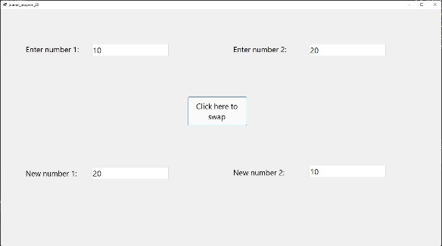

**21) Function Overloading**

**Code:**

**Public Class Form1**

**Private Function Add(ByVal a As Integer, ByVal b As Integer) As Integer**

**Dim c As Integer = a + b**

**Return c**

**End Function**

**Private Function Add(ByVal a As String, ByVal b As String) As String**

**Dim c As String = a + b**

**Return c**

**End Function**

**Private Sub Button1_Click(sender As Object, e As EventArgs) Handles Button1.Click**

**MsgBox(String.Format("My name is {0}", Add("Naresh ", "Sharma")))**

**End Sub**

**Private Sub Button2_Click(sender As Object, e As EventArgs) Handles Button2.Click**

**MsgBox(String.Format("The addition of 10 and 20 is {0}", Add(10, 20)))**

**End Sub**

**End Class**

**Output:**

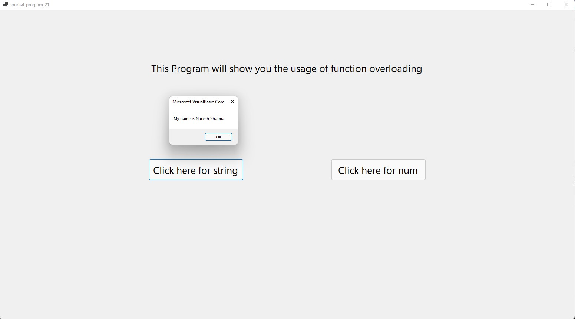

**22) Only characters enter in the textbox otherwise print appropriate messages.**

**Code:**

**Public Class Form1**

**Private Sub TextBox1_KeyPress(sender As Object, e As KeyPressEventArgs) Handles TextBox1.KeyPress**

**If Not Char.IsLetter(e.KeyChar) And Not e.KeyChar = Chr(Keys.Delete) And Not e.KeyChar = Chr(Keys.Back) And Not e.KeyChar = Chr(Keys.Space) Then**

**e.Handled = True**

**MsgBox("Enter correct character!")**

**End If**

**End Sub**

**End Class**

**Output:**

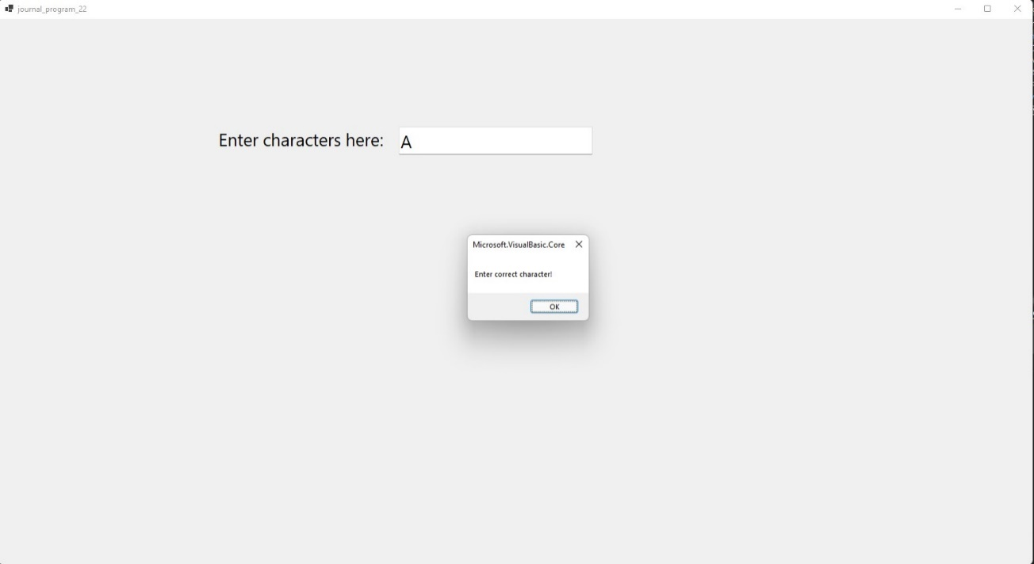

**23) Create simple calculator using the concept of sender**

**CODE:-**

**Public Class Form1**

**Dim no1 As Integer**

**Dim op As Char**

**Private Sub Btn0_Click(sender As Object, e As EventArgs) Handles Btn0.Click, Btn00.Click, Btn1.Click, Btn2.Click, Btn3.Click, Btn4.Click, Btn5.Click, Btn6.Click, Btn7.Click, Btn8.Click, Btn9.Click**

**TextBox1.Text &= sender.Text**

**End Sub**

**Private Sub BtnDiv_Click(sender As Object, e As EventArgs) Handles BtnDiv.Click, BtnMin.Click, BtnMul.Click, BtnPlus.Click**

**no1 = TextBox1.Text**

**TextBox1.Clear()**

**op = sender.Text**

**End Sub**

**Private Sub BtnEqual_Click(sender As Object, e As EventArgs) Handles BtnEqual.Click**

**If op = "+" Then**

**TextBox1.Text = no1 + Val(TextBox1.Text)**

**ElseIf op = "-" Then**

**TextBox1.Text = no1 - Val(TextBox1.Text)**

**ElseIf op = "*" Then**

**TextBox1.Text = no1 * Val(TextBox1.Text)**

**ElseIf op = "/" Then**

**TextBox1.Text = no1 / Val(TextBox1.Text)**

**End If**

**End Sub**

**Private Sub BtnClear_Click(sender As Object, e As EventArgs) Handles BtnClear.Click**

**TextBox1.Clear()**

**End Sub**

**End Class**

**Output:**

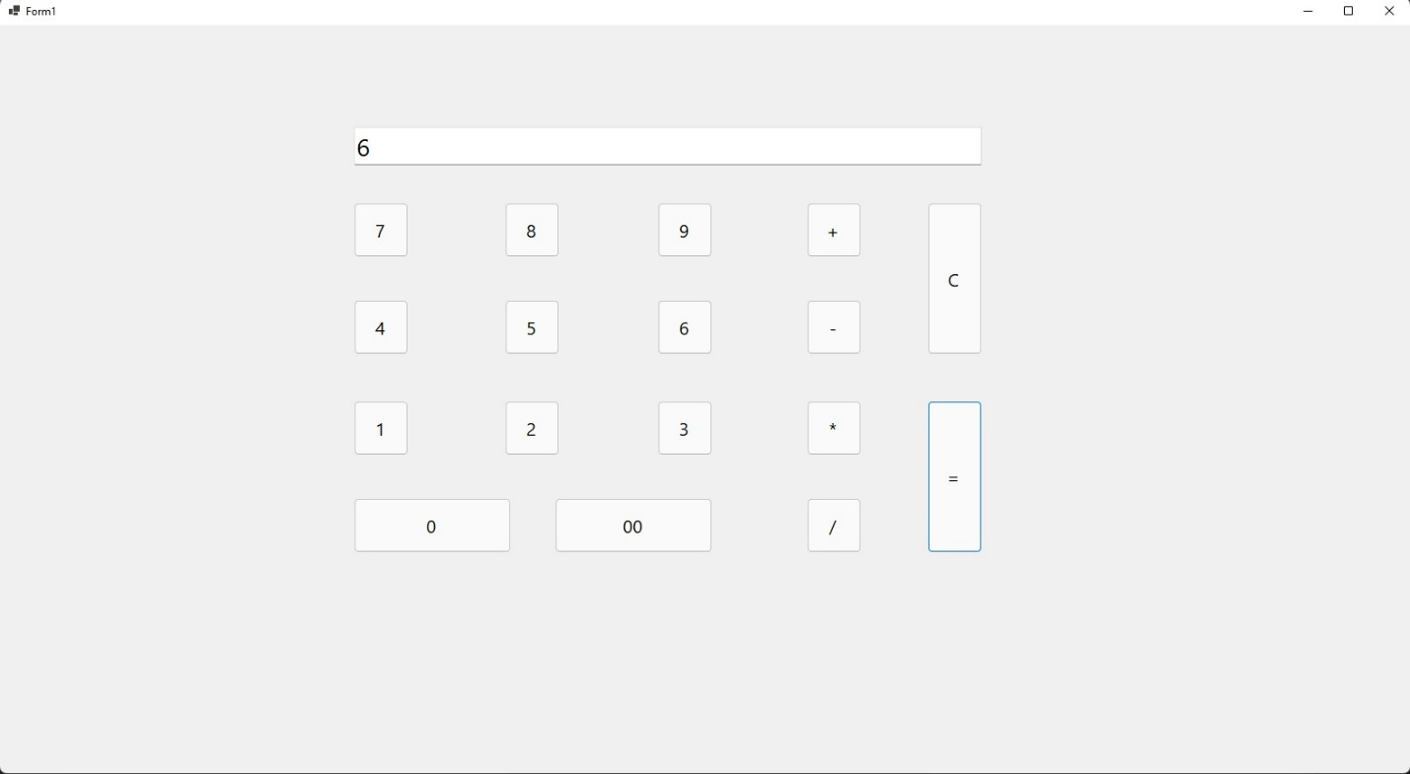

**24) Write a program to calculate number is Prime or not.**

**CODE:-**

**Public Class Form1**

**Private Sub Button1_Click(sender As Object, e As EventArgs) Handles Button1.Click**

**Dim num As Integer = TextBox1.Text**

**Dim flag As Boolean**

**Dim i As Integer**

**For i = 2 To num - 1**

**If num Mod i = 0 Then**

**flag = False**

**End If**

**Next**

**If flag = False Then**

**Label2.Text = String.Format("{0} is not a prime number", num)**

**Else**

**Label2.Text = String.Format("{0} is a prime number", num)**

**End If**

**End Sub**

**End Class**

**Output:** 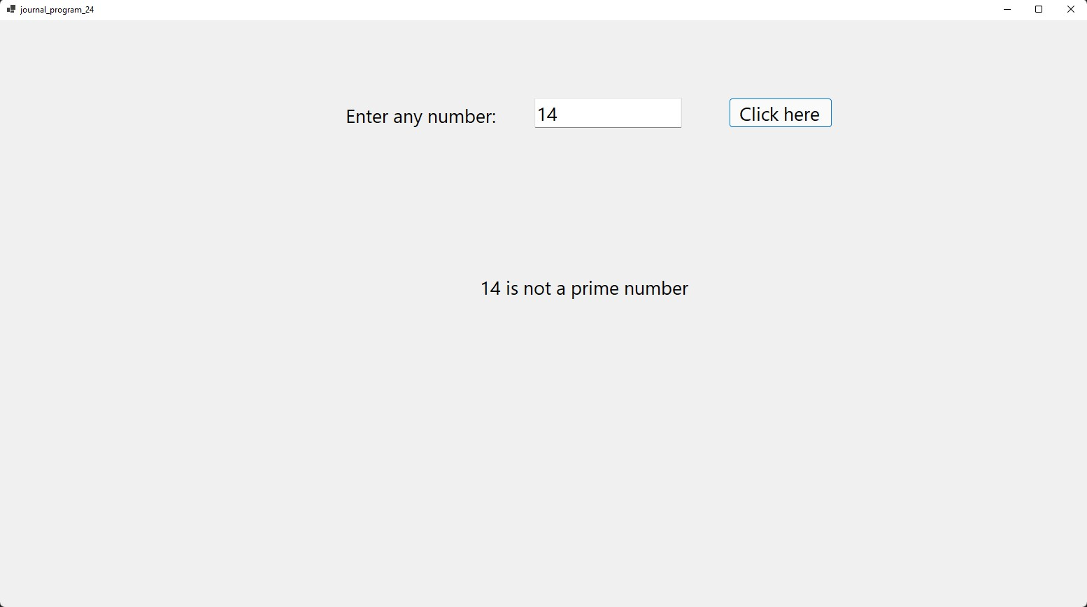

**25) String Class’s Properties and Method (Demo).**

**CODE:-**

**Public Class Form1**

**Private Sub Form1_Load(sender As Object, e As EventArgs) Handles MyBase.Load**

**Dim str1, str2 As String**

**str1 = "Naresh "**

**str2 = "Sharma "**

**'Length**

**MsgBox(str1.Length())**

**'Concat**

**str1 = String.Concat(str1, str2)**

**MsgBox(str1)**

**'Copy**

**str2 = String.Copy(str1)**

**MsgBox(str2)**

**'Equals**

**MsgBox(String.Equals("NARESH", "Naresh"))**

**'Trim**

**str1 = str1.Trim(" ")**

**MsgBox(str1)**

**'EndsWith**

**If str1.EndsWith("a") Then**

**MsgBox("Correct!")**

**Else**

**MsgBox("Wrong!")**

**End If**

**'IndexOf**

**Dim no As Integer = str1.IndexOf("N")**

**MsgBox(String.Format("N is a {0}th place", no))**

**'Substring**

**MsgBox(str1.Substring(5))**

**End Sub**

**End Class**

**Output:**

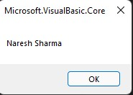

**26) Other inbuilt function (like Spit, join, Mid, Shell, Substr etc…)**

**CODE:-**

**Split**

**Public Class Form1**

**Private Sub Button1_Click(sender As Object, e As EventArgs) Handles Button1.Click**

**Dim arr() As String = Split(TextBox1.Text, (" "))**

**TextBox2.Text = arr(0)**

**TextBox3.Text = arr(1)**

**End Sub**

**End Class**

**Join**

**Public Class Form1**

**Private Sub Button1_Click(sender As Object, e As EventArgs) Handles Button1.Click**

**Dim arr() As String = {"Naresh ", "Sharma "}**

**TextBox1.Text = Join(arr, ",")**

**End Sub**

**End Class**

**Shell**

**Public Class Form1**

**Private Sub Button1_Click(sender As Object, e As EventArgs) Handles Button1.Click**

**Dim o As Integer**

**o = Shell("c:\Program Files\Visual Studio Code\code.exe", AppWinStyle.NormalFocus)**

**End Sub**

**End Class**

**Output:**

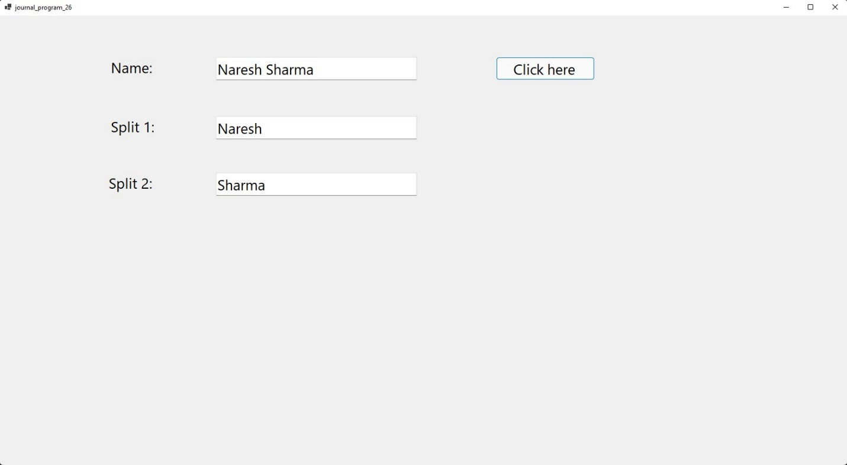

**27) Create login from and user name “SAI RAM” password=”123” then message will display login succefully otherwise access denied.**

**CODE:-**

**Public Class Form1**

**Private Sub Button1_Click(sender As Object, e As EventArgs) Handles Button1.Click**

**If LCase(Trim(TextBox1.Text)) = "sai ram" And LCase(Trim(TextBox2.Text)) = "123" Then**

**MsgBox("Logged in Successfully!", MsgBoxStyle.Information, "Welcome")**

**Else**

**MsgBox("Access Denied!", MsgBoxStyle.Exclamation, "Warning")**

**End If**

**End Sub**

**Private Sub Button2_Click(sender As Object, e As EventArgs) Handles Button2.Click**

**TextBox1.Clear()**

**TextBox2.Clear()**

**End Sub**

**End Class**

**Output:**

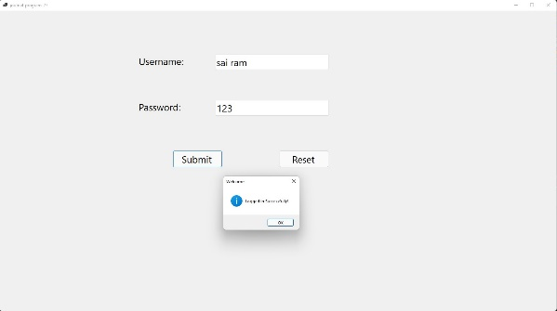

**28) Small Notepad**

**Code:**

**Public Class Form1**

**Private Sub Button1_Click(sender As Object, e As EventArgs) Handles Button1.Click**

**RichTextBox1.Cut()**

**End Sub**

**Private Sub Button2_Click(sender As Object, e As EventArgs) Handles Button2.Click**

**RichTextBox1.Copy()**

**End Sub**

**Private Sub Button3_Click(sender As Object, e As EventArgs) Handles Button3.Click**

**RichTextBox1.Paste()**

**End Sub**

**Private Sub Button4_Click(sender As Object, e As EventArgs) Handles Button4.Click**

**RichTextBox1.Undo()**

**End Sub**

**Private Sub Button5_Click(sender As Object, e As EventArgs) Handles Button5.Click**

**If RichTextBox1.CanUndo = True Then**

**RichTextBox1.Undo()**

**RichTextBox1.ClearUndo()**

**End If**

**End Sub**

**Private Sub Button6_Click(sender As Object, e As EventArgs) Handles Button6.Click**

**RichTextBox1.Clear()**

**End Sub**

**Private Sub Button7_Click(sender As Object, e As EventArgs) Handles Button7.Click**

**RichTextBox1.Text = UCase(RichTextBox1.Text)**

**End Sub**

**Private Sub Button8_Click(sender As Object, e As EventArgs) Handles Button8.Click**

**RichTextBox1.Text = LCase(RichTextBox1.Text)**

**End Sub**

**End Class**

**Output:**

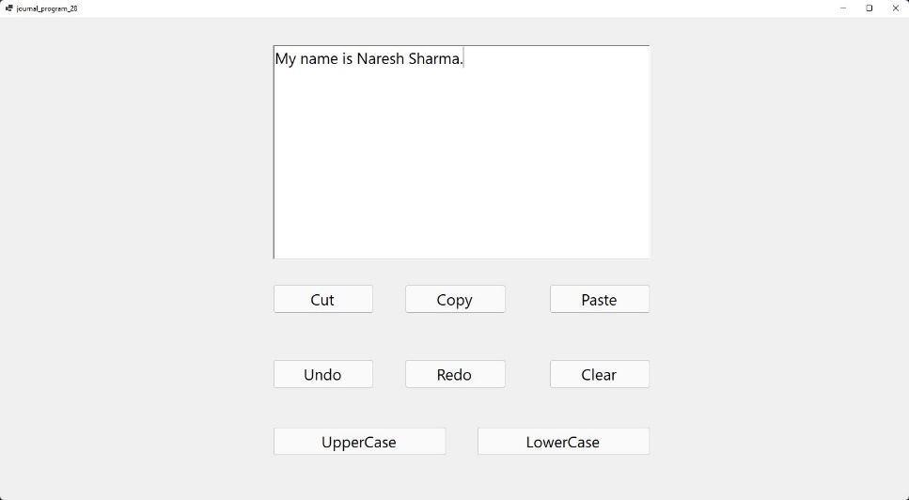

**29) Enter restricted data only (use of Error provider)**

**CODE:-**

**Public Class Form1**

**Private Sub TextBox1_KeyPress(sender As Object, e As KeyPressEventArgs) Handles TextBox1.KeyPress**

**If Asc(e.KeyChar) >= 48 And Asc(e.KeyChar) <= 57 Then**

**e.Handled = True**

**ErrorProvider1.SetError(TextBox1, "You can enter only string value here!")**

**Else**

**e.Handled = False**

**End If**

**End Sub**

**Private Sub TextBox2_KeyPress(sender As Object, e As KeyPressEventArgs) Handles TextBox2.KeyPress**

**If Asc(e.KeyChar) >= 48 And Asc(e.KeyChar) <= 57 Or Asc(e.KeyChar) = 8 Then**

**e.Handled = False**

**Else**

**e.Handled = True**

**ErrorProvider1.SetError(TextBox2, "You can enter only numbers here!")**

**End If**

**End Sub**

**End Class**

**Output:**

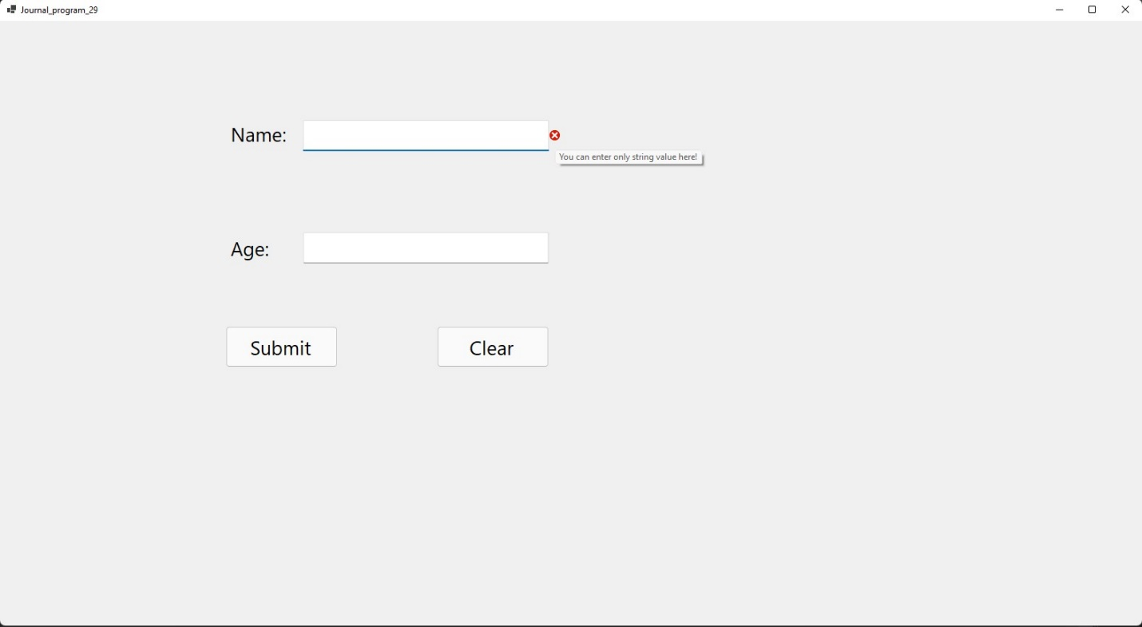

**30) Use of Radio Button Control**

**CODE:-**

**Public Class Form1**

**Private Sub Button1_Click(sender As Object, e As EventArgs) Handles Button1.Click**

**If RadioButton1.Checked = True Then**

**MsgBox(String.Format("Name: {0}. Gender: Male", TextBox1.Text))**

**Else**

**MsgBox(String.Format("Name: {0}. Gender: Female", TextBox1.Text))**

**End If**

**End Sub**

**End Class**

**Output:**

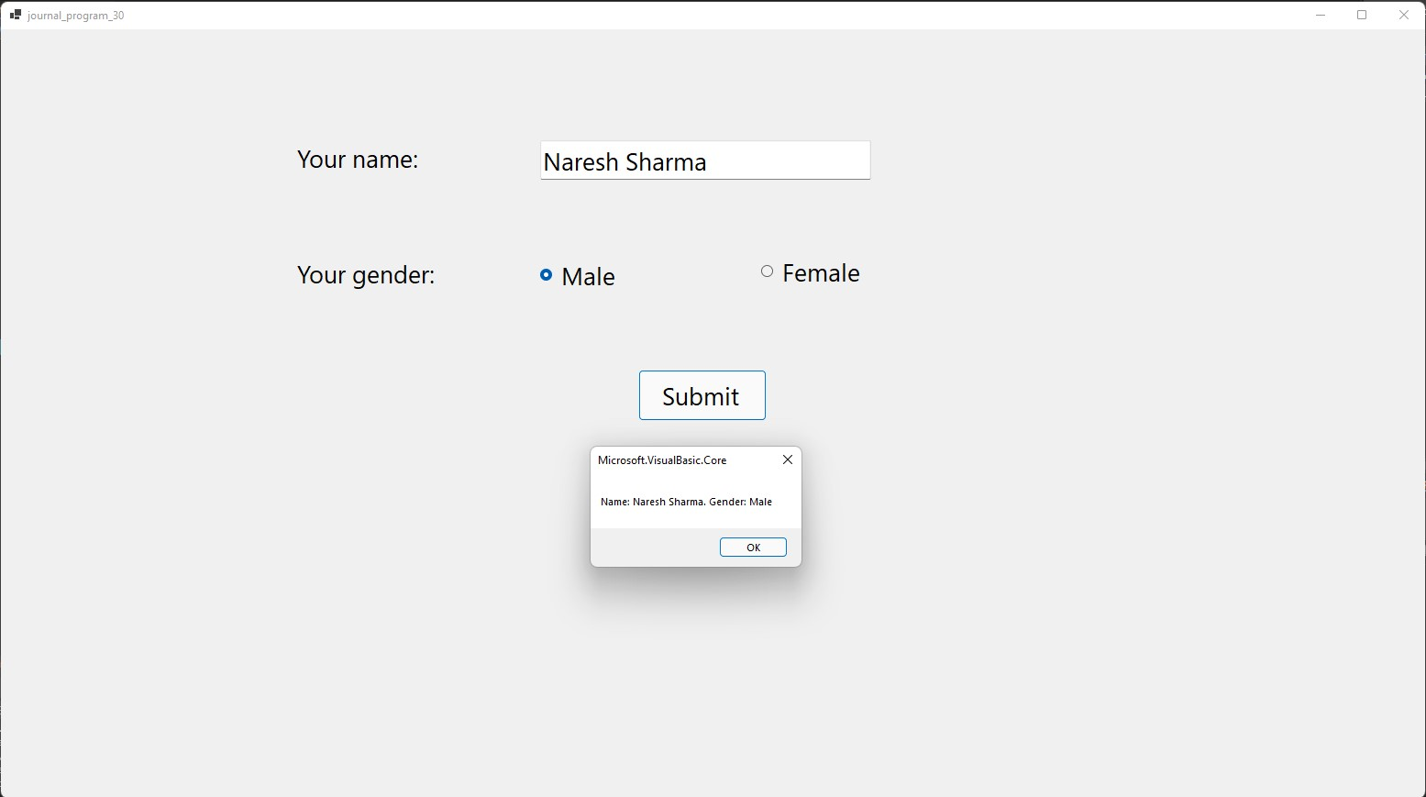

**31) According to Radio Button selection display the appropriate image on label control. You can click on male then in Picture Box and same as female.**

**CODE:-**

**Public Class Form1**

**Private Sub RadioButton1_CheckedChanged(sender As Object, e As EventArgs) Handles RadioButton1.CheckedChanged**

**PictureBox1.Image = Image.FromFile("D:\practicals\vb.NET projects\Journal Programs\journal_program_31\boy.jpg")**

**End Sub**

**Private Sub RadioButton2_CheckedChanged(sender As Object, e As EventArgs) Handles RadioButton2.CheckedChanged**

**PictureBox1.Image = Image.FromFile("D:\practicals\vb.NET projects\Journal Programs\journal_program_31\girl.jpg")**

**End Sub**

**End Class**

**Output:**

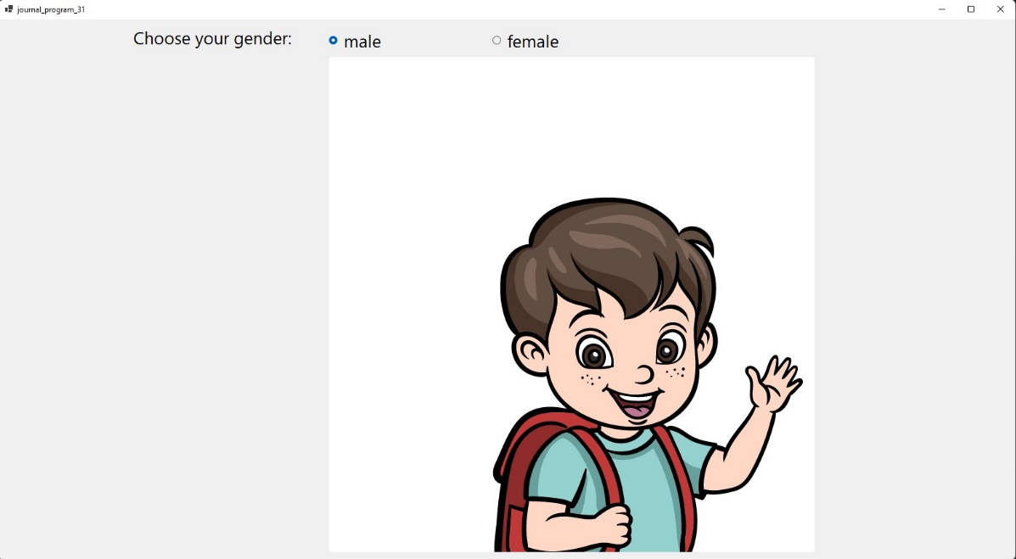

**32) Demo of Insert, Add, Remove methods.**

**CODE:-**

**Public Class Form1**

**Private Sub Button1_Click(sender As Object, e As EventArgs) Handles Button1.Click**

**ListBox1.Items.Add(TextBox1.Text)**

**TextBox1.Clear()**

**End Sub**

**Private Sub Button2_Click(sender As Object, e As EventArgs) Handles Button2.Click**

**If ListBox1.Items.Contains(TextBox1.Text) Then**

**ListBox1.Items.Remove(TextBox1.Text)**

**Else**

**MsgBox("Item not found in the list")**

**End If**

**TextBox1.Clear()**

**End Sub**

**Private Sub Button3_Click(sender As Object, e As EventArgs) Handles Button3.Click**

**ListBox1.Items.Insert(TextBox2.Text, TextBox3.Text)**

**TextBox2.Clear()**

**TextBox3.Clear()**

**End Sub**

**End Class**

**Output:**

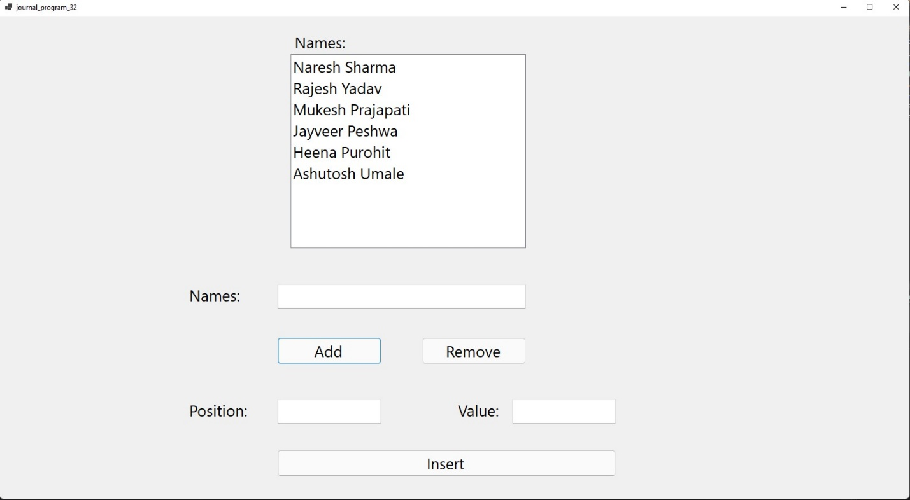

**33) Create following demo.**

**CODE:-**

**Public Class Form1**

**Private Sub Form1_Load(sender As Object, e As EventArgs) Handles MyBase.Load**

**ListBox1.Items.Add("Naresh Sharma")**

**ListBox1.Items.Add("Rajesh Yadav")**

**ListBox1.Items.Add("Ashutosh Umale")**

**ListBox1.Items.Add("Heena Purohit")**

**ListBox1.Items.Add("Sarita Yadav")**

**ListBox1.Items.Add("Mukesh Prajapati")**

**ListBox1.Items.Add("Jayveer Prajapati")**

**End Sub**

**Private Sub Button1_Click(sender As Object, e As EventArgs) Handles Button1.Click**

**ListBox2.Items.Add(ListBox1.SelectedItems)**

**ListBox1.Items.Remove(ListBox1.SelectedItems)**

**End Sub**

**Private Sub Button2_Click(sender As Object, e As EventArgs) Handles Button2.Click**

**Dim i As Integer**

**For i = 0 To ListBox1.Items.Count - 1**

**ListBox2.Items.Add(ListBox1.Items.Item(i))**

**Next**

**ListBox1.Items.Clear()**

**End Sub**

**Private Sub Button3_Click(sender As Object, e As EventArgs) Handles Button3.Click**

**Dim i As Integer**

**For i = 0 To ListBox1.SelectedItems.Count - 1**

**ListBox2.Items.Add(ListBox1.SelectedItems.Item(0))**

**ListBox1.Items.Remove(ListBox1.SelectedItems.Item(0))**

**Next**

**End Sub**

**Private Sub Button4_Click(sender As Object, e As EventArgs) Handles Button4.Click**

**Dim i As Integer**

**For i = 0 To ListBox2.SelectedItems.Count - 1**

**ListBox1.Items.Add(ListBox2.SelectedItems.Item(0))**

**ListBox2.Items.Remove(ListBox2.SelectedItems.Item(0))**

**Next**

**End Sub**

**Private Sub Button5_Click(sender As Object, e As EventArgs) Handles Button5.Click**

**Dim i As Integer**

**For i = 0 To ListBox2.Items.Count - 1**

**ListBox1.Items.Add(ListBox2.Items.Item(0))**

**Next**

**ListBox2.Items.Clear()**

**End Sub**

**Private Sub Button6_Click(sender As Object, e As EventArgs) Handles Button6.Click**

**ListBox1.Items.Add(ListBox2.SelectedItem)**

**ListBox2.Items.Remove(ListBox2.SelectedItem)**

**End Sub**

**End Class**

**Output:**

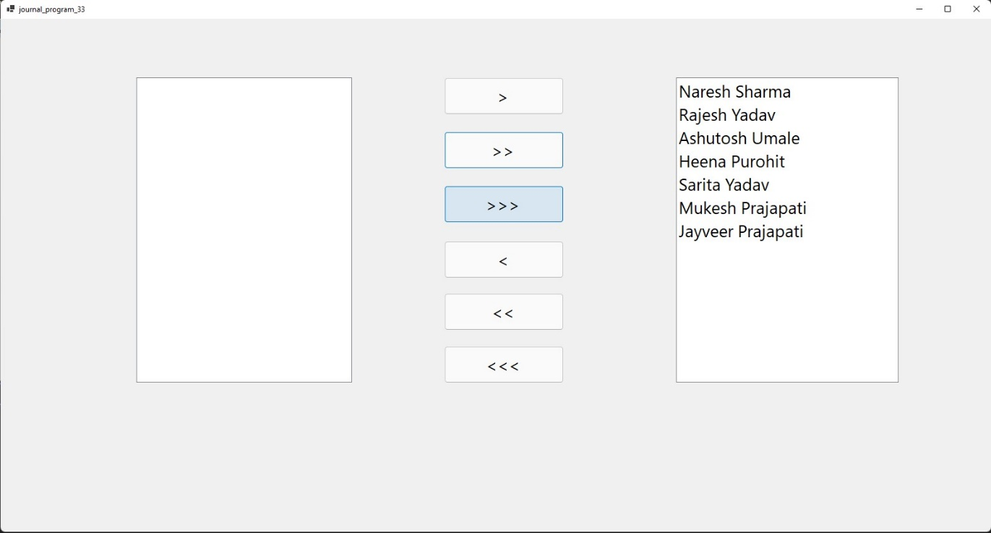

**34) Take input from the user in the Textbox for starting character and check all the List items whose starting character is that.**

**CODE:-**

**Public Class Form1**

**Private Sub Button1_Click(sender As Object, e As EventArgs) Handles Button1.Click**

**Dim myStr As String**

**Dim i As Integer**

**For i = 0 To CheckedListBox1.Items.Count - 1**

**myStr = CheckedListBox1.Items.Item(i)**

**If myStr.StartsWith(TextBox1.Text) = True Then**

**CheckedListBox1.SetItemChecked(i, True)**

**Else**

**CheckedListBox1.SetItemChecked(i, False)**

**End If**

**Next**

**End Sub**

**Private Sub Button2_Click(sender As Object, e As EventArgs) Handles Button2.Click**

**Dim i As Integer**

**For i = 0 To CheckedListBox1.Items.Count - 1**

**CheckedListBox1.SetItemChecked(i, False)**

**Next**

**End Sub**

**End Class**

**Output:**

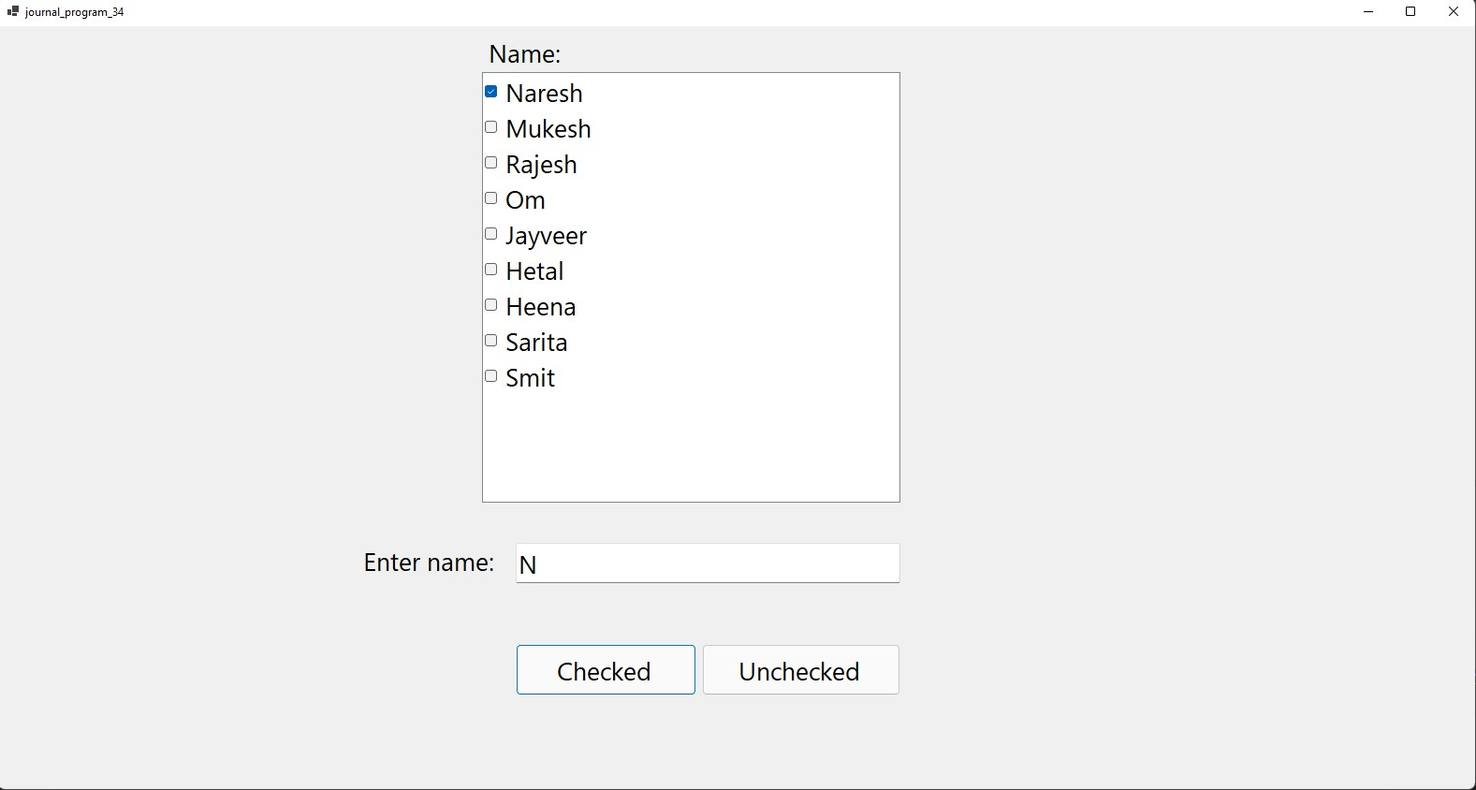

**35) Take 2 ComboBox set their name like cmbRollNo which contains number of the student, second one cmbName which contains names of the student. When we select rollno then student should display vice versa.**

**CODE:-**

**Public Class Form1**

**Private Sub Form1_Load(sender As Object, e As EventArgs) Handles MyBase.Load**

**With ComboBox1.Items**

**.Add("1")**

**.Add("2")**

**.Add("3")**

**.Add("4")**

**.Add("5")**

**.Add("6")**

**End With**

**With ComboBox2.Items**

**.Add("Naresh")**

**.Add("Rajesh")**

**.Add("Ashutosh")**

**.Add("Heena")**

**.Add("Hetal")**

**.Add("Mukesh")**

**End With**

**End Sub**

**Private Sub ComboBox1_SelectedIndexChanged(sender As Object, e As EventArgs) Handles ComboBox1.SelectedIndexChanged**

**ComboBox2.SelectedIndex = ComboBox1.SelectedIndex**

**End Sub**

**Private Sub ComboBox2_SelectedIndexChanged(sender As Object, e As EventArgs) Handles ComboBox2.SelectedIndexChanged**

**ComboBox1.SelectedIndex = ComboBox2.SelectedIndex**

**End Sub**

**End Class**

**Output:**

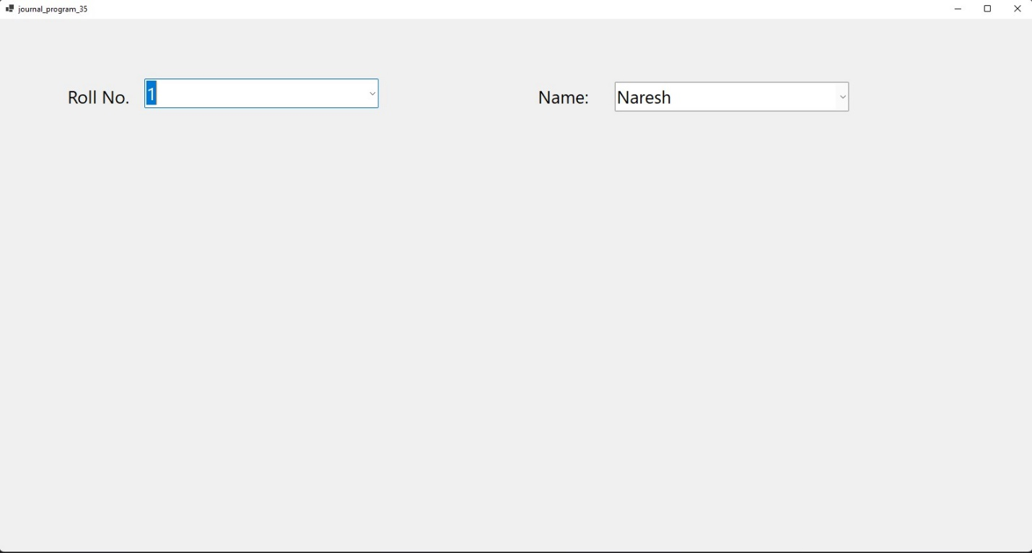

**36) Login page like following and Tooltip control**

**Code:**

**37) Color Mixer using Horizontal Scroll bar control**

**CODE:-**

**Public Class Form1**

**Private Sub HScrollBar1_Scroll(sender As Object, e As ScrollEventArgs) Handles HScrollBar1.Scroll**

**Label4.BackColor = Color.FromArgb(HScrollBar1.Value, HScrollBar2.Value, HScrollBar3.Value)**

**NumericUpDown1.Value = HScrollBar1.Value**

**NumericUpDown2.Value = HScrollBar2.Value**

**NumericUpDown3.Value = HScrollBar3.Value**

**End Sub**

**Private Sub HScrollBar2_Scroll(sender As Object, e As ScrollEventArgs) Handles HScrollBar2.Scroll**

**Label4.BackColor = Color.FromArgb(HScrollBar1.Value, HScrollBar2.Value, HScrollBar3.Value)**

**NumericUpDown1.Value = HScrollBar1.Value**

**NumericUpDown2.Value = HScrollBar2.Value**

**NumericUpDown3.Value = HScrollBar3.Value**

**End Sub**

**Private Sub HScrollBar3_Scroll(sender As Object, e As ScrollEventArgs) Handles HScrollBar3.Scroll**

**Label4.BackColor = Color.FromArgb(HScrollBar1.Value, HScrollBar2.Value, HScrollBar3.Value)**

**NumericUpDown1.Value = HScrollBar1.Value**

**NumericUpDown2.Value = HScrollBar2.Value**

**NumericUpDown3.Value = HScrollBar3.Value**

**End Sub**

**End Class**

**Output:**

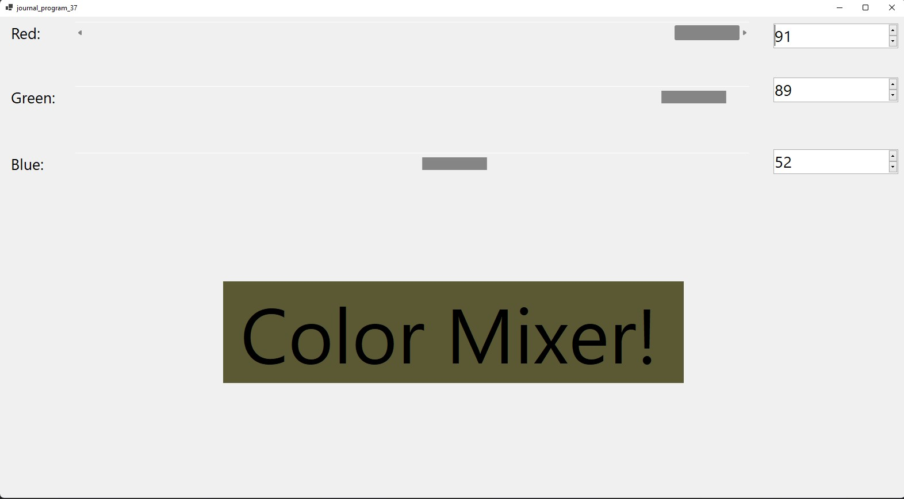

**40) Timer Demo**

**Code:**

**Public Class Form1**

**Dim i As Integer = 0**

**Dim colour(9) As Color**

**Private Sub Form1_Load(sender As Object, e As EventArgs) Handles MyBase.Load**

**colour(0) = Color.DarkBlue**

**colour(1) = Color.Gray**

**colour(2) = Color.Khaki**

**colour(3) = Color.OliveDrab**

**colour(4) = Color.Violet**

**colour(5) = Color.Chocolate**

**colour(6) = Color.WhiteSmoke**

**colour(7) = Color.Magenta**

**colour(8) = Color.Bisque**

**End Sub**

**Private Sub Timer1_Tick(sender As Object, e As EventArgs) Handles Timer1.Tick**

**Label1.BackColor = colour(i)**

**Label1.ForeColor = colour(i + 1)**

**i += 1**

**If i = 8 Then**

**i = 0**

**End If**

**End Sub**

**Private Sub Label1_Click(sender As Object, e As EventArgs) Handles Label1.Click**

**If Left = False Then**

**Label1.Left = Label1.Left + 50**

**If Label1.Left >= 700 Then**

**Left = True**

**End If**

**ElseIf Left = True Then**

**Label1.Left = Label1.Left - 50**

**If Label1.Left <= 10 Then**

**Left = False**

**End If**

**End If**

**End Sub**

**Private Sub Timer2_Tick(sender As Object, e As EventArgs) Handles Timer2.Tick**

**Label2.Text = TimeOfDay**

**End Sub**

**Private Sub Button1_Click(sender As Object, e As EventArgs) Handles Button1.Click**

**Timer1.Start()**

**Timer2.Start()**

**End Sub**

**Private Sub Button2_Click(sender As Object, e As EventArgs) Handles Button2.Click**

**Timer1.Stop()**

**Timer2.Stop()**

**End Sub**

**End Class**

**Output:**

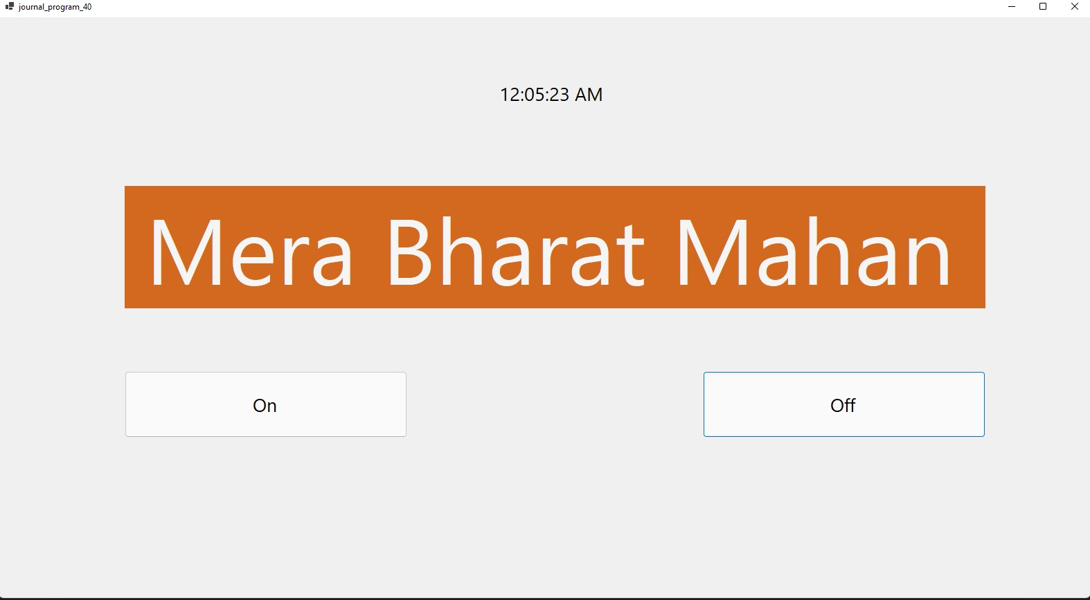

**41) Print the Table according to position of the Track Bar**

**CODE:-**

**Public Class Form1**

**Private Sub TrackBar1_Scroll(sender As Object, e As EventArgs) Handles TrackBar1.Scroll**

**Label1.Text = ""**

**Dim i As Integer**

**For i = 1 To 10**

**Label1.Text &= TrackBar1.Value & " X " & i & " = " & (TrackBar1.Value * i) & vbNewLine**

**Next**

**End Sub**

**End Class**

**Output:**

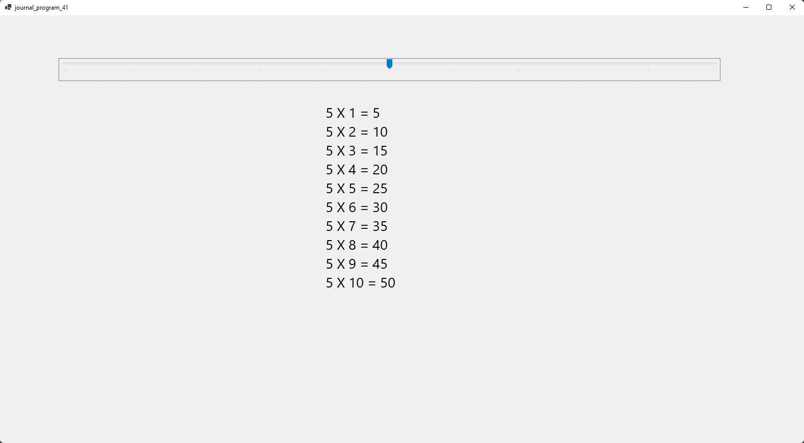

**42) Change the background**

**CODE:-**

**Public Class Form1**

**Private Sub TrackBarRed_Scroll(sender As Object, e As EventArgs) Handles TrackBarRed.Scroll**

**Me.BackColor = Color.FromArgb(TrackBarRed.Value, TrackBarGreen.Value, TrackBarBlue.Value)**

**TextBox1.Text = TrackBarRed.Value**

**TextBox2.Text = TrackBarGreen.Value**

**TextBox3.Text = TrackBarBlue.Value**

**End Sub**

**Private Sub TrackBarGreen_Scroll(sender As Object, e As EventArgs) Handles TrackBarGreen.Scroll**

**Me.BackColor = Color.FromArgb(TrackBarRed.Value, TrackBarGreen.Value, TrackBarBlue.Value)**

**TextBox1.Text = TrackBarRed.Value**

**TextBox2.Text = TrackBarGreen.Value**

**TextBox3.Text = TrackBarBlue.Value**

**End Sub**

**Private Sub TrackBarBlue_Scroll(sender As Object, e As EventArgs) Handles TrackBarBlue.Scroll**

**Me.BackColor = Color.FromArgb(TrackBarRed.Value, TrackBarGreen.Value, TrackBarBlue.Value)**

**TextBox1.Text = TrackBarRed.Value**

**TextBox2.Text = TrackBarGreen.Value**

**TextBox3.Text = TrackBarBlue.Value**

**End Sub**

**End Class**

**Output:**

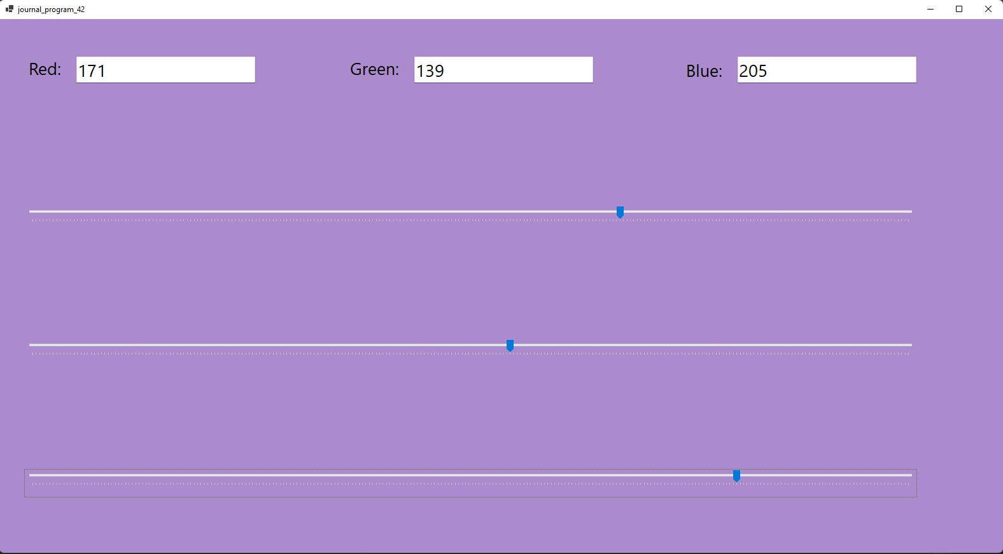

**43) Change background color of the from runtime and default set orange color as selected color in the color Dialog.**

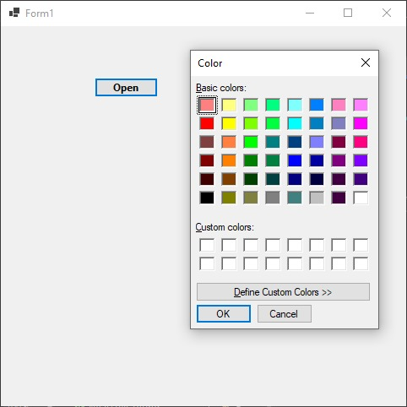

**CODE:-**

**Public Class Form1**

**Private Sub Button1_Click(sender As Object, e As EventArgs) Handles**

**Button1.Click()**

**With ColorDialog1**

**.Color = Color.Orange**

**If .ShowDialog() = Windows.Forms.DialogResult.OK Then**

**Me.BackColor = .Color**

**End If**

**End With**

**End Sub**

**End Class**

**44) Change the background color and foreground color (font color) of the Rich Textbox. You can click on back color then open color dilogbox that same font color then open font dilogbox and change in textbox contain.**

**CODE:-**

**Public Class Form1**

**Private Sub Form1_Load(sender As Object, e As EventArgs) Handles MyBase.Load**

**RichTextBox1.Text = "My name is Naresh Sharma"**

**End Sub**

**Private Sub Button1_Click(sender As Object, e As EventArgs) Handles Button1.Click**

**If ColorDialog1.ShowDialog = Windows.Forms.DialogResult.OK Then**

**RichTextBox1.BackColor = ColorDialog1.Color**

**End If**

**End Sub**

**Private Sub Button2_Click(sender As Object, e As EventArgs) Handles Button2.Click**

**If ColorDialog1.ShowDialog = Windows.Forms.DialogResult.OK Then**

**RichTextBox1.ForeColor = ColorDialog1.Color**

**End If**

**End Sub**

**Private Sub Button3_Click(sender As Object, e As EventArgs) Handles Button3.Click**

**If FontDialog1.ShowDialog = Windows.Forms.DialogResult.OK Then**

**RichTextBox1.Font = FontDialog1.Font**

**End If**

**End Sub**

**End Class**

**Output:**

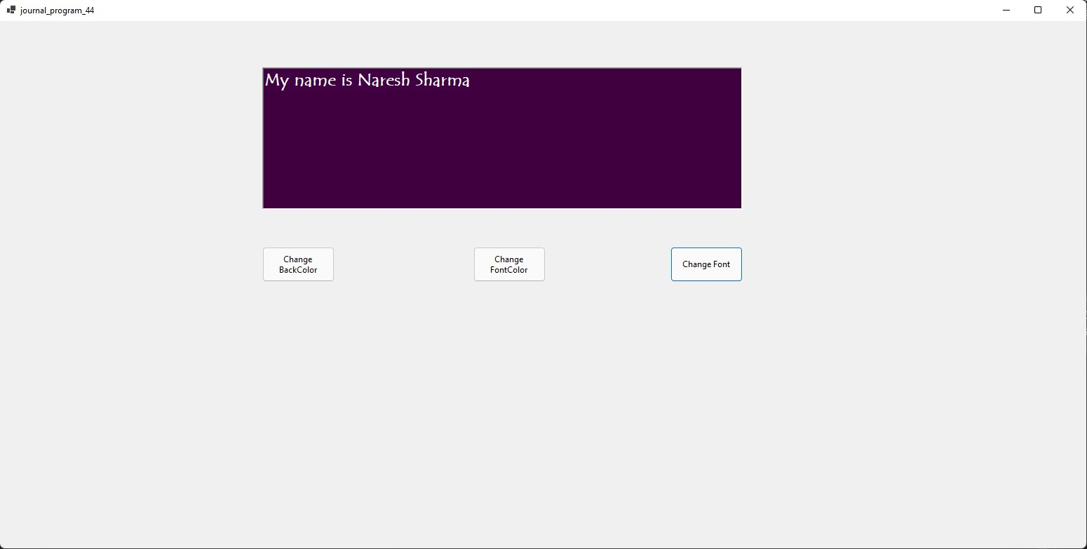

**45) Create WordPad with Menus as given below:**

**File -> New, Open, Save, SaveAs, Exit**

**Edit -> Undo, Redo, Cut, Copy, Paste, SelectAll**

**Format -> Font ->Selected**

**->All**

**-> Color -> Selected**

**->All**

**-> Alignment -> Left**

**-> Center**

**-> Right**

**-> Bullet**

**View ->Zoom ->2, 5, 10, 15**

**CODE:-**

**Public Class Form1**

**Dim open As OpenFileDialog**

**Dim save As SaveFileDialog**

**Dim font As FontDialog**

**Dim color As ColorDialog**

**Private Sub NewToolStripMenuItem_Click(sender As Object, e As EventArgs) Handles NewToolStripMenuItem.Click**

**If Me.Text <> "notepad" Then**

**MsgBox("Your file is saved", MsgBoxStyle.Information, "Notepad")**

**Me.Text = "Notepad"**

**RichTextBox1.Clear()**

**Else**

**End If**

**End Sub**

**Private Sub OpenToolStripMenuItem_Click(sender As Object, e As EventArgs) Handles OpenToolStripMenuItem.Click**

**With Open**

**.Filter = "Text file|*.txt|RTF file|*rtf"**

**If .ShowDialog = Windows.Forms.DialogResult.OK Then**

**RichTextBox1.LoadFile(.FileName, RichTextBoxStreamType.PlainText)**

**Me.Text = .FileName**

**End If**

**End With**

**End Sub**

**Private Sub SaveToolStripMenuItem_Click(sender As Object, e As EventArgs) Handles SaveToolStripMenuItem.Click**

**If Me.Text = "Notepad" Then**

**With save**

**.Filter = "Text file|*.txt|RTF file|*.rtf"**

**.Title = "Save file"**

**If .ShowDialog = Windows.Forms.DialogResult.OK Then**

**RichTextBox1.SaveFile(.FileName, RichTextBoxStreamType.PlainText)**

**Me.Text = .FileName**

**End If**

**End With**

**Else**

**RichTextBox1.SaveFile(Me.Text, RichTextBoxStreamType.PlainText)**

**MsgBox("Your file saved", MsgBoxStyle.Information, "Notepad")**

**End If**

**End Sub**

**Private Sub SaveAsToolStripMenuItem_Click(sender As Object, e As EventArgs) Handles SaveAsToolStripMenuItem.Click**

**With save**

**.Filter = "Text file|*.txt|RTF file|*.rtf"**

**If .ShowDialog = Windows.Forms.DialogResult.OK Then**

**RichTextBox1.SaveFile(.FileName, RichTextBoxStreamType.PlainText)**

**Me.Text = .FileName**

**End If**

**End With**

**End Sub**

**Private Sub ExitToolStripMenuItem_Click(sender As Object, e As EventArgs) Handles ExitToolStripMenuItem.Click**

**End**

**End Sub**

**Private Sub UndoToolStripMenuItem_Click(sender As Object, e As EventArgs) Handles UndoToolStripMenuItem.Click**

**RichTextBox1.Undo()**

**End Sub**

**Private Sub RedoToolStripMenuItem_Click(sender As Object, e As EventArgs) Handles RedoToolStripMenuItem.Click**

**RichTextBox1.Redo()**

**End Sub**

**Private Sub CutToolStripMenuItem_Click(sender As Object, e As EventArgs) Handles CutToolStripMenuItem.Click**

**RichTextBox1.Cut()**

**End Sub**

**Private Sub CopyToolStripMenuItem_Click(sender As Object, e As EventArgs) Handles CopyToolStripMenuItem.Click**

**RichTextBox1.Copy()**

**End Sub**

**Private Sub PasteToolStripMenuItem_Click(sender As Object, e As EventArgs) Handles PasteToolStripMenuItem.Click**

**RichTextBox1.Paste()**

**End Sub**

**Private Sub SelectAllToolStripMenuItem_Click(sender As Object, e As EventArgs) Handles SelectAllToolStripMenuItem.Click**

**RichTextBox1.SelectAll()**

**End Sub**

**Private Sub SelectedToolStripMenuItem_Click(sender As Object, e As EventArgs) Handles SelectedToolStripMenuItem.Click**

**With font**

**If .ShowDialog = Windows.Forms.DialogResult.OK Then**

**RichTextBox1.SelectionFont = .Font**

**End If**

**End With**

**End Sub**

**Private Sub AllToolStripMenuItem_Click(sender As Object, e As EventArgs) Handles AllToolStripMenuItem.Click**

**With font**

**If .ShowDialog = Windows.Forms.DialogResult.OK Then**

**RichTextBox1.Font = .Font**

**End If**

**End With**

**End Sub**

**Private Sub SelectedToolStripMenuItem1_Click(sender As Object, e As EventArgs) Handles SelectedToolStripMenuItem1.Click**

**With color**

**If .ShowDialog = Windows.Forms.DialogResult.OK Then**

**RichTextBox1.SelectionColor = .Color**

**End If**

**End With**

**End Sub**

**Private Sub AllToolStripMenuItem1_Click(sender As Object, e As EventArgs) Handles AllToolStripMenuItem1.Click**

**With color**

**If .ShowDialog = Windows.Forms.DialogResult.OK Then**

**RichTextBox1.ForeColor = .Color**

**End If**

**End With**

**End Sub**

**Private Sub SelectedToolStripMenuItem2_Click(sender As Object, e As EventArgs) Handles SelectedToolStripMenuItem2.Click**

**RichTextBox1.SelectionAlignment = HorizontalAlignment.Left**

**End Sub**

**Private Sub ALLToolStripMenuItem2_Click(sender As Object, e As EventArgs) Handles ALLToolStripMenuItem2.Click**

**RichTextBox1.SelectionAlignment = HorizontalAlignment.Center**

**End Sub**

**Private Sub RightToolStripMenuItem_Click(sender As Object, e As EventArgs) Handles RightToolStripMenuItem.Click**

**RichTextBox1.SelectionAlignment = HorizontalAlignment.Right**

**End Sub**

**Private Sub BulletToolStripMenuItem_Click(sender As Object, e As EventArgs) Handles BulletToolStripMenuItem.Click**

**RichTextBox1.BulletIndent = 2**

**RichTextBox1.SelectionBullet = True**

**End Sub**

**Private Sub ToolStripMenuItem2_Click(sender As Object, e As EventArgs) Handles ToolStripMenuItem2.Click**

**RichTextBox1.ZoomFactor = 2**

**End Sub**

**Private Sub ToolStripMenuItem3_Click(sender As Object, e As EventArgs) Handles ToolStripMenuItem3.Click**

**RichTextBox1.ZoomFactor = 5**

**End Sub**

**Private Sub ToolStripMenuItem4_Click(sender As Object, e As EventArgs) Handles ToolStripMenuItem4.Click**

**RichTextBox1.ZoomFactor = 10**

**End Sub**

**Private Sub AToolStripMenuItem_Click(sender As Object, e As EventArgs) Handles AToolStripMenuItem.Click**

**Dim frm As New About me**

**Form.ShowDialog()**

**'MsgBox("Developed By: Mukesh prajapati")**

**End Sub**

**End Class**

**Output:**

**46) Process Bar Demo using start and stop buttons.**

**CODE:-**

**Public Class Form1**

**Dim i As Integer = 0**

**Private Sub Button1_Click(sender As Object, e As EventArgs) Handles Button1.Click**

**Timer1.Start()**

**End Sub**

**Private Sub Timer1_Tick(sender As Object, e As EventArgs) Handles Timer1.Tick**

**ProgressBar1.Value = ProgressBar1.Value + 1**

**Label1.Text = "Progress " & i & "%"**

**i += 1**

**If i > 100 Then Timer1.Enabled = False**

**End Sub**

**Private Sub Button2_Click(sender As Object, e As EventArgs) Handles Button2.Click**

**Timer1.Stop()**

**End Sub**

**End Class**

**Output:**

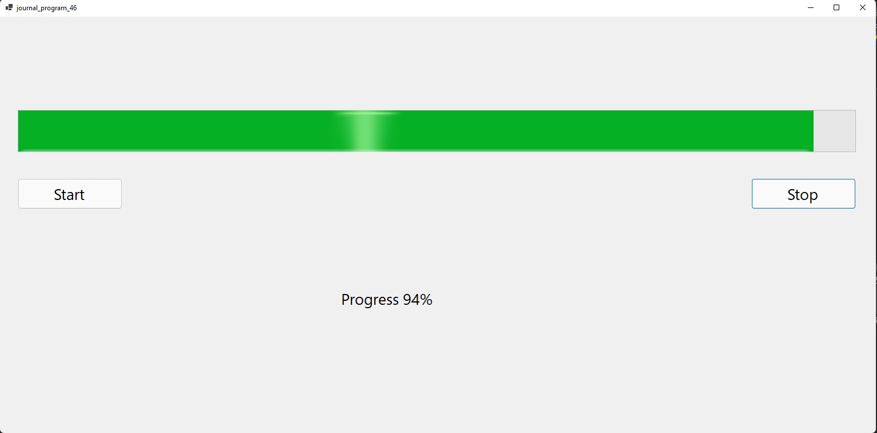

**47) TreeView Demo and List view Demo using TabControl.**

**Code:**

**Public Class Form1**

**Private Sub Button1_Click(sender As Object, e As EventArgs) Handles Button1.Click**

**ListView1.View = View.Details**

**ListView1.Columns.Add("Director", 40, HorizontalAlignment.Left)**

**ListView1.Columns.Add("Movies", 40, HorizontalAlignment.Left)**

**ListView1.Columns.Add("Reviews", 40, HorizontalAlignment.Left)**

**ListView1.Items.Add("Sanjay Leela")**

**ListView1.Items.Add("Yash Chopra")**

**ListView1.Items.Add("Rakesh")**

**ListView1.Items(0).SubItems.Add("Padmavat")**

**ListView1.Items(0).SubItems.Add("Great")**

**ListView1.Items(1).SubItems.Add("Lamhe")**

**ListView1.Items(1).SubItems.Add("Good")**

**ListView1.Items(2).SubItems.Add("Krish")**

**ListView1.Items(2).SubItems.Add("Awesome")**

**Dim node As New TreeNode**

**node = TreeView1.Nodes.Item(1)**

**MsgBox(node.Text)**

**End Sub**

**End Class**

**Output:**

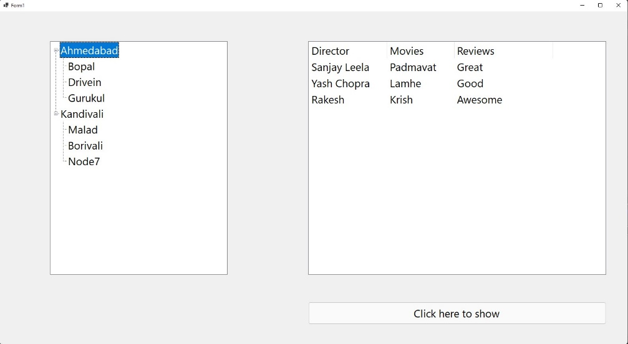

**48) Database store in the list box and combobox (Using Entity class and Database Class and also use with array and ArrayList) & use MastTextBox in date of join.**

**Code:**

**Public Class Form1**

**Public Class EmployeeEntity**

**Public eid As Integer**

**Public ename As String**

**Public edoj As New DateTime**

**End Class**

**Private Sub BtnSave_Click(sender As Object, e As EventArgs) Handles BtnSave.Click**

**Dim obj As New EmployeeEntity**

**obj.eid = TxtId.Text**

**obj.ename = TxtName.Text**

**obj.edoj = Convert.ToDateTime(TxtDoj.Text)**

**ListBox1.Items.Add(obj.eid & "---" & obj.ename & "---" & obj.edoj)**

**TxtId.Clear()**

**TxtName.Clear()**

**TxtDoj.Clear()**

**End Sub**

**Private Sub BtnDisplay_Click(sender As Object, e As EventArgs) Handles BtnDisplay.Click**

**ComboBox1.Items.Add(ListBox1.Items(0))**

**ComboBox1.Items.Add(ListBox1.Items(1))**

**ComboBox1.Items.Add(ListBox1.Items(2))**

**ComboBox1.Items.Add(ListBox1.Items(3))**

**ComboBox1.Items.Add(ListBox1.Items(4))**

**End Sub**

**End Class**

**Output:**

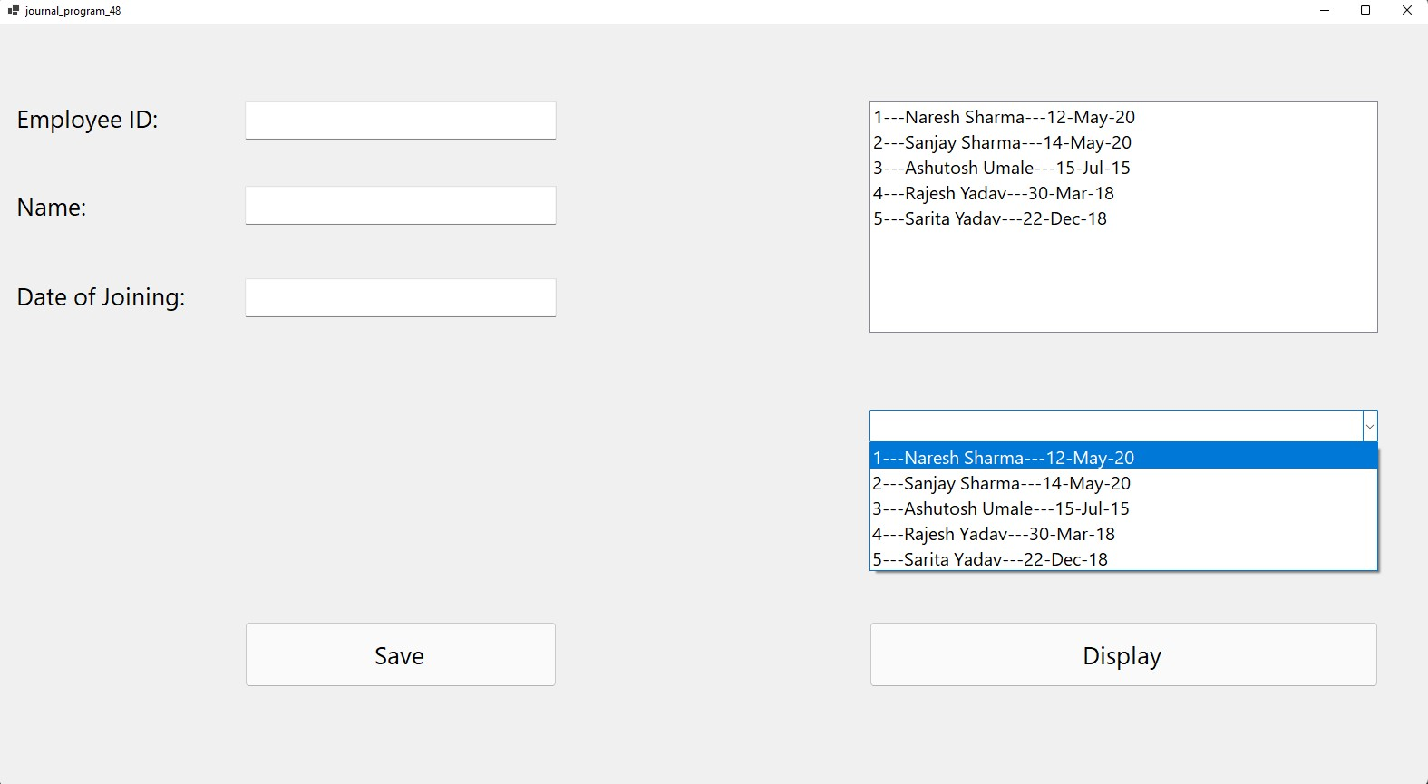

**49) Birth Day Remainder Demo with insert, update and delete connectivity operation with ms access (With Connected Architecture).**

**Code:**

**Imports System.Data.OleDb**

**Public Class Form1**

**Dim cn As OleDbConnection**

**Dim cmd As OleDbCommand**

**Dim da As OleDbDataAdapter**

**Dim dt As DataTable**

**Dim ds As DataSet**

**Private Sub Form1_Load(sender As Object, e As EventArgs) Handles MyBase.Load**

**cn = New OleDbConnection("Provider=Microsoft.ACE.OLEDB.12.0;Data Source=V:\SEM-4\vb.net\Exam\Student.accdb")**

**cn.Open()**

**MsgBox("Connection Done...!")**

**cn.Close()**

**End Sub**

**Private Sub BtnInsert_Click(sender As Object, e As EventArgs) Handles BtnInsert.Click**

**Try**

**cmd = New OleDbCommand("insert into stud values(" & TxtId.Text & ",'" & TxtName.Text & "','" & TxtCity.Text & "','" & TxtCourse.Text & "','" & DateTimePicker1.Value & "','" & TxtAddress.Text & "')", cn)**

**cn.Open()**

**cmd.ExecuteNonQuery()**

**cn.Close()**

**MsgBox("Record Insert ...!")**

**Catch ex As Exception**

**MsgBox("Record Not insert...!")**

**End Try**

**End Sub**

**Private Sub BtnUpdate_Click(sender As Object, e As EventArgs) Handles BtnUpdate.Click**

**Try**

**cmd = New OleDbCommand("update stud set Name='" & TxtName.Text & "',City='" & TxtCity.Text & "',Course='" & TxtCourse.Text & "',DOB='" & DateTimePicker1.Value & "',Address='" & TxtAddress.Text & "' where ID=" & TxtId.Text & "", cn)**

**cn.Open()**

**cmd.ExecuteNonQuery()**

**cn.Close()**

**MsgBox("Record Update...!")**

**Catch ex As Exception**

**MsgBox("Record Not update...!")**

**End Try**

**End Sub**

**Private Sub BtnDelete_Click(sender As Object, e As EventArgs) Handles BtnDelete.Click**

**Try**

**cmd = New OleDbCommand("delete from stud where ID=" & TxtId.Text & "", cn)**

**cn.Open()**

**cmd.ExecuteNonQuery()**

**cn.Close()**

**MsgBox("Record Delete...!")**

**Catch ex As Exception**

**MsgBox("Record Not Delete...!")**

**End Try**

**End Sub**

**Private Sub BtnSearch_Click(sender As Object, e As EventArgs) Handles BtnSearch.Click**

**Try**

**da = New OleDbDataAdapter**

**dt = New DataTable**

**cmd = New OleDbCommand("select*from stud where id=(" & TxtId.Text & ")", cn)**

**cn.Open()**

**da.SelectCommand = cmd**

**da.Fill(dt)**

**cn.Close()**

**TxtId.Text = dt.Rows(0).Item(0)**

**TxtName.Text = dt.Rows(0).Item(1)**

**TxtCity.Text = dt.Rows(0).Item(2)**

**TxtCourse.Text = dt.Rows(0).Item(3)**

**DateTimePicker1.Value = dt.Rows(0).Item(4)**

**TxtAddress.Text = dt.Rows(0).Item(5)**

**MsgBox("Record Found.....!")**

**Catch ex As Exception**

**MsgBox("Record Not Found...!")**

**End Try**

**End Sub**

**Private Sub BtnDisplay_Click(sender As Object, e As EventArgs) Handles BtnDisplay.Click**

**ds = New DataSet**

**Dim tables As DataTableCollection**

**tables = ds.Tables**

**da = New OleDbDataAdapter("select * from stud where Course='BCA'", cn)**

**da.Fill(ds, "stud")**

**Dim view As New DataView(tables(0))**

**DataGridView1.DataSource = view**

**End Sub**

**Private Sub BtnExit_Click(sender As Object, e As EventArgs) Handles BtnExit.Click**

**Me.Close()**

**End Sub**

**Private Sub Button1_Click(sender As Object, e As EventArgs) Handles BtnClere.Click**

**TxtId.Clear()**

**TxtAddress.Clear()**

**TxtCity.Clear()**

**TxtName.Clear()**

**TxtCourse.Clear()**

**End Sub**

**End Class**

**Output:**

**50)Create a vb.net application to maintain item information.**

**Item_mst(itemNo,Name,Cost, Quantity)**

**Design proper from which search for particular item if it is found accept new cost and quantity otherwise insert new record in the table also generate report of out of stock items name in datagridview.**

**Code:**

**Imports System.Data.OleDb**

**Public Class Form1**

**Dim cn As OleDbConnection**

**Dim cmd As OleDbCommand**

**Dim da As OleDbDataAdapter**

**Dim dt As DataTable**

**Dim ds As DataSet**

**Private Sub Form1_Load(sender As Object, e As EventArgs) Handles MyBase.Load**

**cn = New OleDbConnection("Provider=Microsoft.ACE.OLEDB.12.0;Data Source=D:\SEM-4\.Net programing\journal50\Stock.accdb")**

**cn.Open()**

**MsgBox("Connection Done...!")**

**cn.Close()**

**End Sub**

**Private Sub BtnInsert_Click(sender As Object, e As EventArgs) Handles BtnInsert.Click**

**cmd = New OleDbCommand("insert into item_mst values(" & TxtItemNo.Text & ",'" & TxtName.Text & "'," & TxtCost.Text & "," & TxtQty.Text & ")", cn)**

**cn.Open()**

**cmd.ExecuteNonQuery()**

**cn.Close()**

**MsgBox("Record Insert...!")**

**End Sub**

**Private Sub BtnUpdate_Click(sender As Object, e As EventArgs) Handles BtnUpdate.Click**

**cmd = New OleDbCommand("update item_mst set Name='" & TxtName.Text & "',Cost=" & TxtCost.Text & ",Quantity=" & TxtQty.Text & " where ItemNo=" & TxtItemNo.Text & "", cn)**

**cn.Open()**

**cmd.ExecuteNonQuery()**

**cn.Close()**

**MsgBox("Record Update...!")**

**End Sub**

**Private Sub BtnSearch_Click(sender As Object, e As EventArgs) Handles BtnSearch.Click**

**Try**

**da = New OleDbDataAdapter**

**dt = New DataTable**

**cmd = New OleDbCommand("select*from item_mst where ItemNo=(" & TxtItemNo.Text & ")", cn)**

**cn.Open()**

**da.SelectCommand = cmd**

**da.Fill(dt)**

**cn.Close()**

**TxtItemNo.Text = dt.Rows(0).Item(0)**

**TxtName.Text = dt.Rows(0).Item(1)**

**TxtCost.Text = dt.Rows(0).Item(2)**

**TxtQty.Text = dt.Rows(0).Item(3)**

**MsgBox("Record Found...!")**

**Catch ex As Exception**

**MsgBox("Record not found new record inserted...!")**

**If TxtName.Text = "" & TxtCost.Text = "" Then**

**MsgBox("Plz Insert Record...!")**

**Else**

**cmd = New OleDbCommand("insert into item_mst values(" & TxtItemNo.Text & ",'" & TxtName.Text & "'," & TxtCost.Text & "," & TxtQty.Text & ")", cn)**

**cn.Open()**

**cmd.ExecuteNonQuery()**

**cn.Close()**

**MsgBox("Record Insert...!")**

**End If**

**End Try**

**End Sub**

**Private Sub BtnDispaly_Click(sender As Object, e As EventArgs) Handles BtnDispaly.Click**

**ds = New DataSet**

**Dim tables As DataTableCollection**

**tables = ds.Tables**

**da = New OleDbDataAdapter("select Name from item_mst where Quantity<=0", cn)**

**da.Fill(ds, "item_mst")**

**Dim view As New DataView(tables(0))**

**DataGridView1.DataSource = view**

**End Sub**

**Private Sub BtnClear_Click(sender As Object, e As EventArgs) Handles BtnClear.Click**

**TxtCost.Clear()**

**TxtItemNo.Clear()**

**TxtName.Clear()**

**TxtQty.Clear()**

**End Sub**

**Private Sub BtnExit_Click(sender As Object, e As EventArgs) Handles BtnExit.Click**

**Me.Close()**

**End Sub**

**End Class**

**Output:**