**Introduction of Computer Science Homework #1**

**D0888011 陳為安**



背景來源: https://www.pixiv.net/artworks/76553314

* **邏輯說明**
  + **K進位轉10進位**

**跑For迴圈，從最高位(左邊)讀到最低位**

**M的第1~N+1位的值 = (1~N位的值*K) + (第N+1位值)**

**e.g. (FA50)16**

**Sum0 = 0**

**Sum1 = Sum0 * 16 + 0xF = (15)10**

**Sum2 = Sum1 * 16 + 0xA = (250)10**

**Sum3 = Sum2 * 16 + 0x5 = (4005)10**

**Sum4 = Sum3 * 16 + 0x0 = (64080)10**

* **(FA50)16 = (64080)10**
  + **10進位轉K進位**

**輸入為(M0)10，用while迴圈不斷以K除之，直到MN等於零**

**令總共需除N次，第P次的餘RP就是從高位(左邊)數來第N-P+1位**

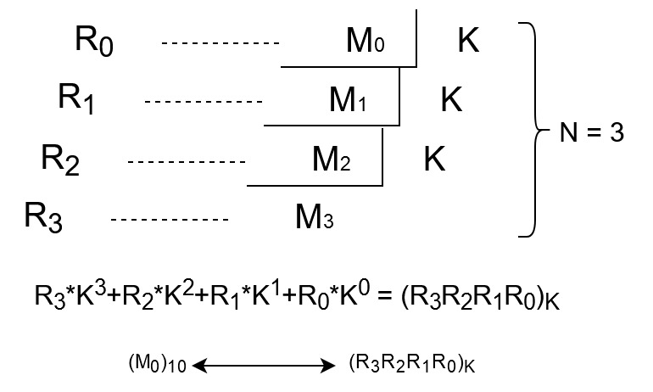**但除完的順序是從低位到高位，所以最後把前半字串跟後半字串對調**