GitHub Pages
HTML Verification:
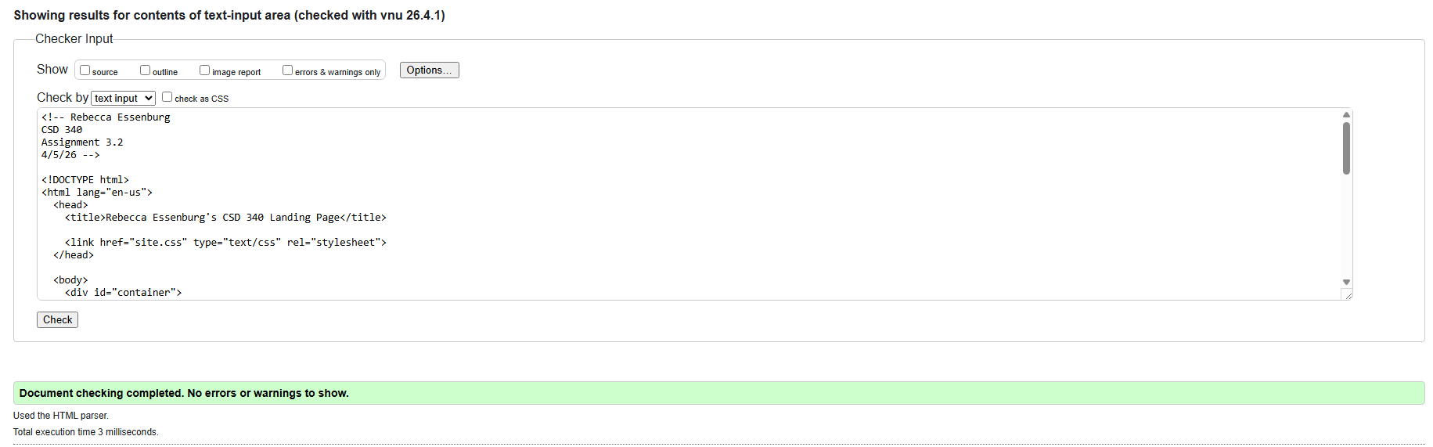

CSS Verification:
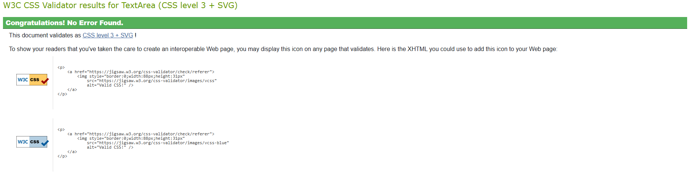

Finished Landing Page:
