bioSite: Ideas, Sketches, and Inspiration
Interview Questions & Responses:
- What is your earliest (or favorite) childhood memory?
“I stayed a lot with my grandma Cora and Grandpa Ed as a child. I never wanted to leave, I would hide behind their recliners so my parents couldn’t take me back home. Grandpa was one of my favorite people on the planet, most of my good childhood memories come from him just doing his chores, cleaning the church, mowing the lawn, working in the garage or the garden, and him letting me tag along with him.”
- What was your relationship with your parents like growing up?
“ My mother is the most fantastic woman I have ever met, and it is an honor and a privilege to be her daughter. She has had five kids spanning three generations, taken care of all of us, kept food on the table, made us good people, and supported us the best she could with what she had. When I was in high school, she pawned off her jewelry to send me on an art field trip. I didn’t even tell her I wanted to go, I didn’t show her the permission slip, my art teacher called her to say she thought it would be good for me, and mom gave me the money.
My mom worked two jobs for a big chunk of my childhood, working five in the morning in a factory, and then went to work at Walmart until sometimes eleven at night. She was a super woman, and my favorite person. I remember the whole 2012 world ending thing and going to work with her because I was so scared and all I wanted was to be close to her, in what I feared would be my final moments I just wanted my mom. She always took my anxieties like a champ, and trust me there were a lot.
To me, my mom is the definition of bad things happen to good people, because she is the best human, will give you all her time and the shirt off her back, and my dad is almost the worst. I only say almost because at least he didn’t kill any of us, though not through a lack of trying. My father only loved us when it made him look good, and beat us when he felt bad. It’s weird having survivor's guilt when everyone is still alive, but I feel awful that my siblings got the worst of him. By the time I was born, my oldest sister was seventeen and leaving for college and my brother was getting to be big enough to fight back, and dad was thirty eight. I still remember being hit, thrown, and slapped, but most of the abuse I was dealt was emotional. As a child I have a clear memory of being terrified to leave my bedroom and telling my sister I was worried he was hiding behind the door with a knife ready to kill me.
I thought families fought when I was a kid, I thought all dads beat their wife and kids. I would come home from elementary school, try to walk in the house and I’d be told to wait on the porch while he screamed at mom for whatever he was mad about that day. I can only recall him going to jail once when I was young, and despite being younger than ten I had to give my mom any birthday and Christmas money I had to pay for my dads medicines, and had to take them to the jail. I don't think he was there for more than forty eight hours. When I was eighteen, he started getting violent with mom again. It got so bad I called the cops, they took twenty five minutes to get there, but thankfully his ego wouldn’t let him leave until he felt he had done enough damage, allowing the cops to arrive just as he left the driveway. He was arrested down the road and served a whole whopping three days in jail, but divorce started and restraining orders were issued.”
- What are some important traditions for you/your family?
“ We do a saran wrap ball for Christmas every year. The factory mom used to work at had giant rolls of food grade saran wrap to test the machines they built. She gets little doodads and things throughout the year like lighters, gift cards, chapstick, jerky, etc and wraps it in layers and layers of saran wrap until the ball is around ten inches in diameter. We roll dice and pass the ball around, messing with each other until the big gift card in the center is unwrapped. I’m writing it tame, it is chaos. We five siblings, some of our spouses, and now my three oldest nieces and nephew join but, if we’re honest, they’re still really timid and kinda scared. Ever been pelted by mini balls of saran wrap while trying to roll doubles and the person next to you is yelling “Why are there so many small pieces?” and someone else is yelling “No ripping! Ripping is against the rules!” and the person on the other side is waiting to rip the dice away as soon as you get said doubles? You should. My tip: throw the dice once you get the doubles.”
- Where have you lived? Which was your favorite place to live and why?
“ I grew up in Ohio, then I moved to Kentucky when I was around nineteen. After five years, I moved back to Ohio and stayed there for a little less than a year before moving to Michigan where I just passed my four year Michigander anniversary. Michigan has so far won the best place to live award with the amazing diversity, food, sports, and I’m not thirty minutes away from the nearest grocery store anymore, but little middle of nowhere Ohio will always be home.“

- What is your work history and where do you currently work?
“ I have worked so many places. Technically my first job was at a haunted house when I was in highschool. I did special effects makeup as a fun hobby back in the day, and loved screaming super loud so it was pretty fun while I could maintain it. I would go after marching band competitions some nights and it was rough. I didn’t last very long. My first real job was at a deli in an IGA when I moved to Kentucky, I lasted three days because I was left alone on my first day after getting the most bare bones training, and then the owner screamed at me over them running out of chicken. I cried and I called them the next day to inform them I was not going to be in for my shift or ever again. Then I worked at the nursing home, too much death. I cleaned the bank at the same time, the company was weird and sketchy and they lost my social security number and ID. I worked at subway, fun fact you can toast your veggies on your sandwich and if you like peppers and onions I super recommend everyone give that a try. I packed car parts for Dormans, made hemp oil, and worked at a different car part distributor during covid times before leaving for Ohio where I worked in childcare. In Michigan I have worked at Lowes, then back to childcare before I pursued my dream of being a piercer. I left that job after the owner allowed his manager to assault someone. I am in an incredibly amazing position now that my boyfriend makes enough to support us and I don’t currently need a job, so I am in my house wife era cooking, cleaning, and managing the home the best I can until I get my drivers license and go find a new shop to pierce at.”

- What has been your favorite job and why?
“ Piercing is truly a calling I think for me. I am grateful that I got to enter my dream career and learn all that I have learned. Getting to help people express themselves, and having people tell me that I was helpful and made a scary experience better just means the world to me. I don’t often have confidence in anything I do, but I am a damn good piercer and it’s what I am meant to do. “

- What are your hobbies?
“ I love baking and cooking. Feeding people is definitely one of my favorite things. Everyone loves food. I read. Not as much as I should for someone who puts “I read” as a hobby, but I do and I am working more on reading instead of reading for my phone. My boyfriend said to put that I’m a gamer, so uh I’m a gamer.”
- What are your goals/aspirations for the future?
“ I will get my drivers license. I will get back to piercing. Maybe I will find a random human that loves my energy and friendship and has just way too much money so they invest in me opening a shop for piercings and perhaps tattoos. That’s called manifestation, baby.”

- What have been your biggest achievements?
“ I’m funny. I got to do my dream job. I have a fat ass.”

- Is there anything else you would like to share about yourself?
“ My name is Rebecca and it’s nice to meet you, even if it is one sided. I’m twenty nine and from a small town so small it’s considered a village. I can play clarinet, and I have dabbled in piano, percussion, bass, guitar, and ukulele. I also marched color guard for two years, which isn’t super relevant, but it’s a thing I did. I love animals so much, over my life I’ve had sheep, rabbits, fish, dogs, and cats. I adore horror movies, but I can’t watch an animal get hurt in a movie, doesthedogdie.com is favorite of mine for checking. Currently, I just have my one cat named Bean after losing my other cat Oreo just a few weeks ago. I think that loving people is free and that love is an infinite resource. Tell your friends you love them, no it’s not weird. Sometimes all anyone needs is a hug and reminded that someone cares. I have been obsessed with Nic Cage for years. I’m an Aries sun, Pisces moon, Libra rising which means things to some people. I wish I was one of those people sometimes.”

Photos:
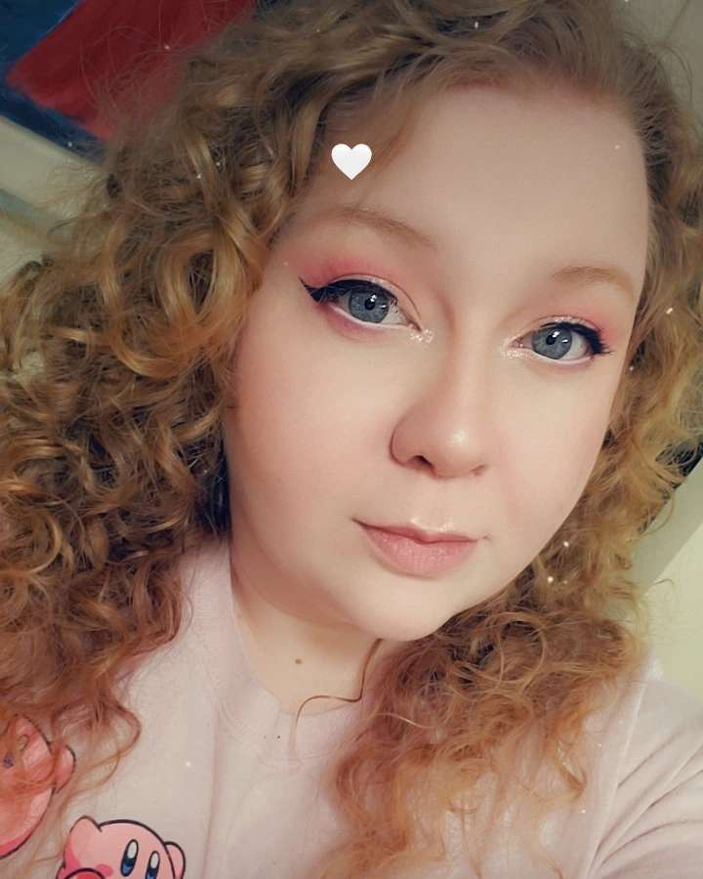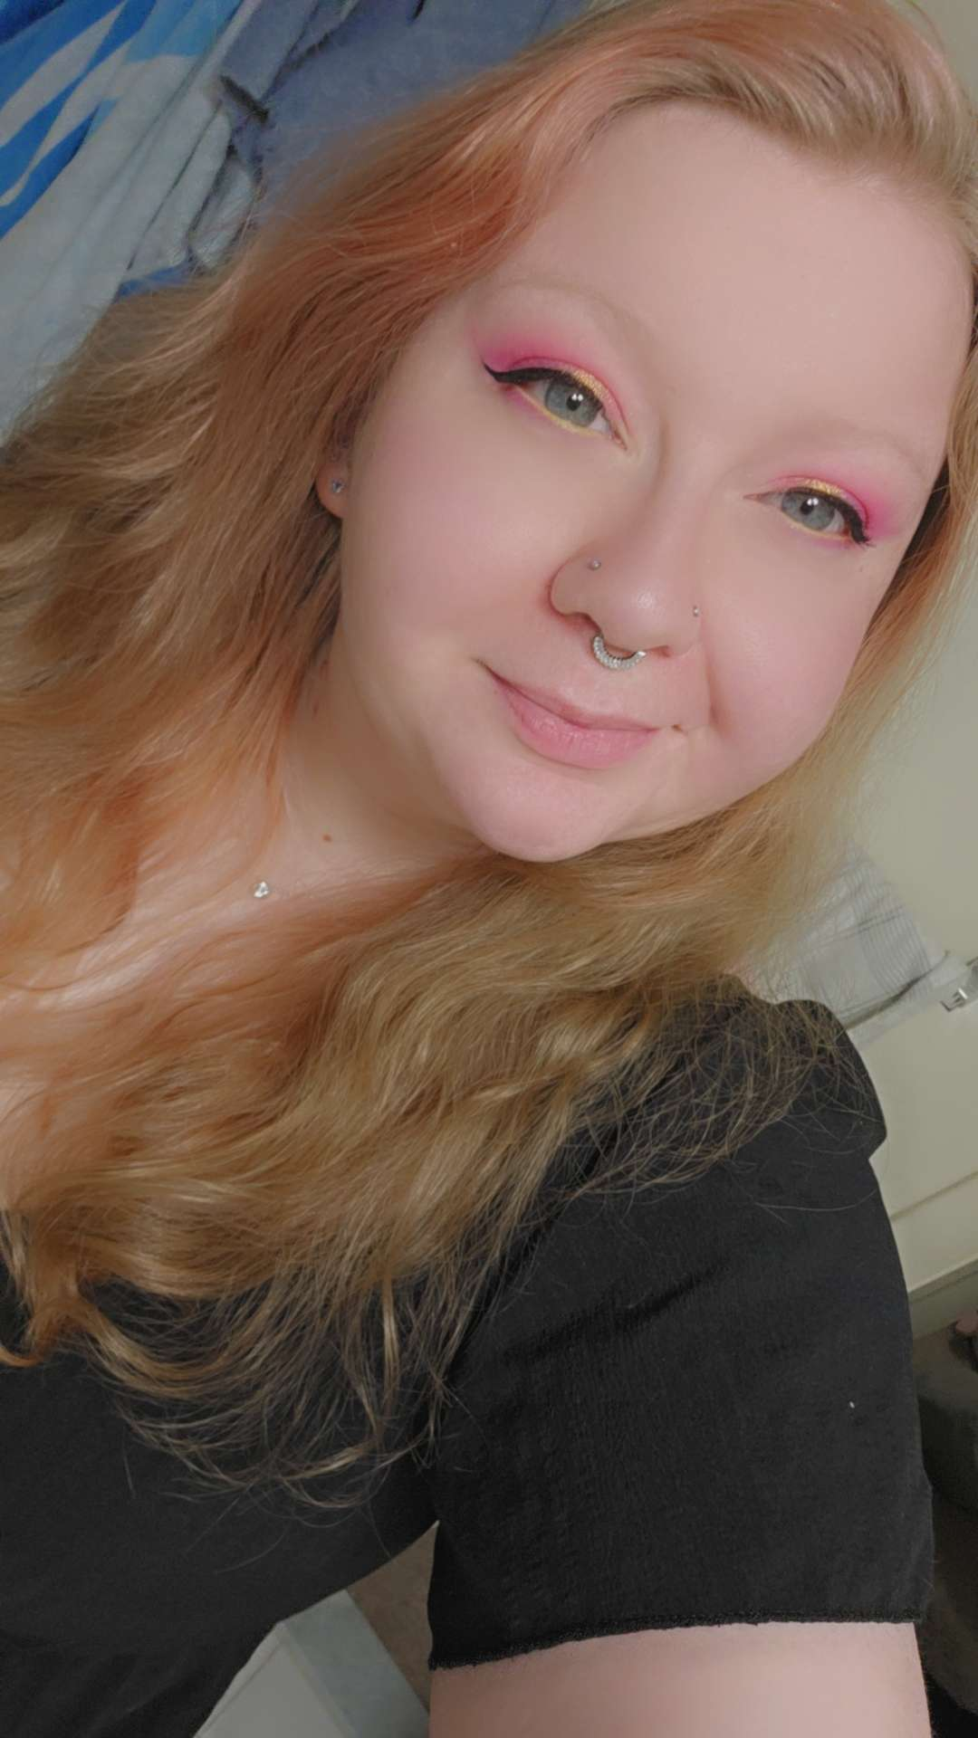
Portraits

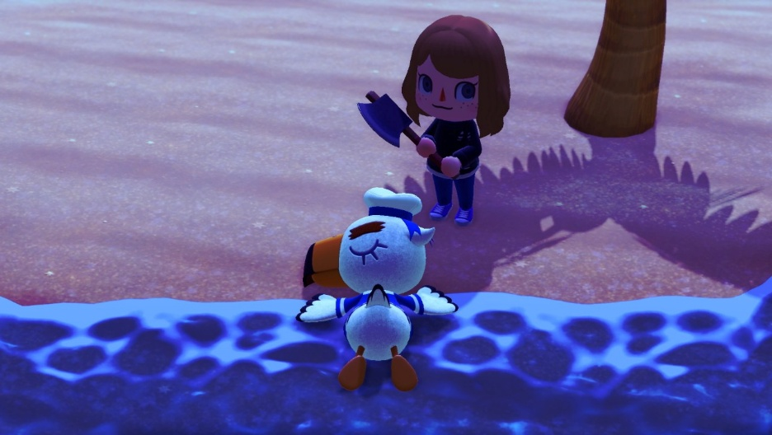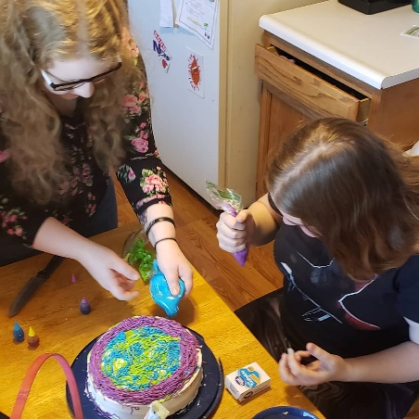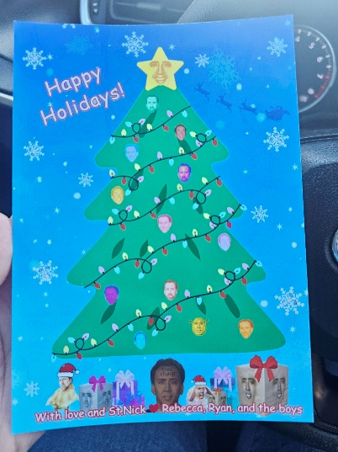
Hobbies
(Gaming, Baking, Nic Cage – yes that is a Christmas Card she made)

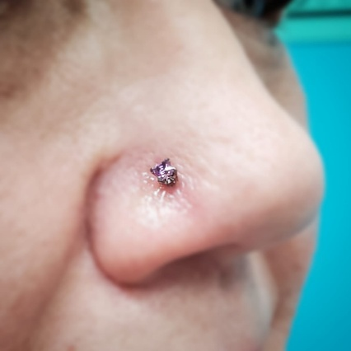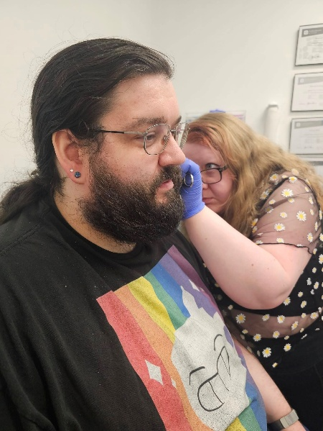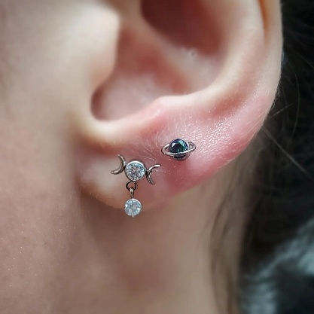
Goals
(Getting back to piercing!)

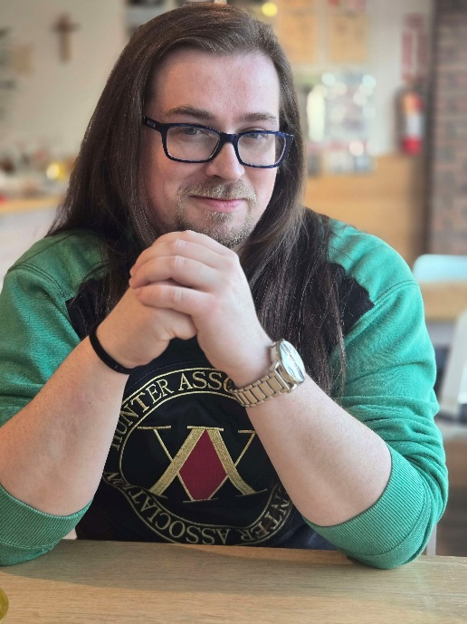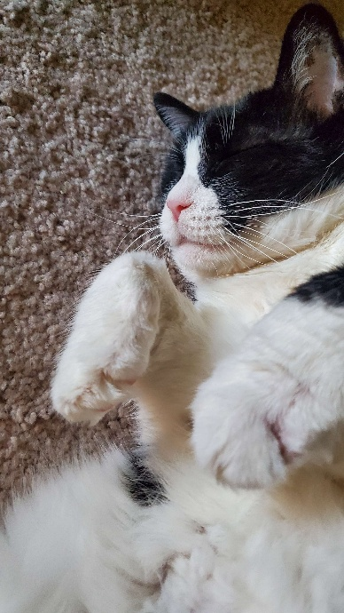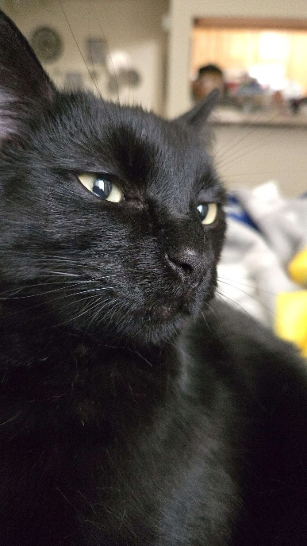
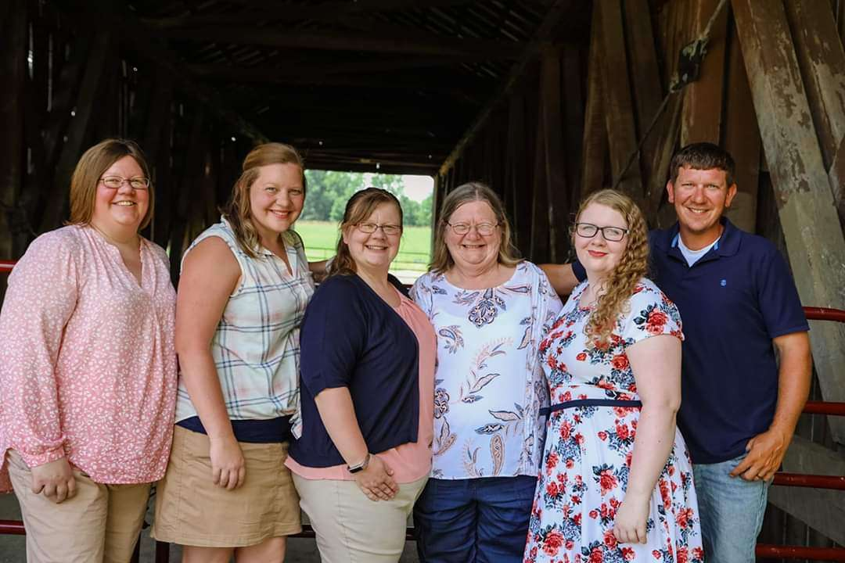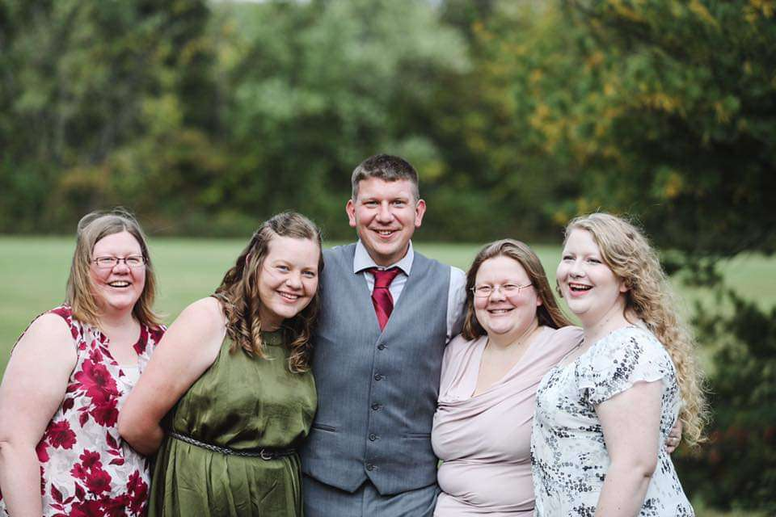
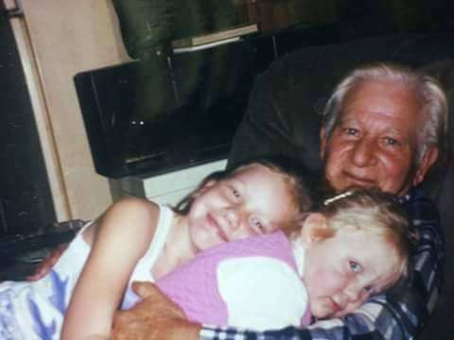
Additional Photos
(Boyfriend Ryan, two kitties)
(Family Pictures – Siblings, mom, and Grandpa)
Formal Biography:

