GitHub Repository Setup
Link to Repository:
https://github.com/mikuraver/csd-340.git

Screenshot of Repository:
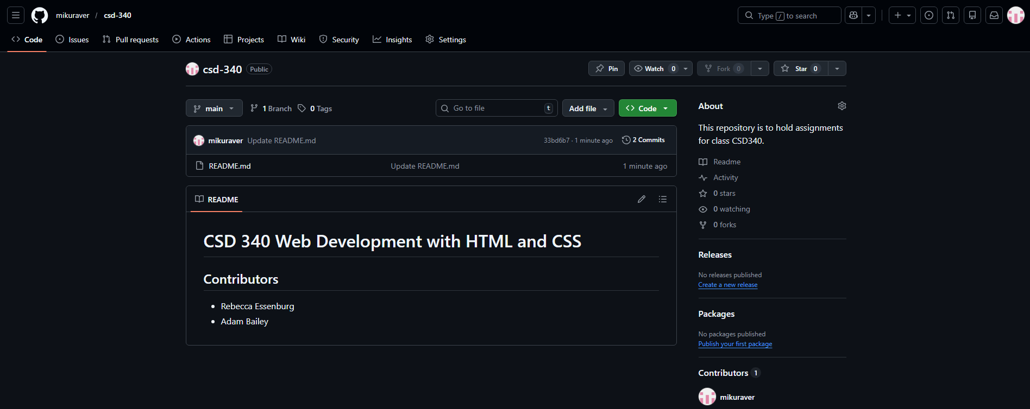

Screenshot of Local Directory:
