Java & Java FX Installation
Proof of Java Install:
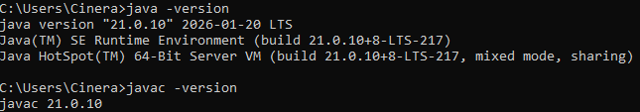

Proof of Java FX Install:
I’ll be honest, I spent over 12 hours this week trying to figure out how to get Java FX to function. I could not get it to work with VS Code or NetBeans. I tried JDK 10 and JDK 21, I tried setting up a project through Maven, through Gradle, and somehow always ran into a different error every time. I was unable to figure it out by the assignment deadline. Please let me know if I missed an obvious tutorial somewhere, or if I am using the incorrect version of something. All my attempts were with the latest version of JavaFX (26). I will continue to research but may also be reaching out for assistance.

