Characters

Sophie Hatter
Sophie is a young witch, in love with Howl and friend of all of the castle guests. Genuinely cheerful and positive, she is able to exert an innate influence on those around her. Sophie, decidedly wise for her age, seems to positively influence the fate of the difficulties she has to face, and of those she meets. As soon as the scope of the danger is understood, she manages to keep control of the situation and to meet her fate, keeping high the morale of the group, that loves her very much in return. In Sophie the calm meekness of an elderly lady and the vital energy of a young girl coexist, to which the sure pride of a sorceress will be added soon.
© 2004 Studio Ghibli
Sophie has recently discovered her magical potential, so the girl dedicates herself for to the first experimentation of the magical arts a period, with howl and Suliman as masters and Calcifer and Markl as allies. It is immediately evident how confident she is with the magic world, so, once learned how to control it, she brilliantly overcomes a first training. Meanwhile, her relationship with Howl is strengthened, and their life as a couple proceeds happily, except for some hitch linked to Howl’s childish character.

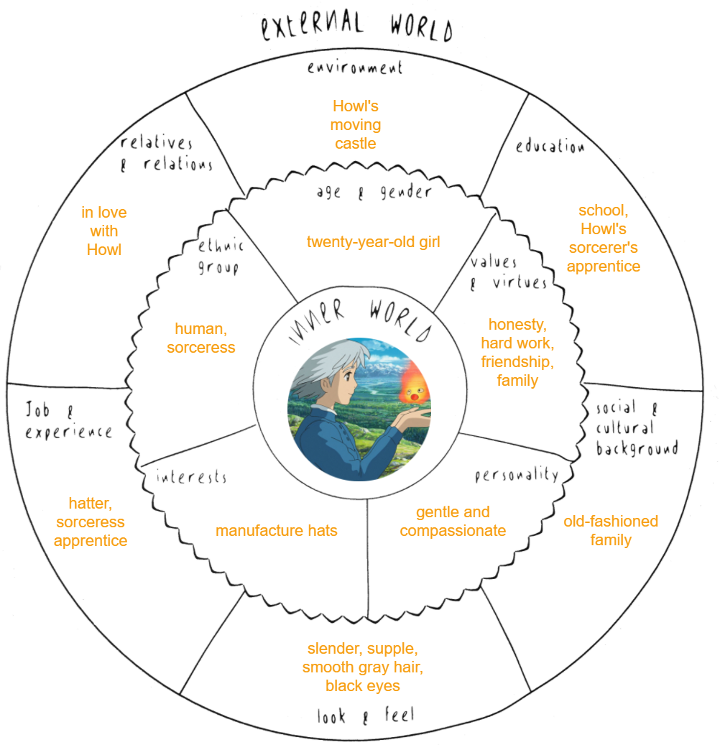Picture 1: Sophie’s circumplex

Howl
Howl is a powerful wizard, he is in love with Sophie and is the owner of the moving castle. He can rely on the support of his friend, the fire demon Calcifer, and the young apprentice Markl. He is very vain, he dyes his hair and pays great attention to how he dresses. When he’s depressed he evokes the spirits of desperation, evil demons that emanate rivers of green slime able to break down and to control the feeble souls. Howl, although he’s extremely good, still is childish and narcissistic, and despite of the great security he flaunts, intervening whenever essential, he has a tendency toward depression and a deep fear of failure. This aspects of his character make him tended to paranoid thoughts and to an evasive behavior, in particular with the authoritarian figures like his teacher Suliman, that persists even after finding more emotional stability thanks to Sophie. His new relationship is a big change for his rigidity, and it has a powerful influence on him. He immediately recognizes his own desperation’s green slime on Layton’s monsters coming to Ingary.
© 2004 Studio Ghibli
Howl recalls that time when his apprentice mate (Layton) tried to steal Calcifer from him while they were still studying at Suliman’s. Layton decided to make him fall in love by transforming himself in a woman (Carla), in this way he would have get to know his weaknesses. However once he entered the house and revealed himself, he was quickly defeated by the demon whose power he had underestimated. At the time, Howl despaired so much for the sincere infatuation that he evoked a myriad of spirits. Impulsive and vindictive as just an adolescent can be, he locked them all in a small urn, damning Layton to the same faith.

Orphan child
The orphan child is extremely cheerful and lively, but at the same time almost dumb and without memory. He follows Ben everywhere he goes, sometimes even without his permission. Aesthetically remembers Howl, but it is very dirty, and his eyes and hair are brown (they were colored with magic).
© 2004 Akira Amano
After freeing King Beuron in the capital of Radme, Howl (still adult) proceeds to Layton’s fortress. But Layton is waiting for him in the swamp, where after a long battle he uses a powerful spell to extract from Howl a liquid that he calls experience. After that Howl, transformed into a child, is thrown into the river, where Layton believes he is drowning. Instead he survived dragged by the current to Cal, where Ben will rescue him from the water.

Layton
Egocentric and maniacal, Layton has developed a symbiotic bond with the slime of the spirits that Howl produces, which allows him to control them, spreading despair on everything that crosses his path. He intends to take revenge on Howl, for the humiliation of being defeated and for the cruel way he was punished, and on Suliman, for preferring Howl om him despite his power was certainly hiding a misconduct or a big fortune.
© 2002 Masashi Kishimoto
Layton, in fact, was Suliman’s apprentice, and he had great admiration for her. He cared a lot about her opinion about him, and the arrival of Howl and his rapid progress in the magical arts did not bother him because of his advanced experience. When Howl suddenly reached his abilities, he decided to investigate moved by envy. He learned about the existence of Calcifer and tried to steal it pretending to be a charming girl. Howl was so deeply infatuated with the image created by the magician that he released umpteen demons of despair once the deception was revealed. Defeated Layton, Howl secretly exiled him in a small magical urn, filling it for further punishment with the powerful evoked spirits. During this imprisonment, however, Layton has learned how to control the spirits becoming powerful beyond all expectations.

Madame Suliman
Suliman is the sorceress of the king of Ingary, and as such is reputed to be the greatest sorceress of the kingdom. She was the teacher of Howl, for whom she is constantly apprehensive and whose behavior can not explain. Despite his powers she can not move, and gets tired easily. This leads her to play a marginal role in the action, but through Heen she is constantly in contact with the group, and controls a small network of emissaries on Radme.
© 2004 Studio Ghibli
She does not know that Layton has merged with the spirits of despair after having fought with Howl and must accept his disappearance. She searched the parts of Heen for a long time to reassemble the body of Ingary's best soldier. So is aware of several places where parts of Heen may have been spotted, even in Radme.

Calcifer
Calcifer is a young and powerful fire demon, freed by the magical power of Sophie. Now it is extremely autonomous and can move on its liking. He is able to amplify the magical power of mages with whom it has a deep bond. He often moves inside an exoskeleton, such as an enchanted armor made with the help of Suliman, which allows him to disguise himself among the people. It is capricious and easily complains, but it is also very determined, and has a profound knowledge of all that is magical.
© 2004 Studio Ghibli
Calcifer recognized Layton’s intentions as soon as he saw him enter the castle, while Howl was deceived by the transformation into Carla. After defeating him with Howl he was deeply concerned by the mixture of wizard and spirit that Howl had created, and suggested to hide the whole thing. So Howl hid him in a remote land.
Since he was freed from the contract, Calcifer is even more tied to his friends, and hardly spends a day away from them. Since the castle has expanded, he travels to the most exotic places.

Heen
He is the most faithful servant of Suliman. Known by everyone in the form of a dog, he has obtained the ability to return to his state of huge human, even if incomplete and similar to a golem. His will is all about serving Suliman and Sophie who have a great influence on him. However, while traveling with the group, he pays attention to the eventual discovery of one of his parts, which leads him to a better state of consciousness and health.
© 2004 Studio Ghibli
Heen is actually the greatest warrior of Ingary, who years ago was cursed by the Witch of the Waste, and teared apart in different parts. Although Heen remains the most important part of the body, his other parts have been sold or lost by the Witch over the years. Suliman has been rowing for years to reassemble him but she is too sick for a mission like that and had little success.

King Beuron
Beuron is the King of Radme, his castle is on the main hill of Cal. Beuron’s mind was one of the first to be controlled by the slime in the capital, this led him to age prematurely and to mature a discreet paranoia. He is still a skilled strategist, completely devoted to Howl, who saved him as soon as he arrived in Cal. Helps a lot Sophie and her companions, he has in fact gathered a resistance out of the city, where refugees are heading from all over Radme
© 1997 Eiichiro Oda
Beuron is known as the best Radme King of the last centuries. It allowed the continent to develop quickly, which soon led to compete with Ingary. The sudden death due to illness of his two sons leads him to depression, and Layton easily makes him fall under his clutches.

Ben
Faithful guard of King Beuron, expert in many techniques of combat and infiltration, he honorably accepts the task at the forefront of Cal, where he has the opportunity to study the phenomenon of the slime and to save several people. Among these there is a small child who soon catches his attention because of the great magical power that he emanates. When he is in the condition to do so, he leads a revolt to drive away the spirits from Cal.
© 2009 Isayama Hajime
Trained by the best masters of Radme at the behest of the King himself, who saw his potential, Ben always proved to be virtuous and honest, helping the weak with great modesty.

Markl
Markl grew quickly, in a few months he gained several centimeters and became a good level apprentice. Motivated by the presence of Sophie, Markl has made a lot of progresses, and now controls a discreet power. Nevertheless, he continues to show a certain insecurity, and he asks for help with his own spells.
© 2004 Studio Ghibli

Witch of the Waste
She’s apparently a completely harmless old woman. She has a great experience with magic but his brain is too old to be able to use her knowledge in a functional way. On many occasions her intervention adds an element of randomness to the situation, as she is very naive and curious. Suliman gave her a magic stick, which allows her to keep up with the team
© 2004 Studio Ghibli
She does not remember where she lost or who bought the parts of Heen, but often a small incentive is enough to start recalling. Helps the group as an odd counselor.
The most powerful and arcane spell that the witch has ever performed allowed her to form a puzzle with parts of Ingary’s most powerful warrior (Heen), obtaining a prodigious object from each. Unfortunately, over the years she has lost or sold them all.

