
ProcessName

Version 1.0

PDD
Contents
Purpose of Document 2
Risk Assessment 2
Success Criteria 2
Project Stakeholders Mapping 2
Automation Pre-requisites 3
Process Overview 3
Software Preparation 4
As Is Process Map and Program Logic 5
To Be Process Map and Program Logic 6
Process workflow Description 6
<Step Number>-<Step Name> 6
<Screenshot> 6
<Description> 6
<Step Number>-<Step Name> 6
<Screenshot> 6
<Description> 6
Exception Scenario 6
Process Reporting 6
PDD Signoff 6
Additional sources of process documentation 7

Purpose of Document
The Process Definition Document outlines the business process chosen for automation and it’s the living document which should be updated with every approved change request. The document describes the sequence of actions performed as part of the business process, the conditions and rules of the process prior to automation (AS IS) as well as the new sequence of actions that the process will follow as a result of preparation for automation (TO BE).
The PDD is a communication document between:
- The RPA Business Analyst and the Development team (represented by the Solution Architect and RPA Development Lead). The goal is to ensure that the process is documented appropriately and to a sufficient level of detail so that the Solution Architect can then create the solution based on the PDD content. Only described version of the process will be automated, every change in it should be reflected in this file and approved by stakeholders.

Date | Short Description | Version | Approval
23.10.2024 | Initial document created | 1.0 | Mikolaj Zielinski

Risk Assessment
The business team together with the assigned project Business Analyst from the RPA team did not identify any process-specific risks which would have to be taken into consideration.

Success Criteria
The business objectives and benefits expected by the Business Process Owner after automation of the selected business process are:
- Reduce processing time per item by 80%.
- Reduce the number of errors in process.
- Better Monitoring of the overall activity by using the logs provided by the robots.

Project Stakeholders Mapping
Role | Name | Contact Details | Deputy
Process Owner
Application Owner
Project Sponsor
SME
Business Analyst
Project Manager
Solution Architect
RPA Developer

Automation Pre-requisites
- SME Availability: Secure access to Subject Matter Experts (SMEs) who can provide in-depth knowledge of the process.
- Test Data: Prepare and make available representative test data for development and testing phases.
- System Accesses: Arrange necessary system accesses and permissions for RPA development and execution.
- Access to [client] network(VPN Setup)
- Exception Handling Procedures: Define procedures for handling exceptions and errors that may occur during automation. (BCP)

Process Overview
Item | Description/Answer
Process Full Name
Process Area Affected
Department Affected
Short Description
Process schedule and frequency
The number of times the process is executed based on the selected frequency.
Process manual execution time (1 item) min.
Peak Period
Peak Volume Approximate increase
Number of people performing the process
Input data description
Output data description

Software Preparation
ID | Application Name | Application Language | Access Req. (Roles) | Software Update Frequency | Authorization Method | Password Policy | Application Owner
1. | SAP | ENG | BW_ADMIN | Annually | SSO login | Monthly password update | John.Smith@example.com

As Is Process Map and Program Logic
(Expected exceptions marked by colour and assigned to Swimline+ID)
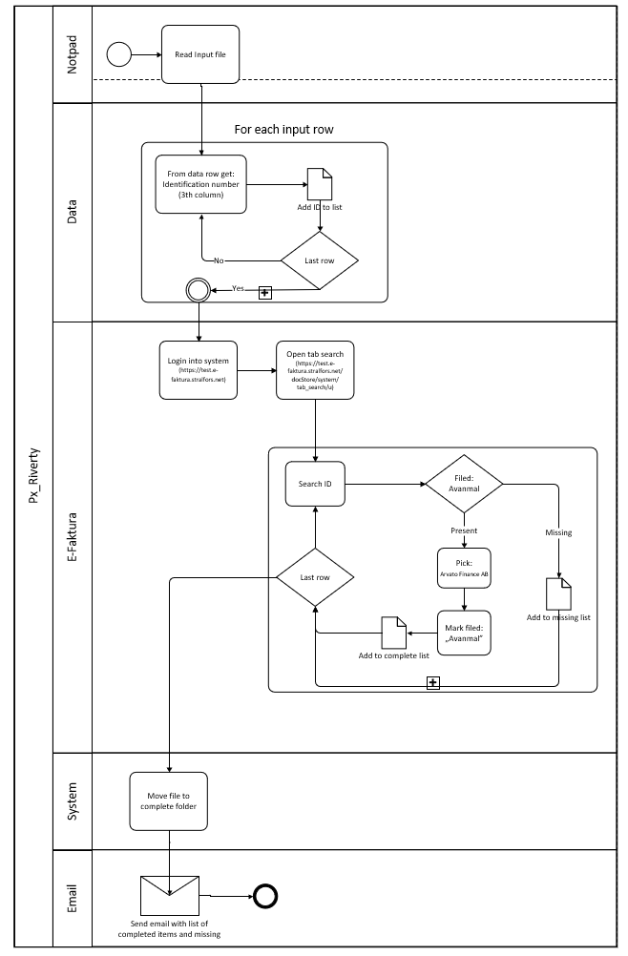
1.N1

To Be Process Map and Program Logic
(Expected exceptions marked by colour and assigned to Swimline+ID)
If process As Is the same as To Be leave section with:
The process was optimized, and the automation will follow the same process as in presented in AS IS section
If process was modified during working on PDD please present its new version here.

Process workflow Description

<Step Number>-<Step Name>

<Screenshot>

<Description>

<Step Number>-<Step Name>

<Screenshot>

<Description>

Exception Scenario
Exception ID | Name | Type  (BE/SE) | Description
1.N1 | Missing data | BE | If file is missing data, mark this transaction as “Manual Check Required”. Add this entry to final report and send it as registered BE

Process Reporting
In order to verify that robot is processing data as required Business will receive a report generated by robot after processing last item in defined time. The report contains 3 tabs:
- Success
- BE
- SE
Business Receiver | Frequency | Role
John.Smith@example.com | Weekly | Business Owner

PDD Signoff
Email | Role | Date | Approval
John.Smith@example.com | SME | 15.10.2024 | Approved

Additional sources of process documentation
Document name | Description | Localization
Process Assessment | Documents describe assessment potential of process. | Automation team SharePoint/RPA/[ProcessName]

