

SDD
ProcessName

Version 1.0
Contents
Introduction 2
Purpose of Document 2
Objectives 2
Process Key Contacts 2
Automated Master Project 2
Project Details 2
Process Metrics 2
Solution Details 3
Application Data 3
Credentials 3
Solution Design 3
Configuration Details 3
To be Process Map 4
Object Design Instructions 5
Workload Management 5
Exceptions 5
Queue Details 6
Data Storage 6
Project Dependencies 6
Reporting 6
Other Details 6
Future Improvements 6
Other Remarks 7
Post UAT Specifications 7
Glossary 7
Document History 8
Sign-Off 8

Introduction

Purpose of Document
The Solution Design Document (SDD) outlines the design of automation of the business process using UiPath Studio Robotic Process Automation (RPA) technology.
The SDD document should be reviewed and updated for every change requested and applied to the automation process. This document will provide a technical snapshot and must always reflect the latest design and key features of the automated workflow.

Objectives
The purpose of the SDD is to provide the RPA COE, IT Support and RPA supervisor with a snapshot of the automated process and components. It also may help developers with an overview of the process, prior to a detailed review of the code, to troubleshoot or update changes.

Process Key Contacts
As well as the RPA Developer and Solution architect, there also will be other key team members participating in the solution design.
Role | Full Name | Email | Approval | Date
Solution Architect |  |  |  | dd-MM-yyyy
RPA Developer
Business Analyst

Automated Master Project

Project Details
The following section provides an overview of the basic project details and assumptions.
# | Item | Details
1 | Master project name and version
2 | Robot type  (specify if process being automated is FOR, BOR or both)
3 | Is orchestration (Orchestrator, Control Room..) to be used?  (Yes / No)
4 | Scalable? (Yes / No)  (can the process be run by multiple robots in parallel)

Process Metrics
Overview of the key process metrics that will be used to assess and monitor the solution design requirements and development throughout the project lifecycle.
Number of Items per Day | Average Processing Time | Total Processing time per day | Number of machines require | SLA*
12 | 20 min | 4h | 1 | 24h
*Service Level Agreement for a particular item(i.e. payment needs to be processed within 24h from receiving the value in the system)

Solution Details

Application Data
Application Name | Application Type | Access Type | Responsible Person | Test Environment | API
SAP | Desktop | Non-SSO | Example@email.com | Yes | No

Credentials
Credentials management in software and system design refers to the handling of usernames, passwords, tokens, and other forms of authentication and authorization data. This section of the Solution Design Document (SDD) outlines how credentials are managed and secured within the solution.
Credential Name | Application / Type | Expiration | Storage | Password Requirements
Process Name – App Name | SAP | Yes, on Monthly Basis | Orchestrator Asset | Password must contain min 1 capital letter, 1 special sign and 1 number

Solution Design
Section should provide a comprehensive overview of the entire solution in a clear and concise manner. It serves as a high-level summary of the project and should describe the following key components: inputs, outputs, all processes, workflows, their dependencies and interactions, queue design and data it stores.
(Add Network Architecture Diagram)

Configuration Details
Basic information regarding the configuration of the solution.
# | Item | Details
1 | Environment used for development  (name, location, configuration details etc)
2 | Environment prerequisites  (OS details, libraries, required apps)
3 | Logging level
4 | Details about automation  (if the apps were automated using UI Automation, Image & Text)
5 | In case of FOR, can the user operate the computer while the robot is running?
6 | Repository for project  (where the developed project is stored)
7 | List of reused components
8 | Custom logs defined in the workflows  (where Throw Activity was used or custom log message was defined)
9 | Frequent errors found in the development phase
10 | Workarounds used in the automation phase
11 | Configuration method  (assets, excel file, Json file)
12 | Configuration details  (path for input files, configuration Orchestrator assets used)
13 | Workflow File Export List

To be Process Map
Shows the interaction between components (packages / robots, orchestration queues, and running order.
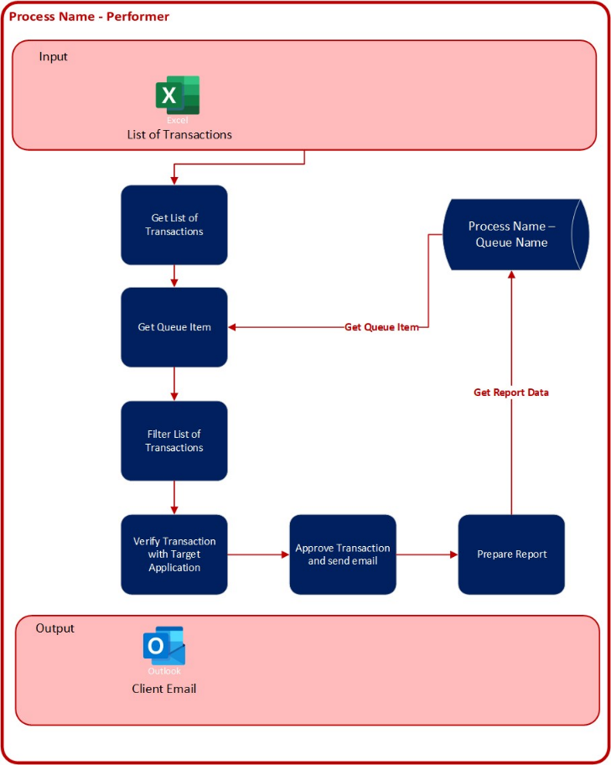

Object Design Instructions
Attached is ODI document containing a list of all workflows, sequences and connectors to be used by the process.
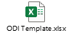

Workload Management
Section specifies the number of BOT required to process the total Volume per Day/Week/Month and how the load will be balanced in case of Multiple BOT deployment. (Please add a diagram for Multiple BOT deployment for load balancing)
Calculating the number of bots required for Robotic Process Automation (RPA) involves several factors that depend on the nature of the processes you are automating and the specific RPA tool you are using. Here are some key considerations:
- Process Complexity: Simple processes may require fewer bots, while complex processes may need more. Assess the complexity of the tasks being automated.
- Transaction Volume: Consider the number of transactions or tasks that need to be processed within a given time frame. Higher transaction volumes may require more bots to handle the workload efficiently.
- Processing Time: Evaluate the time it takes for a bot to complete a single transaction or task. If the processing time is relatively long, you might need more bots to handle a higher volume of tasks.
- Bot Utilization: Determine the average utilization rate of a bot. If a bot is idle for a significant portion of the time, you may be able to optimize and potentially reduce the number of bots needed.
- Workload Distribution: Analyse whether the workload is consistent or varies throughout the day. If there are peak hours with higher demand, you may need additional bots to handle the increased load during those times.

Exceptions
Section describes all Business and critical System Exceptions, their severity and if required, alert mechanism implemented.
Exception Details | Exception Type | Severity | Alerts

Queue Details
This section of the Solution Design Document (SDD) provides information about how queues are utilized within the solution
Queue Name | Fields | Sensitive Information | Encryption Method
Process Name – Queue Name | Item ID  Client Data | Yes | Data to be encrypted and then added to queue. Encryption key to be stored as a password in Orchestrator

Data Storage
The Data Storage section of the Solution Design Document is crucial for defining how data is managed within the solution. This includes specifying the types of data used or produced, their location, access restrictions, and the access management policies. Additionally, it outlines who can access these data files and how access is controlled.
Data Type | Data Location | Classification | Access Management Policy | Retention | User Access
MS Excel with client data | Example path | Highly Restricted | Access restricted to Robot only | 30 days | Managed by the Operational Lead

Report Template: 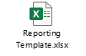

Project Dependencies
Comprehensive reference for all packages, libraries, and dependencies that are utilized within the software solution are defined in Deployment Protocol file.

Reporting
The Reporting section of a Solution Design Document (SDD) outlines what data is collected, processed, and presented in the form of reports within the software solution. Reporting is a critical component for decision-making and monitoring the performance of the system.
Report Type | Frequency | Contents | Distribution Method | Recipients
MS Excel | Daily, after each run | All items processed since last run (Success, AE and BE) | Email with a link to a file stored on a shared drive | dl@example.com

Other Details

Future Improvements
[List any future improvements here]

Other Remarks
[Add any other information that may be of value]

Post UAT Specifications
Documentation | Comments
Average duration per transaction:
(varies depending on the Test environment)

Glossary
Term | Description
Master project | The overall output of the development, containing one or multiple projects that together cover the scope of the robotic process automation.
Project | A UiPath Studio project containing one or multiple workflow files.  A project can be converted to a package and run independently, covering a particular scope within the master project.  The project is used when defining the development and support phase of the automation.
Package | The output of compiling a project. A package can be deployed on the robot machine and be executed by the robot service.  Only one package can be executed at a given time by a robot.  The package is used when defining the running phase of the automation
Workflow | A component of the package, the workflow encapsulates a part of the project logic.  The workflow can be of type: sequence, flowchart or state machine.  A workflow is saved as an .xaml file inside the project folder.  A workflow file can be invoked from another workflow and by default there is an initial workflow file that will run when executing the package.
Activity | An action that the robot executes.
Sequence | A workflow where activities are executed one after another, in a sequential order
Flowchart | A workflow where activities are connected by arrows and the logic of the workflow can be easily followed in a visual manner.  The flowchart can also be exported as an image from UiPath studio
State machine | A more advanced way of organizing a workflow, similar to a flowchart.
BOR | Back office robot
FOR | Front office robot
Orchestrator | Enterprise architecture server platform supporting: release management, centralized logging, reporting, auditing and monitoring tools, remote control, centralized scheduling, queue/robot workload management, assets management.

Document History
Date | Version | Role | Name | Organisation  /Department | Function | Comments

Sign-Off
I hereby confirm that the bot has successfully passed all required tests and is now ready for deployment into the production system.
Role | Full Name | Email | Approval | Date
Process Owner |  |  |  | dd-MM-yyyy
SME/Tester

