Understanding Why Balanced Token Pruning Fails on Text-Based Tasks
An Empirical Failure-Mode Study of BTP on Qwen2.5-VL-7B

1. Objective
During our reproduction of the NeurIPS 2025 paper Balanced Token Pruning (BTP), we observed a severe performance drop on TextVQA when BTP was applied to Qwen2.5-VL-7B:
- Baseline (no pruning): 82.7
- With BTP: 23.6
This study asks why this happens, and whether the same thing shows up on other text- and document-heavy tasks. The goal here is to understand the failure mode of BTP, not to fix or improve the method.

Research Questions
- Is the drop limited to TextVQA, or does it appear on similar benchmarks?
- Does performance decrease gradually as more tokens are removed?
- Which parts of the image are removed during pruning?
- Are text-rich regions removed more frequently than other regions?

2. Method
Model. Qwen2.5-VL-7B-Instruct, the model with the largest observed degradation, run on a single NVIDIA A100-40GB with FlashAttention-2.
Datasets. TextVQA and DocVQA (text-heavy), ChartQA (charts), and AI2D (diagrams), chosen to span everything from heavy to light text dependence. Metrics: accuracy (TextVQA, AI2D), ANLS (DocVQA), relaxed accuracy (ChartQA), evaluated with the standard lmms-eval harness.
Retention control. BTP's retention is hard-coded across three halving stages (final 12.5%). We parameterised it via an environment variable so any target retention can be swept, and clamped an index-selection step that overflowed at high retention.
Token instrumentation. We logged the exact image-token indices retained at each of the three pruning stages, composed them to the final 12.5% set, and mapped each token to its image patch (Qwen's merged patch grid). Text regions were located with EasyOCR to measure how often text vs. non-text patches are pruned.

3. Experiment 1: Does the Failure Spread?
Baseline vs. BTP across all four datasets:
Dataset | Metric | Baseline | BTP | Drop
TextVQA | Accuracy | 86.2 | 23.3 | −62.9
DocVQA | ANLS | 94.7 | 19.2 | −75.5
ChartQA | Relaxed acc. | 76.8 | 29.0 | −47.8
AI2D | Accuracy | 86.4 | 79.6 | −6.8
Finding. The drop is not just a TextVQA quirk. It shows up on every text-heavy task, with TextVQA, DocVQA and ChartQA all falling somewhere between 48 and 76 points. The one that holds up is AI2D, down only 6.8. AI2D leans on diagram layout and arrows rather than reading small print, and that contrast is the tell: the failure is specifically about reading dense text, not about vision in general. (This answers our first question.)

4. Experiment 2: It Breaks Instantly, Not Slowly
We swept retention from 100% down to 12.5% on TextVQA and DocVQA:
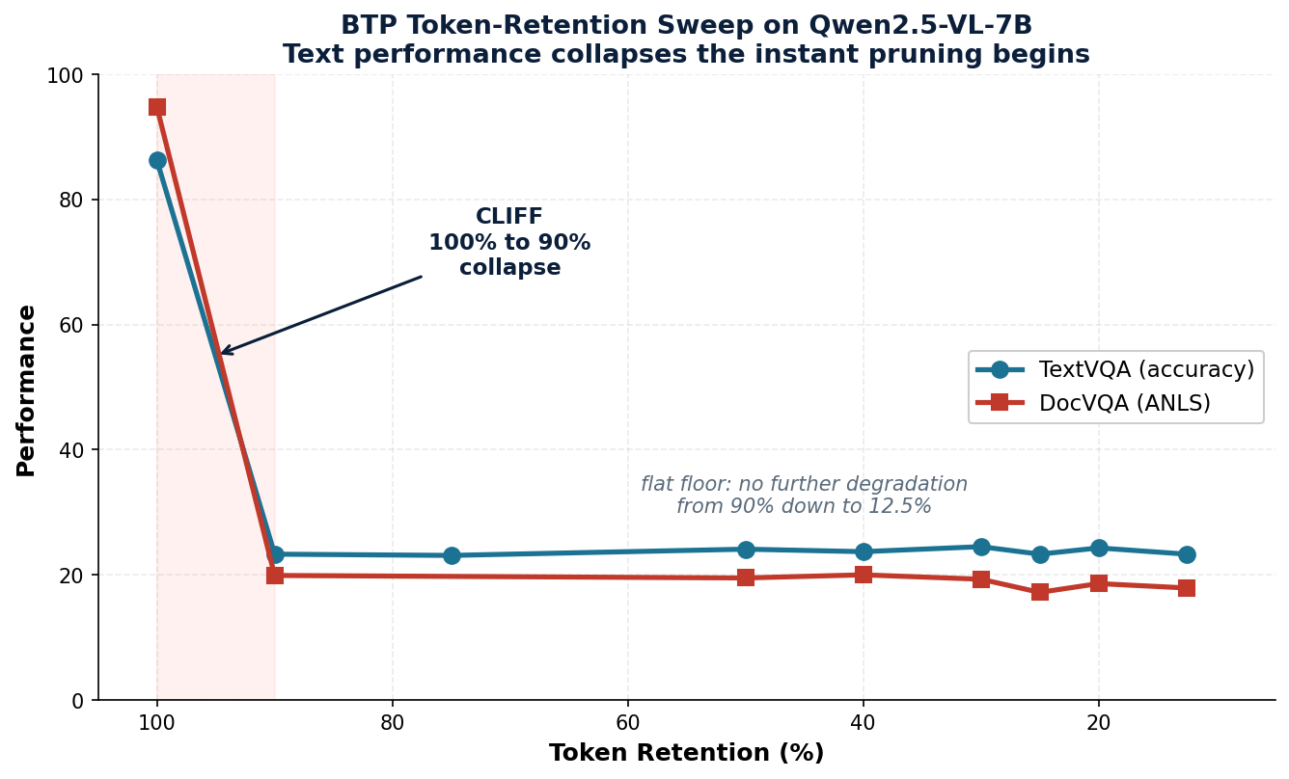
Figure 1. Performance vs. token retention. The collapse is a cliff between 100% and 90%, then a flat floor. It is not a gradual decline.
Finding. We expected a gentle slope: keep fewer tokens, lose a little accuracy. Instead we got a cliff. The moment pruning starts, even at 90% retention (trimming just 10% of tokens), TextVQA has already collapsed (86.2 down to 23.3), and it stays flat all the way to 12.5%. There is simply no safe amount of pruning for text. (This answers our second question.)

5. Experiment 3: What Actually Gets Thrown Away
We overlaid the removed patches (red) at the deployed 12.5% operating point. At this level 87.5% of image patches are discarded.
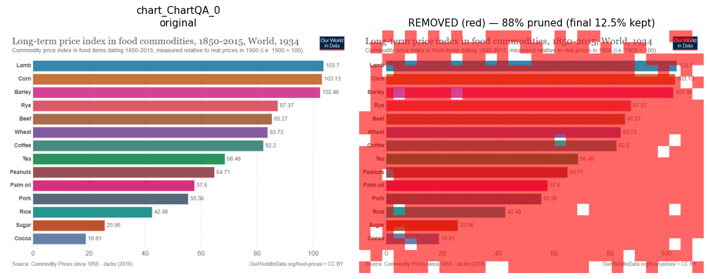
Figure 2. ChartQA: the chart is almost entirely removed. A few surviving patches cluster on the left-side labels, but far too few remain to actually read the values.
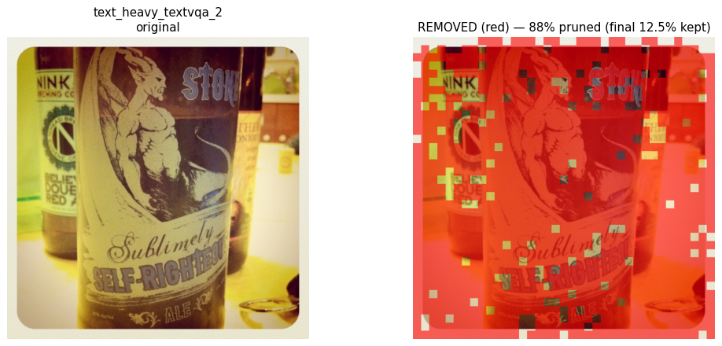
Figure 3. A text-heavy natural image: the label text (“Sublimely / Self-Righteous”) is buried under removed patches.
Finding. At the 12.5% setting BTP actually ships with, almost nothing survives. What little does remain leans toward the detailed, text-heavy regions, but there is nowhere near enough left to keep the text readable. (This answers our third question.)

6. Experiment 4: Is Text the Target? Surprisingly, No.
Using EasyOCR text boxes, we compared how often text vs. non-text patches are removed at the final 12.5% operating point:
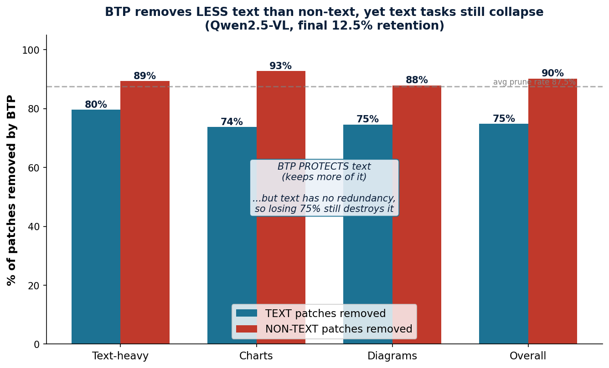
Figure 4. BTP removes less text than non-text across every category, yet all of these tasks still collapse.
Category | % text removed | % non-text removed
Text-heavy | ~79.6 | ~89.3
Charts | 73.7 | 94.5
Diagrams | ~74.6 | ~87.9
Overall | 74.8 | 90.2
Finding. The answer to our fourth question is a clear no. BTP removes text less often than everything else (74.8% vs. 90.2%), and on charts it clearly shields the text (73.7% vs. 94.5%). In other words, the selection is doing its job: it spots text as important and tries to keep it. So the failure is not that BTP mishandles text.

7. Conclusion
Put the four experiments together and a single, slightly surprising explanation falls out. The failure is not that BTP goes after text; it actually protects it. The real cause lies in the nature of the content itself:

In a photo, one patch of sky looks much like the next, so throwing most of them away costs almost nothing. That is exactly why AI2D holds up. Charts and documents are the opposite: every label, number and character carries unique meaning. BTP's core assumption, that visual tokens are redundant and so pruning is safe, simply does not hold for text.
Implication. This is not a bug to patch out of the algorithm; it is a fundamental mismatch between aggressive pruning and information-dense content. No method that keeps only an eighth of the tokens can preserve text that needs nearly all of them. The natural way forward is content-aware retention: find the text-dense regions first, and leave them out of the cut.

8. Summary of Findings
- The TextVQA collapse spreads to every text-heavy task (TextVQA, DocVQA, ChartQA); diagram reasoning (AI2D) holds up.
- Degradation is a cliff, not a slope: even keeping 90% of tokens already collapses text.
- At the 12.5% operating point, 87.5% of patches are removed, and almost nothing readable survives.
- BTP removes text less than non-text (74.8% vs 90.2%); it protects text, yet text tasks still fail.
- Root cause: text has almost no redundancy, so any aggressive pruning is fatal no matter how good the selection is.
Repository: github.com/milab-iitj-dev/btp-reproduction

