1. **Create an S3 bucket with a unique name and upload the CSV file to the S3 bucket (ensure that the file is in UTF-8 format only)**

1. Create a folder for placing datasets in it:

1. **Create a crawler to crawl the CSV data and generate a metadata catalog.**

* 1. Select the folder that file is in there(not the file itself):

* 1. Create an IAM

* 1. After Role is created, run it, and table will be created

1. **Create a Glue job to transform the data into the Parquet format as CSV is not optimal for data warehouse queries**

Create a Job to Convert CSV to Parquet file:

1. Create IAM ROLE FOR GLUE  
     
   A computer screen capture

   Description automatically generated with medium confidence
2. Create a Glue Job  
     
   A screenshot of a computer

   Description automatically generated
3. Create a name, add IAM role in job detail  
     
   Graphical user interface, application

   Description automatically generated
4. Create a folder output for output target:  
     
   Graphical user interface, application

   Description automatically generated
5. Create source, target and transform action to change datatype.

Done and save and RUN  
  
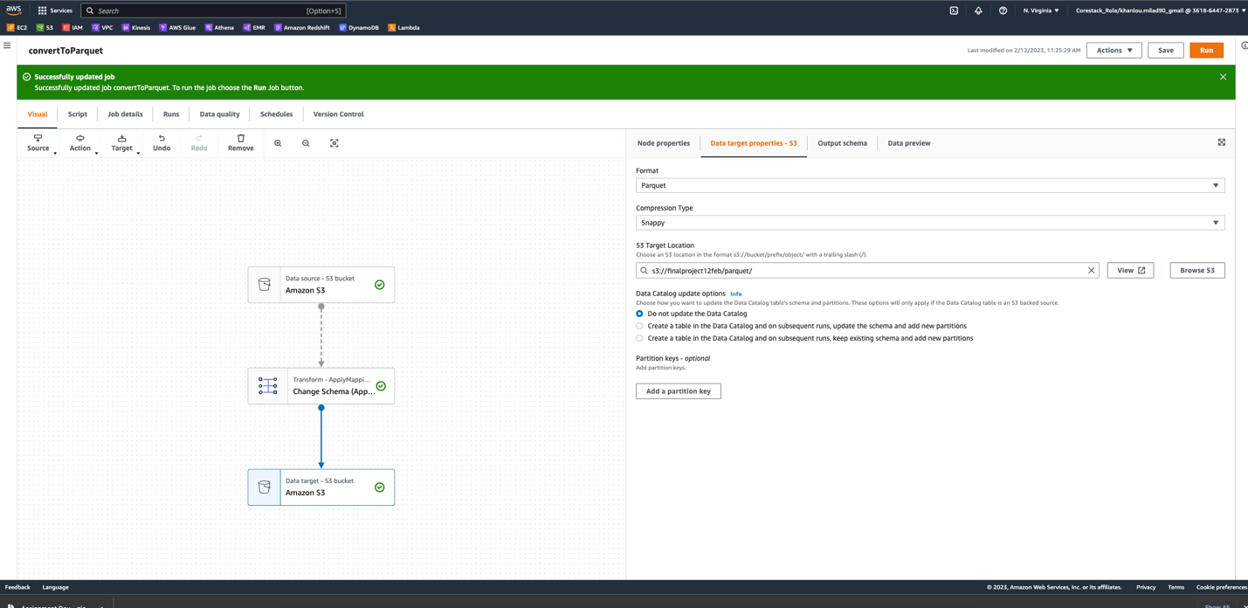

JOB CREATED PARQUET FILE IN S3 BUCKET:

1. **Add another crawler to crawl the Parquet data files to generate the metadata catalog of the Parquet file in order to query it with Athena**
2. Create a Database:  
     
   Graphical user interface, text, application, email

   Description automatically generated
3. Create a crawler for parquet file  
     
   Graphical user interface, text, application, email

   Description automatically generated  
     
     
     
   Graphical user interface, application

   Description automatically generated  
     
     
   Graphical user interface, text, application, email

   Description automatically generated  
   Create an IAM role:  
     
   Graphical user interface

   Description automatically generated  
     
   Graphical user interface, text, application, email

   Description automatically generated
5. SAVE AND RUN THE CRAWLER:  
     
   A screenshot of a computer

   Description automatically generated  
     
   Graphical user interface

   Description automatically generated
6. TABLE CREATED in separate database  
     
   Graphical user interface

   Description automatically generated
7. **Query the data to identify the best-selling item and countries where customers have bought the most-sold item using Athena**

In Athena choose the database and query:

