**Технически Университет София**

Факултет Компютърни системи и технологии

**Куросова Работа по НЕФОТОРЕАЛИСТИЧНА ВИЗУАЛИЗАЦИЯ**

**Тема №3**

Изготвил:

Мила Иванова Иванова

Специалност: КСИ

Курс: Четвърти

Група: 42

Фак. № 121214080

София, Януари 2018 г.

1. ***Задание:***

**Theme 3.** Create a project performing the following steps (use a program environment like Visual Studio .NET):

* Design of a set of dithering patterns for 16 intensity levels (4 x 4 patterns) thinking about reducing artifacts as well as deliberately creating artifacts;
* Implement the ordered dithering algorithm using the designed patterns (use the program from Exercise 3 that implements ordered dithering algorithm using 2 x 2 patterns as a prototype);
* Experiment with different input images; compare and analyze the results.

1. Теоретична част:

Създаваме квадратна матрица 4х4 като инициализираме редовете и стълбовете й със стойности от 0 до 15.

Матрицата изглежда по следния начин:

0 1 2 3

4 5 6 7

8 9 10 11

12 13 14 15

1. Source code:

using System;

using System.Collections.Generic;

using System.ComponentModel;

using System.Data;

using System.Drawing;

using System.Linq;

using System.Text;

using System.Threading.Tasks;

using System.Windows.Forms;

namespace CourseWorkNFRV

{

public partial class CourseWorkNFRV_N3 : Form

{

private Bitmap inBitMap;

private Bitmap outBitMap;

private int width;

private int height;

private int[,] ditherMatrix;

public CourseWorkNFRV_N3()

{

InitializeComponent();

inBitMap = null;

outBitMap = null;

ditherMatrix = new int[4, 4];

ditherMatrix[0, 0] = 0;

ditherMatrix[0, 1] = 1;

ditherMatrix[0, 2] = 2;

ditherMatrix[0, 3] = 3;

ditherMatrix[1, 0] = 4;

ditherMatrix[1, 1] = 5;

ditherMatrix[1, 2] = 6;

ditherMatrix[1, 3] = 7;

ditherMatrix[2, 0] = 8;

ditherMatrix[2, 1] = 9;

ditherMatrix[2, 2] = 10;

ditherMatrix[2, 3] = 11;

ditherMatrix[3, 0] = 12;

ditherMatrix[3, 1] = 13;

ditherMatrix[3, 2] = 14;

ditherMatrix[3, 3] = 15;

}

private int Aproxim(int intensity)

{

if (intensity > 0 && intensity < 16)

return 15;

else

if (intensity >= 16 && intensity < 32)

return 14;

else

if (intensity >= 32 && intensity < 48)

return 13;

else

if (intensity >= 48 && intensity < 64)

return 12;

else

if (intensity >= 64 && intensity < 80)

return 11;

else

if (intensity >= 80 && intensity < 96)

return 10;

else

if (intensity >= 96 && intensity < 112)

return 9;

else

if (intensity >= 112 && intensity < 128)

return 8;

else

if (intensity >= 128 && intensity < 144)

return 7;

else

if (intensity >= 144 && intensity < 160)

return 6;

else

if (intensity >= 160 && intensity < 176)

return 5;

else

if (intensity >= 176 && intensity < 192)

return 4;

else

if (intensity >= 192 && intensity < 208)

return 3;

else

if (intensity >= 208 && intensity < 224)

return 2;

else

if (intensity >= 224 && intensity < 240)

return 1;

else

if (intensity >= 240 && intensity < 255)

return 0;

else

return 0;

}

private void btnLoadImage_Click(object sender, EventArgs e)

{

if (openFileDialog1.ShowDialog() == System.Windows.Forms.DialogResult.OK)

{

string fname = openFileDialog1.FileName;

inBitMap = new Bitmap(Image.FromFile(fname));

width = inBitMap.Width;

height = inBitMap.Height;

imageBox.Size = new System.Drawing.Size(width, height);

imageBox.Image = inBitMap;

}

}

private void CourseWorkNFRV_Load(object sender, EventArgs e)

{

}

private void btnOrderedDither_Click(object sender, EventArgs e)

{

int k;

int m;

outBitMap = new Bitmap(inBitMap);

for (int i = 0; i < width; i++)

for (int j = 0; j < height; j++)

{

k = i % 2;

m = j % 2;

if (Aproxim(outBitMap.GetPixel(i, j).R) < ditherMatrix[k, m])

{

outBitMap.SetPixel(i, j, Color.White);

}

else

{

outBitMap.SetPixel(i, j, Color.Black);

}

}

imageBox.Image = outBitMap;

}

}

}

1. Резултати:

Case 1:

Original:

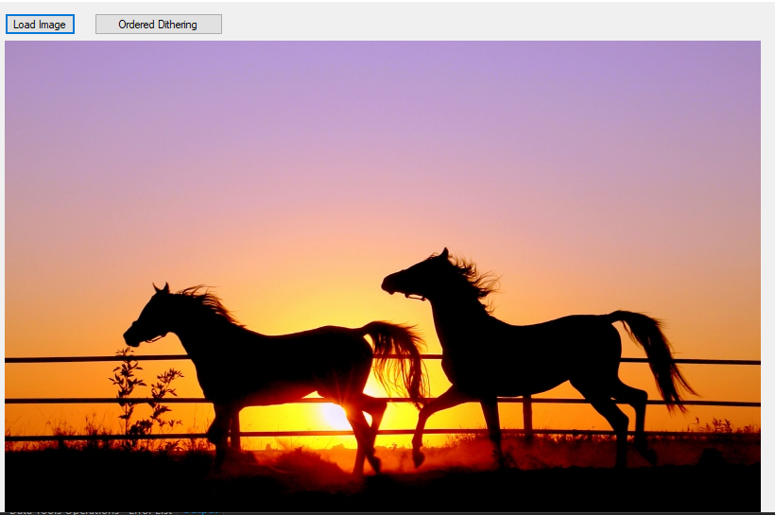

Dithering:

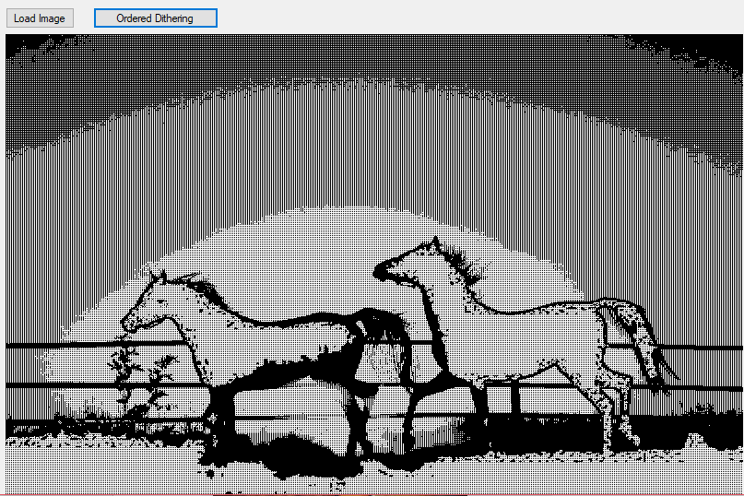

Case 2:

Original: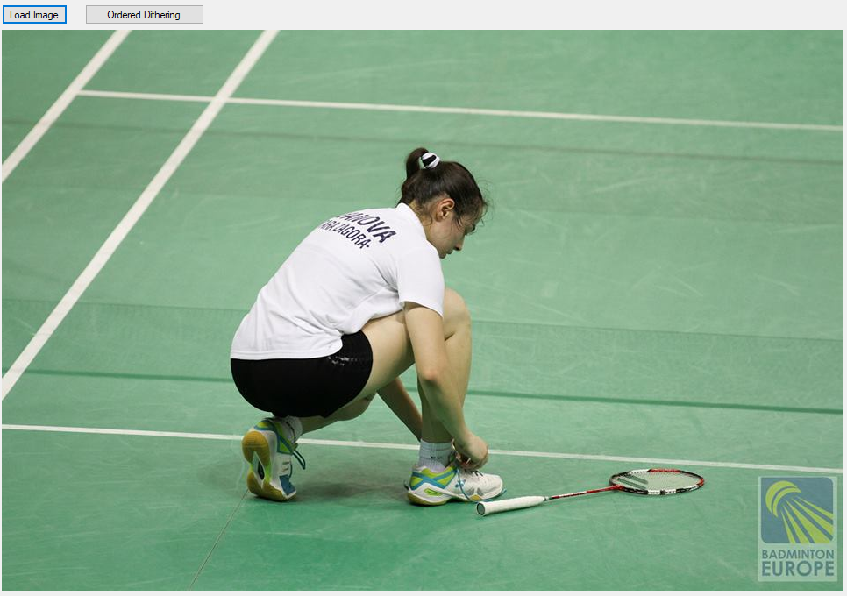

Dithering: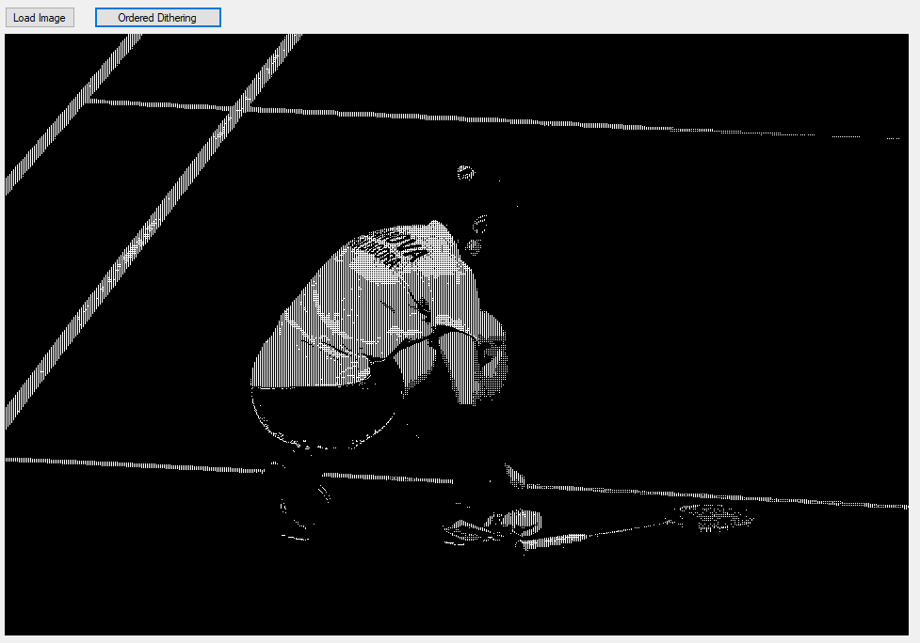

Case 3:

Original:

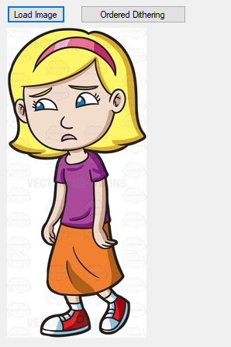

Dithering:

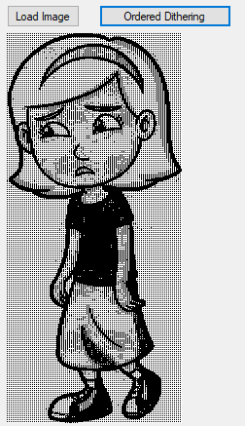

Case 4:

Original:

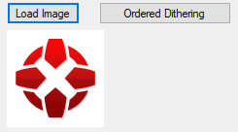

Dithering:

