CORN MAFIA WEB

System Map
Simple diagrams showing how identity, roles, content, navigation, and admin tools connect

Purpose
This document shows how the main parts of the website connect. It is meant to give non-technical users a simple mental model of the system.

1. User Access Flow
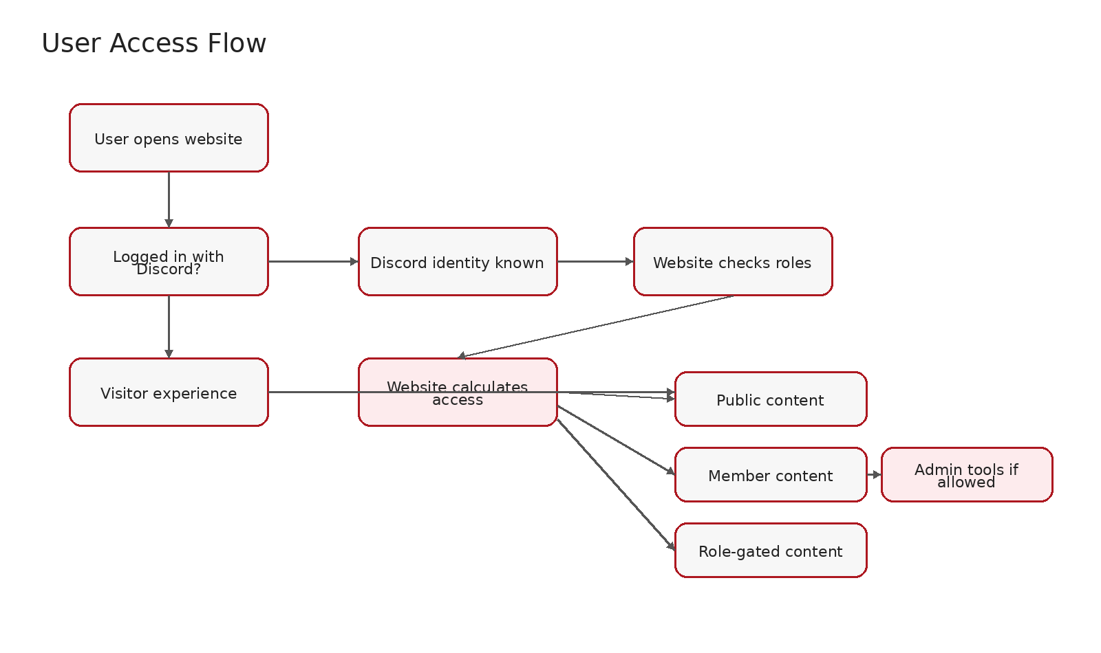
The website first checks whether the user is logged in. If not logged in, the user is treated as a visitor. If logged in, the website knows the user's Discord identity and can check their roles. Those roles help decide what the user can see or manage.

2. Content And Navigation Flow
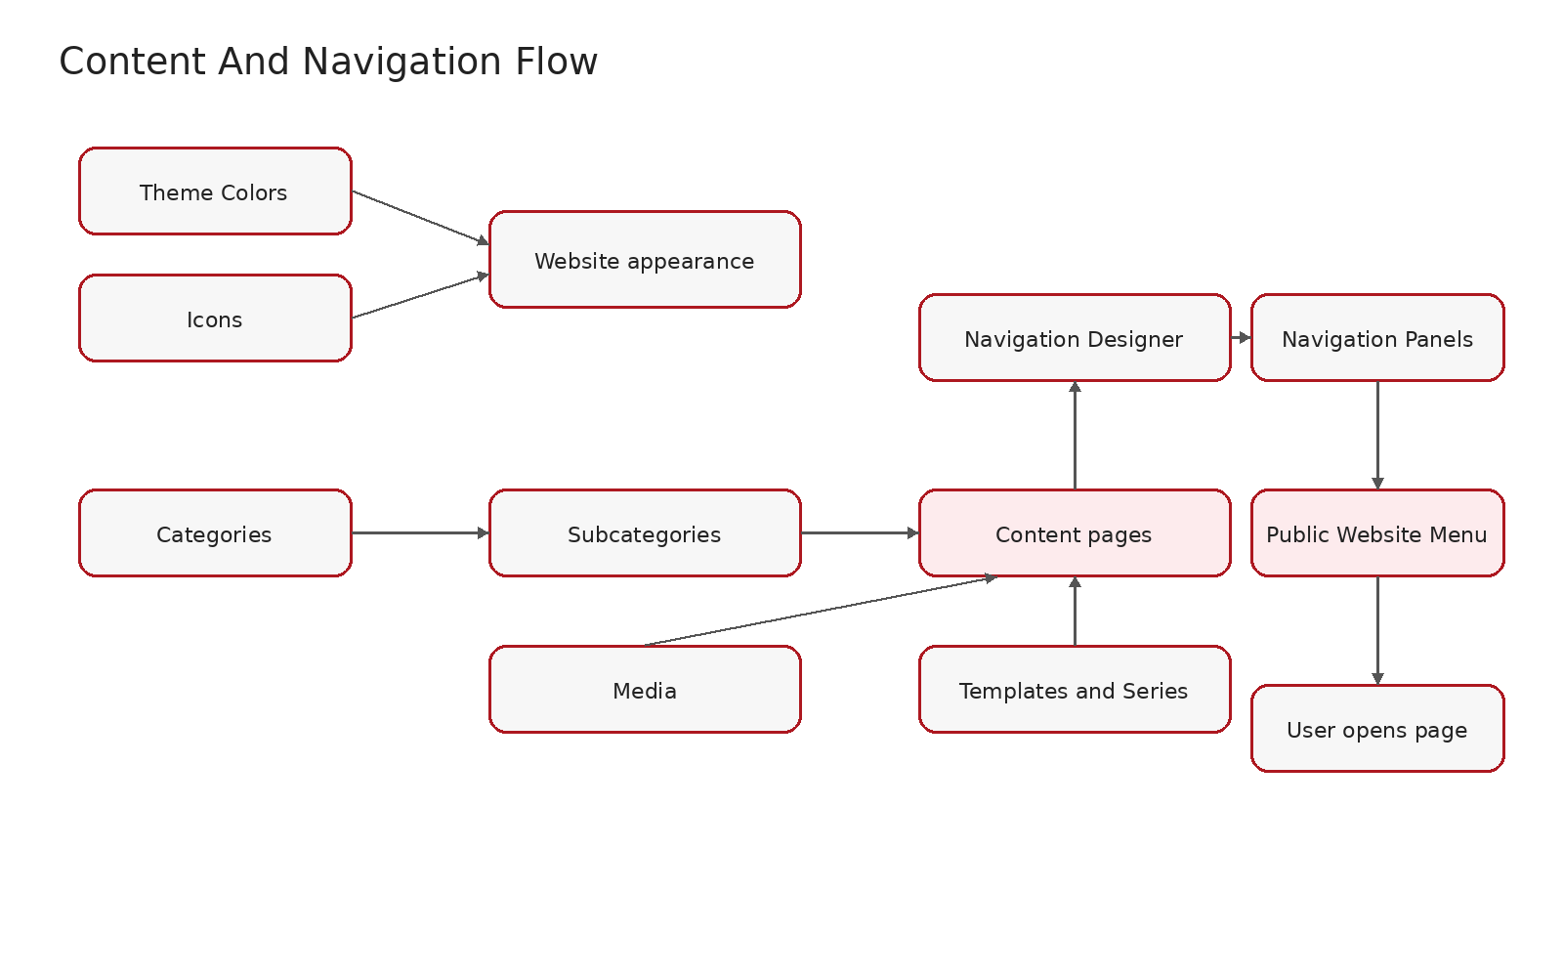
Categories and subcategories organize the website. Content pages are the actual pages people open. Media, templates, and series help shape content. Navigation panels decide which content appears in menus.

3. Admin Management Map
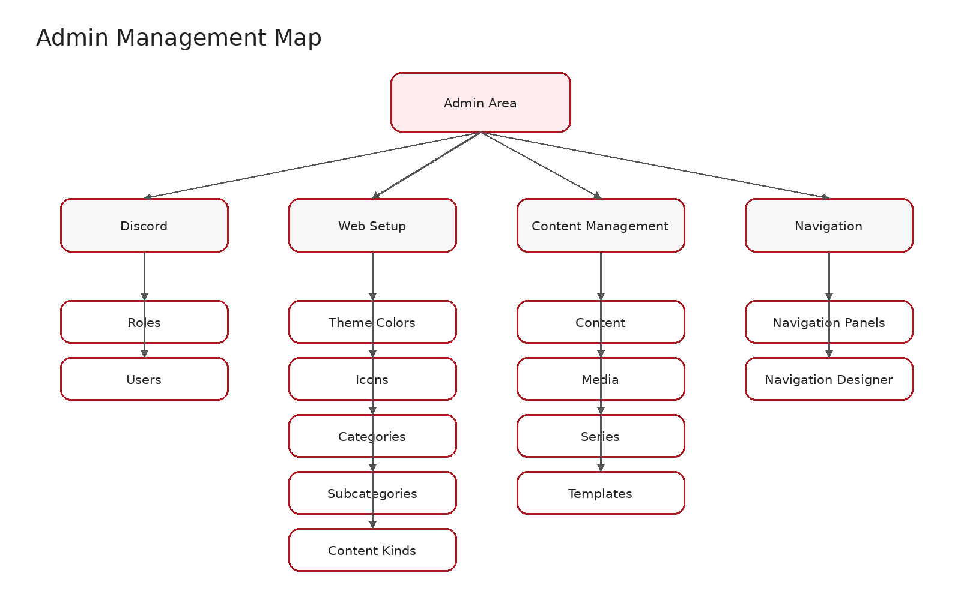
Discord controls identity and roles. Web setup controls reusable structure. Content management controls pages and files. Navigation controls what appears in menus.

4. Regular User Experience Map
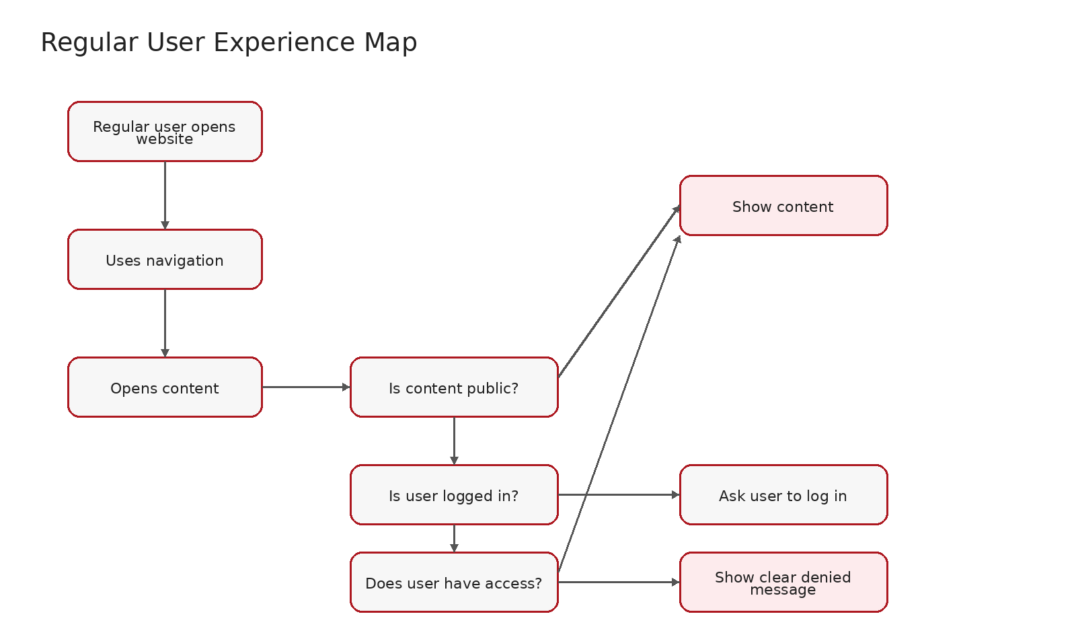
Regular users use the menu, open pages, and see only what they are allowed to see.

5. How Everything Ties Together
Area | Meaning
Discord | Controls identity and roles.
Roles | Control access.
Access | Controls what users can see or manage.
Categories and Subcategories | Organize content.
Content | Creates the actual pages.
Media | Supports content with files and images.
Templates | Help structure repeated content.
Navigation Panels | Decide what appears in menus.
Public Website | Shows the final result to visitors and members.

6. Most Important Rule
Area | Meaning
Content | The page exists.
Navigation | The page appears in a menu.
Access | The user is allowed to see it.

A page should only feel complete when the content exists, the navigation points to it, and the right users can access it.

