Project Overview:
This project simulates a secure examination network environment using Cisco Packet Tracer. The aim is to design a controlled setup where Admin, Server, and Student systems operate in separate VLANs to ensure security and prevent unauthorized communication.
In a real-world exam environment, students must be restricted from accessing unauthorized websites or communicating with other networks. To achieve this, VLAN segmentation, Router-on-Stick, and ACL-based filtering are implemented.
- Admin VLAN (10) is used by examination staff with full access to all services.
- Server VLAN (20) hosts the internal Web and DNS services used during the exam.
- Student VLAN (30) contains student PCs and wireless users, where strict ACL rules are applied to block AI tools, social media, and restricted websites during examinations.
A wireless router is integrated into the Student VLAN to represent students connecting through Wi-Fi. All wired and wireless traffic is filtered using ACLs, ensuring that students can access only approved resources while Admin users retain full privileges.
This project demonstrates essential enterprise-grade networking concepts such as VLANs, trunking, inter-VLAN routing, DHCP, DNS, Web Server hosting, wireless integration, and policy enforcement. The final design closely mirrors a real examination centre network used in schools, colleges, and competitive exam labs.
Step 1: setup all components and assign IP add

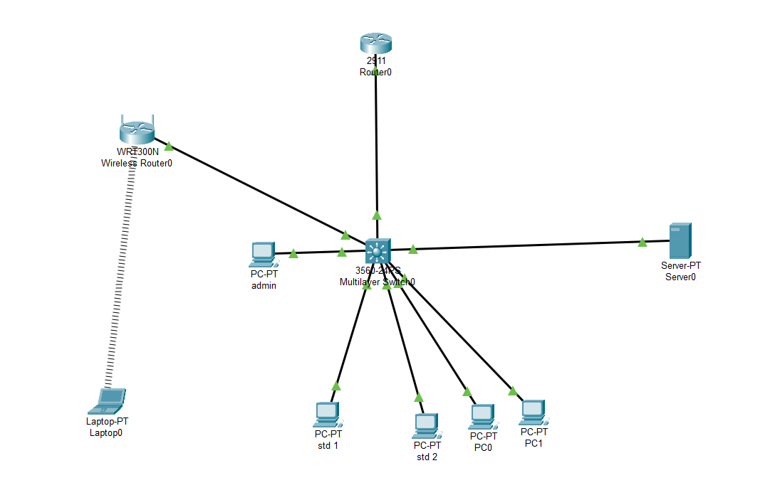

Device / VLAN | Interface / Port | IP Address | Subnet Mask | Default Gateway
Admin PC (VLAN 10) | Fa0/3 | 11.0.0.10 | 255.255.255.0 | 11.0.0.1
Server (VLAN 20) | Fa0/2 | 12.0.0.10 | 255.255.255.0 | 12.0.0.1
Student PC 1 (VLAN 30) | Fa0/4 | 13.0.0.10 | 255.255.255.0 | 13.0.0.1
Student PC 2 (VLAN 30) | Fa0/5 | 13.0.0.11 | 255.255.255.0 | 13.0.0.1
Student PC 3 (VLAN 30) | Fa0/6 | 13.0.0.12 | 255.255.255.0 | 13.0.0.1
Student PC 4 (Wi-Fi, VLAN 30) | Wireless LAN | DHCP (192.168.x.x → NAT) | — | 13.0.0.1
Router - Admin VLAN | G0/1.10 | 11.0.0.1 | 255.255.255.0 | —
Router - Server VLAN | G0/1.20 | 12.0.0.1 | 255.255.255.0 | —
Router - Student VLAN | G0/1.30 | 13.0.0.1 | 255.255.255.0 | —

Step 2: Config Switch-> CLI
1.Create VLAN
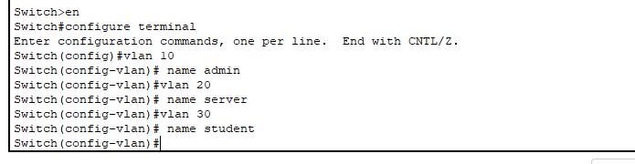
2. Assign port to Respective VLANs
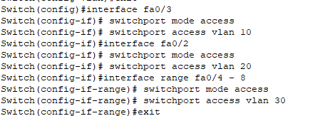
3. Configure the Trunk Port (Switch → Router Link)
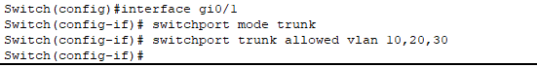

Step 4: Configure Router-on-a-Stick (Router Subinterfaces)
- Line high
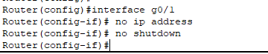
- Admin VLAN subinterface
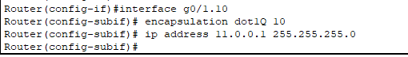
- Server VLAN subinterface:
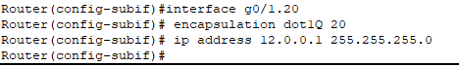
- Student VLAN subinterface:
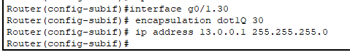
Step 6: ACL to Block Students from Accessing Restricted Websites
- Create ACL
- Apply ACL to Student VLAN subinterface:
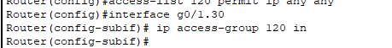

STEP 7: Verify the connectivity
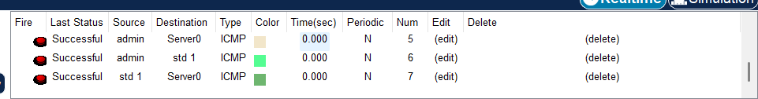

Step 8: Configure DNS and Web server on server device
- Server->services->DNS/HTTPS mark ON
- And add 3 DNS entry
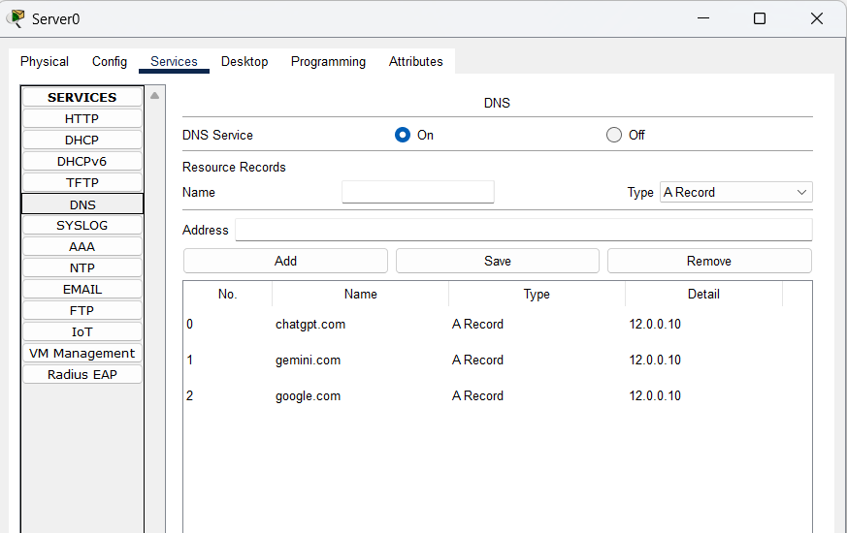
- Goto http->index.html->edit
And add some fake details and save it
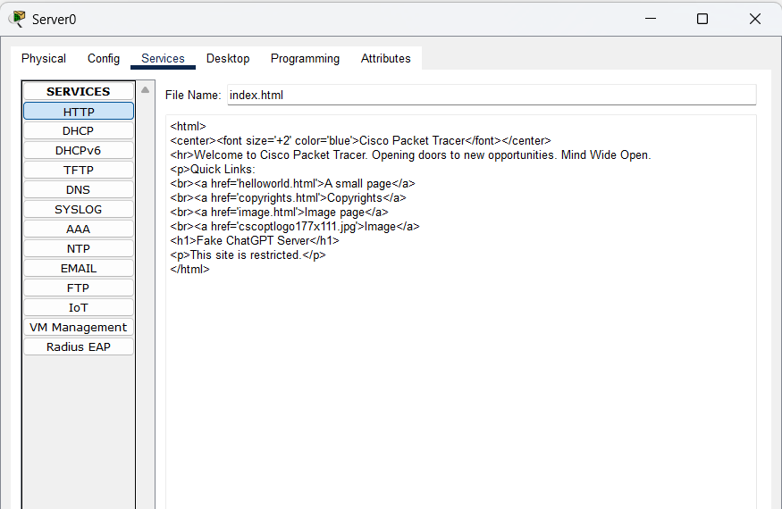

Step 8: Verification
- Open chatgpt.com from admin pc
Admin pc->desktop->web browser (It should open)

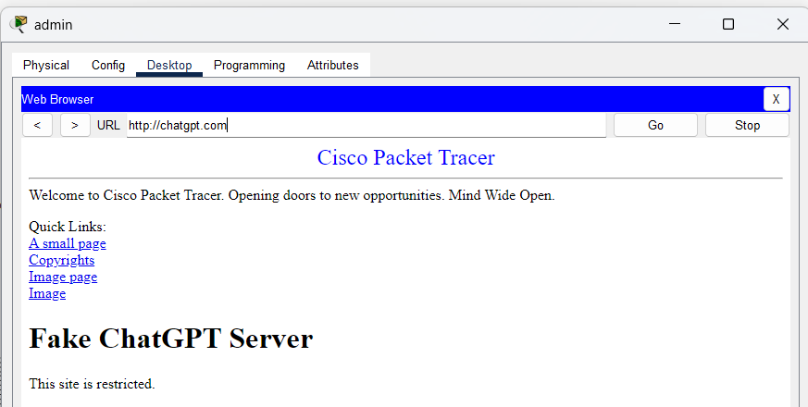

- Do the same from student pc (It will block an after some buffer it will show “request timeout”)
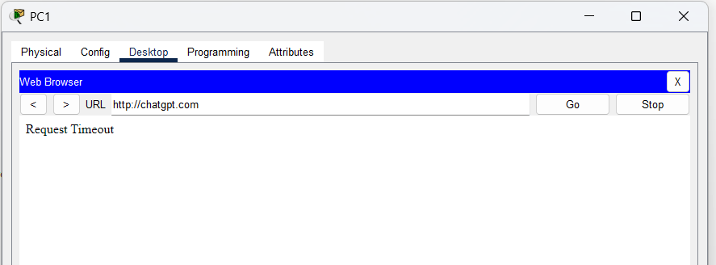

- Also verify from remote laptop , it will give the same result
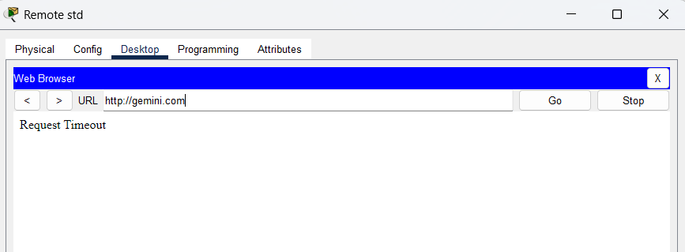

Important terminology:

- VLAN (Virtual Local Area Network)
- Logically divides a single switch into multiple separate networks.
- Different VLANs cannot communicate without a router.

- Trunk Port
- A switch port that carries multiple VLANs at the same time.
- Used between Switch ↔ Router or Switch ↔ Switch links.

- Access Port
- A switch port assigned to only one VLAN.
- Used for PCs, servers, printers, etc.

- Router-on-a-Stick
- Routing technique where one physical router interface carries multiple VLANs using subinterfaces.

- Subinterface
- A virtual interface created on a router to handle a specific VLAN.
Example: G0/1.10 for VLAN 10.

- Encapsulation Dot1Q
- The command used to tag traffic for a specific VLAN on a router’s subinterface.

- Default Gateway
- The router IP address that hosts use to reach other networks or VLANs.

- ACL (Access Control List)
- Firewall rules used to allow or block traffic based on IP, ports, or protocol.

- HTTP / HTTPS (Port 80 / 443)
- Web traffic protocols.
- Used when blocking websites with ACL.

- DNS (Domain Name System)
- Translates website names (e.g., chatgpt.com) into IP addresses.

- Access Point (AP)
- Device that gives wireless connectivity.
- In this project, the AP is placed in VLAN 30 to apply the same restrictions to students.

- Firewall Rule
- A condition inside an ACL that allows or blocks specific traffic.

Conclusion:
- Implemented a secure exam-style network using VLANs for Admin, Server, and Students.
- Router-on-Stick used to enable inter-VLAN communication while keeping traffic isolated.
- ACL firewall applied to Student VLAN to block restricted/AI websites.
- Wireless access point added so student Wi-Fi devices also follow the same security rules.
- Internal DNS + Web Server used to simulate real exam-center services.
- Overall setup demonstrates how VLANs, access points, and ACL firewalls create a safe and controlled examination network.

