IoT Scenario: Here I have made an automatic speed controller for fan using temperature controller.
Components used: Fan, temperature monitor device, wireless router, a laptop and a server for IoT registration.

Step 1: Take all the components from the panel
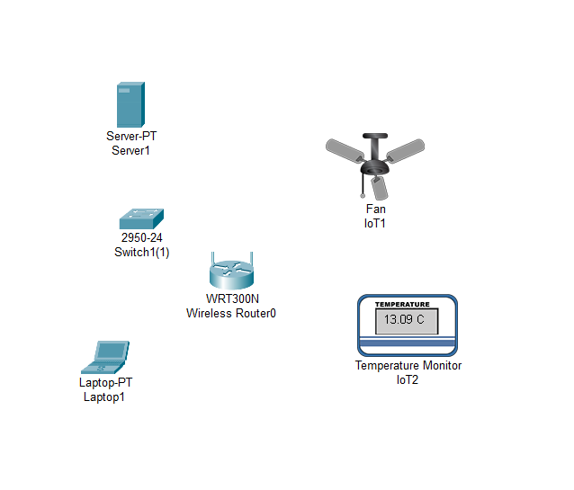

Step 2: Connect the router and switch with cross cable , and laptop and server to switch with straight copper cable.
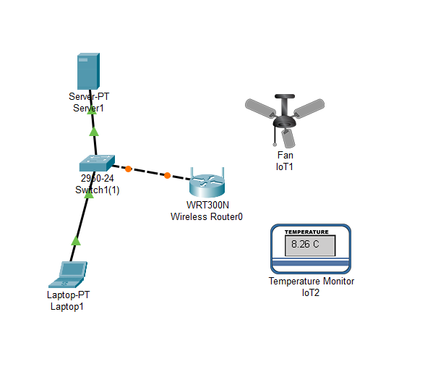

Step 3: Give Ip add to server and laptop (used any static or DHCP)
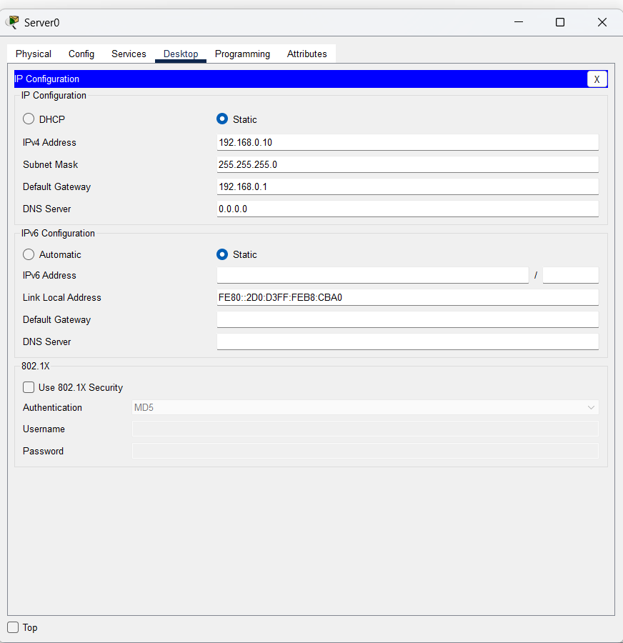
(Server->desktop->ip config )

Step 4: Open server and goto services and open AAA(Authentication ,Authorization .Accounting) and make enter the details of router and make radius client, and make one secret key which will router use for authentication.
Client Name= anything (ex: home)
Ip= routers ip
Below that add devices which were used in IoT scenario
Ex: name : fan , pass is also fan
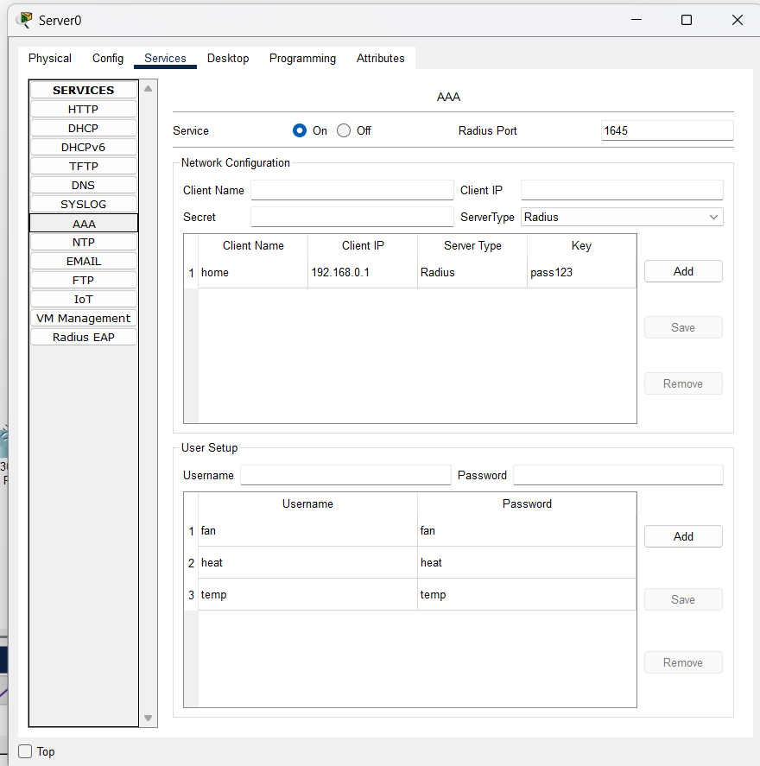

Step 5: Tap on IoT and enable it
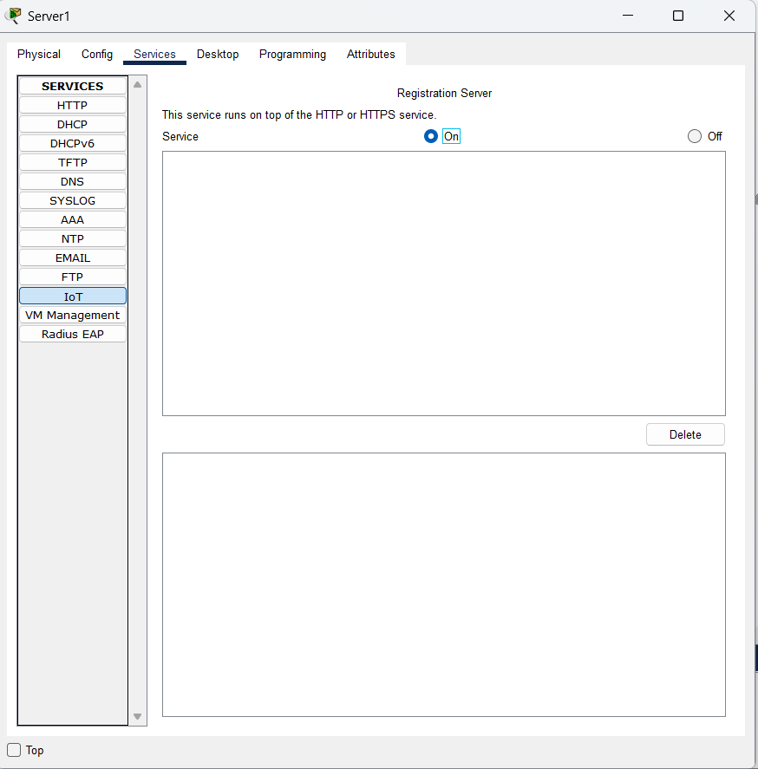

Step 6: Goto server->desktop->web browser and enter server’s Ip add to make IoT server from which we can see the status of IoT devices from remote places. Also manipulate it
One login page will open , click sign up now
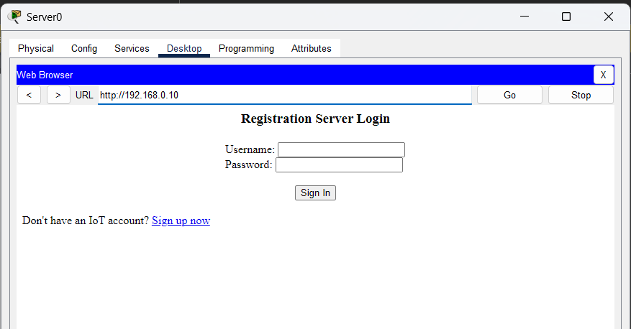

And create a user and pass.
Also U can verify your server in server->services-> IoT

Step 7:
- Open router->wireless and set the ssid as client name saved earlier at server side , in my case it is home. scroll it and save it.
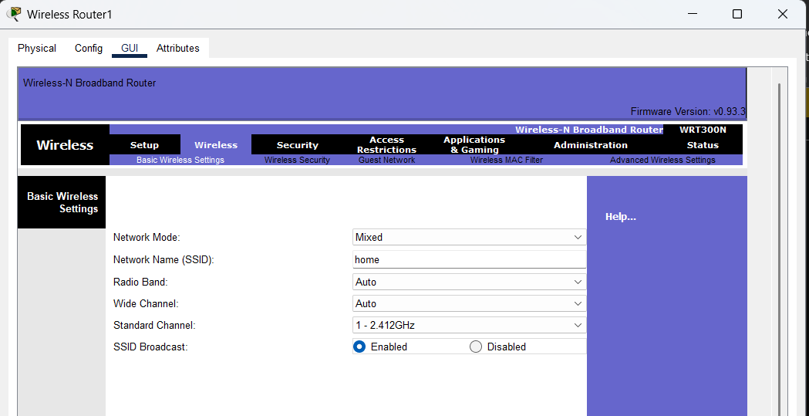
- And then in the same section goto wireless security , select WPA2 Enterprise in security mode ,
- enter ip add of server in radius server , ans secret code which was again set earlier in server side and scroll it and save it.
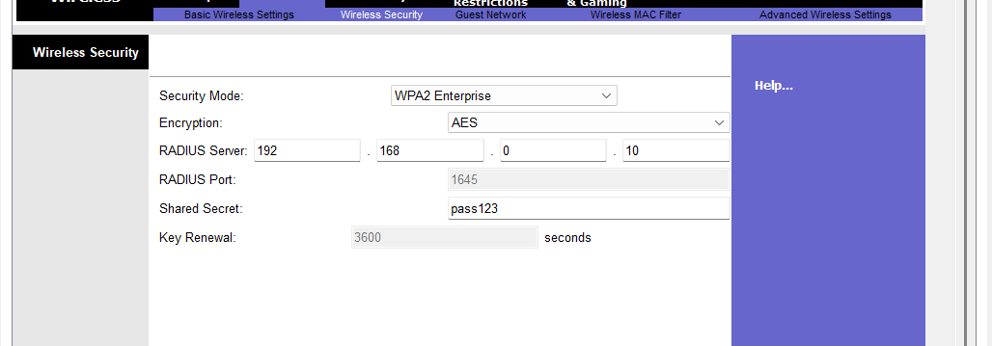

Step 8: Now after doing this all , configure the IoT components

- Open Fan->config , in that at bottom side tap remote server under IoT server , and fill the details , enter server ip add and server’s login username and pass, in my case the details are:
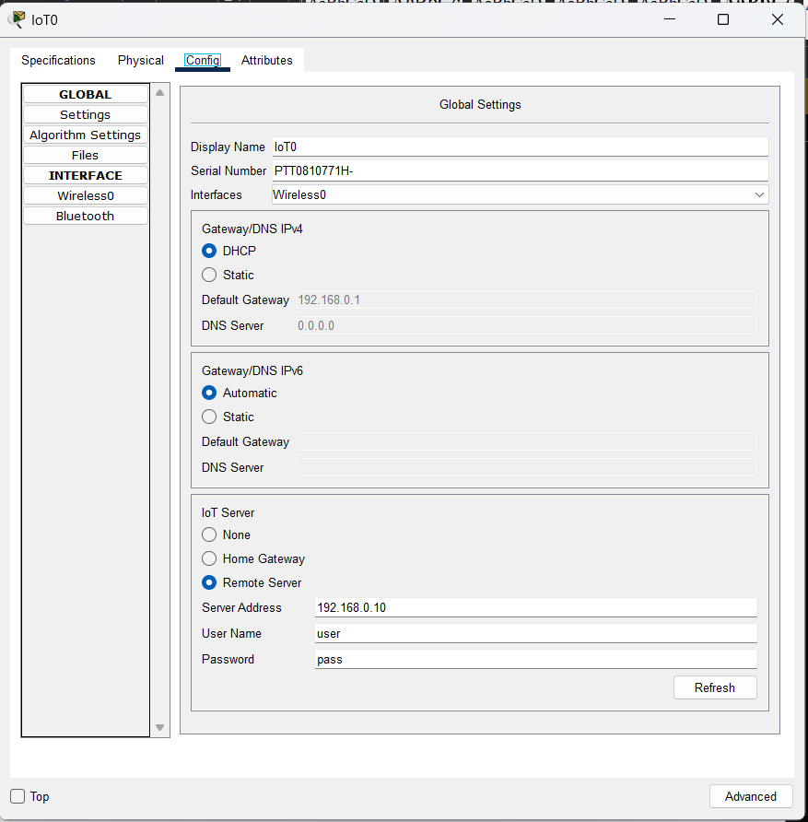
- In the same section goto wireless 0 and enter ssid as home , and tap WPA2 under authentication and enter user id and pass (that was set during the server setup , IoT components config under AAA section)
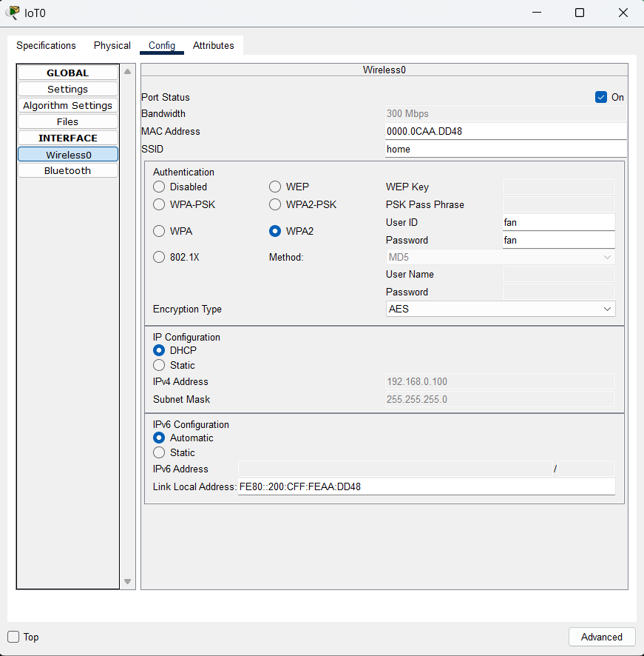

Step 9: Repeat this step 8 for all IoT devices and enter details accordingly.

Step 10:
- Open laptop -> desktop->web browser->search server ip add
- Login with server user and pass
- You will see all the devices which are connected and sending data to server
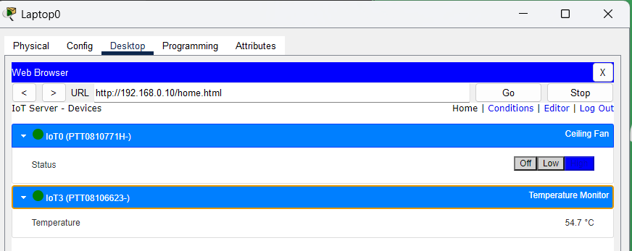

- Goto right side condition and set conditions accordingly (ex like if this happen then do this)
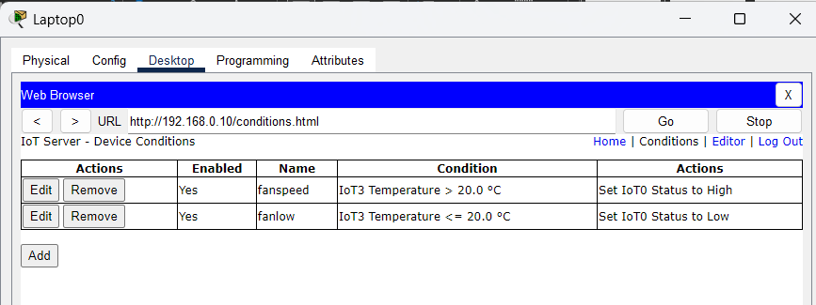

Step 11: verify the results
- When temp is <20 fan is slow (one circular line means fan is slow)
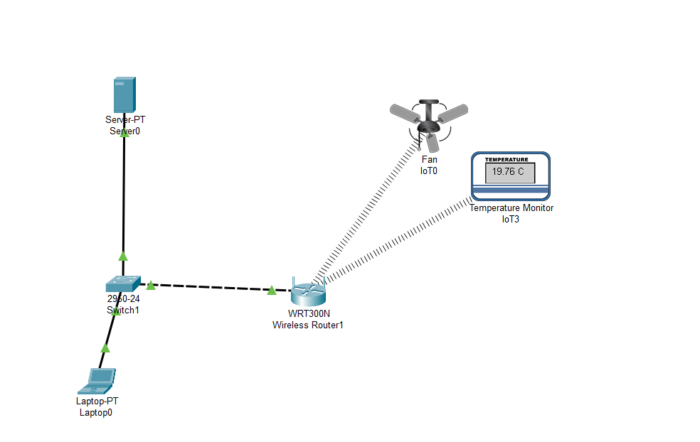

- When temp >20 fan is fast (one circular line means fan is fast)

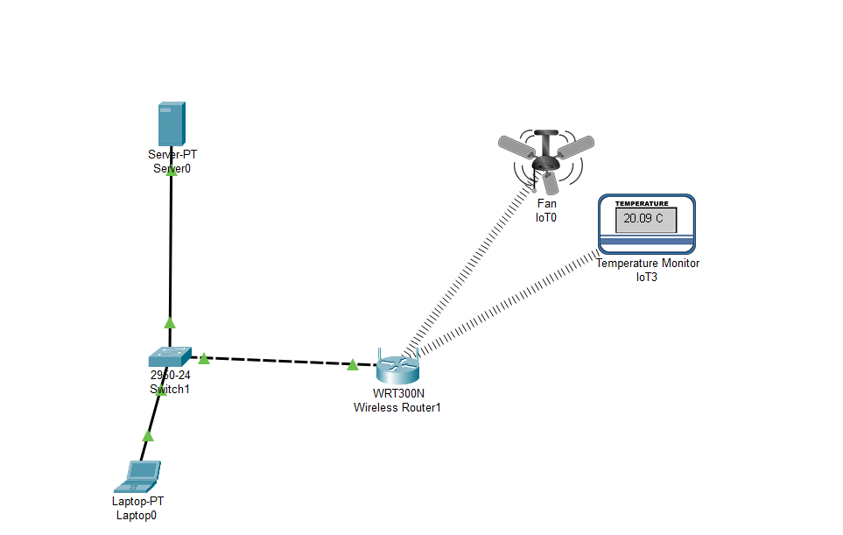

Conclusion: In this experiment I learnt how to make IoT based scenario, how to use AAA, server and in that how to make IoT registration, how to manipulate that and put conditions.

