Aim: Introduce networking simulator tool and demonstrate various functionality.
About the Tool: Tool name is Cisco Packet Tracer, which is freely available at Cisco Networking Academy. It is a powerful tool for network simulation to build the connection, configure the devices, and do troubleshooting. To experience real world scenario of Connections and working flow.
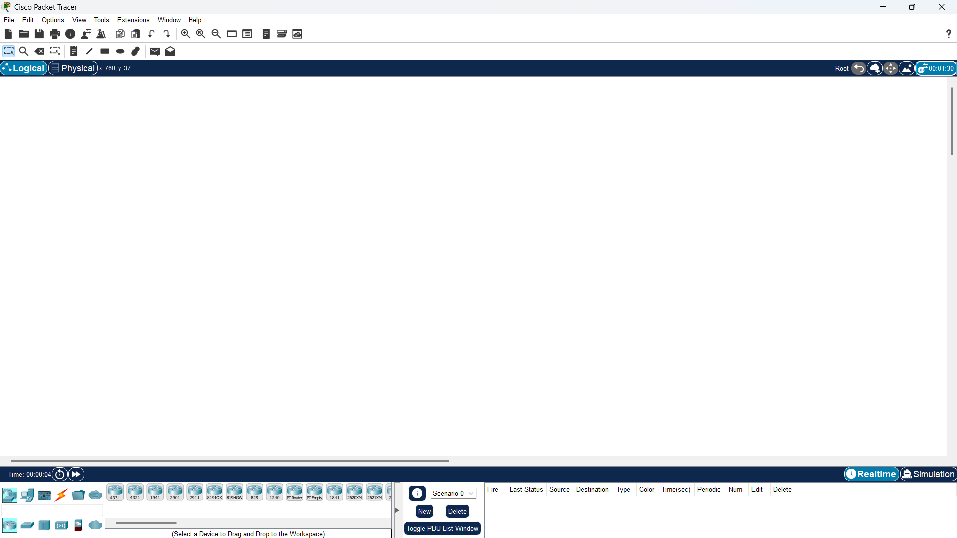
: It Is a home page of the tool from there we have diff section.
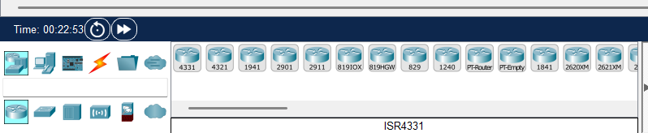
:From this section we can select various components like PC, laptops, switch, routers, wirings etc. From here we can just drag and drop or select and paste

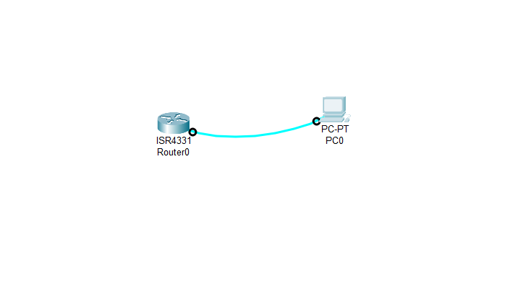
: Like this we can do connections between devices. And by clicking on them we can configure as per are expectation.
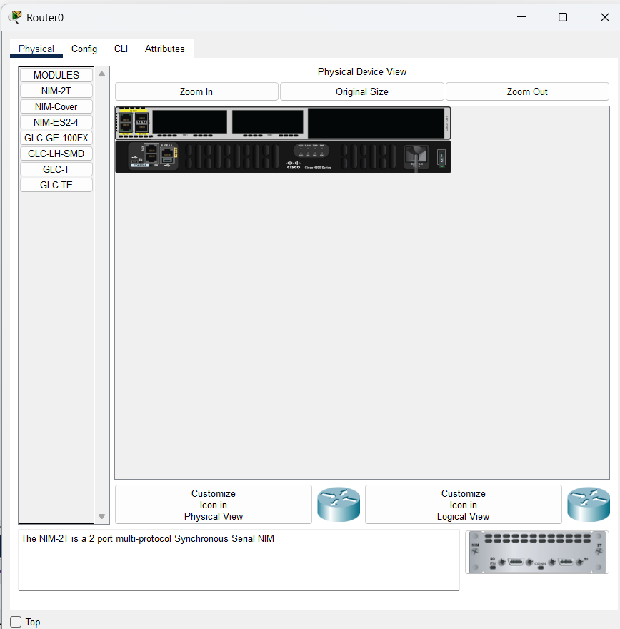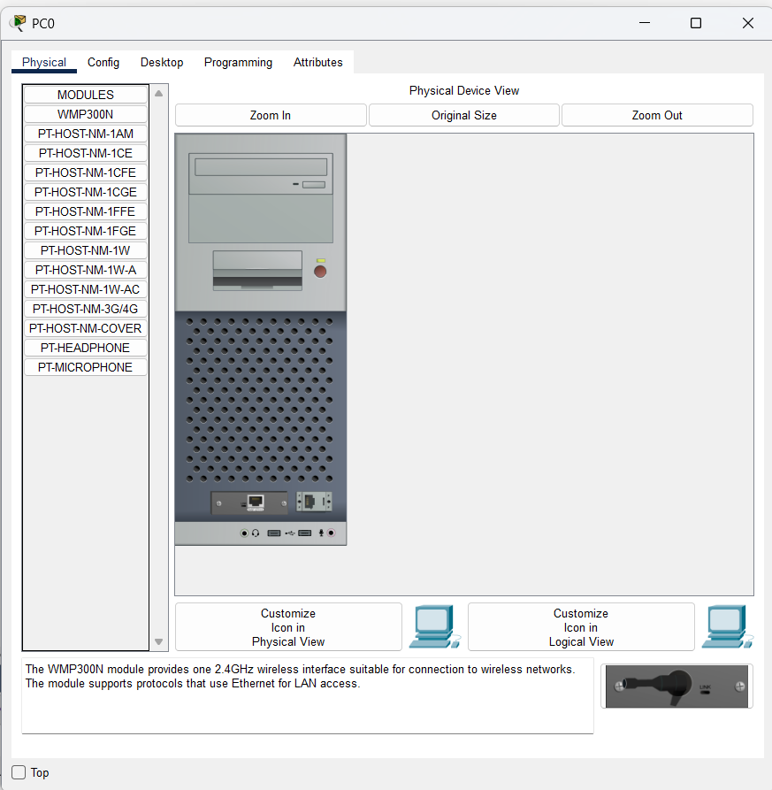
:These were the section appears after clicking on the devices, from the pc we can go to terminal wingow and fisdstly configure the termiinal configuration and perform CLI commands

some Functionalities:
Basic Network Topology Creation
- Drag and drop PCs, switches, and cables.
- Assign IP addresses and verify connectivity using ping.
- Ideal for learning basic LAN setup.
Router Configuration
- Configure router interfaces using CLI.
- Assign IP addresses and enable ports (no shutdown).
- Helps understand inter-network communication.

Conclusion: In this experiment, I explored a new tool named CISCO PACKET TRACER which is used for simulating the network and understood the concepts which are actually done in real world like connection between router and pc and how to configure the switch and routers. Tool has multiple section from there we can select whichever component along with the wirings for the communication.

