Aim:
Step 1: make physical connection of switch, and pc using straight copper cable

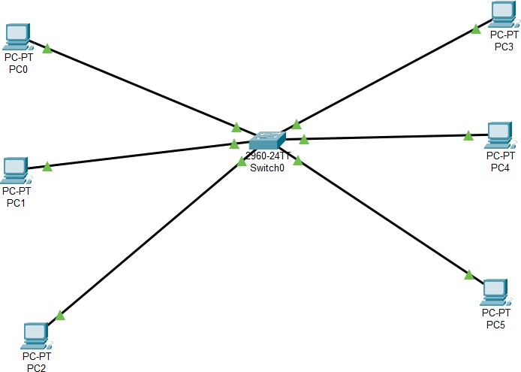

Step 2: assign IP add to all pc and check connectivity

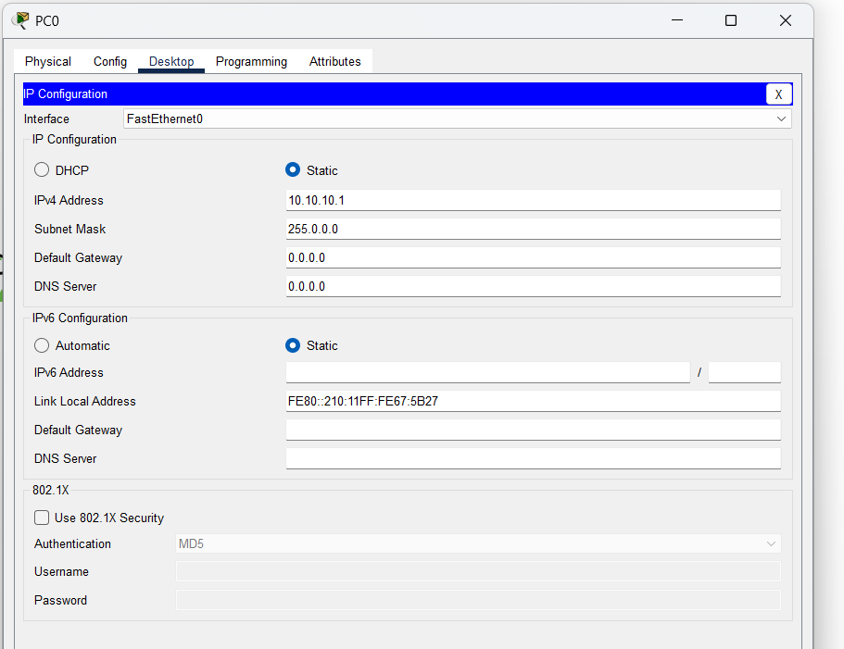
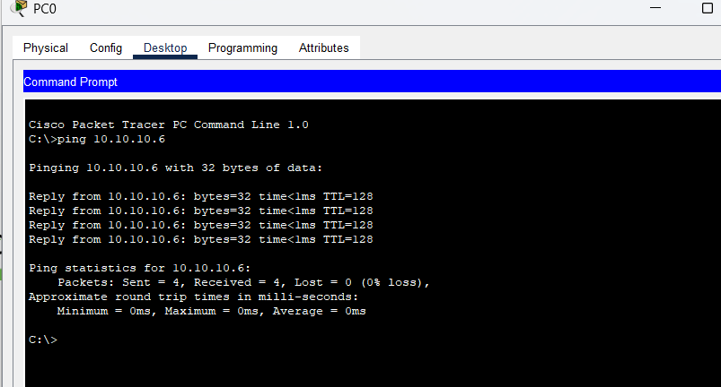

Step 3: first check default vlan status

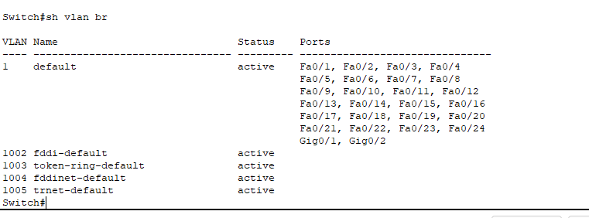
Here all the ports are in default vlan 1
Step 4: now create a new vlan 10 name student and assign ports from 1 to 10 to this vlan and another vlan 20 named faculty and assign the port to 11 to 20.
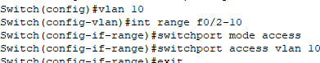
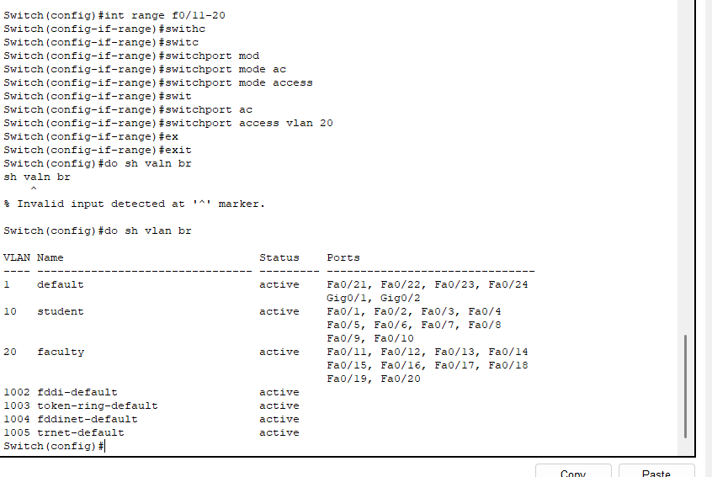

Step 6: lastly check the connectivity between pc inside the Vlan nad outside the vlan or in other vlan
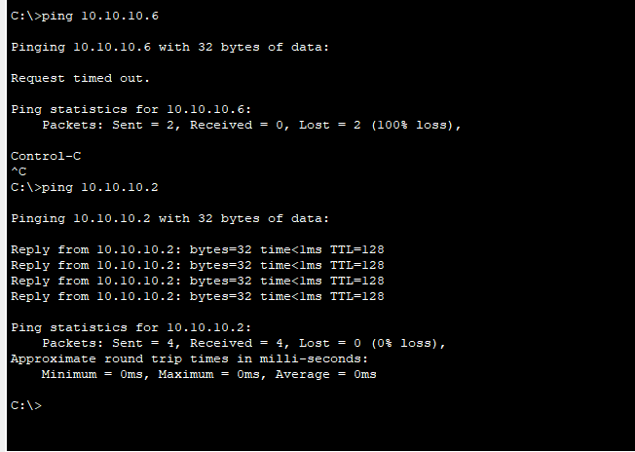

Note: if we have to remove the ports from the vlan, command is “no switchport access vlan no.”
Conclusion: In this I learnt about Vlan that is virtual LAN which divides the network into smaller isolate network. In this exp I have created 2 Vlan student and assign the port from 1 to 10 and 11 to 20 respectively. Using int range f0/1-10. And used command switchport mode access for assigning it access line(one user data on that line) and then using command “switchport access vlan 10” that for that whole vlan network we are assigning access line. After dividing into two VLan we cross check the connectivity at last so we can see that in VLan we have connectivity but not outside it.

