Aim: Experiment 12 - Monitor the live/real time network and analyze the concepts of various networking protocols like ARP, RARP, DHCP, HTTP, etc.
Step 1: firstly connect to router/wifi and start wireshark
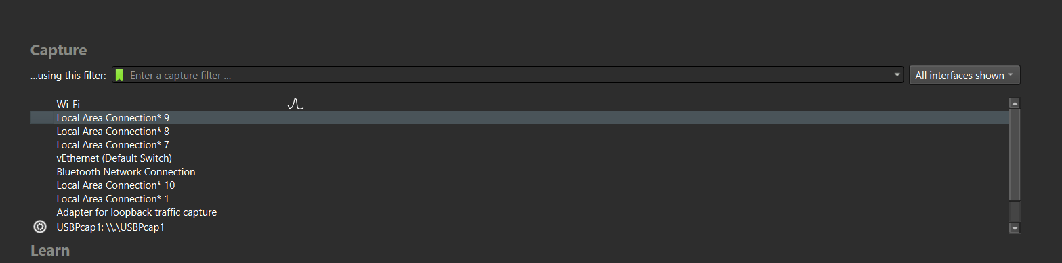
Step 2: double click on wifi and live capture will start
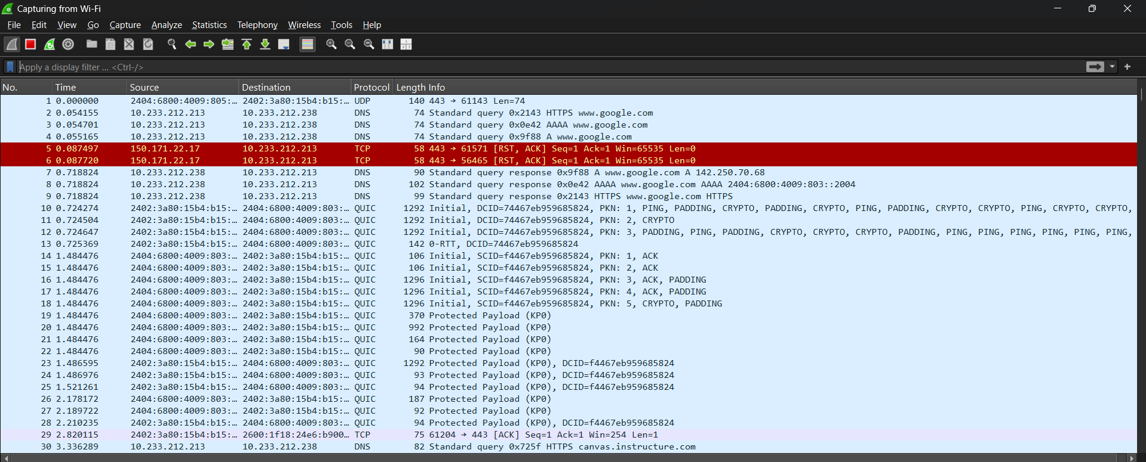
Step 3: On filter bar , search for any filter what ever you want to do
1.ARP
Understanding: Here Arp (address resolution protocol) works like this device broadcasting this Ip and asking which device has this Ip tell me, because directly device can’t get the mac using Ip that’s why ARP used, first packet is broadcasting in network that why color is

yellow,and in second packet the reply came from that device that “it is my Ip and this is my mac address” so reply will be unicast so it is in grey color. This process keep continues after every time out occurs
2. RARP
RARP (Reverse Address Resolution Protocol) is an obsolete protocol used to map MAC addresses to IP addresses. Modern networks no longer use RARP because DHCP performs this function. Therefore, no RARP packets were captured during the experiment.
3. DHCP
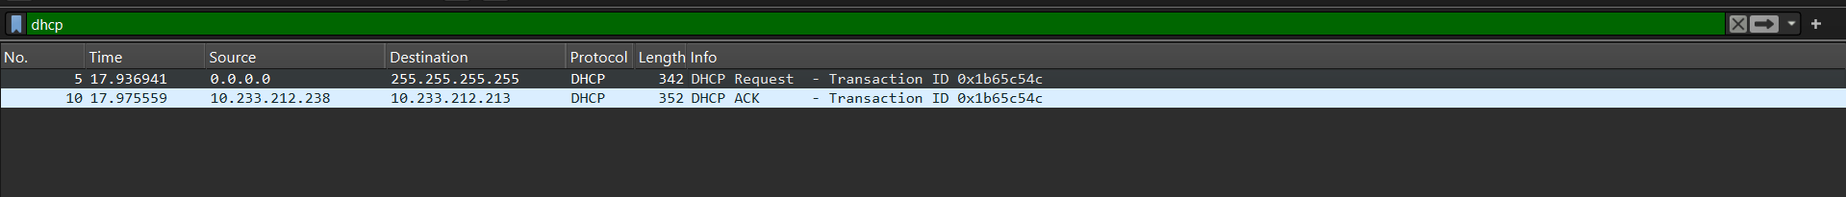
When my laptop is already known to WIFI that why is showing only 2 packets , just client requesting for the old Ip and dhcp allocating that Ip.
Then I release that ip and again check then I got 4 packets
D= discover
O= Offer
R=request
A= acknowledgement
Here first client will say I want Ip (broadcast packet)
Then dhcp will offer him Ip
Clent will confirm
And last dhcp will ack it that Ip confirm

4. HTTP
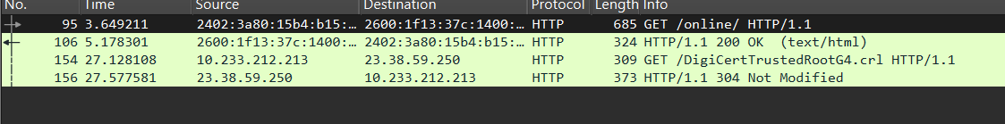
Here analysis is client is sending http request to server side in fist packet , in second packet response came from server status 200 ok, And type html/text means html page is successfully fetched

Conclusion: In this exp, I show the live traffic of network using Wireshark , where I show the Ip to mac accessing by ARP, how DHCP were assigning the Ip to any new or already connected client/device , also some http side request.

