Aim: Perform basic CLI commands to configure switch and router.

Step 1 : make physical connection between hardware

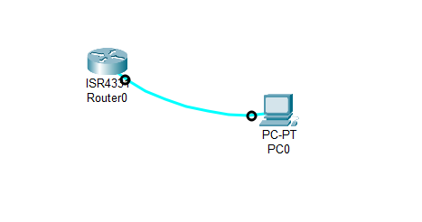
Step 2 : click the pc and go to the desktop and click the terminal and config the terminal first or set is as default
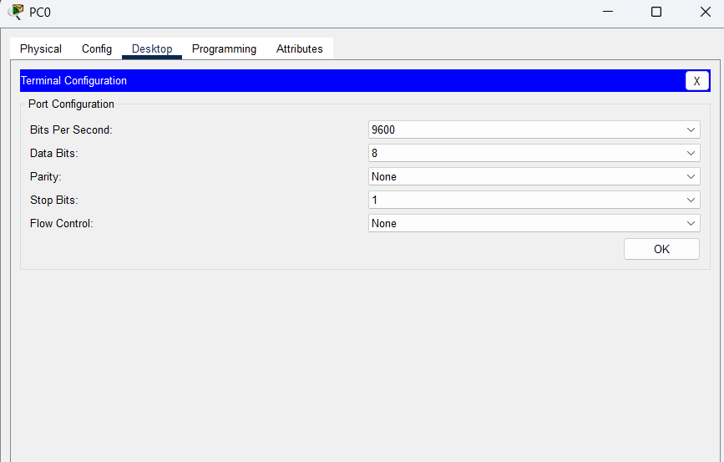
Step 3: hit the enter and terminal will be open or either direct CLI option form router itself can also open terminal for performing CLI commands
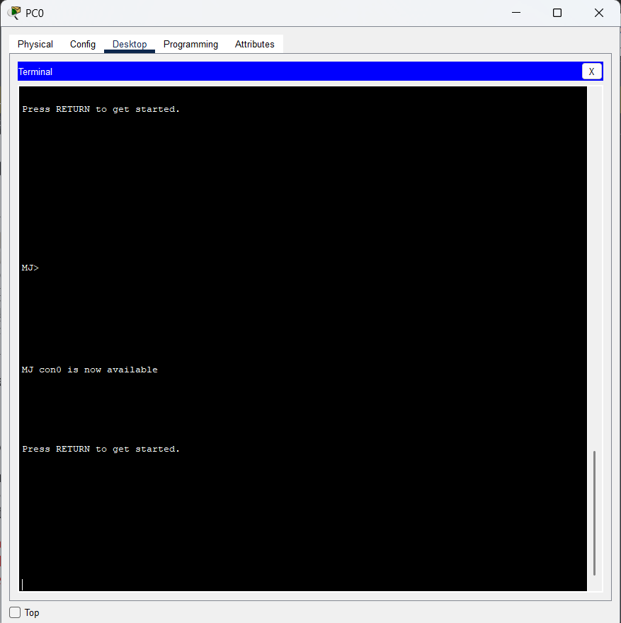

Step 4 : firstly we will in user mode ,perform some CLI commands to enter in diff mode , to go in privilege mode type “enable” or from that if want to enter in config mode then type “config t” and want to come back then “exit”
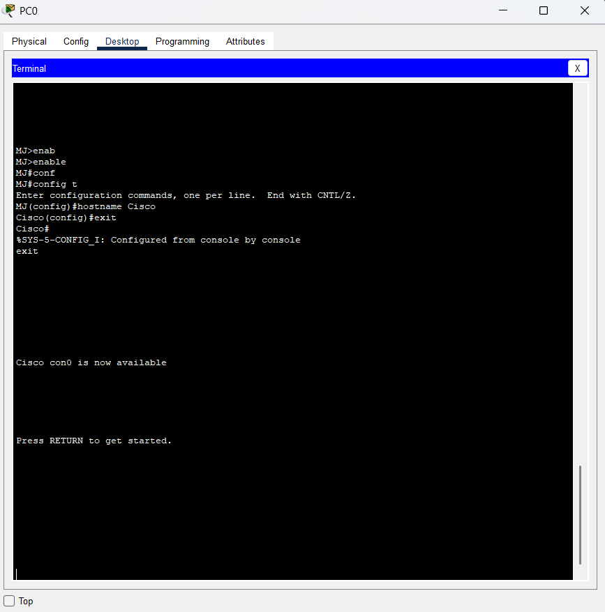
Step 6:perform some CLI commands
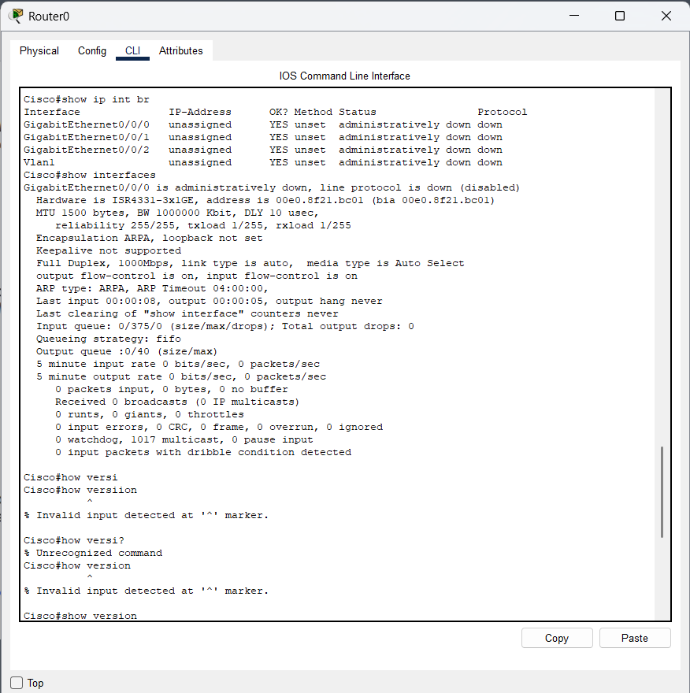
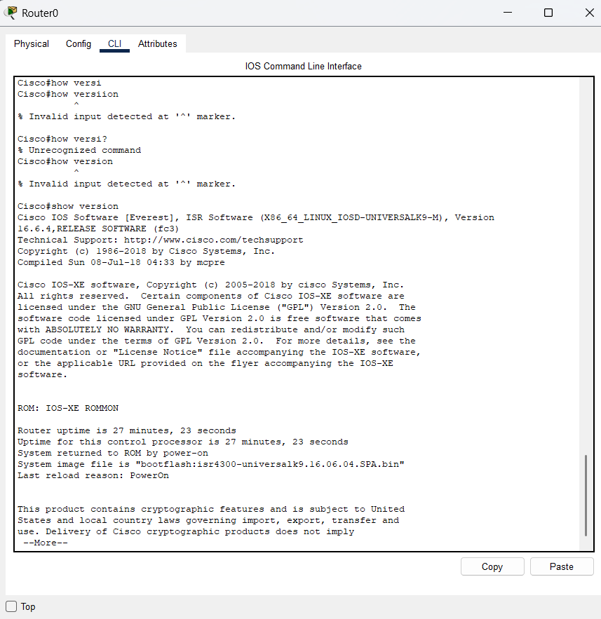
Conclusion: In this experiment, I have learnt about the connection between devices, also how to select hem form the given panel and where to fix the wires. How to configure the router or switch using console cable. Got to know about basics of CLI Commands how to switch between diff modes like USER to PRIVILEGE to CONFIGURE and revert also. Also perform some CLI commands for practice. How to open terminal and start applying the commands also we can do command from CLI tab already available in the router itself.

