Aim: Simulate star topology and check the connectivity between devices.

Topology: It shows the connection of networks, how every device is connected to each other.
Star Topology: it is type of connection where all devices are connected to one central device (Hub, Switch).

Step1: Make connection in star topology using straight through cable
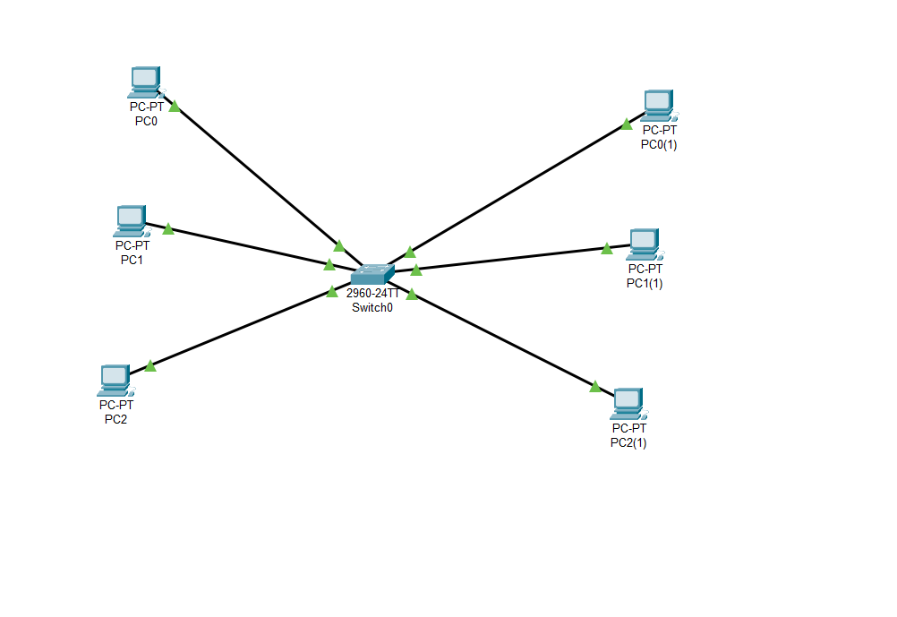
Step 2:assign of IP address to each pc
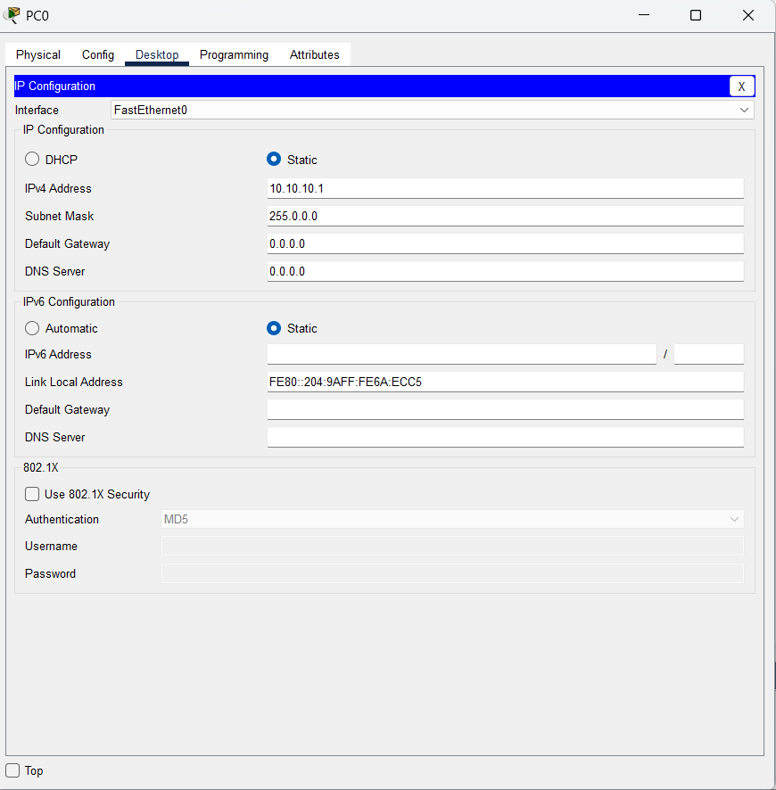
Step 3: verify the connection using ping command to check whether the connection is established or not
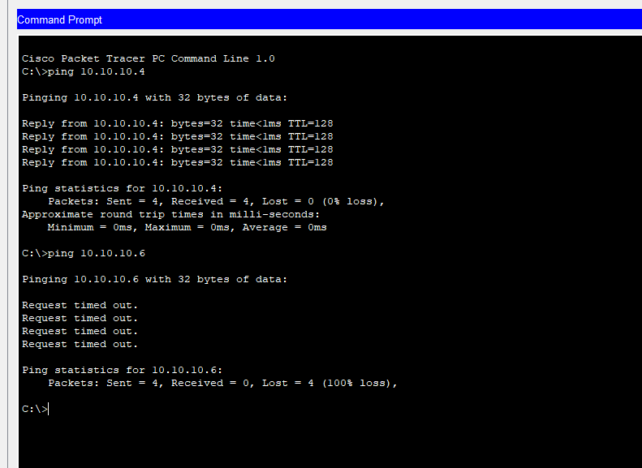
Here we can see the connection between 1st pc and 4th pc is established but for 6th pc it is giving timeout error because the IP add for pc 6th I have set it 11.10.10.6 so it is not the part of this network as all other are the part of network 10.
Conclusion: In this exp I got to know about topology int that I make the connection using star topology where I have used switch as a central device and check the connection between every pc by sharing packets or using ping command and passing the IP add as parameter. Timeout stands for packet was destroyed in between so TTL is 0,packet hasn’t received at receiver side because the IP add I passed as parameter which is not the part of the network.

