Aim: Monitor the live/real time network and analyze the concepts of various networking protocols like IP, TCP, UDP, etc.
Step 1: firstly connect to router/wifi and start wireshark
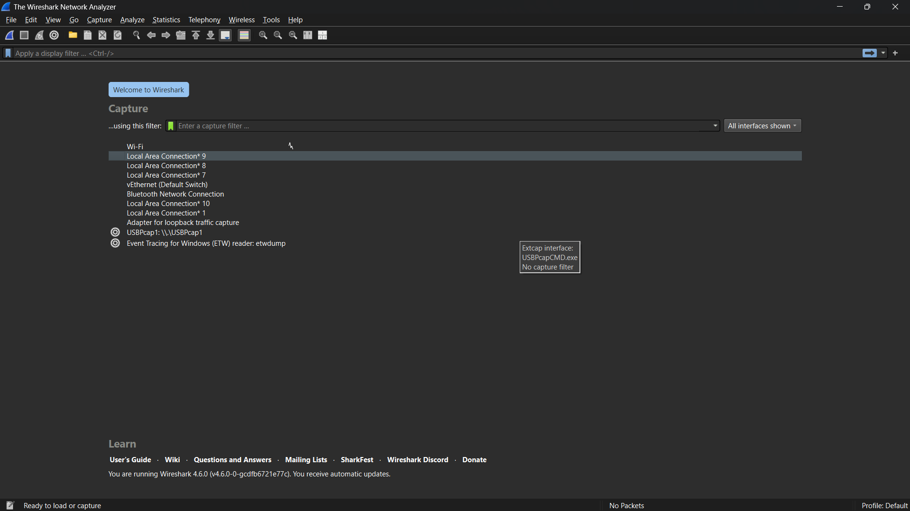

Step 2: Then there are many options , but beside that there is a graph , it shows that u are connected to that, In my case I have connected to wifi and graph is right side of WIFI.
Now double click on WIFI and there in few seconds lot many packets will be display.
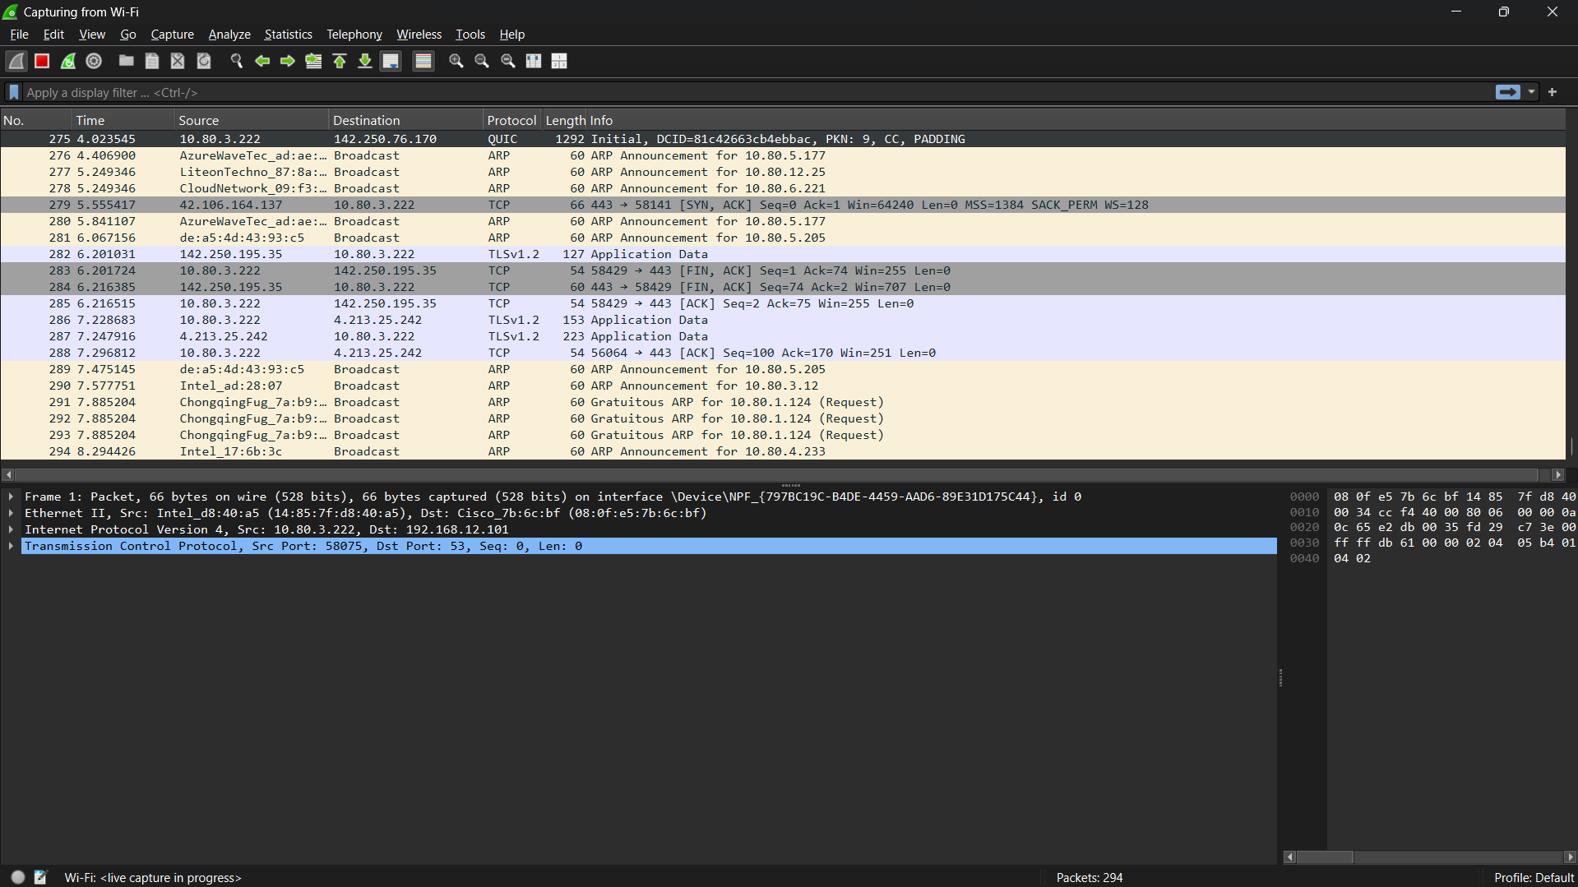
There are multiple panels, options available. Left side corner we have three options to start , end, restart the capture of packets.
In bottom panel mid side there is displaying the current package captured digits and it will keep increasing as u use the internet.
When u will click any packet it will show its information as we can see in above image.
Step 3: lets capture a site that I will open , lets I am opening youtube.com I my browser and look for it
As it is difficult to find for specific thing , so that’s why there is a option of filter , there we can use defined command to make things easier for us
For our task I am using this command : tls.handshake.extensions_server_name contains "youtube"
This command will just display things regarding to YouTube only
And here are the result
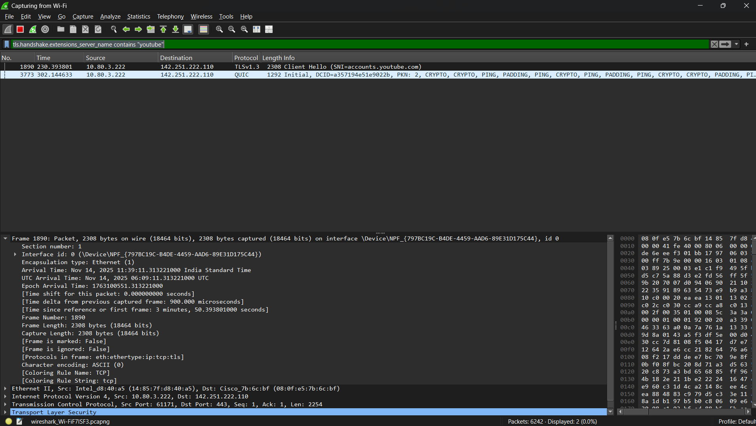
As we can see here I got the related packets for youtbube.com
In down side panel there are all details of it for example: In frame section there are the details of packet .
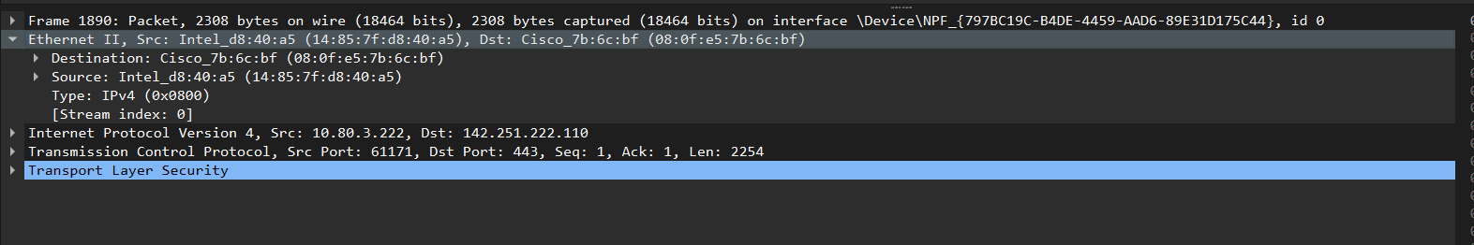Here in Ethernet 2 section there is our(src) Ip add and Destination Ip add which is of youtube side.
In TCP panel it is showing the port add of source and destination.
Step 4: Verify for TCP protocol
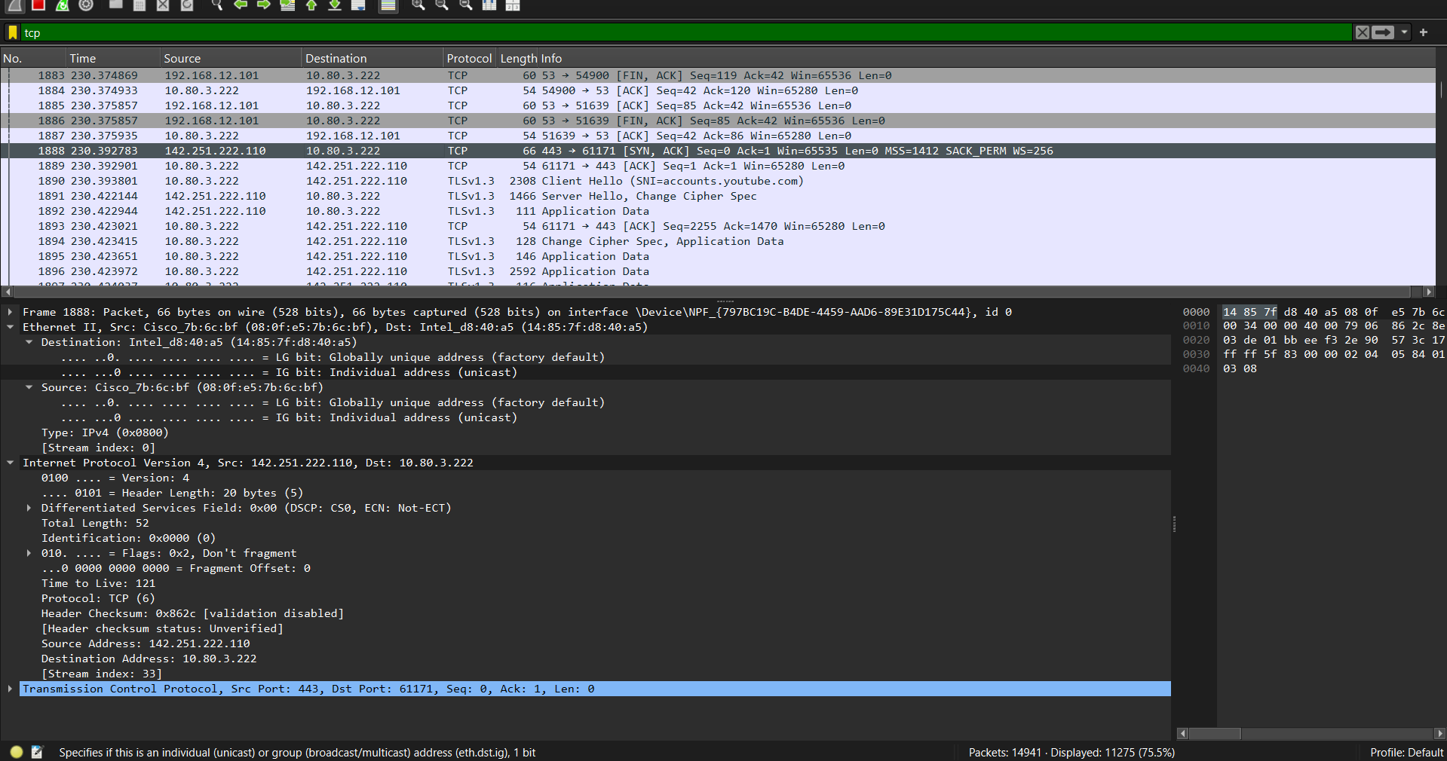

Here it is showing the TCP packets and here we can see the handshaking done by TCP.
Conclusion: In this exp I came to know about the connection between router and pc using switch and via remotely. Also, I learnt how to secure the router access using ‘enable secret’ command and console lines and remote access using ‘’password login’ command. After assigning IP add to one of the ports of router, we have to active it using ‘no shut’ command. Then checked the connectivity between pc and router using ‘ping’ command and then connect the router remotely using ‘telnet’ command and after running it asked for authentication.

