IoT Scenario: Here I have made an automatic speed controller for fan using temperature controller.
Components used: Fan, temperature monitor device, wireless router, a laptop and a server for IoT registration.

Step 1: Take all the components from the panel
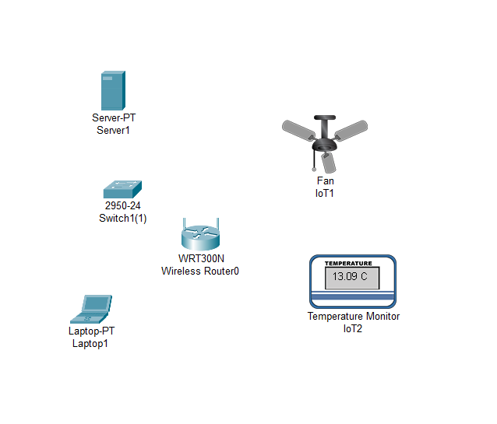

Step 2: Connect the router and switch with cross cable , and laptop and server to switch with straight copper cable.
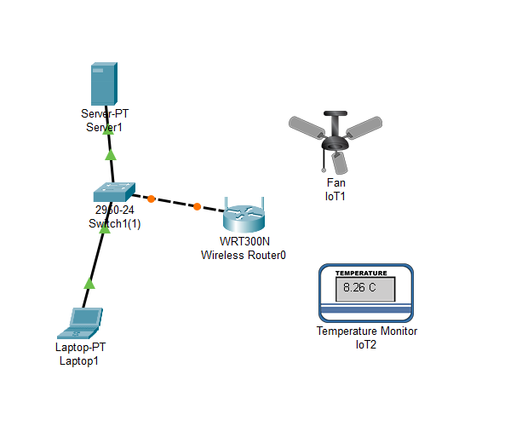

Conclusion: In this exp I learnt about the static routing protocol where it routes the router if request is come for specific router , need of this protocol is that when the request come with any IP router don’t where to route so wee need to configure using routing protocols.

