Aim:
Step 1: make physical connection of switch, and pc using straight copper cable
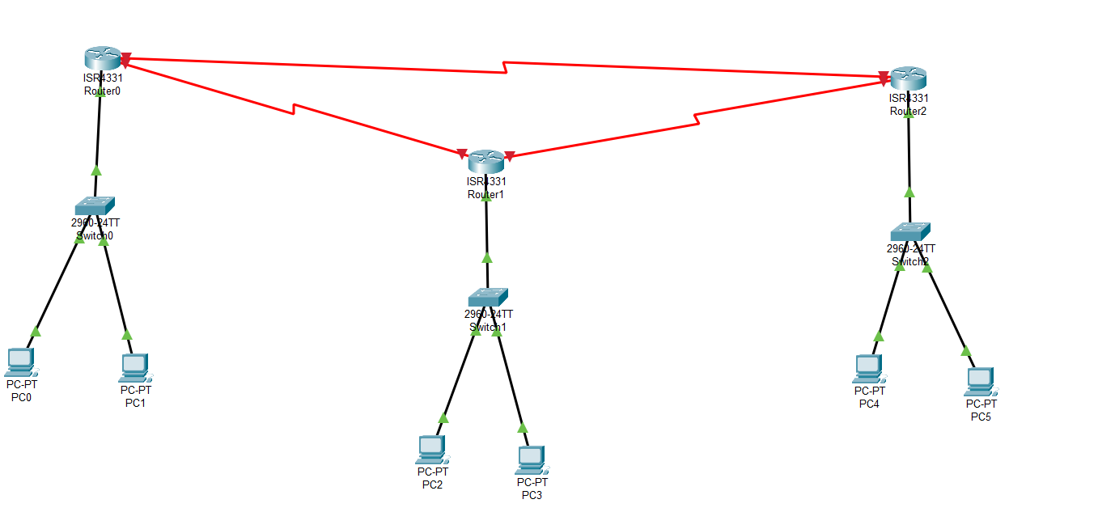

Step 2:assign the ip and configure the router and assign the ip to ports of router
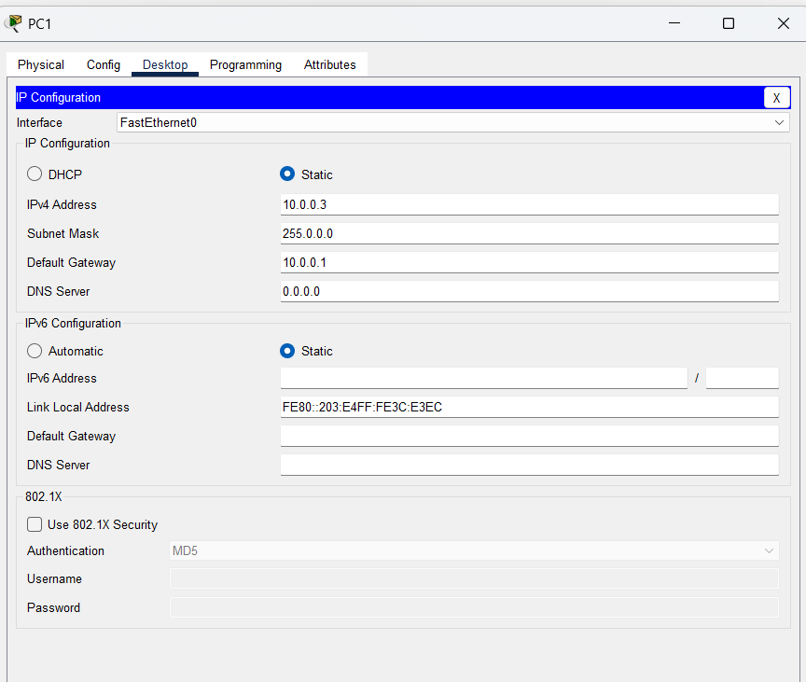
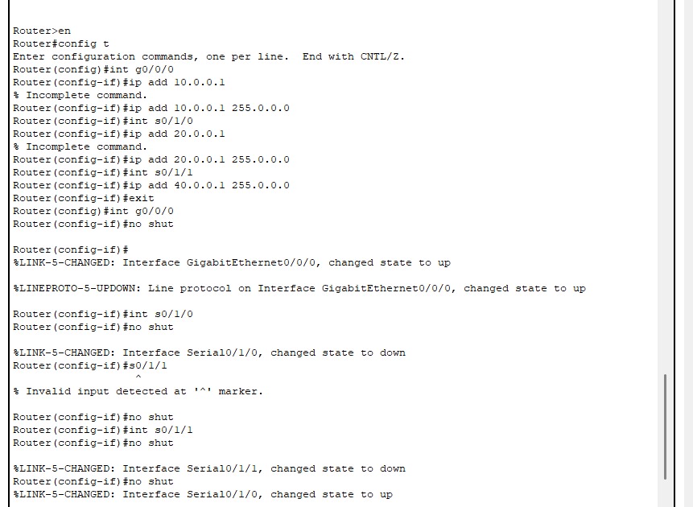

Step 3 : configure routing using RIP protocol (router info protocol) and inform the router about all those network which are directly connected
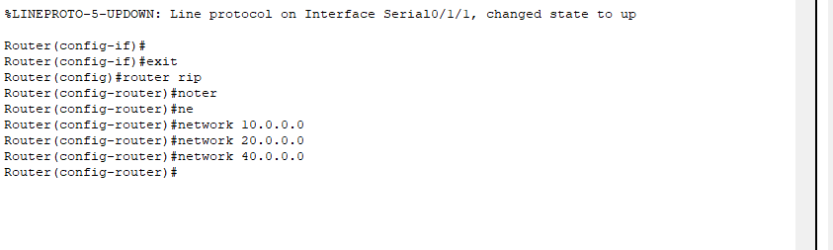
Using command router rip
network “ip address”
Step 4 : use command show ip route
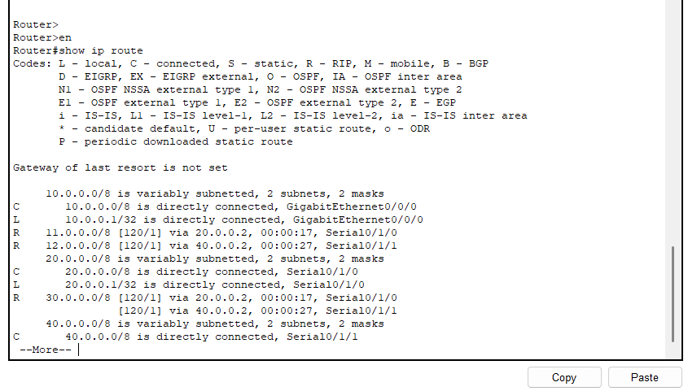
Here it will show the configuration how the ports are configured and how they are connected

Step 6 : check the connection between pcs
using ping command and tracert(shows the path which path it will take to reach to destination (shortest))

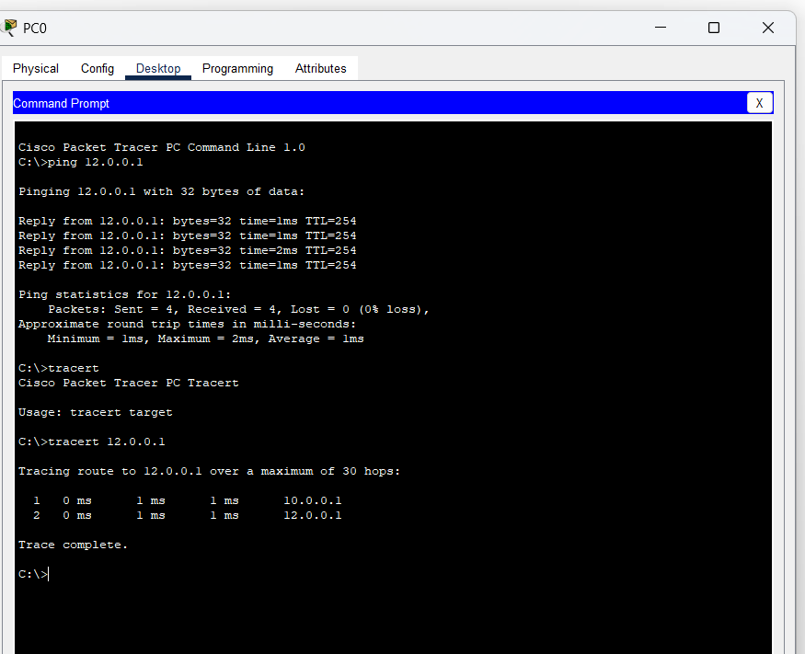

Step 7 : down one of the port and recheck the route
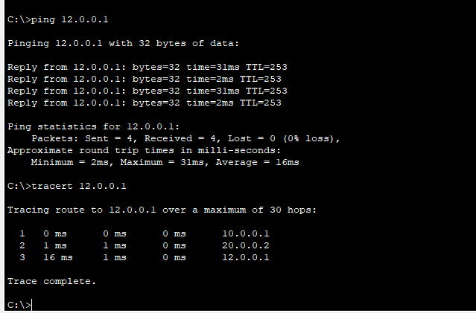
So now it took another available shortest route .
Conclusion: In this experiment , I got to know about dynamic routing in which I learnt about RIP protocol (route information protocol ) here we have to make router informed about those all networks which are connected directly to that router using router rip and network “ip add” commands . and then “show ip route ” it shows routing connection and tracert uses to show the route which follows to take the package from receiver to destination .`

