Aim:

Step 1: make physical connection of switch, and pc using straight copper cable and serial cable
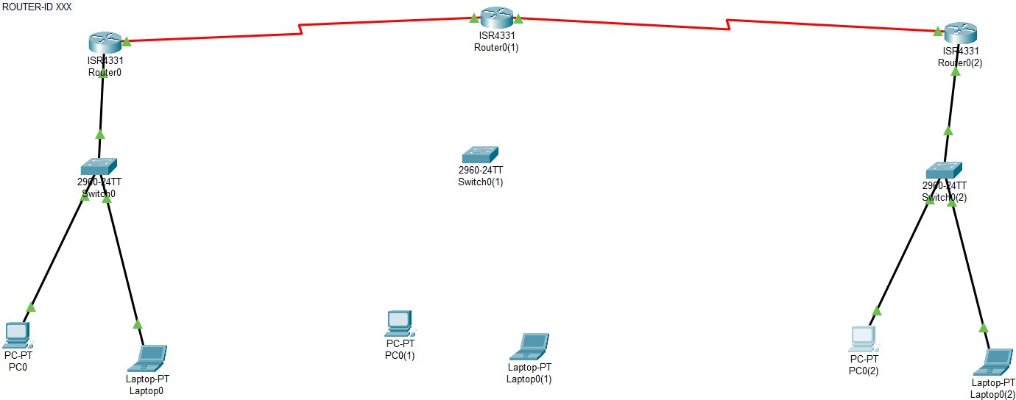

Step2: assign the ip add to pc and port of router

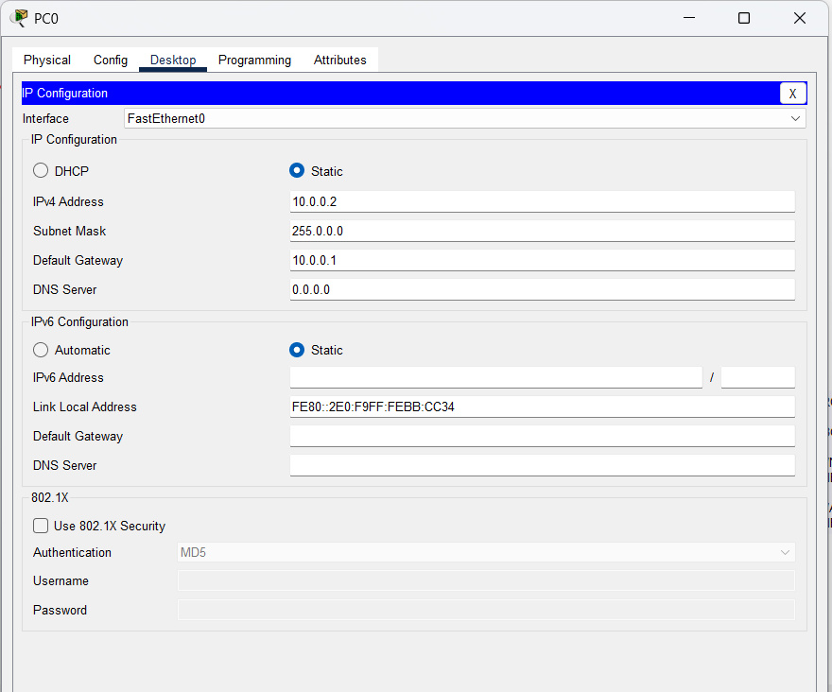
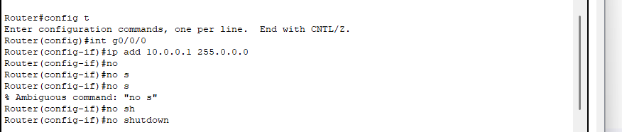
Step 3 : perform BGP protocol ,first assign Autonomous system number to router and then assign id number then then acknowledge the router of directly connected routers and networks using commands :

ROUTER BGP 20

BGP ROUTER-ID 2.2.2.2

//NEIGHBOURS
NEIGHBOUR (NEXT CONNECTED ROUTER'S IP-ADD) REMOTE-AS (NUM)

//ASSIGN THE NETWORK CONNECTED DIRECTLY TO ITSELF USING COMMAND: NETWORK (N-ID)

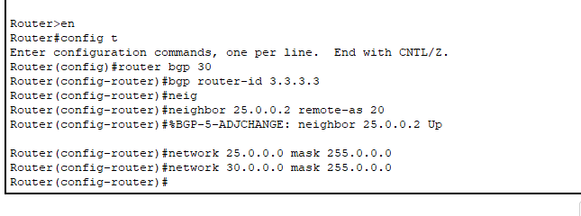

Extra: if we want to change the AS num after once assigned , it will not directly change , use command “no router bgp x”.

Step 4 : check the connection
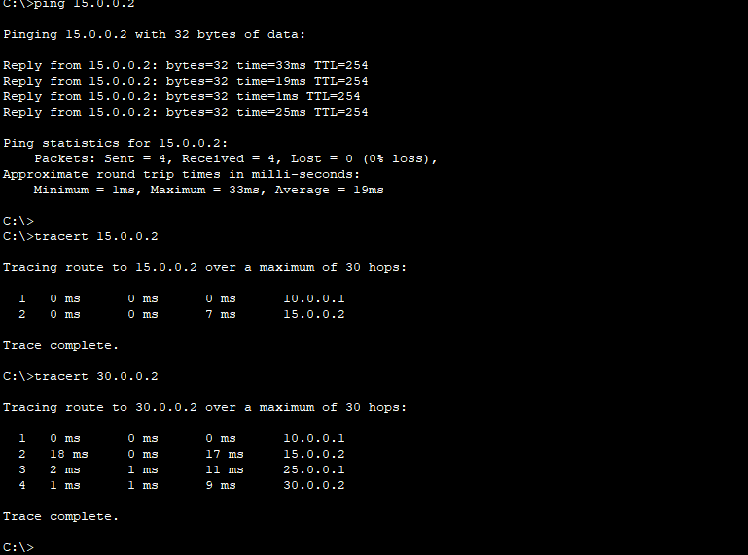

Conclusion: In this exp, I got to know about the another dynamic protocol which is BGP (Border Gateway Protocol), in this there are some new terms like autonomous num, id num , here we are doing the same, acknowledging the router about those router and networks which are connected directly to itself. And as mentioned command I am routing the touter using bgp protocol.

