Aim:
Step 1: make physical connection of switch, and pc using straight copper cable and serial cable
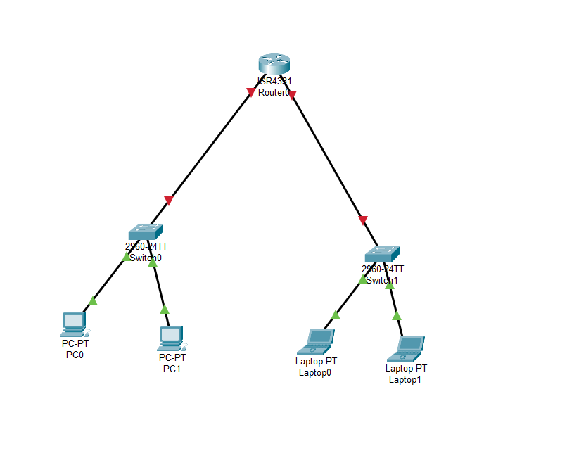

Step 2: assign the ip to routers port

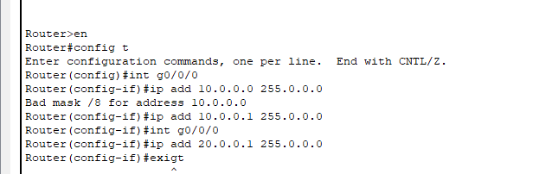

.

Step 3: Now route using dhcp protocol ans we exclude the port address from that network so it will not assign to any other device and tehn we create a pool and assign the network ip , then we assign default router gateway then dns , so by doing this it will automatically assign ip add , subnet mask, gateway , and dns server to it when u click dhcp instead of static in ip config tab of end device

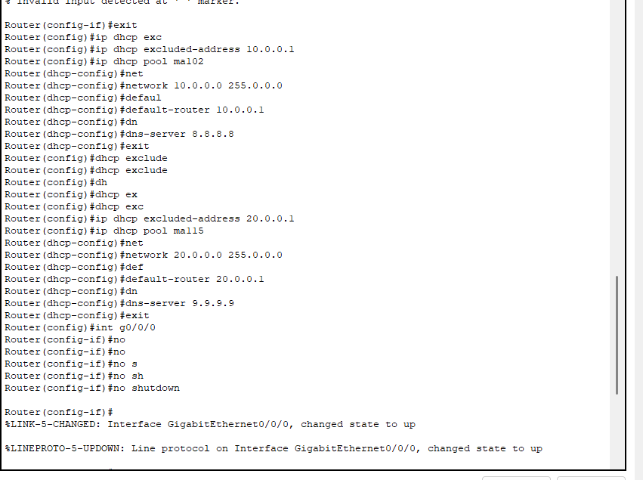
Step 4: Verify the connection
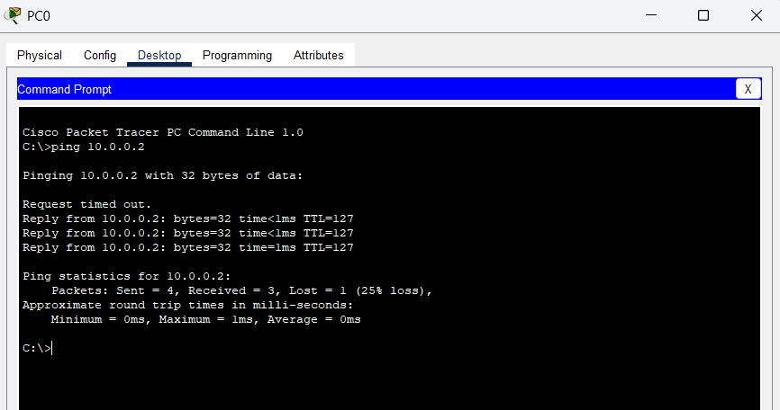

Conclusion: In this exp , I learnt about another dynamic protocol i.e., DHCP(dynamic host configuration protocol) in which we tell the router to assign ip add, subnet mask , gateway and DNS server to all end device which are in its network via dhcp commands. In this we first exclude a network which is already assigned to the port of router and then make a pool of remaining networks and also tell the default gateway and dns.
By doing this router will now automatically assign ip add , subnet mask, gateway and dns to existing as well as newly connected end devices .

