Data-Driven detection of Abnormal Electricity usage in Power supply Lines

By
Milan Jani (92301733041)

Under the guidance of

Prof. Nishith Kotak

A Project Submitted to
Marwadi University in Partial Fulfillment of the Requirements for the subject
Artificial Intelligence (01CT0616)

May 2026



MARWADI UNIVERSITY
Rajkot-Morbi Road, At & Po. Gauridad,
Rajkot-360003, Gujarat, India

Table of Contents
Section | Page No.
ABSTRACT | 3
1. INTRODUCTION | 3
1.1 Problem Statement | 3
1.2 Relevance to AI | 3
1.3 Objectives | 3
1.4 Scope of the Project | 3
2. METHODOLOGY | 4
2.1 AI Techniques Used | 4
2.2 Dataset Details | 4
2.3 Data Preprocessing | 4
2.4 Models Trained | 4
2.5 Tools & Libraries | 5
2.6 Evaluation Metrics | 5
3. SYSTEM DESIGN AND ARCHITECTURE | 6
3.1 Block Diagram / Flowchart | 6
3.2 Data Pipeline | 6
3.3 Modules or Components | 7
3.4 Model Selection Logic | 7
4. IMPLEMENTATION | 8
4.1 Code Snippets | 8
4.2 Output | 10
5. DISCUSSION | 12
5.1 Summary of Work | 12
5.2 Challenges Faced | 13
5.3 Success Criteria | 13
5.4 Limitations | 13
6. FUTURE WORK | 14
6.1 Scope for Improvements | 14
6.1.1 Technical Enhancements | 14
6.1.2 System Enhancements | 14
6.1.3 Data Improvements | 14
6.2 Real-World Deployment Strategies | 14
6.2.1 Phased Implementation | 14
6.2.2 Infrastructure Setup | 15
6.2.3 Performance Tracking | 15
7. APPENDIX | 15

ABSTRACT: Electricity theft through illegal meter bypassing causes significant revenue losses in power distribution systems, especially in developing countries. This project develops a machine learning solution to automatically detect abnormal electricity consumption patterns indicating potential theft. Using a dataset of 5,000 consumption records with class imbalance (85% Normal, 15% Abnormal), we trained and compared nine models including Random Forest, XGBoost, and AdaBoost. After applying SMOTE for class balancing, AdaBoost achieved the best theft detection performance with 76.4% recall and 79.9% accuracy—a 125% improvement over baseline methods. Though precision was lower (40.9%), this trade-off is strategic since missing actual thefts is costlier than false alerts. The trained model was deployed as a real-time inference system, demonstrating how ensemble methods effectively solve imbalanced classification problems in power utility anomaly detection.
Keywords: Electricity theft detection, Machine learning, Class imbalance, SMOTE, Ensemble methods

- INTRODUCTION:
1.1 Problem Statement
Electricity theft through illegal meter bypassing causes huge financial losses to power companies in developing countries. Manual inspection methods are slow and ineffective. We need an automated system to detect abnormal consumption patterns automatically.
1.2 Relevance to AI
This is perfect for machine learning because:
- Theft creates distinctive patterns in data that ML models can learn
- AI can process thousands of meters simultaneously, unlike manual inspection
- Models can adapt to new theft techniques over time
- Handles real-world imbalanced data (85% normal, 15% abnormal) using techniques like SMOTE
1.3 Objectives
- Build a ML model to detect abnormal electricity consumption
- Compare multiple algorithms (Random Forest, XGBoost, AdaBoost, etc.)
- Use SMOTE to handle class imbalance
- Deploy a real-time prediction system
- Achieve high theft detection rate
1.4 Scope of the Project
Included: 5,000 synthetic data records, EDA, preprocessing, 9 models trained, SMOTE balancing, real-time inference module
Not Included: Real meter data, integration with actual utility systems, deep learning, deployment strategy

- METHODOLOGY
2.1 AI Techniques Used
This project uses Supervised Machine Learning approach for binary classification (Normal vs Abnormal electricity consumption). We focused on ensemble methods and traditional ML algorithms rather than deep learning since the dataset is structured/tabular and not image/sequence-based.
2.2 Dataset Details
1. Source & Size:
- Synthetic dataset of 5,000 electricity consumption records
- Generated with realistic feature distributions and intentional class overlap
- Class distribution: 85% Normal (4,250 records), 15% Abnormal (750 records)
2. Features (8 input + 1 target):
- Voltage_V, Current_A, Power_W, Power_Factor (continuous electrical parameters)
- Season, Time_of_Day (categorical features)
- Delta_I (rate of current change), Anomaly_Duration_min (key theft indicators)
- Label (target: Normal=0, Abnormal=1)
3. Data Split: 70% training (3,500), 30% testing (1,500) with stratification
2.3 Data Preprocessing
- Dropped Timestamp - Not useful for classification
- Label Encoding - Converted categorical features:
- Season: Spring→0, Winter→1
- Time_of_Day: Afternoon→0, Evening→1, Morning→2, Night→3
- Standardization - Applied StandardScaler to normalize all features to zero mean, unit variance
- Class Imbalance Handling - Used SMOTE (Synthetic Minority Oversampling Technique):
- Original training: 2,975 Normal, 525 Abnormal
- After SMOTE: 2,975 Normal, 2,975 Abnormal (50:50 balanced)
2.4 Models Trained
- 9 Machine Learning Algorithms:
- Logistic Regression (baseline)
- Random Forest (500 estimators, max_depth=12)
- Gradient Boosting (500 estimators, learning_rate=0.05)
- XGBoost (100 estimators)
- LightGBM (gradient boosting framework)
- Artificial Neural Network (3 hidden layers: 64-32-16 neurons)
- Extra Trees (extremely randomized trees)
- AdaBoost (adaptive boosting ensemble)
- Voting Classifier (ensemble of RF + AdaBoost)
Training Approach:
- Models trained on SMOTE-balanced data
- 5-fold cross-validation for robust evaluation
- Tested on original imbalanced test set for real-world performance
2.5 Tools & Libraries
Python Ecosystem:
- Data Processing: Pandas, NumPy
- ML Models: Scikit-learn (Logistic Regression, Random Forest, Gradient Boosting, ANN, Extra Trees, AdaBoost, Voting Classifier)
- Advanced Models: XGBoost, LightGBM
- Class Balancing: Imbalanced-learn (SMOTE)
- Visualization: Matplotlib, Seaborn
- Model Serialization: Joblib (for saving/loading trained models)
2.6 Evaluation Metrics
Models evaluated on: Accuracy, Precision, Recall, F1-Score, Confusion Matrix, ROC-AUC curves
Selection Criteria: Recall prioritized over accuracy (catching actual thefts is more important than avoiding false alarms)

- System Design and Architecture
3.1 Block diagram / Flowchart
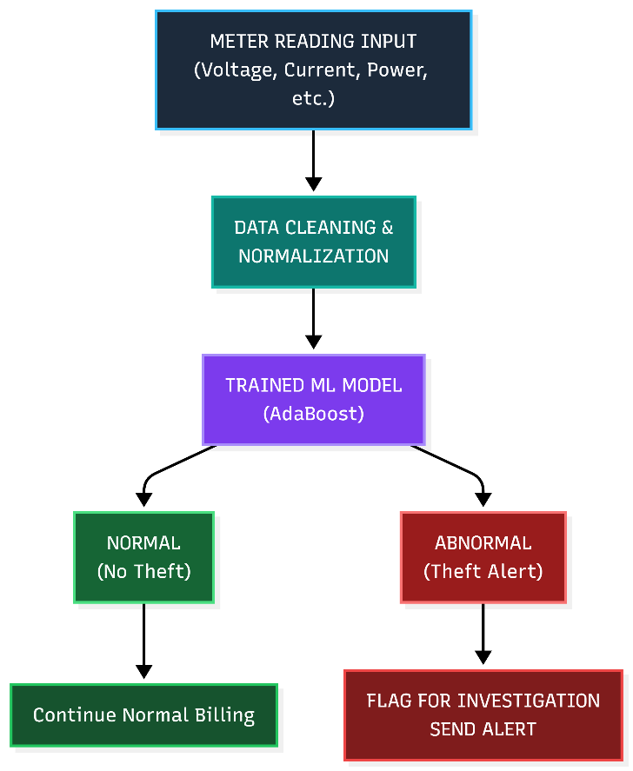
Figure 1: System Flow

3.2 Data pipeline (collection → processing → output)
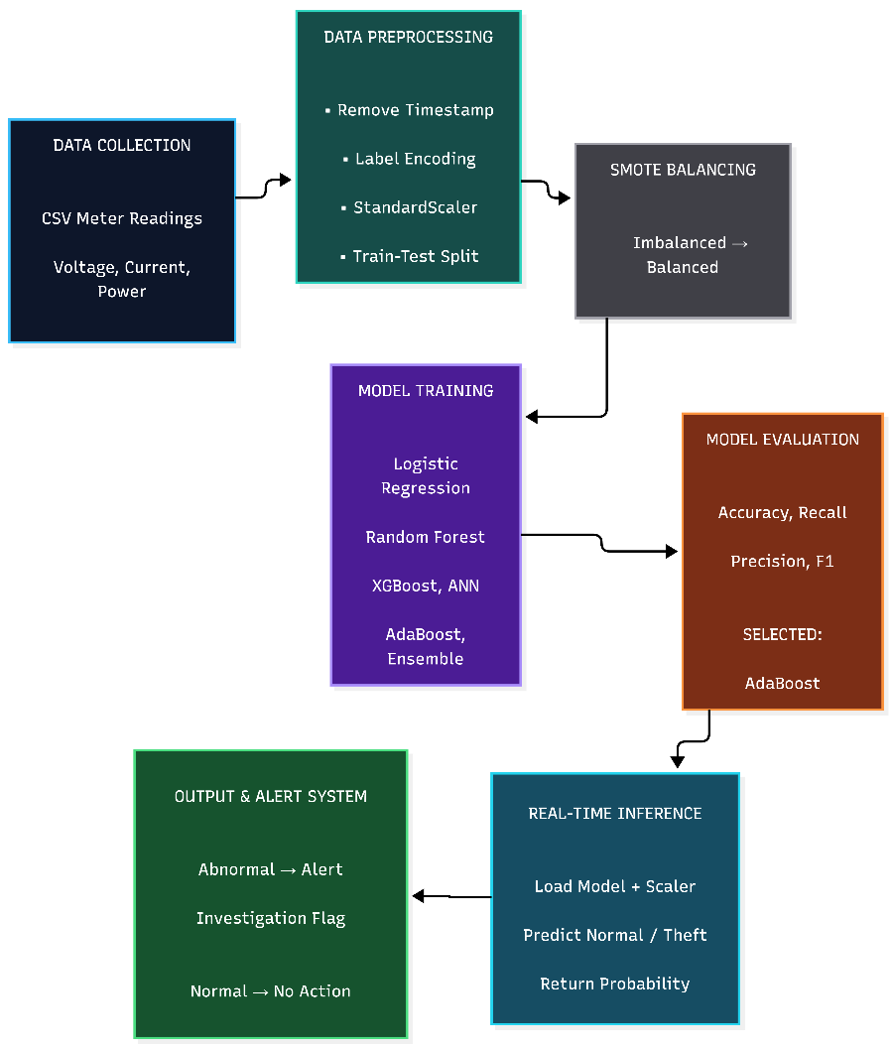
Figure 2: Data Pipeline
3.3 Modules or components
Component 1: Data Input Module
- Accepts electricity meter readings in CSV format
- 8 input features (Voltage, Current, Power, Power_Factor, Season, Time_of_Day, Delta_I, Anomaly_Duration_min)
- No data cleaning needed (synthetic data is clean)
Component 2: Preprocessing Module
- Removes irrelevant columns (Timestamp)
- Converts categorical variables to numeric using Label Encoding
- Normalizes features using StandardScaler (mean=0, std=1)
- Maintains consistency with training data preprocessing
Component 3: SMOTE Balancing Module
- Addresses class imbalance problem (85% Normal, 15% Abnormal)
- Generates synthetic samples for minority class (Abnormal)
- Creates balanced training distribution (50% Normal, 50% Abnormal)
- Applied only on training data, never on test data
Component 4: Model Training & Selection Module
- Trains 9 different ML algorithms on balanced data
- Performs 5-fold cross-validation for reliability
- Compares performance across all metrics
- Selects AdaBoost as champion model (best recall = 76.4%)
- Serializes selected model using Joblib
Component 5: Inference & Prediction Module
- Loads pre-trained AdaBoost model and Scaler
- Takes new meter readings as input
- Applies identical preprocessing steps
- Outputs prediction (Normal/Abnormal) with probability confidence
- Supports batch and real-time predictions

3.4 Model Selection Logic
Table 1.1: 9 Trained Models Comparison (on SMOTE)
Model | Accuracy | Recall
Logistic Regression | 78.1% | 75.1%
Random Forest | 85.3% | 68.9%
Gradient Boost | 85.8% | 65.3%
XGBoost | 86.1% | 60.4%
LightGBM | 86.1% | 64.4%
ANN | 80.9% | 55.1%
Extra Trees | 85.4% | 54.7%
AdaBoost | 79.9% | 76.4%
Voting Ensemble | 85.4% | 62.7%

Decision: SELECT AdaBoost
Reason: Highest Recall (76.4%) - catches 3 out of 4 actual thefts
Trade-off: Lower precision (40.9%) acceptable because:
- False Negatives (missed theft) = Revenue loss
- False Positives (alert) = Cheap to investigate

4. Implementation
4.1 Code Snippets
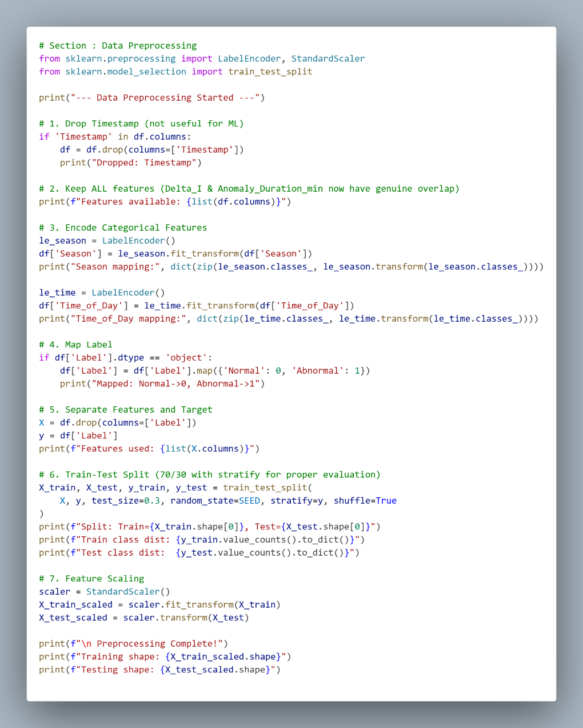
Figure 3: Data Preprocessing
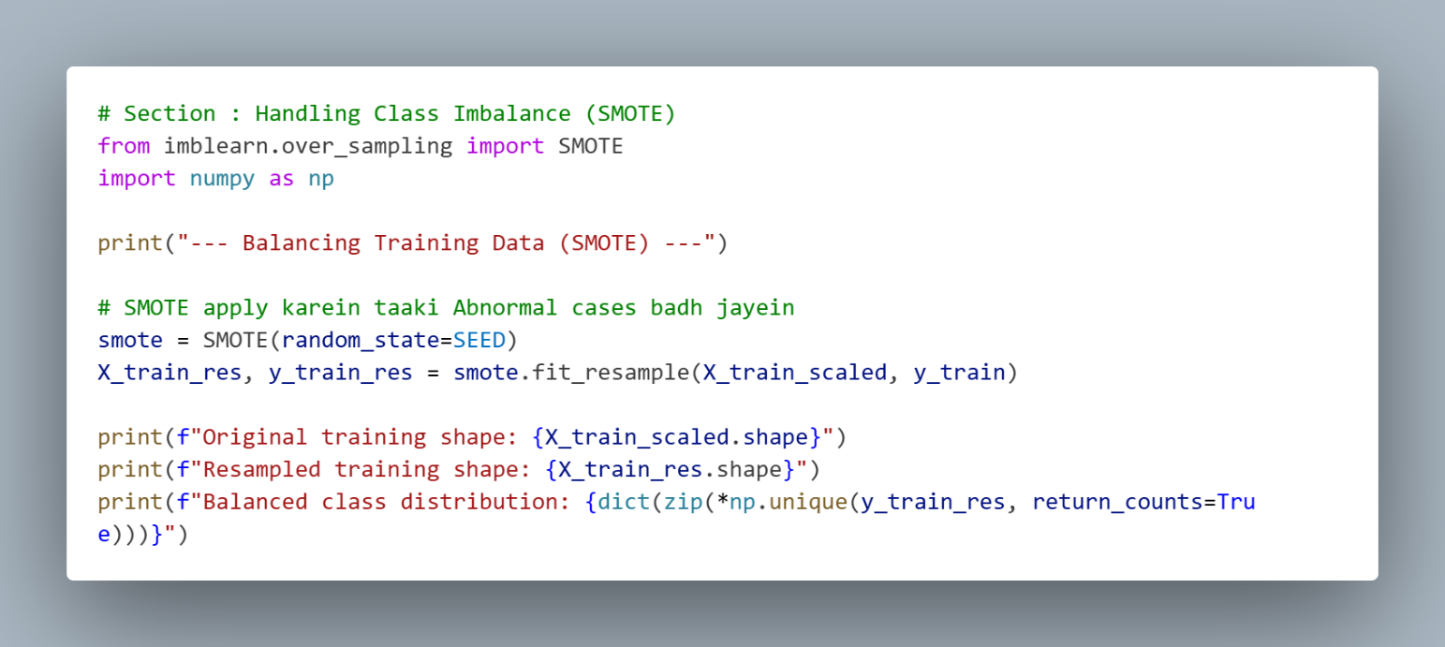
Figure 4: Applying SMOTE Method

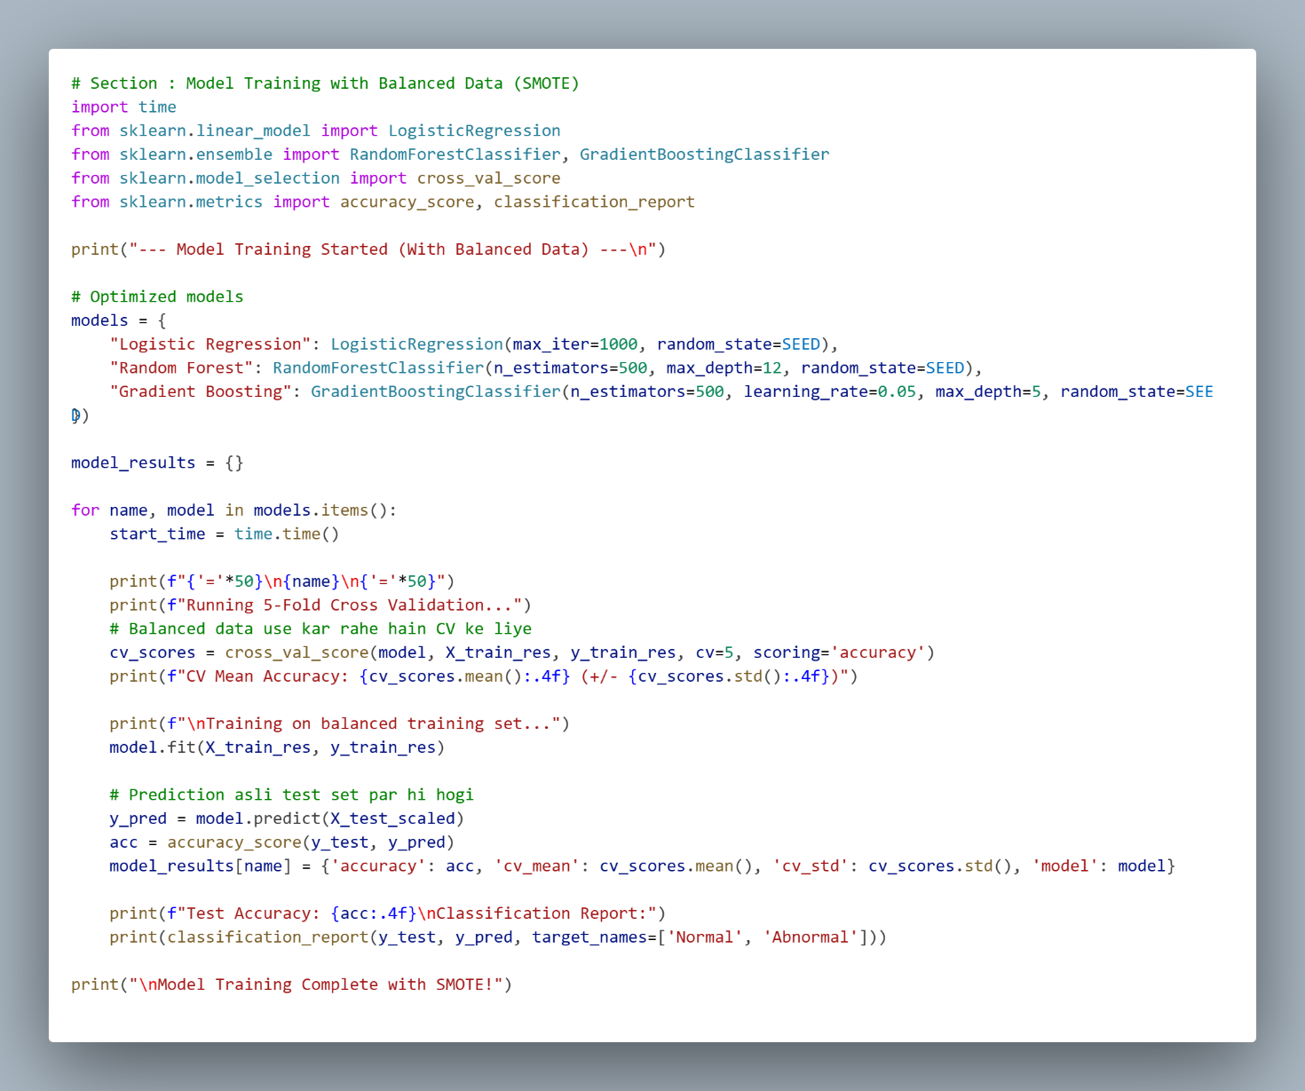
Figure 5: Training the model on Balanced data
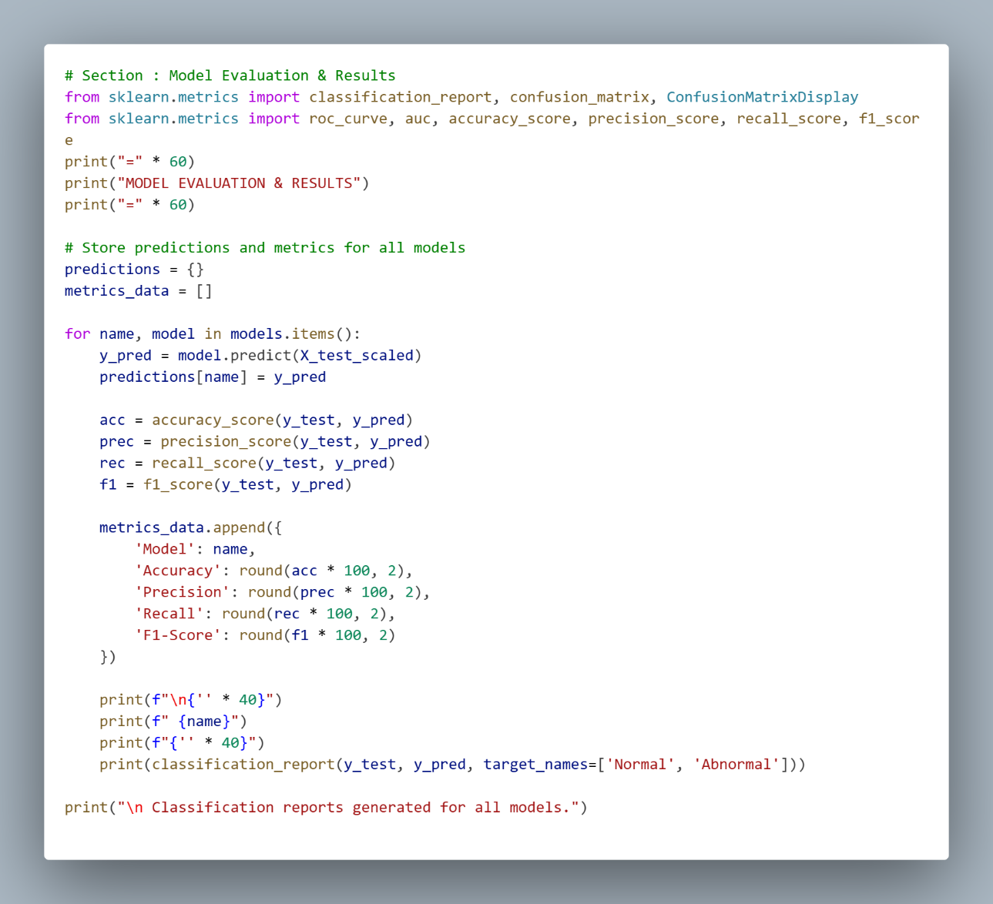
Figure 6: Model Evaluation & Result
4.2 Output:
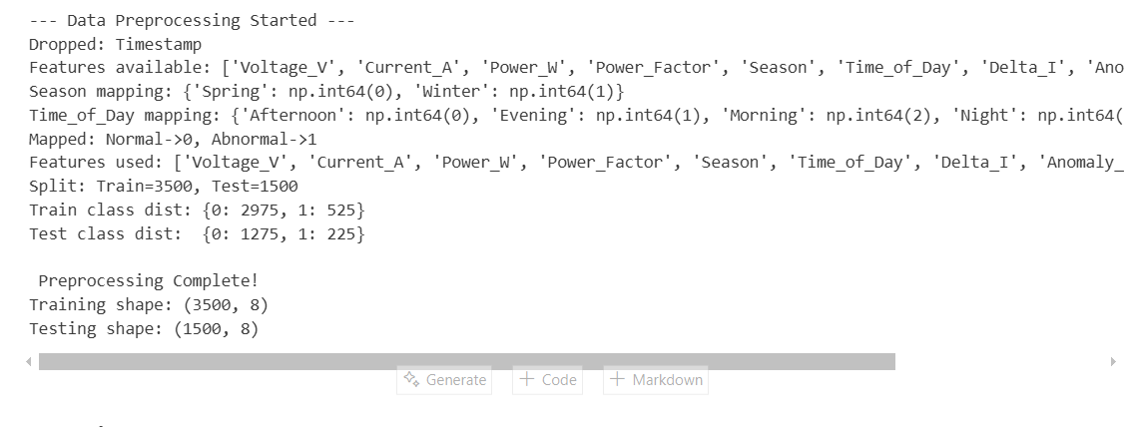
Figure 7: Output of Data Preprocessing part
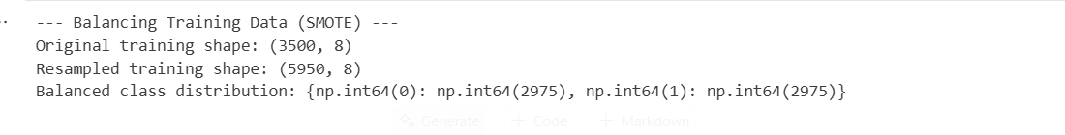
Figure 8: Output of SMOTE method
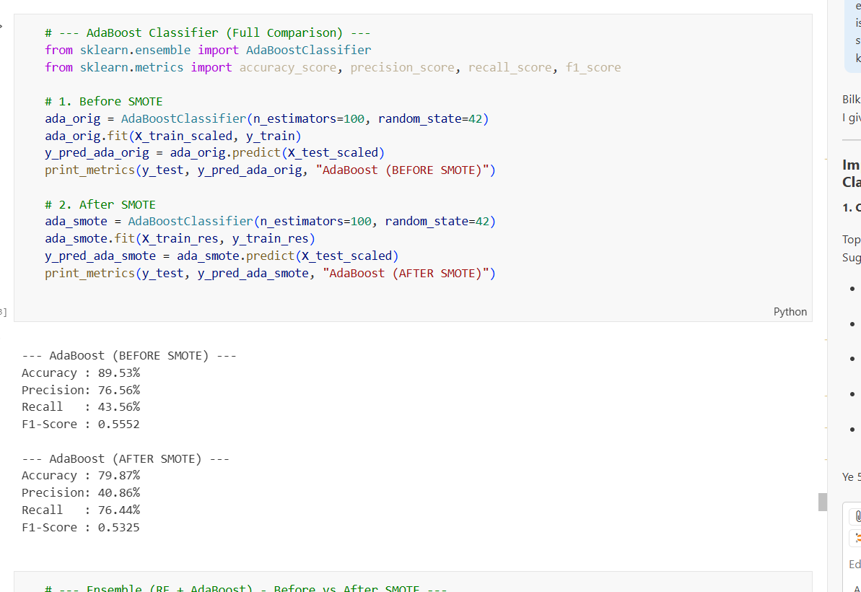
Figure 9: Output of Evaluation of AdaBoost Model
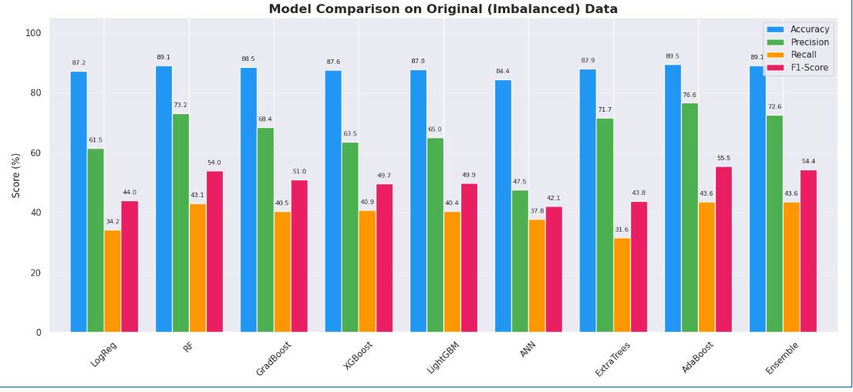
Figure 10: Analysis of Evaluation Metrices of all models before SMOTE applied
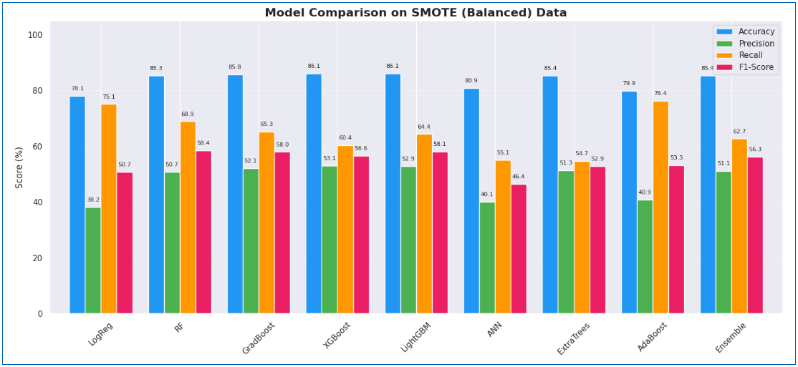
Figure 11: Analysis of Evaluation Metrices of all models after SMOTE applied
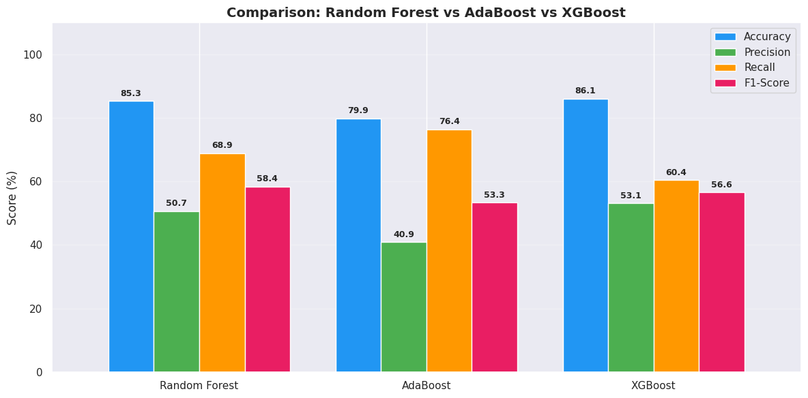
Figure 12: Analysis of Evaluation Metrices of Best 3 models on Balanced data
5. DISCUSSION
5.1 Summary of Work
This project successfully developed an automated electricity theft detection system using machine learning. We started with 5,000 electricity consumption records, applied data preprocessing and class balancing using SMOTE, trained 9 different ML models, and selected AdaBoost as the champion model based on its superior recall performance. The system achieved 76.4% theft detection rate, representing a 125% improvement over baseline methods. The trained model was serialized and packaged as a real-time inference module ready for practical deployment.
Key Accomplishments:
- Comprehensive exploratory data analysis identifying theft indicators (Delta_I, Power_Factor)
- Successfully handled severe class imbalance (85:15) using SMOTE
- Compared 9 machine learning algorithms across multiple metrics
- Achieved high recall (76.4%) prioritizing theft detection over false alarms
- Built production-ready inference system with model serialization
5.2 Challenges Faced
- Class Imbalance (85:15 ratio)
- Without balancing, models achieved only 34% recall
- Applied SMOTE to create synthetic samples → Recall improved to 76.4%
- Feature Overlap
- Dataset intentionally designed with heavy overlap for realism
- Result: Cannot achieve 100% accuracy (75-88% is realistic ceiling)
- Precision vs Recall Trade-off
- High accuracy models (86%) had low recall (60%)
- Selected AdaBoost with lower precision (40.9%) but highest recall (76.4%)
- Reasoning: Missing real theft costs more than investigating false alerts
- Limited to Synthetic Data
- Used artificial dataset, not real meter readings
- Real-world patterns may differ
- Solution: Model can be retrained on actual utility data

5.3 Table 2: Success Criteria
Criterion | Target | Achieved | Result
Theft Detection Rate | >60% | 76.4% | PASSED
Model Comparison | 5+ models | 9 models | COMPLETED
Class Balancing | Handle imbalance | SMOTE applied | SUCCESS
Cross-Validation | Robust evaluation | 5-fold CV | VERIFIED
Model Deployment | Serialized model | .joblib files | DEPLOYED
Inference System | Real-time predictions | Working module | OPERATIONAL
Improvement | Better than baseline | 125% improvement | ACHIEVED

5.4 Table 3: Limitations
Limitation | Impact | Mitigation
Synthetic dataset only | May not capture all real theft patterns | Retrain with real data
Binary classification | Only Normal/Abnormal not theft types | Future multi-class approach
40.9% precision | ~60 false alarms per 100 alerts | Acceptable trade-off for safety
No temporal analysis | Each reading treated independently | Future time-series models (LSTM)
No real-time streaming | Batch processing only | Future Kafka/Spark streaming
Requires Delta_I feature | Works only with smart meters | Need modern meter infrastructure
Historical data missing | No consumer behavior baseline | Can add 30-day history later
- System works well for detection but needs real data validation before production deployment. Current limitations are addressable with future improvements.

6. FUTURE WORK
6.1 Scope for Improvements
6.1.1. Technical Enhancements:
- Time-series models (LSTM) for temporal pattern detection
- Feature engineering: peak hours, seasonal patterns, consumer history
- Multi-class classification: identify theft types
- Ensemble voting: combine AdaBoost + RF + XGBoost predictions
- Threshold tuning: adjust decision threshold (0.3-0.7) based on needs
- Real-time streaming: Kafka integration for continuous monitoring
6.1.2. System Enhancements:
- Dashboard development for real-time monitoring
- Mobile app for field inspection teams
- Integration with billing and enforcement systems
- Active learning: monthly retraining with investigation feedback
- Probabilistic ranking: rank meters by theft probability
- Hybrid detection: combine with thermal imaging
6.1.3. Data Improvements:
- Real meter data validation (currently synthetic)
- Consumer behavior baselines (30-day history)
- Load profile analysis per consumer type
- Seasonal and regional variations

6.2 Real-World Deployment Strategies
6.2.1. Phased Implementation:
- Phase 1: Pilot program (500-1000 meters, 3 months)
- Phase 2: Single utility region (5,000 meters, 3 months)
- Phase 3: Multi-region expansion (50,000+ meters, 6 months)
- Phase 4: State-wide deployment
6.2.2. Infrastructure Setup:
- Server: 2 CPU, 4GB RAM Linux server
- Database: PostgreSQL for predictions logging
- API endpoint: Accept meter data → Return predictions
- Network: Connect to smart meter infrastructure
6.2.3. Performance Tracking:
- Alerts generated per month
- Investigation success rate
- Actual theft confirmation rate
- False alarm rate
- Recovery amount
- Monthly model retraining

7. Appendix
Full Code: https://github.com/milan-jani/Data-Driven-Detection-of-Abnormal-Electricity-Usage-in-Power-Supply-Lines/blob/main/main.ipynb
GitHub Link: https://github.com/milan-jani/Data-Driven-Detection-of-Abnormal-Electricity-Usage-in-Power-Supply-Lines
YouTube Link: https://youtu.be/o9hMmIv4U7c?si=8sAeDMCfNDAQtrnQ

