Experiment-4

Name: Milan Jani
Enrollment number: 92301733041

AIM: Design Butterworth and Chebyshev filter using bilinear transformation method.
Theory: The bilinear transformation method is commonly used to design analog filters and then convert them into digital filters. This method maps the analog frequency response to the digital frequency response using a bilinear transformation.

The Butterworth and Chebyshev filters are two commonly used filter types. The Butterworth filter has a maximally flat frequency response in the passband, while the Chebyshev filter allows for a sharper transition between the passband and the stopband at the expense of ripples in either the passband or stopband.
Program:
import numpy as np
import matplotlib.pyplot as plt
from scipy.signal import butter, bilinear, freqz, cheby1

def design_butterworth_filter(filter_order, cutoff_frequency, sampling_frequency):
# Design the analog Butterworth filter
analog_b, analog_a = butter(filter_order, cutoff_frequency, analog=True, btype='low')

# Perform the bilinear transformation
digital_b, digital_a = bilinear(analog_b, analog_a, sampling_frequency)

return digital_b, digital_a

def design_chebyshev_filter(filter_order, cutoff_frequency, sampling_frequency, ripple):
# Design the analog Chebyshev filter
analog_b, analog_a = cheby1(filter_order, ripple, cutoff_frequency, analog=True, btype='low')

# Perform the bilinear transformation
digital_b, digital_a = bilinear(analog_b, analog_a, sampling_frequency)

return digital_b, digital_a

def plot_filter_response(butter_b, butter_a, cheby_b, cheby_a, sampling_frequency):
# Create a single figure with 2x2 subplots
plt.figure(figsize=(15, 10))

# Butterworth Filter - Magnitude Response
frequency_b, magnitude_response_b = freqz(butter_b, butter_a, fs=sampling_frequency)
plt.subplot(2, 2, 1)
plt.plot(frequency_b, np.abs(magnitude_response_b))
plt.title('Butterworth Filter Magnitude Response')
plt.xlabel('Frequency (Hz)')
plt.ylabel('Magnitude')
plt.grid(True)

# Butterworth Filter - Impulse Response
_, impulse_response_b = freqz(butter_b, butter_a, fs=sampling_frequency, worN=512)
plt.subplot(2, 2, 2)
plt.plot(np.real(impulse_response_b))
plt.title('Butterworth Filter Impulse Response')
plt.xlabel('Samples')
plt.ylabel('Amplitude')
plt.grid(True)

# Chebyshev Filter - Magnitude Response
frequency_c, magnitude_response_c = freqz(cheby_b, cheby_a, fs=sampling_frequency)
plt.subplot(2, 2, 3)
plt.plot(frequency_c, np.abs(magnitude_response_c))
plt.title('Chebyshev Filter Magnitude Response')
plt.xlabel('Frequency (Hz)')
plt.ylabel('Magnitude')
plt.grid(True)

# Chebyshev Filter - Impulse Response
_, impulse_response_c = freqz(cheby_b, cheby_a, fs=sampling_frequency, worN=512)
plt.subplot(2, 2, 4)
plt.plot(np.real(impulse_response_c))
plt.title('Chebyshev Filter Impulse Response')
plt.xlabel('Samples')
plt.ylabel('Amplitude')
plt.grid(True)

plt.tight_layout()
plt.show()

# Specify the desired filter specifications
filter_order = 4 # Filter order
cutoff_frequency = 1000 # Cutoff frequency in Hz
sampling_frequency = 8000 # Sampling frequency in Hz
ripple = 0.5 # Ripple factor for Chebyshev filter

# Design the Butterworth filter
butter_b, butter_a = design_butterworth_filter(filter_order, cutoff_frequency, sampling_frequency)

# Design the Chebyshev filter
cheby_b, cheby_a = design_chebyshev_filter(filter_order, cutoff_frequency, sampling_frequency, ripple)

# Plot both filters' responses in a single 2x2 subplot
plot_filter_response(butter_b, butter_a, cheby_b, cheby_a, sampling_frequency)

# Save the filter coefficients (optional)
filter_path = 'filter_coefficients.txt'
np.savetxt(filter_path, np.vstack((cheby_b, cheby_a)), delimiter=',')
print(f"Filter coefficients saved at: {filter_path}")

Output:
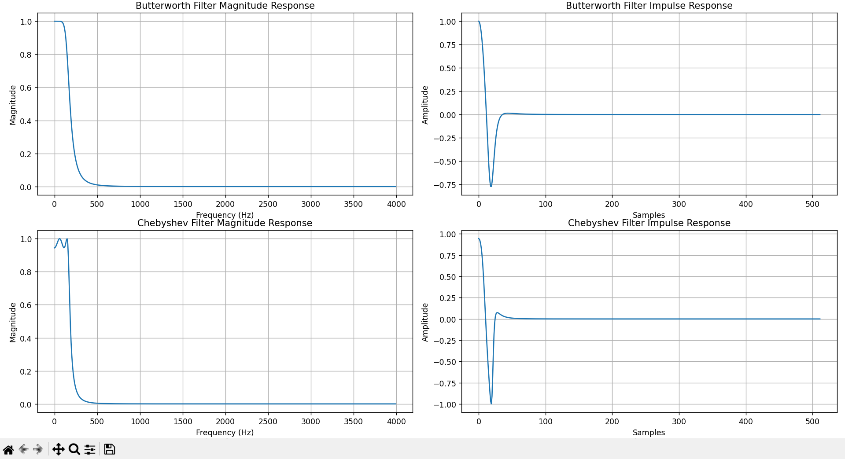

Conclusion:
- Butterworth filter: Smooth rolloff, no ripples, better phase response
- Chebyshev filter: Sharp cutoff, faster rolloff, but has passband ripples
- Both filters are stable with decaying impulse responses
- Choice depends on requirement: flat response (Butterworth) vs sharp cutoff (Chebyshev)

