Experiment-11-OPEN-HANDED

Name: Milan Jani

Enroll No.:92301733041

AIM: Simulate dilation, erosion, opening and closing operation on images.[OPEN HANDED]
Theory:
Dilation, erosion, opening, and closing are morphological operations used in image processing to manipulate the shape and size of objects in an image.

Dilation:
Dilation expands the boundaries of objects in an image by adding pixels to the object's boundaries. It is achieved by sliding a structuring element over the image and assigning the maximum pixel value within the neighborhood of each pixel.

Erosion:
Erosion shrinks the boundaries of objects in an image by removing pixels from the object's boundaries. It is achieved by sliding a structuring element over the image and assigning the minimum pixel value within the neighborhood of each pixel.

Opening:
Opening is an erosion operation followed by a dilation operation. It is used to remove noise and small objects from the image while preserving the larger objects' shapes.

Closing:
Closing is a dilation operation followed by an erosion operation. It is used to close small gaps and holes within objects while preserving the overall object shapes.

Program
import cv2
import numpy as np
import matplotlib.pyplot as plt

# Load the binary fingerprint (grayscale)
image = cv2.imread('Manual/exp_11_OH.png', 0)

# --- Step 1: Remove small bright specks ---
kernel_open = cv2.getStructuringElement(cv2.MORPH_ELLIPSE, (4, 4))
opened = cv2.morphologyEx(image, cv2.MORPH_OPEN, kernel_open)

# --- Step 2: Fill thin dark cracks ---
kernel_close = cv2.getStructuringElement(cv2.MORPH_ELLIPSE, (5,5))
closed = cv2.morphologyEx(opened, cv2.MORPH_CLOSE, kernel_close)

# Optional smoothing
final = cv2.morphologyEx(closed, cv2.MORPH_OPEN, kernel_open)

# --- Display results ---
plt.figure(figsize=(12, 8))

plt.subplot(2, 2, 1)
plt.imshow(image, cmap='gray')
plt.title("Original")
plt.axis("off")

plt.subplot(2, 2, 2)
plt.imshow(opened, cmap='gray')
plt.title("After Opening (remove bright specks)")
plt.axis("off")

plt.subplot(2, 2, 3)
plt.imshow(closed, cmap='gray')
plt.title("After Closing (fill cracks)")
plt.axis("off")

plt.subplot(2, 2, 4)
plt.imshow(final, cmap='gray')
plt.title("Final Output")
plt.axis("off")

plt.tight_layout()
plt.show()

Output

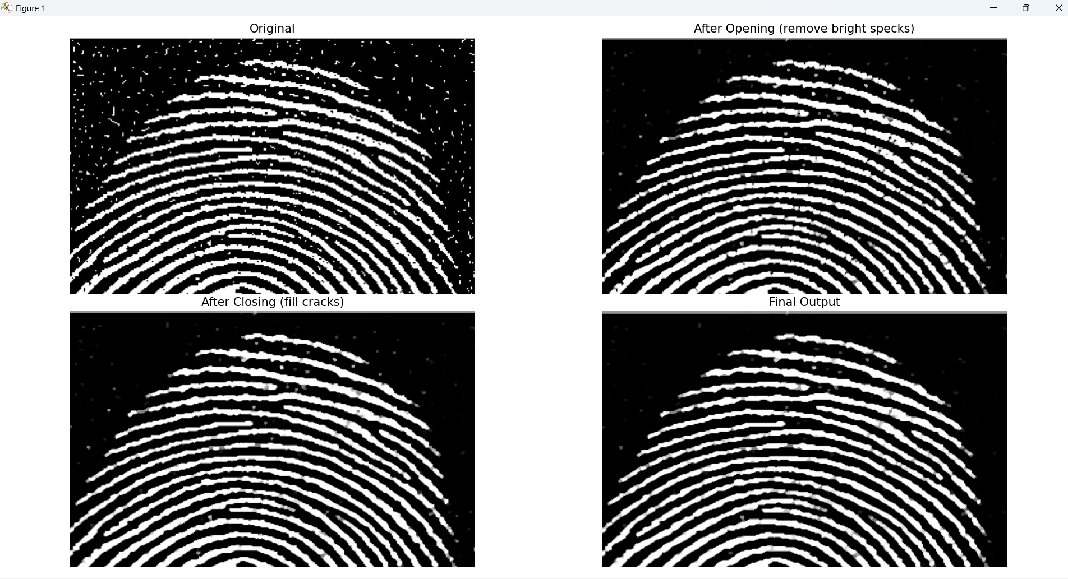

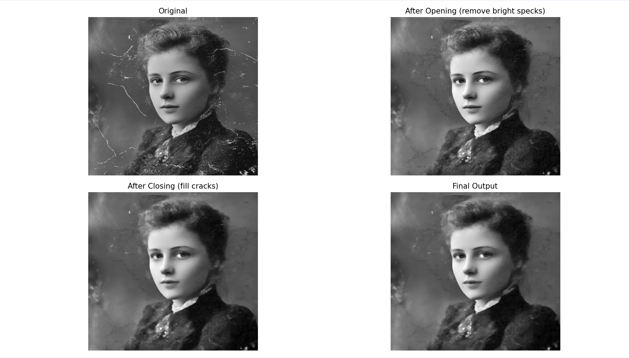

Conclusion

Morphological opening with a 4×4 elliptical kernel effectively removes small bright specks from the binary fingerprint image.

Morphological closing with a 5×5 elliptical kernel successfully fills thin dark cracks between fingerprint ridges.

Applying a final light opening smooths ridge boundaries and reduces leftover micro-noise.

Overall, the sequence preserves the fingerprint’s structural pattern while enhancing clarity and continuity of ridges.

