Experiment-12

Name: Milan Jani

Enroll No.:92301733041

AIM: Simulate dilation, erosion, opening and closing operation on images.
Theory:
Dilation, erosion, opening, and closing are morphological operations used in image processing to manipulate the shape and size of objects in an image.

Dilation:
Dilation expands the boundaries of objects in an image by adding pixels to the object's boundaries. It is achieved by sliding a structuring element over the image and assigning the maximum pixel value within the neighborhood of each pixel.

Erosion:
Erosion shrinks the boundaries of objects in an image by removing pixels from the object's boundaries. It is achieved by sliding a structuring element over the image and assigning the minimum pixel value within the neighborhood of each pixel.

Opening:
Opening is an erosion operation followed by a dilation operation. It is used to remove noise and small objects from the image while preserving the larger objects' shapes.

Closing:
Closing is a dilation operation followed by an erosion operation. It is used to close small gaps and holes within objects while preserving the overall object shapes.

Program
import cv2
import numpy as np
from google.colab.patches import cv2_imshow
# Load the image
image = cv2.imread('/content/Certificate 1698299913.jpg', 0) # Load as grayscale

# Define the kernel (structuring element)
kernel = np.ones((5, 5), np.uint8)

# Perform Erosion
erosion = cv2.erode(image, kernel, iterations=1)

# Perform Dilation
dilation = cv2.dilate(image, kernel, iterations=1)

# Perform Opening (Erosion followed by Dilation)
opening = cv2.morphologyEx(image, cv2.MORPH_OPEN, kernel)

# Perform Closing (Dilation followed by Erosion)
closing = cv2.morphologyEx(image, cv2.MORPH_CLOSE, kernel)

# Display the original image and the results
cv2_imshow(image)
cv2_imshow(erosion)
cv2_imshow(dilation)
cv2_imshow(opening)
cv2_imshow(closing)

# Wait for a key press and then close the windows
cv2.waitKey(0)
cv2.destroyAllWindows()

Output

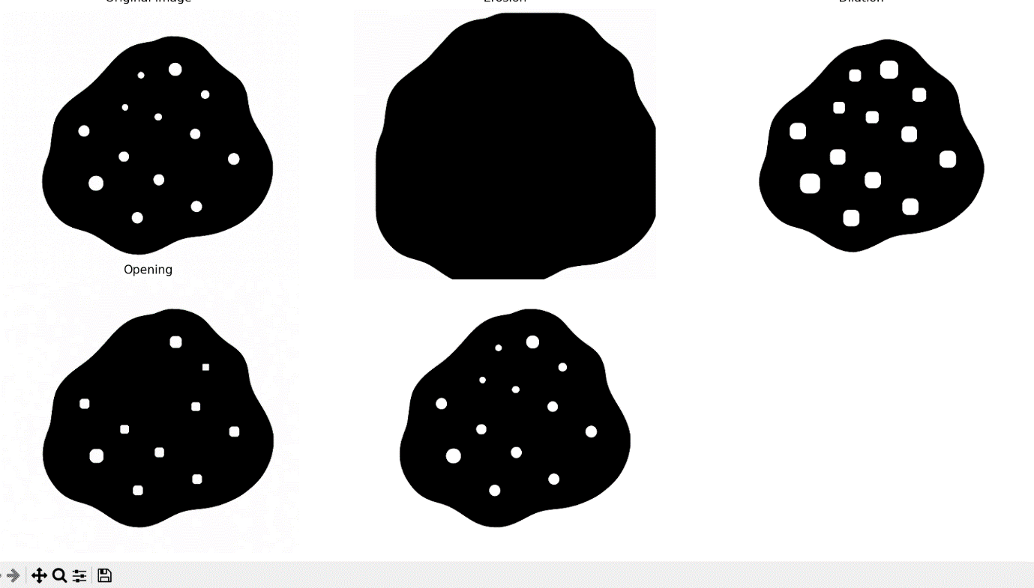

Conclusion

- The morphological operations have demonstrated their effectiveness in processing the image.
- Erosion has removed small noise points, while dilation has helped in connecting disjoint structures.
- Opening has effectively removed small objects from the foreground, and closing has filled small holes in the foreground.
- These operations are crucial in various image processing tasks, including object detection and image segmentation.

