Experiment-13

Name: Milan Jani

Enroll no.: 92301733041

AIM: Simulate Hit or Miss Transformation on images.
Theory:
The Hit or Miss transformation is a morphological operation used to detect specific patterns or shapes in an image. It is commonly used for shape recognition or pattern matching.

The operation requires two structuring elements: one for foreground (hits) and another for background (misses). The foreground structuring element represents the desired pattern to be matched, while the background structuring element represents the complement of the pattern.

During the transformation, the foreground structuring element is matched against the foreground pixels in the image, and the background structuring element is matched against the background pixels. Only those pixels that match both structuring elements are considered hits.
Program
import cv2
import numpy as np
from google.colab.patches import cv2_imshow
# Load the binary image
image = cv2.imread('/content/Certificate 1698299913.jpg', 0)

# Define the structuring element for the pattern to be detected (0 for don't care, 1 for foreground, -1 for background)
pattern = np.array([[-1, 1, -1],
[1, 1, 1],
[-1, 1, -1]], dtype=np.int8)

# Apply the Hit or Miss Transformation
result = cv2.morphologyEx(image, cv2.MORPH_HITMISS, pattern)

# Display the original image and the result
cv2_imshow(image)
cv2_imshow(result)
cv2.waitKey(0)
cv2.destroyAllWindows()

Output

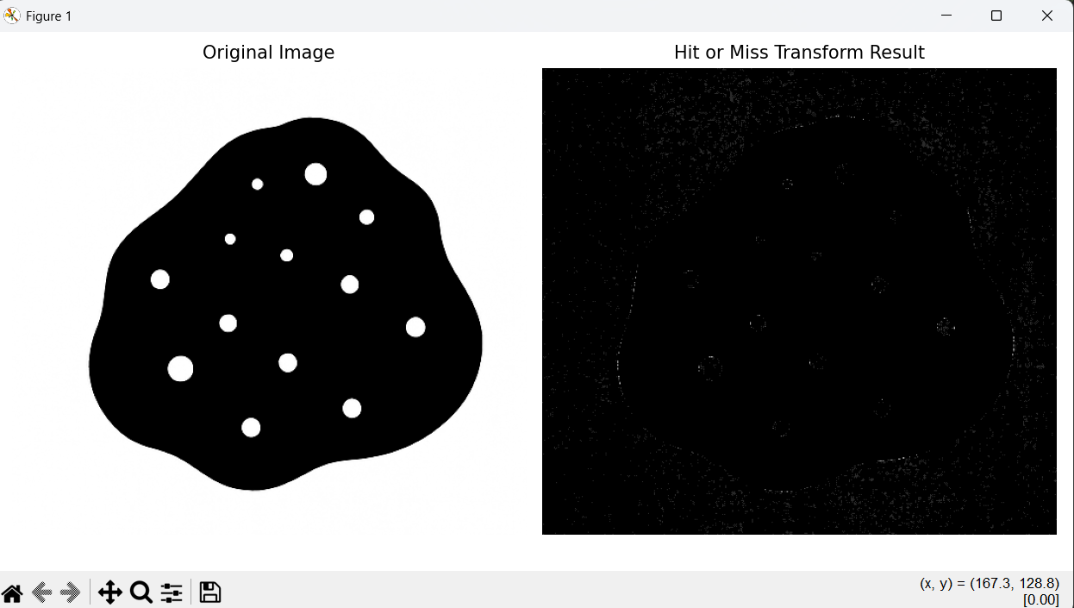

Conclusion
- The Hit-or-Miss transformation has been successfully applied to the image.
- This morphological operation detected specific patterns using the defined structuring element.
- The pattern kernel [-1,1,-1; 1,1,1; -1,1,-1] searches for plus-shaped structures where:
  - The center and cross arms must be foreground (white pixels)
  - The diagonal corners must be background (black pixels)
- The transformation effectively identified and highlighted these specific patterns in the binary image,demonstrating its effectiveness for template matching and pattern recognition tasks.

