Experiment-14

Name: Milan Jani

Enroll No.: 92301733041

AIM: Simulate Boundary Extraction on images.
Theory: Boundary extraction is a morphological operation used to extract the boundary or contour of objects in an image. It highlights the boundaries between object regions and the background, providing important information about the shape and structure of objects.

The boundary extraction operation can be achieved by subtracting the input image from its morphological dilation. This highlights the pixels that are on the object boundaries, as the dilation operation expands the object while maintaining its shape.

Program:
import cv2
import numpy as np
from google.colab.patches import cv2_imshow
# Load the image
image = cv2.imread('/content/Certificate 1698299913.jpg', cv2.IMREAD_GRAYSCALE)

# Apply Gaussian blur to reduce noise
image_blurred = cv2.GaussianBlur(image, (5, 5), 0)

# Apply Canny edge detection
edges = cv2.Canny(image_blurred, threshold1=30, threshold2=100)

# Create a black image with the same size as the original image
boundary_image = np.zeros_like(image)

# Copy the detected edges to the boundary image
boundary_image[edges > 0] = 255

# Display the original image and the boundary image
cv2_imshow(image)
cv2_imshow(boundary_image)

# Save the boundary image
cv2.imwrite('boundary_image.jpg', boundary_image)

# Wait for a key press and then close the windows
cv2.waitKey(0)
cv2.destroyAllWindows()

Output

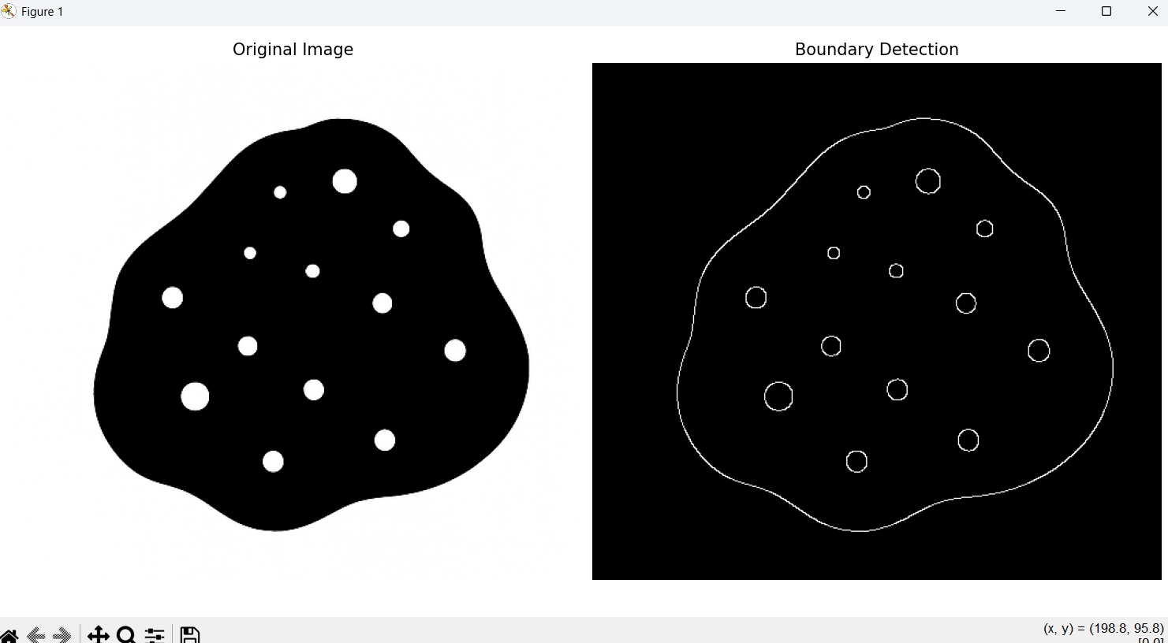

Conclusion
- The Canny edge detection algorithm successfully identified the boundaries in the image.
- Gaussian blur preprocessing helped reduce noise for cleaner edge detection.
- The detected edges provide a clear outline of objects in the original image.

