Objective:
To perform and understand various gray level operations on digital images using Python and OpenCV. These operations include image negation, log transformation, power-law (gamma) transformation, contrast stretching, and thresholding.
Theory:
Gray level operations are point processing techniques applied to individual pixel values of a grayscale image. These operations enhance image features and are useful in image preprocessing tasks. The key operations are:
- Image Negation:
This operation inverts the image by subtracting each pixel value from 255. For example, if a pixel has a value of 100, its negated value becomes 155. It enhances white regions into black and vice versa.
- Logarithmic Transformation:
This transformation enhances dark pixels more than bright ones. It’s useful when an image has a large dynamic range. Formula: s = c * log(1 + r), where r is the input pixel and c is a scaling constant.
- Gamma (Power-Law) Transformation:
This is used to control brightness using a formula s = c * r^γ. If gamma is less than 1, it brightens the image; if greater than 1, it darkens the image.
- Contrast Stretching:
It spreads the intensity values of the image across the full range (0 to 255), improving contrast. Formula:
output = ((r - min) / (max - min)) * 255
- Thresholding:
Converts a grayscale image into a binary image. Pixels above a certain threshold become white (255), and those below become black (0).
CODE:
import cv2
import numpy as np
import matplotlib.pyplot as plt

# Load grayscale image
image = cv2.imread('input.jpg', cv2.IMREAD_GRAYSCALE)

# Check if image loaded
if image is None:
print("Image not found!")
exit()

# Image Negation
neg = 255 - image

# Log Transformation
c = 255 / np.log(1 + np.max(image))
log_trans = c * (np.log(1 + image.astype(np.float32)))
log_trans = np.uint8(log_trans)

# Gamma Transformation
gamma = 2.2
gamma_trans = np.array(255*(image / 255) ** gamma, dtype='uint8')

# Contrast Stretching
min_val = np.min(image)
max_val = np.max(image)
contrast_stretch = ((image - min_val) / (max_val - min_val)) * 255
contrast_stretch = np.uint8(contrast_stretch)

# Thresholding
_, thresh = cv2.threshold(image, 127, 255, cv2.THRESH_BINARY)

# Display images
titles = ['Original', 'Negative', 'Log Transform', 'Gamma Transform', 'Contrast Stretch', 'Threshold']
images = [image, neg, log_trans, gamma_trans, contrast_stretch, thresh]

plt.figure(figsize=(12, 6))
for i in range(6):
plt.subplot(2, 3, i+1)
plt.imshow(images[i], cmap='gray')
plt.title(titles[i])
plt.axis('off')
plt.tight_layout()
plt.show()

Output:
IMAGE_1 :
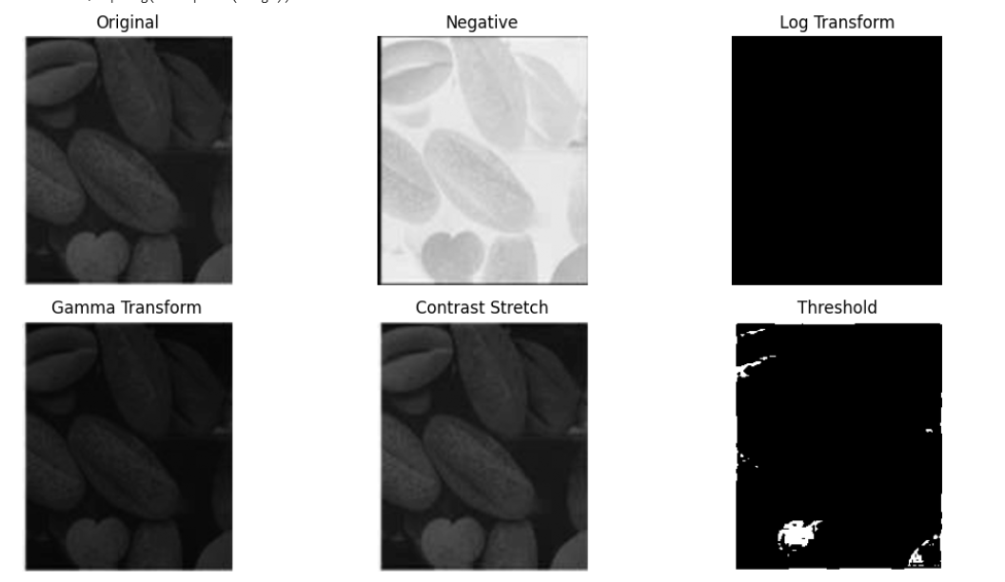
IMAGE _2:

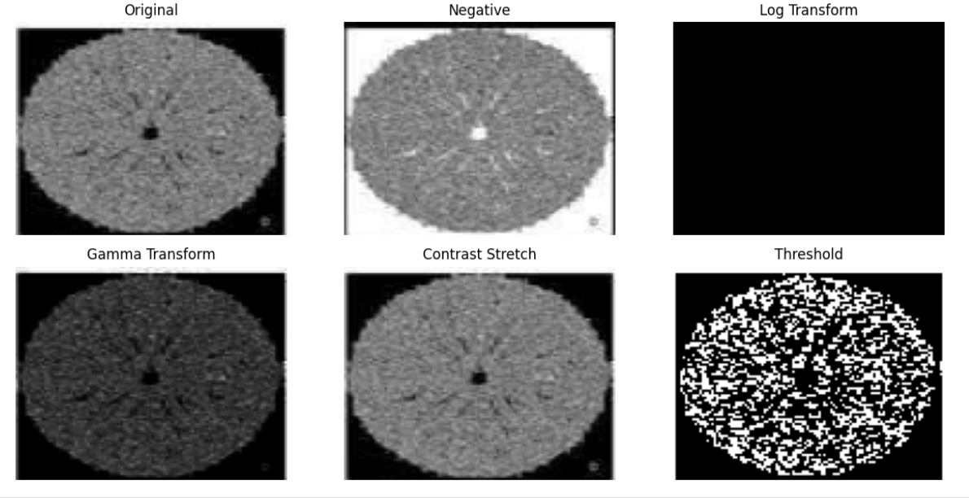
IMAGE _3 :
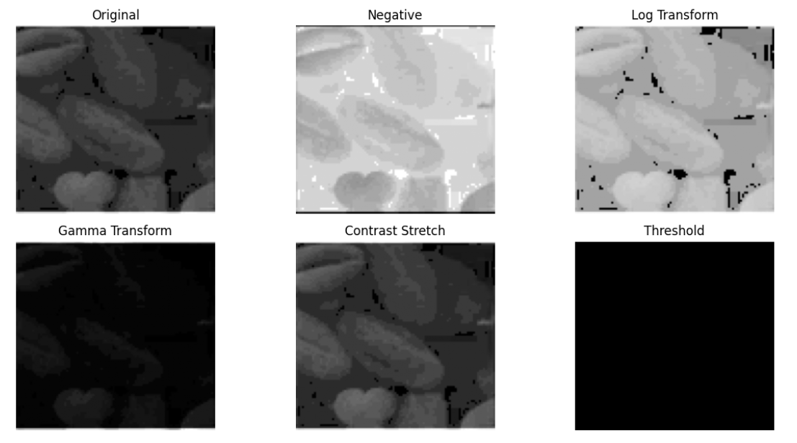
IMAGE _4 :
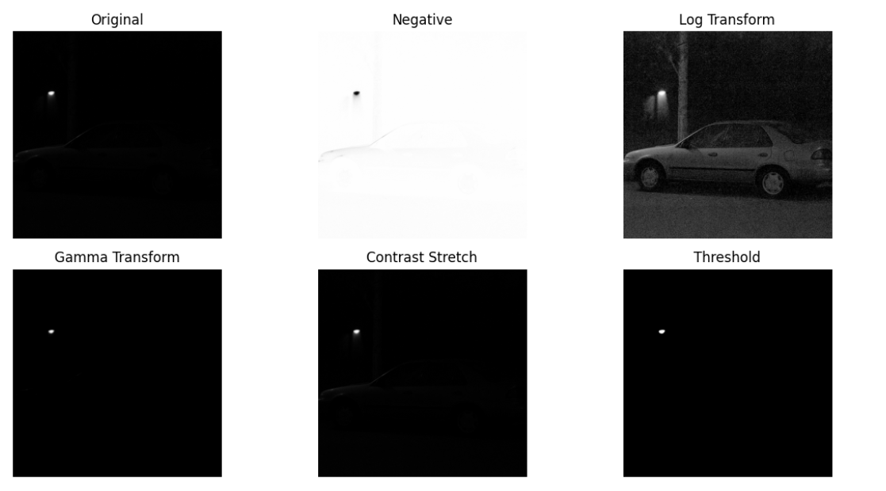

IMAGE _5 :
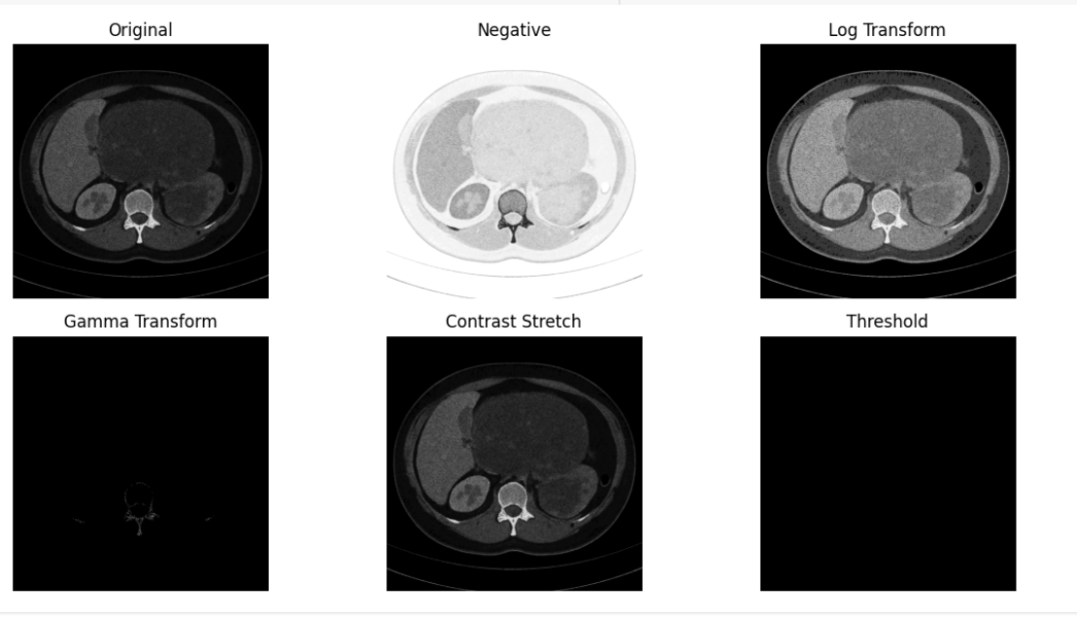
CONCLUSION :
This experiment shows how pixel-wise gray level operations can change an image’s look. These methods help highlight certain features and are often used in preprocessing for computer vision tasks likr object detection, recognition, or segmentation.
- Negative – Switches light areas to dark and vice versa.
- Gamma & Log Transform – Adjust brightness and make darker regions more visible.
- Thresholding – Converts the image into pure black and white.
- Contrast Stretching – Improves overall clarity.

