Experiment-3
AIM: Simulate cross correlation and autocorrelation on discrete time signals.
Theory:
Cross-correlation and autocorrelation are mathematical operations used to measure the similarity or correlation between two signals. They are widely used in various applications, such as signal processing, image processing, and pattern recognition.

Cross-correlation measures the similarity between two signals at different time shifts. It computes the dot product of one signal with a time-shifted version of the other signal. The resulting cross-correlation signal indicates the similarity between the two signals at different time lags.

Autocorrelation, on the other hand, measures the similarity of a signal with a time-shifted version of itself. It computes the cross-correlation of a signal with itself. The autocorrelation signal shows how the signal is correlated with itself at different time lags.

Program:
import numpy as np
import matplotlib.pyplot as plt
def cross_correlation(signal1, signal2):
# Compute the cross-correlation
cross_corr = np.correlate(signal1, signal2, mode='full')
return cross_corr
def autocorrelation(signal):
# Compute the autocorrelation
auto_corr = np.correlate(signal, signal, mode='full')
return auto_corr
# Define the discrete-time signals
signal1 = np.array([1, 2, 3, 4, 5])
signal2 = np.array([2, 4, 6, 8, 10])
# Compute the cross-correlation
cross_corr = cross_correlation(signal1, signal2)
# Compute the autocorrelation
auto_corr = autocorrelation(signal1)
# Plot the cross-correlation and autocorrelation signals
plt.figure(figsize=(10, 6))
plt.subplot(2, 1, 1)
plt.stem(cross_corr)
plt.title('Cross-correlation')
plt.xlabel('Time Lag')
plt.ylabel('Magnitude')
plt.subplot(2, 1, 2)
plt.stem(auto_corr)
plt.title('Autocorrelation')
plt.xlabel('Time Lag')
plt.ylabel('Magnitude')
plt.tight_layout()
plt.show()

Output:

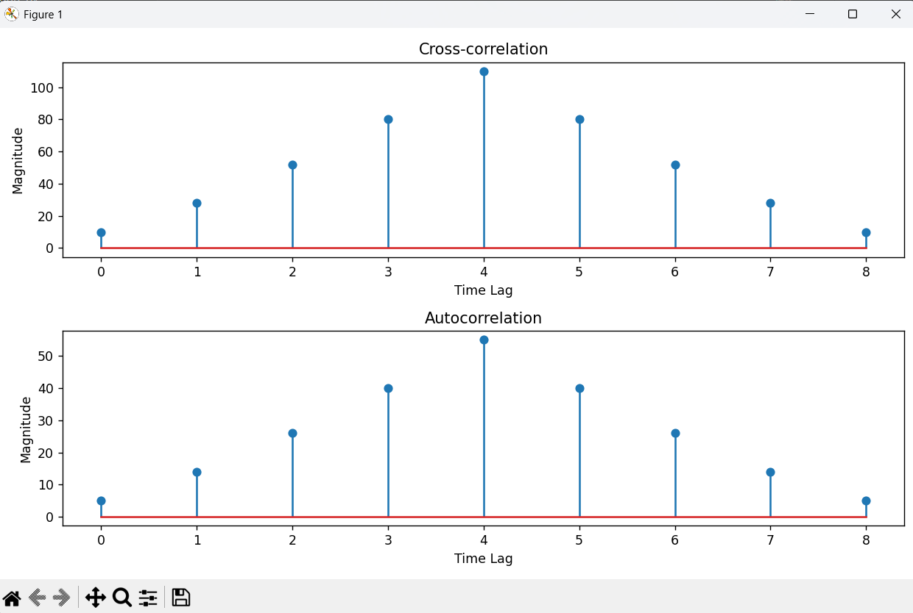

Conclusion

