Experiment-2
AIM: Simulate linear convolution and circular convolution on discrete time signals.

Theory:
Linear convolution and circular convolution are mathematical operations used to combine two signals to obtain a third signal. They are widely used in various applications, such as signal processing, image processing, and audio processing.
Linear convolution calculates the sum of element-wise products of two signals, considering the full range of valid indices. It is typically used for finite-length signals and can produce an output signal that is longer than the input signals.
Circular convolution, on the other hand, calculates the sum of element-wise products of two signals, considering a periodic extension of the input signals. It is commonly used for periodic or infinite-length signals and produces an output signal with the same length as the input signals.

Program

import numpy as np

import matplotlib.pyplot as plt

def linear_convolution(signal1, signal2):

# Compute the linear convolution

linear_conv = np.convolve(signal1, signal2, mode='full')

return linear_conv

def circular_convolution(signal1, signal2):

# Compute the circular convolution

If( len(signal1) > len(signal2) ):

fft_length=len(signal1);

else:

fft_length=len(signal2);

fft_signal1 = np.fft.fft(signal1, fft_length)

fft_signal2 = np.fft.fft(signal2, fft_length)

circular_conv = np.fft.ifft(fft_signal1 * fft_signal2)

return circular_conv

# Define the discrete-time signals

signal1 = np.array([1, 2, 3, 4, 5])

signal2 = np.array([2, 4, 6, 8, 10])

# Compute the linear convolution

linear_conv = linear_convolution(signal1, signal2)

# Compute the circular convolution

circular_conv = circular_convolution(signal1, signal2)

# Plot the linear and circular convolution results

plt.figure(figsize=(10, 6))

plt.subplot(2, 1, 1)

plt.stem(linear_conv)

plt.title('Linear Convolution')

plt.xlabel('Sample')

plt.ylabel('Amplitude')

plt.subplot(2, 1, 2)

plt.stem(circular_conv)

plt.title('Circular Convolution')

plt.xlabel('Sample')

plt.ylabel('Amplitude')

plt.tight_layout()

plt.show()

Output

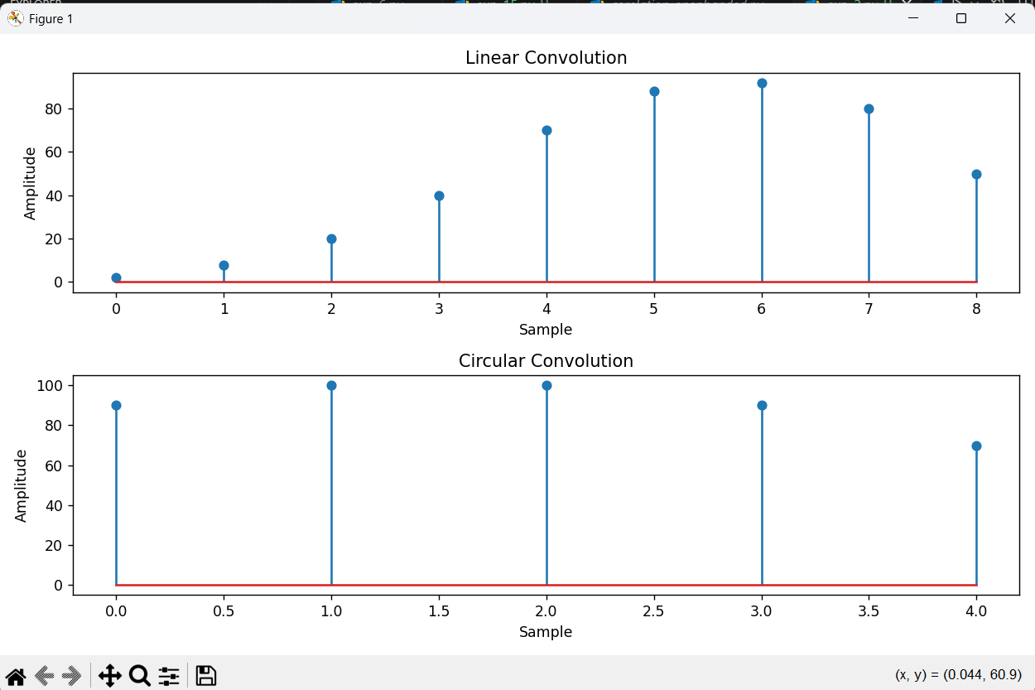

Conclusion

Linear and circular convolution operations have been successfully performed on discrete-time signals.

Linear Convolution: Output length = N1 + N2 - 1 (where N1, N2 are input signal lengths)

Circular Convolution: Output length = max(N1, N2), computed using FFT multiplication

Linear convolution extends the signal, while circular convolution wraps around (periodic)

Both convolutions are fundamental operations in signal processing for filtering and system analysis.

