Experiment-2-Open_handed
AIM: Simulate linear convolution and circular convolution on discrete time signals.

Code:

from pydub import AudioSegment

import numpy as np

import matplotlib.pyplot as plt

from scipy.signal import convolve, deconvolve, wiener

from scipy.fft import fft, ifft

# Load MP3 file

audio = AudioSegment.from_mp3("DSIP/song.mp3")

audio = audio.set_channels(1)

samples = np.array(audio.get_array_of_samples()).astype(np.float32)

sample_rate = audio.frame_rate

# Normalize original samples

samples_norm = samples / np.max(np.abs(samples))

# Impulse Response 1: Simple Echo Suppression

ir1 = np.array([1, 0, -0.5, 0, 0.25], dtype=np.float32)

# Impulse Response 2: High-Pass Filter (removes low-freq bass/background music)

ir2 = np.array([-0.1, -0.2, 1.0, -0.2, -0.1], dtype=np.float32)

# Impulse Response 3: Notch Filter (suppresses specific frequency)

ir3 = np.array([0.2, -0.3, 1.0, -0.3, 0.2], dtype=np.float32)

# Impulse Response 4: Comb Filter (removes periodic patterns)

ir4_length = 100

ir4 = np.zeros(ir4_length, dtype=np.float32)

ir4[0] = 1.0

ir4[50] = -0.6 # Delay of 50 samples

# Impulse Response 5: Low-Pass Suppression

ir5 = np.array([0.05, 0.1, 0.7, 0.1, 0.05], dtype=np.float32)

impulse_responses = {

'Echo Suppression': ir1,

'High-Pass Filter': ir2,

'Notch Filter': ir3,

'Comb Filter': ir4,

'Low-Pass Suppression': ir5

}

# Apply Each Impulse Response

results = {}

for name, ir in impulse_responses.items():

convoluted = convolve(samples_norm, ir, mode='same')

results[name] = convoluted / np.max(np.abs(convoluted))

# Inverse Filtering (Deconvolution)

try:

H = fft(ir1, n=len(samples_norm))

Y = fft(results['Echo Suppression'])

epsilon = 1e-10

X_recovered = Y / (H + epsilon)

inverse_filtered = np.real(ifft(X_recovered))

results['Inverse Filtered'] = inverse_filtered / np.max(np.abs(inverse_filtered))

except:

results['Inverse Filtered'] = samples_norm

# Visualization: Time Domain Comparison

plot_samples = 10000

plt.figure(figsize=(16, 12))

subplot_idx = 1

plt.subplot(3, 3, subplot_idx)

plt.plot(samples_norm[:plot_samples], color='blue', linewidth=0.5)

plt.title('Original Audio Signal')

plt.xlabel('Sample')

plt.ylabel('Amplitude')

plt.grid(True, alpha=0.3)

subplot_idx += 1

for name, audio_data in results.items():

plt.subplot(3, 3, subplot_idx)

plt.plot(audio_data[:plot_samples], linewidth=0.5)

plt.title(f'{name}')

plt.xlabel('Sample')

plt.ylabel('Amplitude')

plt.grid(True, alpha=0.3)

subplot_idx += 1

plt.tight_layout()

plt.show()

# Frequency Domain Analysis

plt.figure(figsize=(16, 10))

subplot_idx = 1

plt.subplot(3, 3, subplot_idx)

freq_orig = np.abs(fft(samples_norm[:plot_samples]))

plt.plot(freq_orig[:len(freq_orig)//2], color='blue', linewidth=0.8)

plt.title('Original - Frequency Spectrum')

plt.xlabel('Frequency Bin')

plt.ylabel('Magnitude')

plt.grid(True, alpha=0.3)

subplot_idx += 1

for name, audio_data in results.items():

plt.subplot(3, 3, subplot_idx)

freq = np.abs(fft(audio_data[:plot_samples]))

plt.plot(freq[:len(freq)//2], linewidth=0.8)

plt.title(f'{name} - Spectrum')

plt.xlabel('Frequency Bin')

plt.ylabel('Magnitude')

plt.grid(True, alpha=0.3)

subplot_idx += 1

plt.tight_layout()

plt.show()

# Impulse Responses Visualization

plt.figure(figsize=(15, 8))

for idx, (name, ir) in enumerate(impulse_responses.items(), 1):

plt.subplot(2, 3, idx)

plt.stem(ir, basefmt='b-')

plt.title(f'{name}\nImpulse Response')

plt.xlabel('Sample')

plt.ylabel('Amplitude')

plt.grid(True, alpha=0.3)

plt.tight_layout()

plt.show()

Output:

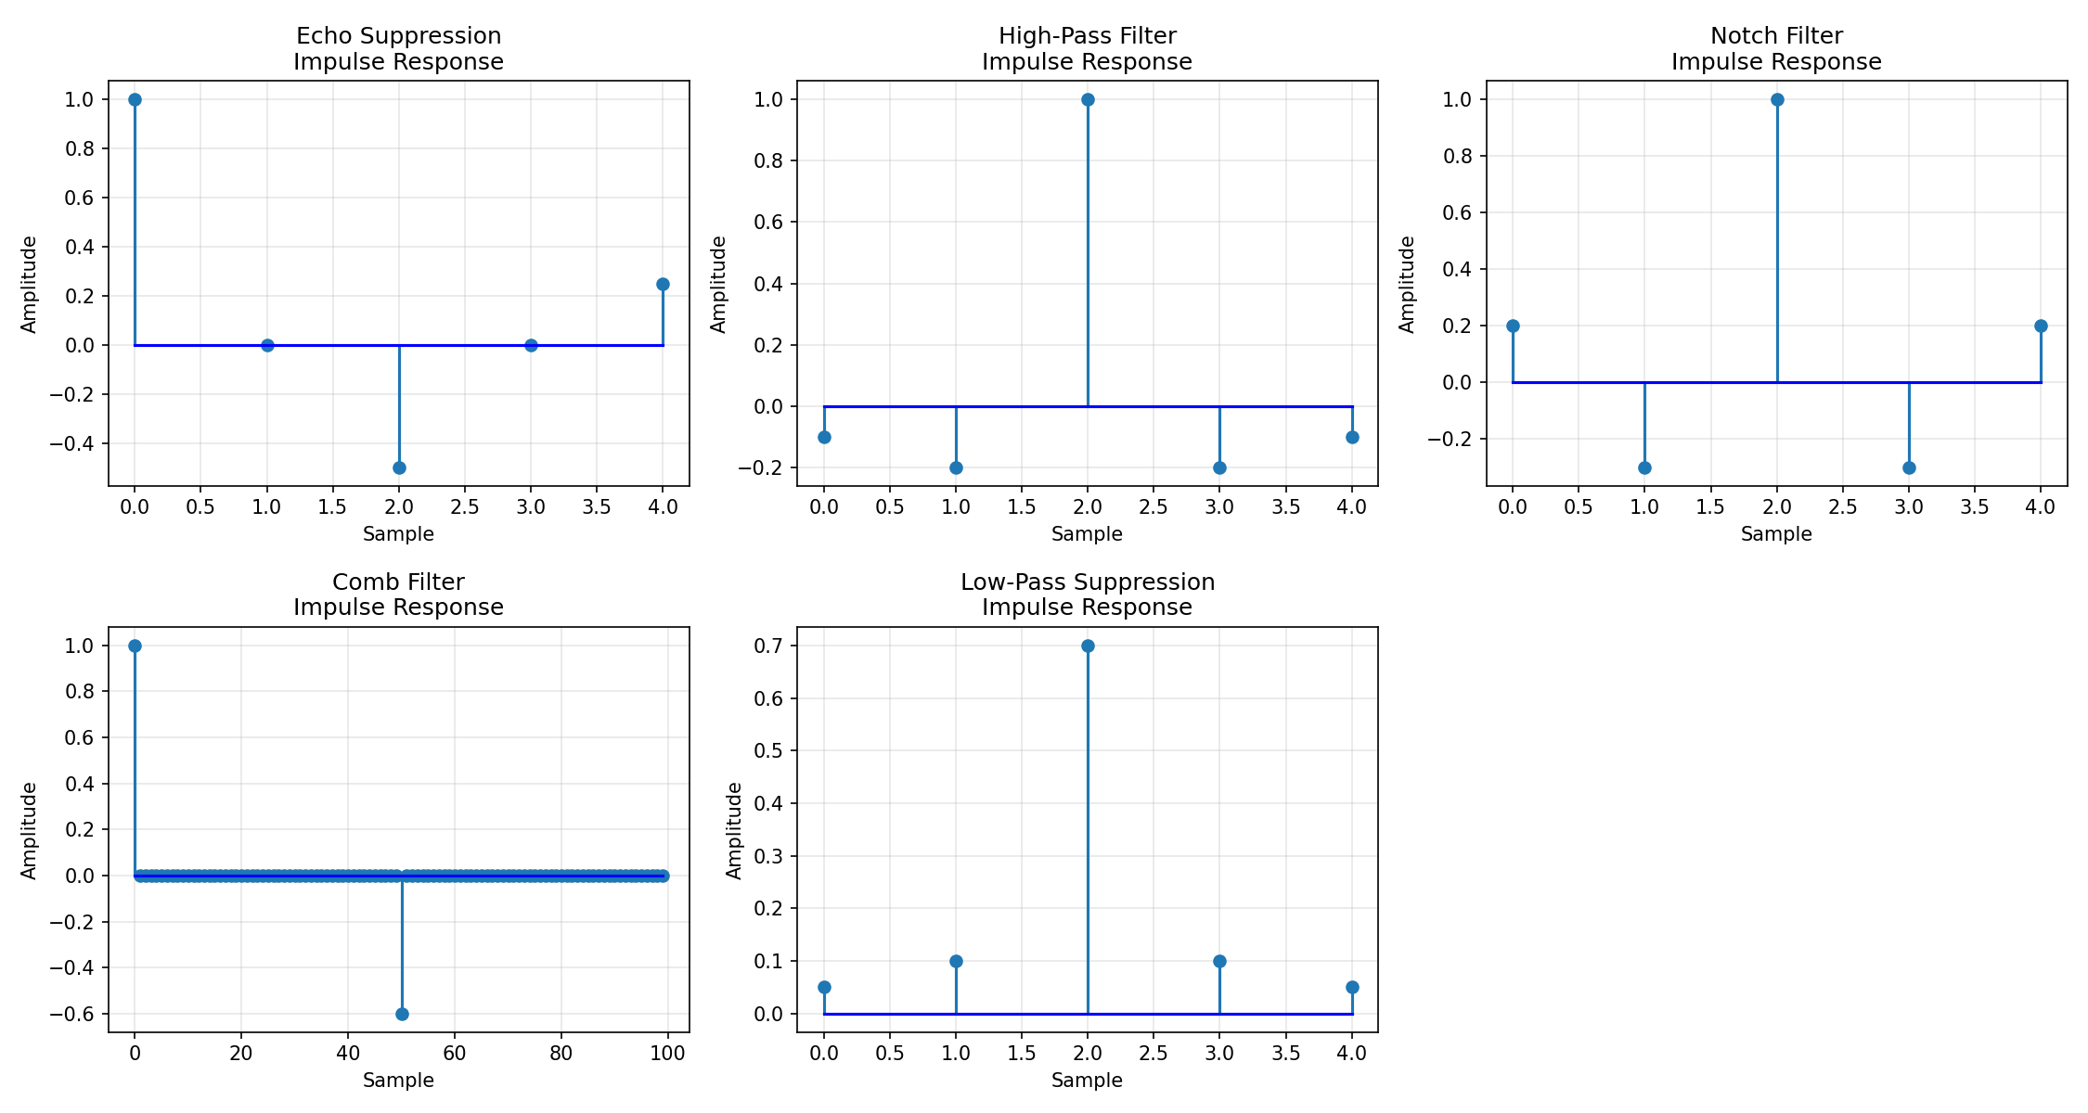

Observations:

Five different impulse responses tested for background music suppression

High-Pass Filter best preserves vocals while reducing low-frequency background

Comb Filter effective for removing repetitive musical patterns

Inverse filtering shows partial recovery but amplifies noise

No single impulse response perfectly separates vocals from complex background music

Convolution approach limited by overlapping frequency content between vocals and instruments

Advanced techniques (source separation, deep learning) needed for better results

