Final Homework Report
NPFL054 Introduction to Machine Learning
Milan Wikarski
Table of Contents
Task 1 – Data analysis 3
Task 1a 4
MOSHOODF 4
MOSTYPE 5
Task 1b 8
Task 2 – Model fitting, optimization and selection 11
Cross-validation 11
Parameter tuning data 11
Task 2a – Decision Tree 12
Task 2b – Random Forest 14
ntree 14
mtry 15
Task 2c – Regularized Logistic Regression 17
Lambda 17
Alpha 17
Task 2d – Model comparison 18
Decision Tree 18
Random Forest 19
Regularized Logistic Regression 19
Comparison and final choice 19
Task 2e – The best model 20
Task 3 – Model interpretation and feature selection 21
Decision Tree vs Random Forest 21
Lasso Model 22
Task 4 – Final prediction on the blind test set 25

Task 1 – Data analysis
Dataset consists of 5822 examples. Each example has 86 attributes. The 86-th attribute Purchase with values Yes (1) and No (0) is the target attribute.
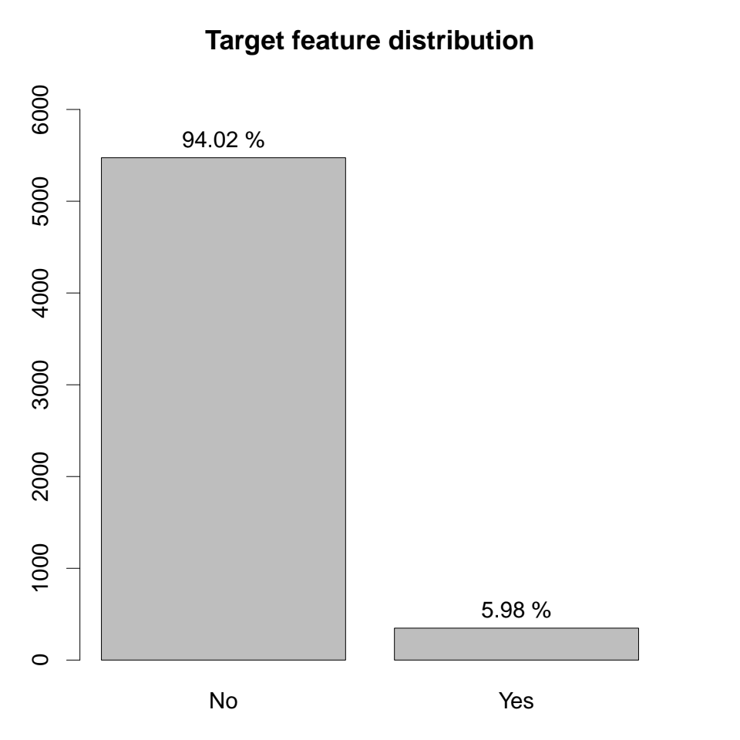
The distribution of the target attribute Purchase is heavily skewed towards No. The frequency of Yes is just 5.98%. This means that the expected precision when randomly selecting 100 examples whould be 5.98%.

Task 1a

MOSHOODF
Attribute MOSHOODF represents the main customer type. This attribute divides customers into 10 groups described in L2. The table below lists the number of customers per group, as well as the percentage of examples in this group with target attribute Purchase value Yes (1) (ie. the percentage of customers who have purchased the caravan insurance policy):
ID | Group | Size | Purchase Frequency
1 | Successfull Hedonists | 552 | 8.7%
2 | Driven Growers | 502 | 13.15%
3 | Average Family | 886 | 6.66%
4 | Career Loners | 52 | 0%
5 | Living Well | 569 | 2.64%
6 | Cruising Seniors | 205 | 1.95%
7 | Retired and Religious | 550 | 3.64%
8 | Family with Grown ups | 1563 | 5.69%
9 | Convervative Families | 667 | 6.3%
10 | Farmers | 276 | 1.81%

This data can also be plotted into two barcharts:
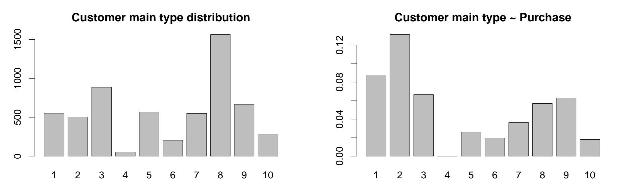
We can further analyze irregularities in groups by plotting the data into two boxplots and looking for outliers:
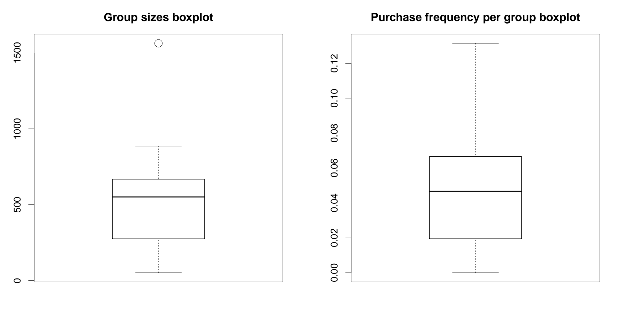
Group 4 (Career Loners) is really small (only 52 members) and contains no positive examples but cannot be classified as an outlier. Group 8 Family with grown ups is the largest (1563 members), thus can be classified as an outlier base on size, but the Purchase frequency of this group is slightly below average (5.69%). When it comes to Purchase frequncy in groups, there are no outliers.

MOSTYPE
Attribute MOSTYPE represents the customer subtype. This attribute divides customers into 41 subgroups described in L0. The table below lists the number of customers per subgroup, as well as the percentage of examples in this subgroup with the target attribute Purchase value Yes (1):
ID | Subgroup | Size | Purchase Frequency
1 | High Income | 124 | 10.48%
2 | Very Important Provincials | 82 | 7.32%
3 | High status seniors | 249 | 10.04%
4 | Affluent senior apartments | 52 | 3.85%
5 | Mixed seniors | 45 | 4.44%
6 | Career and childcare | 119 | 10.08%
7 | Dinki's (double income no kids) | 44 | 6.82%
8 | Middle class families | 339 | 15.04%
9 | Modern | 278 | 4.32%
10 | Stable family | 165 | 5.45%
11 | Family starters | 153 | 5.88%
12 | Affluent young families | 111 | 14.41%
13 | Young all american family | 179 | 7.26%
15 | Senior cosmopolitans | 5 | 0%
16 | Students in apartments | 16 | 0%
17 | Fresh masters in the city | 9 | 0%
18 | Single youth | 19 | 0%
19 | Suburban youth | 3 | 0%
20 | Etnically diverse | 25 | 8%
21 | Young urban have-nots | 15 | 0%
22 | Mixed apartment dwellers | 98 | 4.08%
23 | Young and rising | 251 | 1.59%
24 | Young | 180 | 2.78%
25 | Young seniors in the city | 82 | 2.44%
26 | Own home elderly | 48 | 2.08%
27 | Seniors in apartments | 50 | 2%
28 | Residential elderly | 25 | 0%
29 | Porchless seniors: no front yard | 86 | 2.33%
30 | Religious elderly singles | 118 | 3.39%
31 | Low income catholics | 205 | 2.93%
32 | Mixed seniors | 141 | 5.67%
33 | Lower class large families | 810 | 5.68%
34 | Large family | 182 | 4.95%
35 | Village families | 214 | 3.74%
36 | Couples with teens 'Married with children' | 225 | 7.11%
37 | Mixed small town dwellers | 132 | 7.58%
38 | Traditional families | 339 | 6.78%
39 | Large religous families | 328 | 5.79%
40 | Large family farms | 71 | 0%
41 | Mixed rurals | 205 | 2.44%

The subgroup sizes can also be visualized using a barchart:
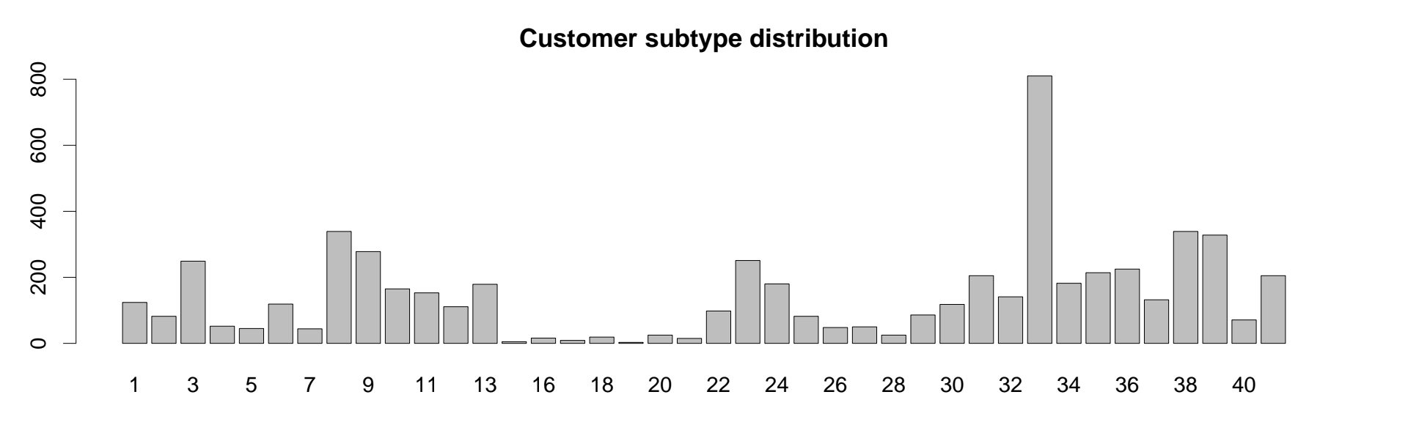
The percentage of people in each subgroup who have purchased the caravan insurance policy can also be plotted to a barchart:
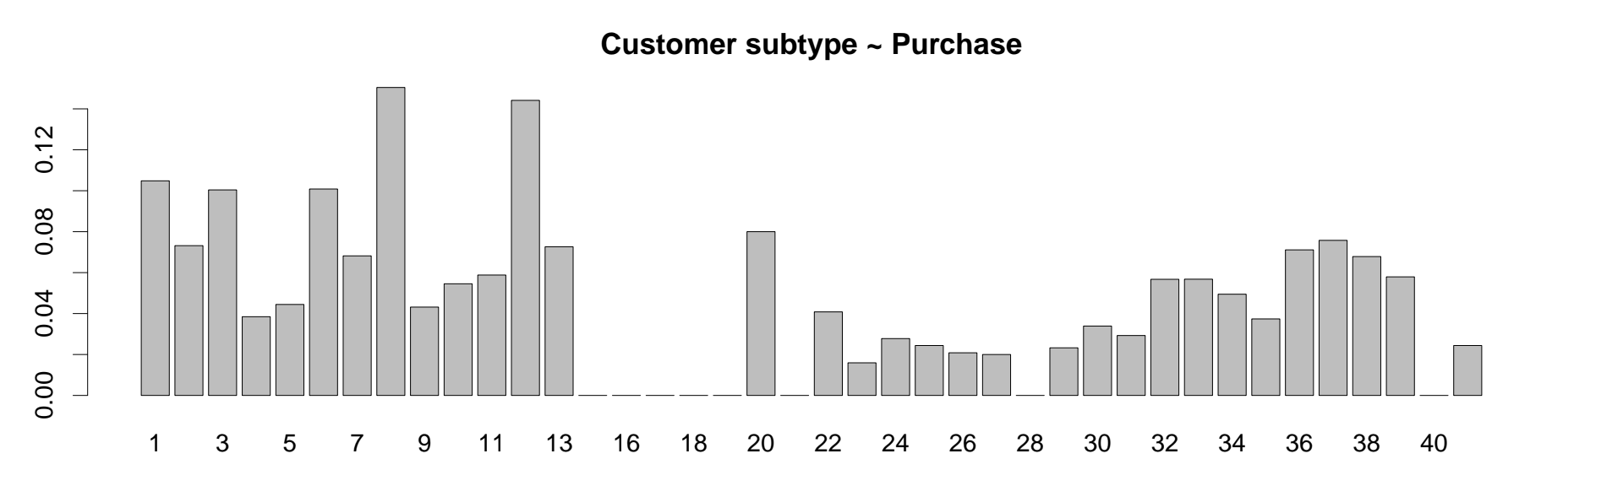
It should be noted that among 5822 examples, there is no representative of subgroup 14 (Junior cosmopolitan). To further see, which subgroups might be interessting, we can plot boxplots for size and Purchase frequency:
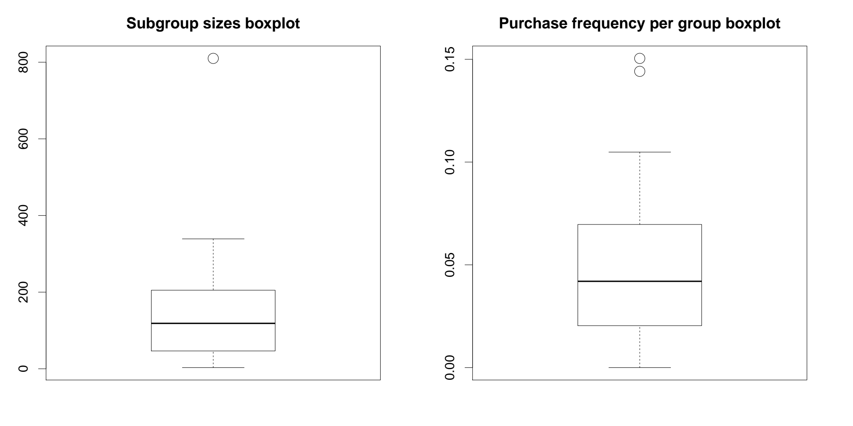
Subgroups 15 – 19 are very small and contain no positive examples but cannot be classified as outliers (the reason for this will be explained in the next chapter). Other subgroups with no positive examples are subgroup 21 Young urban have-nots, subgroup 28 Residential elderly and subgroup 40 Large family farms. Subgroups 21 and 28 are too small to draw any conclusions but there seems to be a correlation between being a member of subgroup 40 and not purchasing the caravan insurance policy.
The largest subgroup 33 Lower class large families is composed of almost 14% of all examples but the Purchase frequency in this subgroup is slightly below the average (5.68%). This subgroup is an outlier based on size.
The most promising subgroups are subgroup 12 Affluent young families with 111 members and 14.41% Purchase frequency, and subgroup 8 Middle class families with 339 members and Purchase frequency 15.04%, which is the greatest among all subgroups. These two subgroups can be classified as outliers based on Purchase frequency.

Task 1b
After some analysis, it can be seen that MOSHOODF divides the customers into 10 groups and MOSTYPE further divides these customers into subgroups. This information can be gained by calling:
table(MOSTYPE, MOSHOOFD)

and analyzing the output:
MOSHOOFD
MOSTYPE 1 2 3 4 5 6 7 8 9 10
1 124 0 0 0 0 0 0 0 0 0
2 82 0 0 0 0 0 0 0 0 0
3 249 0 0 0 0 0 0 0 0 0
4 52 0 0 0 0 0 0 0 0 0
5 45 0 0 0 0 0 0 0 0 0
6 0 119 0 0 0 0 0 0 0 0
7 0 44 0 0 0 0 0 0 0 0
8 0 339 0 0 0 0 0 0 0 0
9 0 0 278 0 0 0 0 0 0 0
10 0 0 165 0 0 0 0 0 0 0
...

It is clear that all customers of certain subgroup (MOSTYPE) belong to just one group (MOSHOOFD) and that every customer from each group (MOSHOOFD) is assigned one subgroup (MOSTYPE).
With this information, we can explore the groups (MOSHOOFD) in more detail by looking at the size of its subgroups:
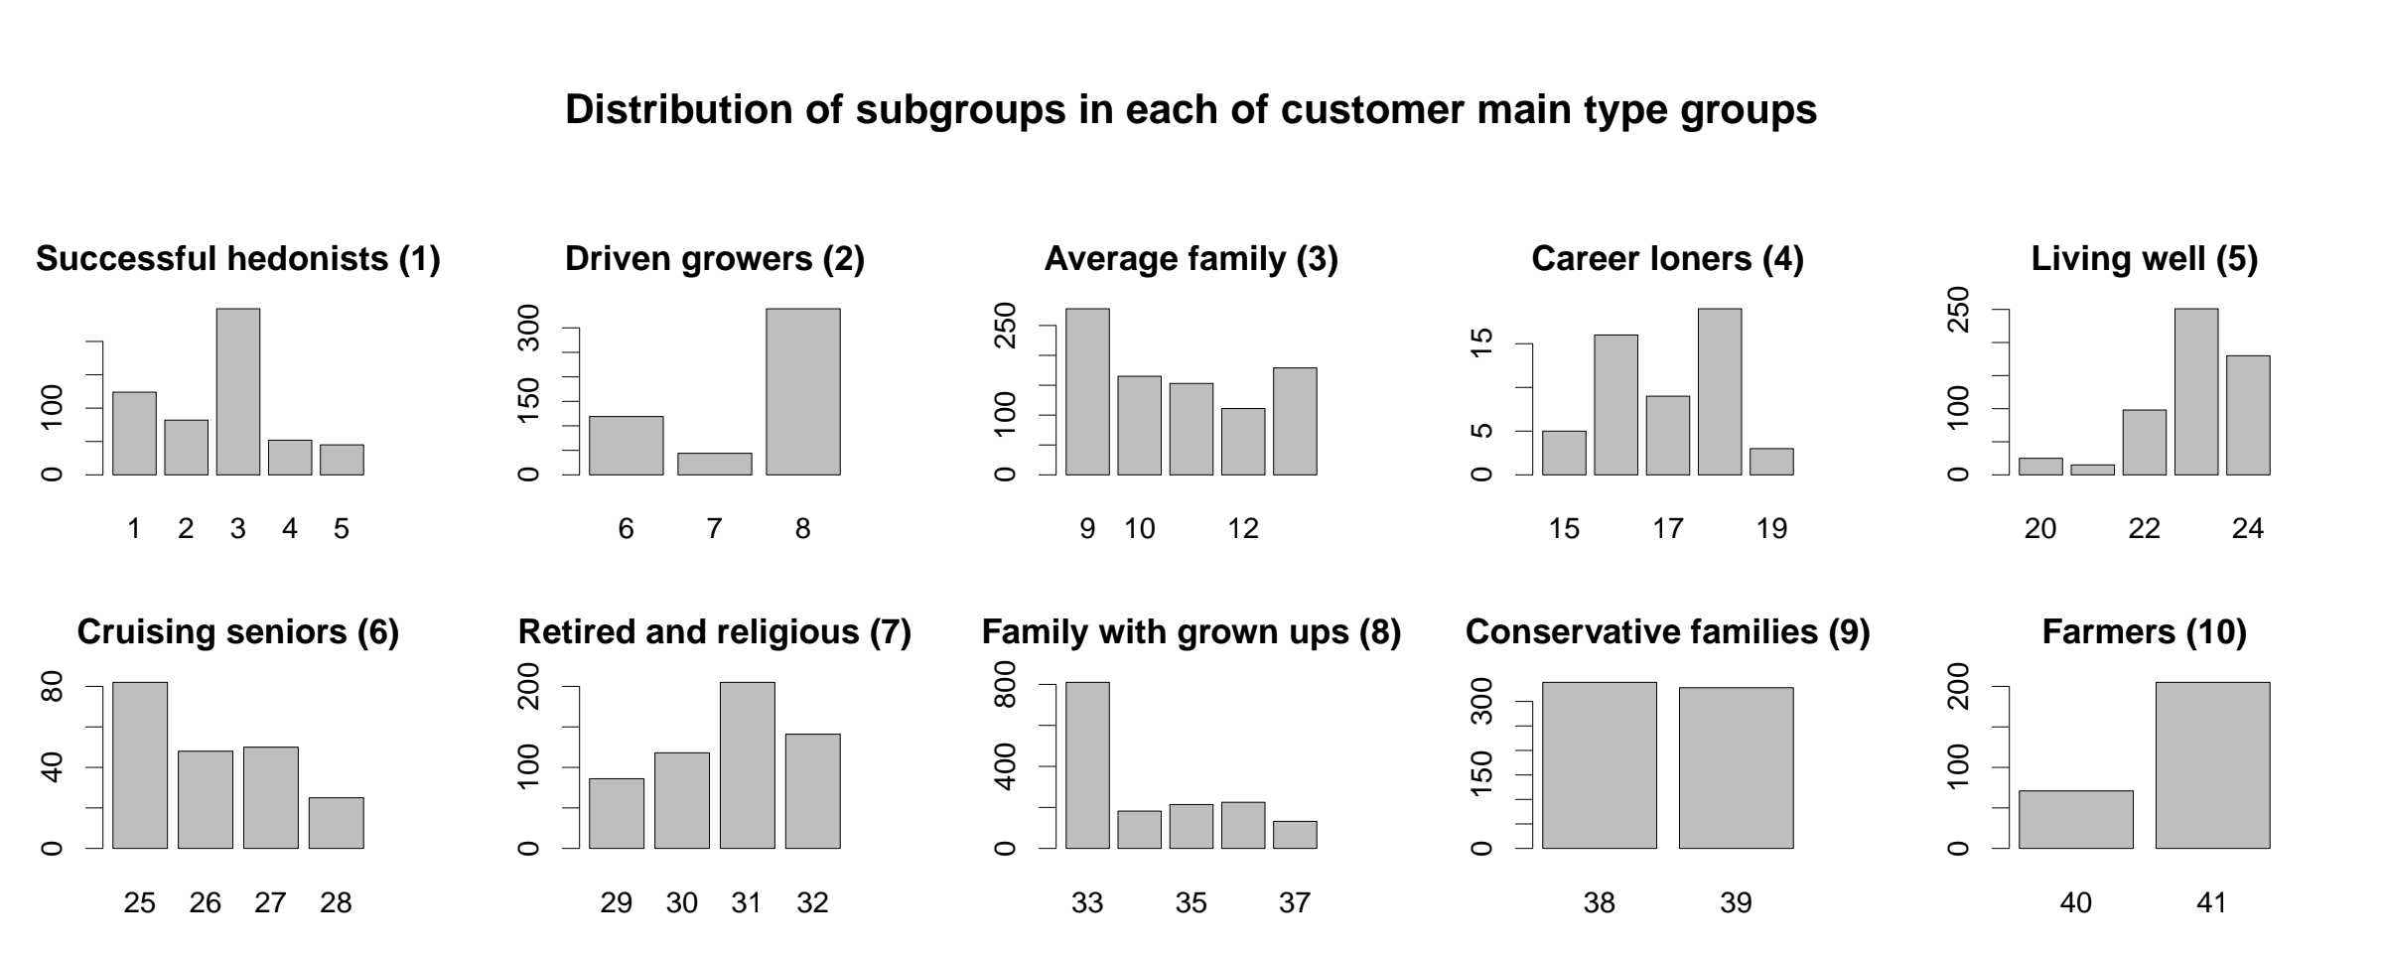
and the Purchase frequency of its subgroups:
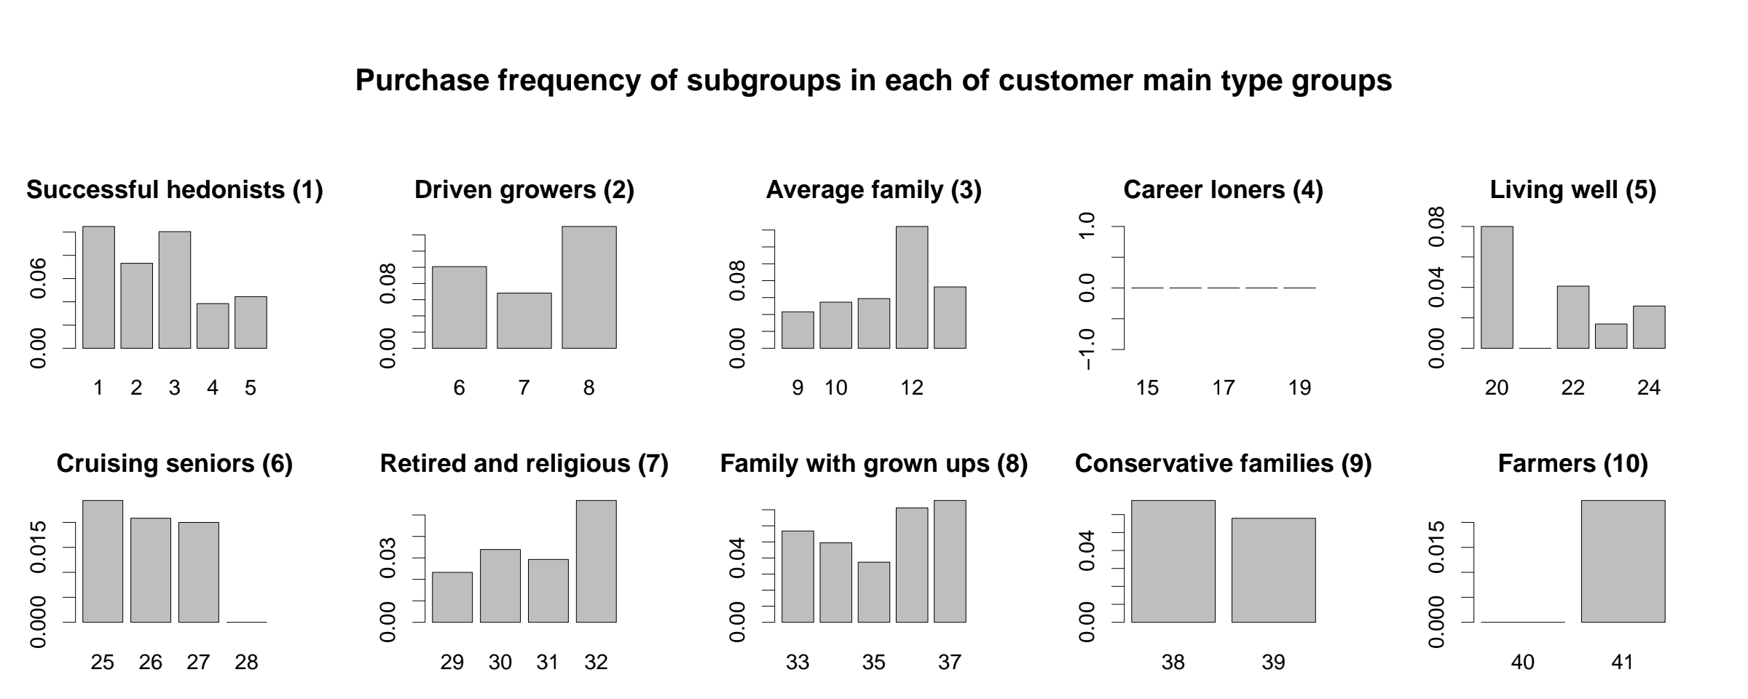
This visuallization is really useful when exlaining why subgroups 15-19 contain no examples. These subgroups are part of group 4 Career loners, which as was shown in Task 1a contains no positive examples.
Groups which are interesting are the ones with irregularities in the Purchase distribution. Most notably, the likelihood of the members of group 3 Average family to purchase the caravan insurance policy is average (6.66%), unless they are part of subgroup 12 Affluent young families, in which case it is 14.41%.
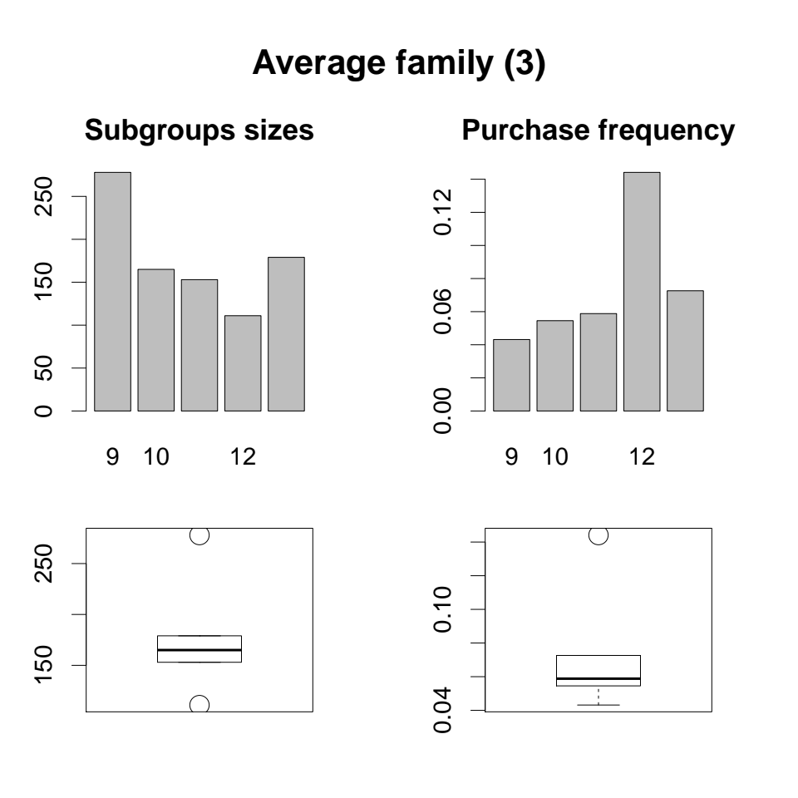
The same can be said about members of group 5 Living well and subgroup 20 Ethnically diverse. Although this subgroup can be classified as an outlier compared to other subgrous in the parent group (based on Purchase frequency), it contains only 25 members which drastically decreases its importance.
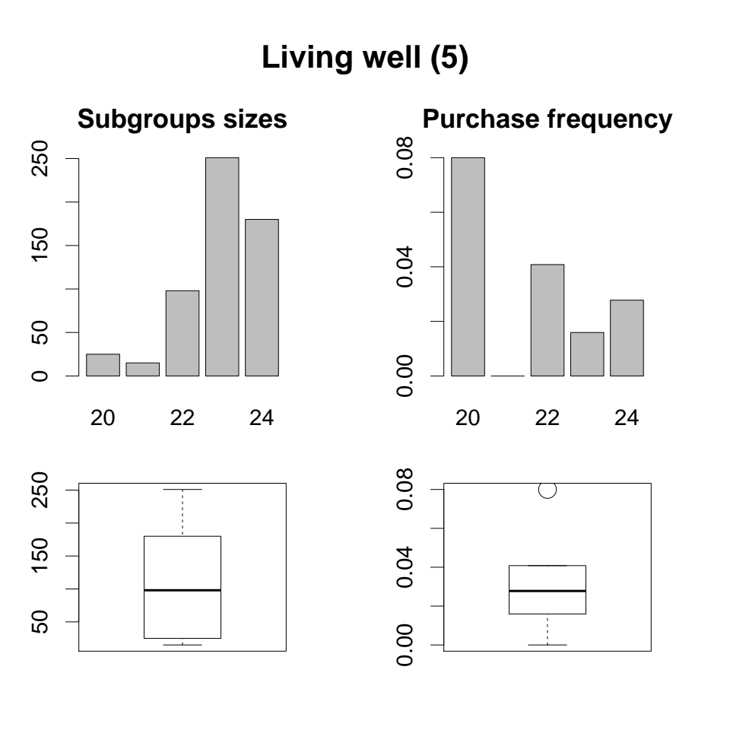
Charts like these two (group details) were created for each group and can be seen in /out/group-<group number>-detail.pdf.

Task 2 – Model fitting, optimization and selection
Three models were fitted, optimized and compared: Decision Tree (2a), Random Forest (2b) and Regularized Logistic Regression (2c).
Each model was fitted and optimized using a similar method: model performance with certain parameters was measured by computing the mean of AUC_{0.2} gathered by performing a 10-fold cross-validation. Parameters which yielded the best performance were selected.
Afterwads, models with best parameters were trained using the train data set and evaluated using the test data set. The model which produced the best results (again, evaluated using AUC_{0.2}) was selected to be the final model.

AUC_{0.2}
Bla Bla Bla

Cross-validation
It is important to note that cross-validation was regularized by ensuring that same number of positive examples was in each fold. For this purpuse a custom function cv.split.safe() was defined.

Parameter tuning
Parameters for a certain model are selected by creating a large number of models, one for each value from a predefined range and then running a 10-fold cross-validation (thus creating and testing 10 models; one per iteration). This is computationally demaning and requires a lot of time. To make sure that this process does not have to run every time the R script is executed, data from parameter optimation process is stored in .csv files (eg. out/decision-tree/decision-tree-eval.csv) and later loaded into R rather than computed from scratch. This is the way the script behaves only if the value of params.readDataFromFiles is set to TRUE.

Task 2a – Decision Tree
Decision tree is an unstable machine learning algorithm. This means that small differences in training data will result in significant differences in the produced model. Therefore high variance is expected when performing the cross-validation.
Only one parameter was tuned: cp – the complexity parameter. cp defines the minimal decrease in impurity in order for a split to be performed. 50 values in range 0.0001-0.0099 were tested, with step 0.0002. Each model, produced by changing the complexity parameter, was evaluated by computing the value of AUC_{0.2}.
This means 10 values for each value of cp. The mean and confidence intervals can be plotted into a line chart with error bars:
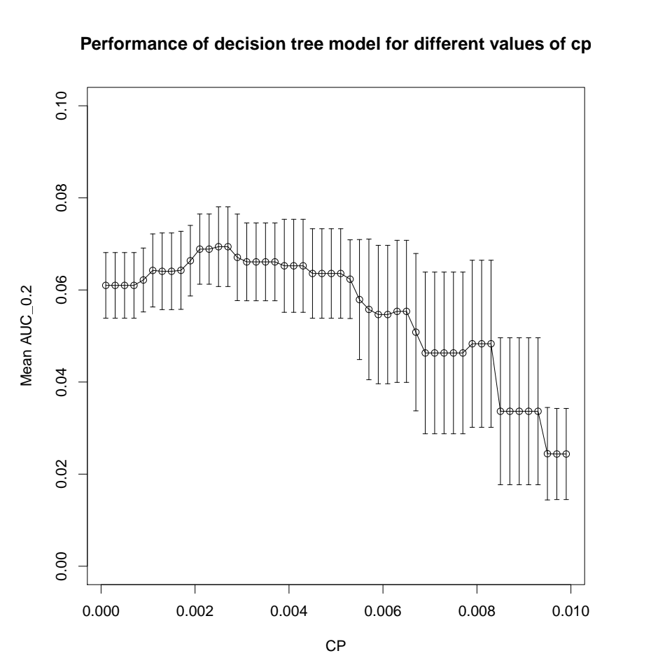
As was predicted, the error bars on the mean of AUC_{0.2} are very large, making it diffucult to select the best value of cp.
cp | AUC_{0.2} mean | AUC_{0.2} standard deviation | AUC_{0.2} confidence interval
0.0025 | 0.0694 | 0.0121 | (0.0607; 0.0780)

The best value of cp in this case is 0.0025.

Task 2b – Random Forest
Random Forest is an ensamble machine learning algorithm which uses bagging to create multiple decision trees and then voting to get the final prediction.
In each node only a subset of features is considered as the split candidates. This results in the more important features appearing more frequently than the less important features. The number of features is controlled by the parameter mtry. It is also possible to control the number of trees built using the parameter ntree. These two parameters will be tuned.

ntree
The more trees you grow, the better the model; but there is an upper limit to the performance of a Random Forest. The goal when tuning the ntree parameter is to find such value of ntree that produces a model which can no longer be improved by increasing the number of trees. We will call this value the Critical Point.
Random Trees can never overfit the data, thus finding the optimal value of the ntree parameter is more about saving computation time than about classifier performance. Also, it is important to find the minimal value of ntree before tuning the value of mtry.
The tuning began by testing the values given by round(seq(1, 30) ** 1.6) to see if we can find the Critical Point. The mtry parameter was set to default (9). Here is the chart of AUC_{0.2} means and confidence intervals from 10-fold cross-validation:
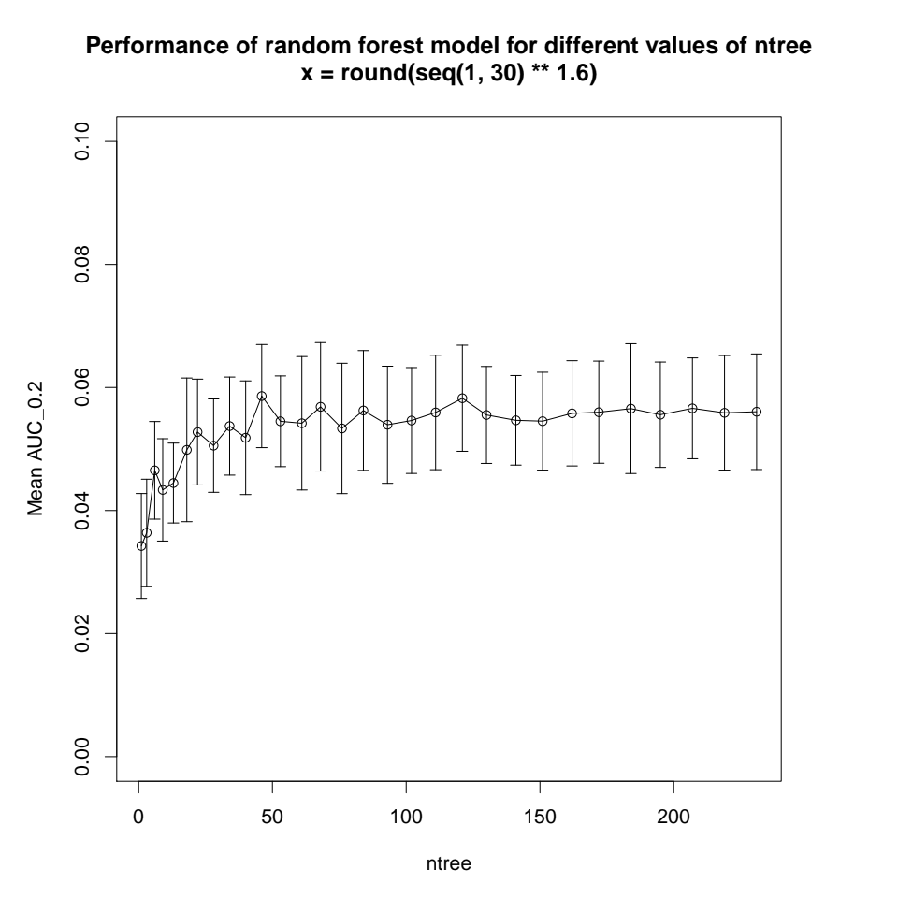
From this chart it looks like the Critical Point might be somewhere between 50 and 70. To analyze this even further, values given by round(seq(1, 30) ** 1.25) were tested. The mtry parameter was again set to default (9):
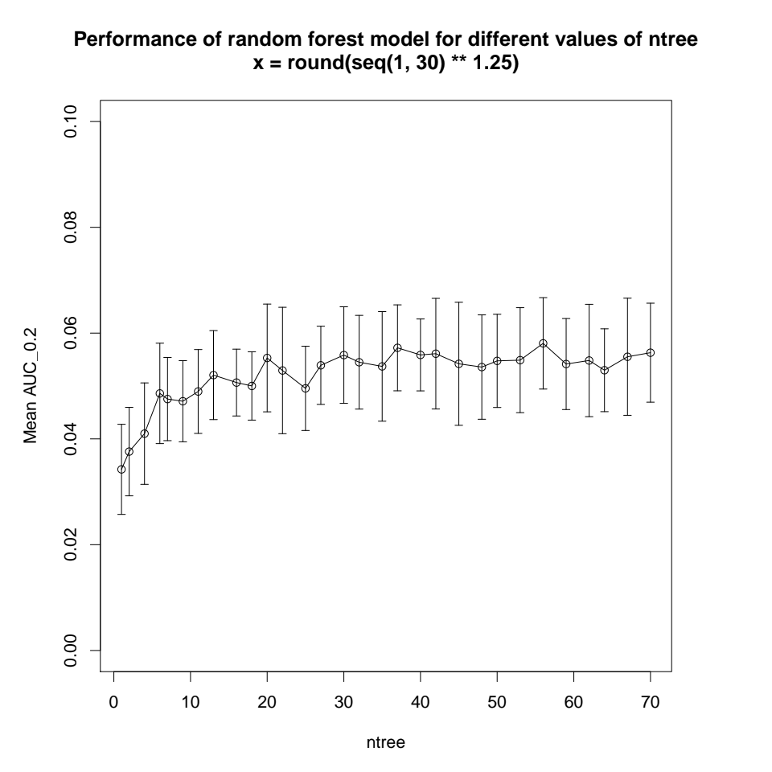
From this chart it is even more clear that it is safe to assume that any value of ntree >69 is going to yield good results. The final step was to check if, by any chance, obscurely large values of the ntree parameter produced a better model. For this purpuse values 500, 1000 and 2000 were tested. Here are the results:
ntree | AUC_{0.2} mean | AUC_{0.2} standard deviation | AUC_{0.2} confidence interval
500 | 0.0583 | 0.0123 | (0.0495; 0.0670)
1000 | 0.0577 | 0.0129 | (0.0485; 0.0669)
2000 | 0.0565 | 0.0130 | (0.0472; 0.0658)

As can be seen, the values of AUC_{0.2} have not improved.

mtry
Now, that it is clear that at least 70 trees (>69) in a Random Forest should be enough, we can start tuning the mtry parameter. Lower values of mtry require more trees in a forest to be effective, so we will work with ntree=150.
Values in range {2, 3, 4, 5, … , 26, 27, 28} have been tested to find the best value:
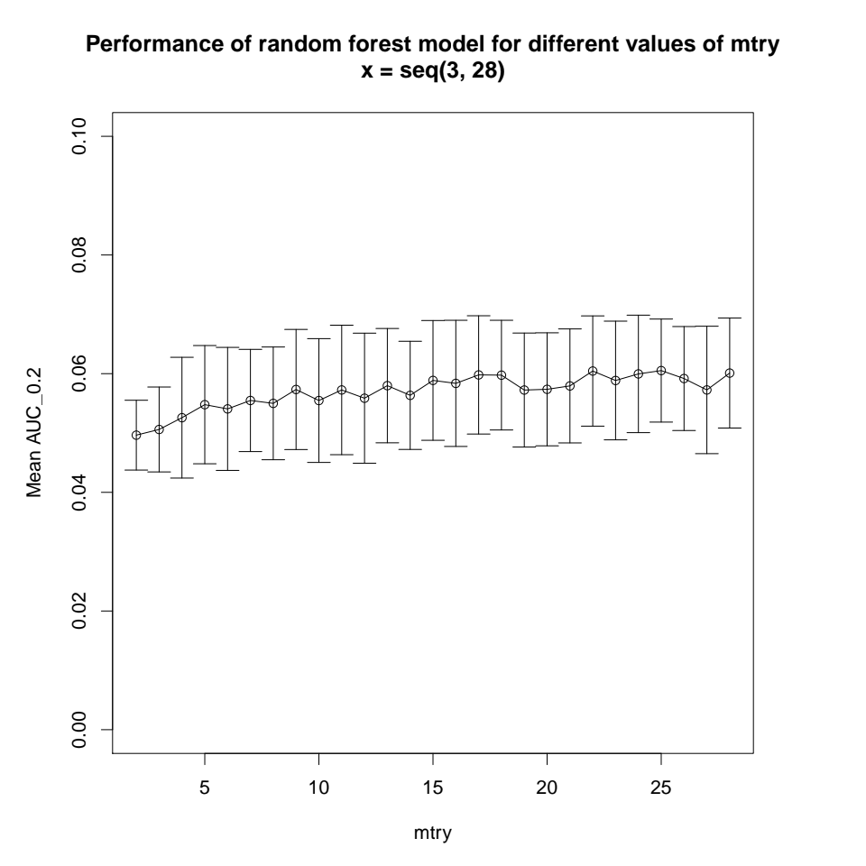
As can be see from the chart, the performance improves with higher values of mtry. Although values >=15 are impossible to compare decisively. Thus the optimal value of the mtry parameter is 15. Because it is the easiest to compute.
mtry | AUC_{0.2} mean | AUC_{0.2} standard deviation | AUC_{0.2} confidence interval
15 | 0.0589 | 0.0141 | (0.0488; 0.0690)

Task 2c – Regularized Logistic Regression
Logistic Regression uses sigmoid function to model the probability that an example is positive. The goal in creating a Logistic Regression model is to find the parameters that minimize the loss function. In Regularized Logistic Regression, a penalty is added to the loss function and the goal is to minimize the sum of loss function and penalty function.
There are two methods for regularization: Lasso and Ridgre Regression. Our model will use a combination of both, which is called an Elastic Net. Elastic Net uses two parameters: lambda – the penalty parameter and alpha – the parameter which determines the proportion of the penalties of Lasso and Ridge Regression in the final penalty function.

Lambda
The best value of lambda depends on the value of alpha and can be easilly calculated using cv.glmnet function. This function runs 10-fold cross validation and determines the best value of lambda for a given value of alpha. This function also builds a model which can later be used for prediction.

Alpha
Since it is easy to find to best lambda for a given alpha. Our goal will be to find the best value of alpha. For this we will create 15 models with different values of alpha given by seq(0, 14) * (1 / 14):

Task 2d – Model comparison
The parameters of the three models were tuned to find the best values. Then the best values were used to produce three candidate models. The best model of the three candidate models will be selected as the final model, which will then be used for final prediction.

Decision Tree
The best parameters for the Decision Tree model are as follows:
cp | 0.0025

The tree that has been build using the value of cp=0.0025 looks like this:
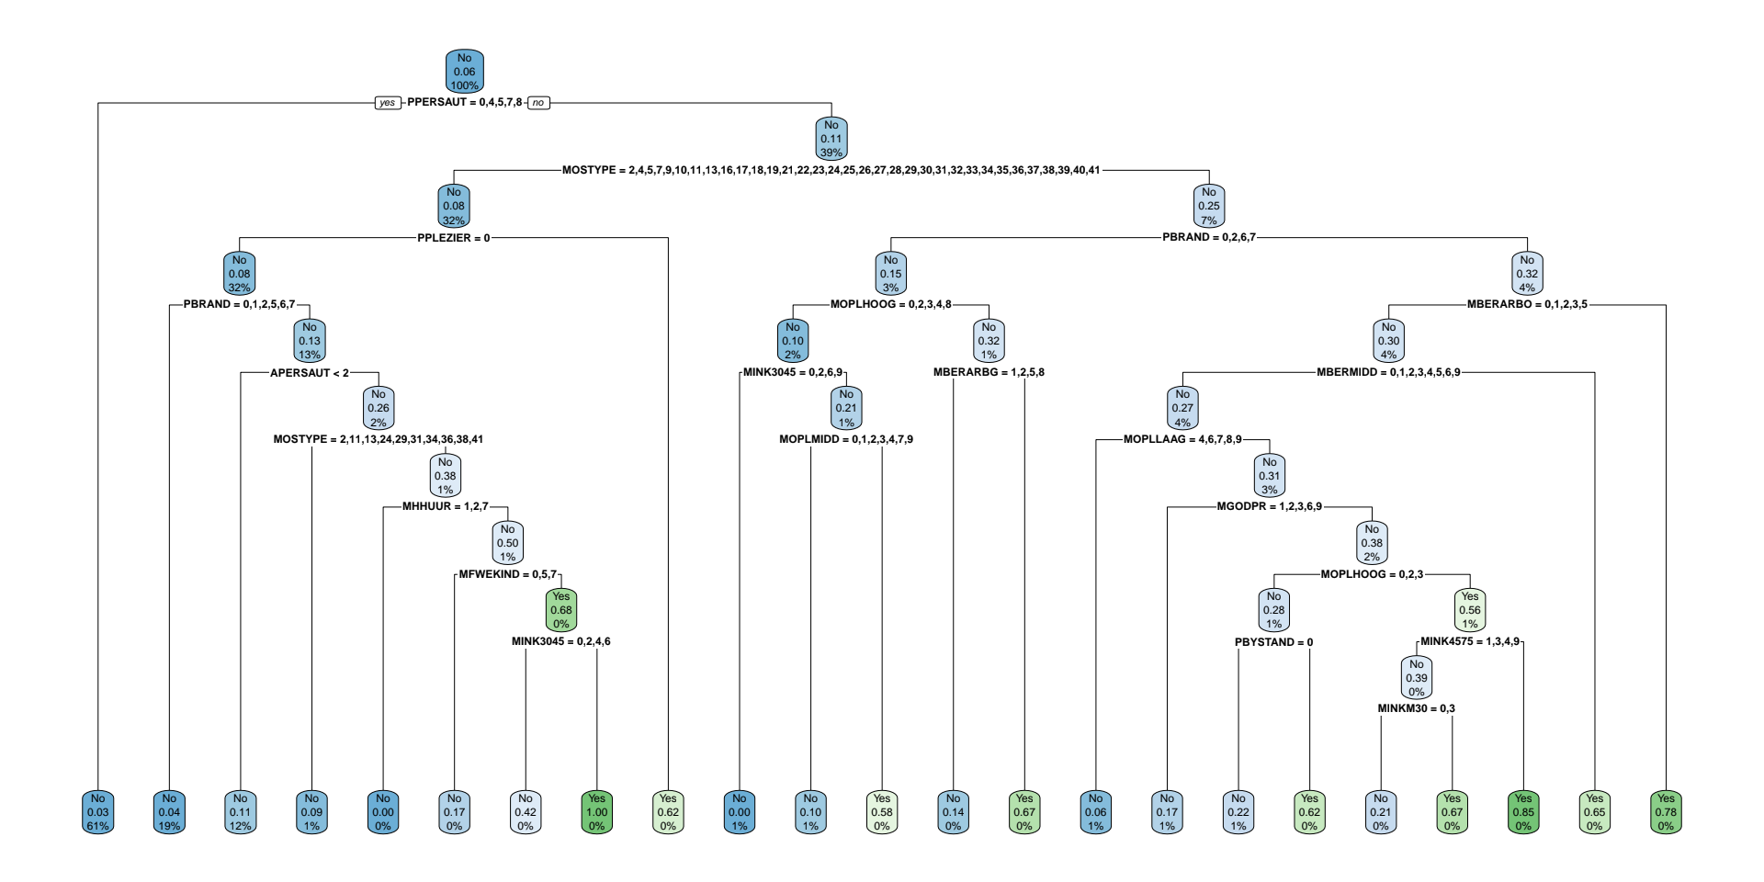
It has been evaluated using an ROC curve. Also, precision when predictng 100 positive examples from 1000 examples in the test data set was calculated:
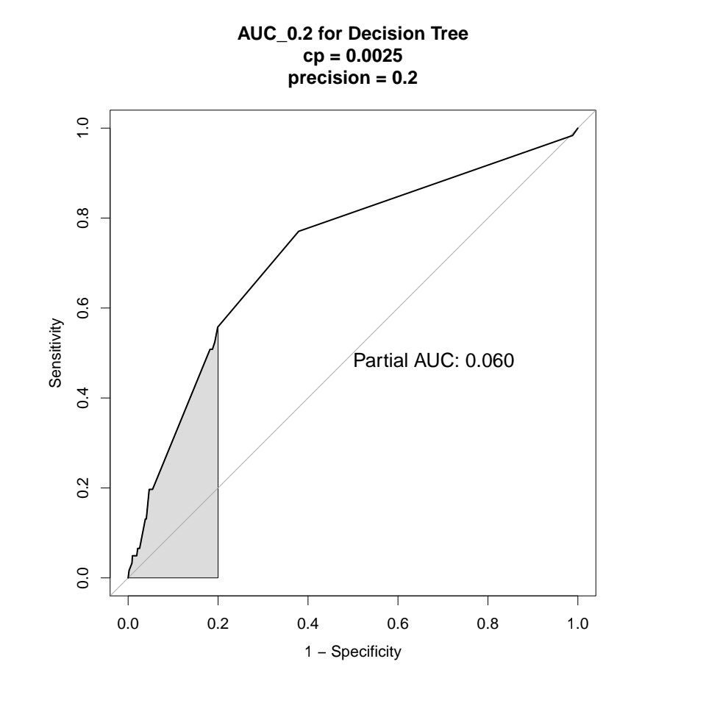
The Decision Tree model has actually shown to be a pretty good choice for this classification task.

Random Forest
The best parameters for the Random Forest model are as follows:
ntree | >69
mtry | 15

We will use the value of ntree=1000, because it cannot hurt us and it will make it easier to explore the feature importance measured by the Random Forest.
The Random Forest model with optimal parameters has been evaluated using an ROC curve. Also, precision when predictng 100 positive examples from 1000 examples in the test data set was calculated:
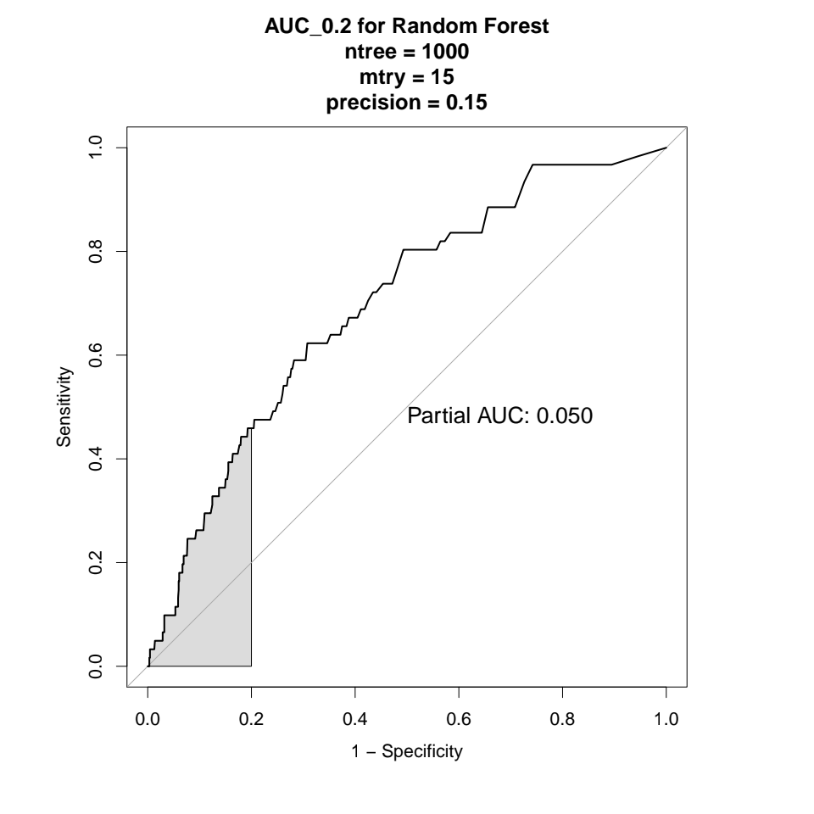
The Random Forest model has suprisingly shown worse results than a single Decision Tree. The reason for this might be that it is really difficult to identify the positive examples and creating an ensamble of very weak classifiers is not going to improve the predictor performance.

Regularized Logistic Regression
Bla Bla Bla

Comparison and final choice
Bla Bla Bla

Task 2e – The best model
Bla Bla Bla

Task 3 – Model interpretation and feature selection
There are multiple ways to do feature selection. One way is to train a model using our data and observe the variable importance produced by this model. Decision Tree and Random Forest models can be used this way. Another way is to use the Lasso model which shrinks some parameters to 0 and select a subset of parameters from the ones that were not shrinked to 0.

Decision Tree vs Random Forest
Decision Tree (cp=0.0025) and Random Forest (ntree=1000, mtry=15) models were produced in Task 2. We can observe the variable importance of all features based on these models:
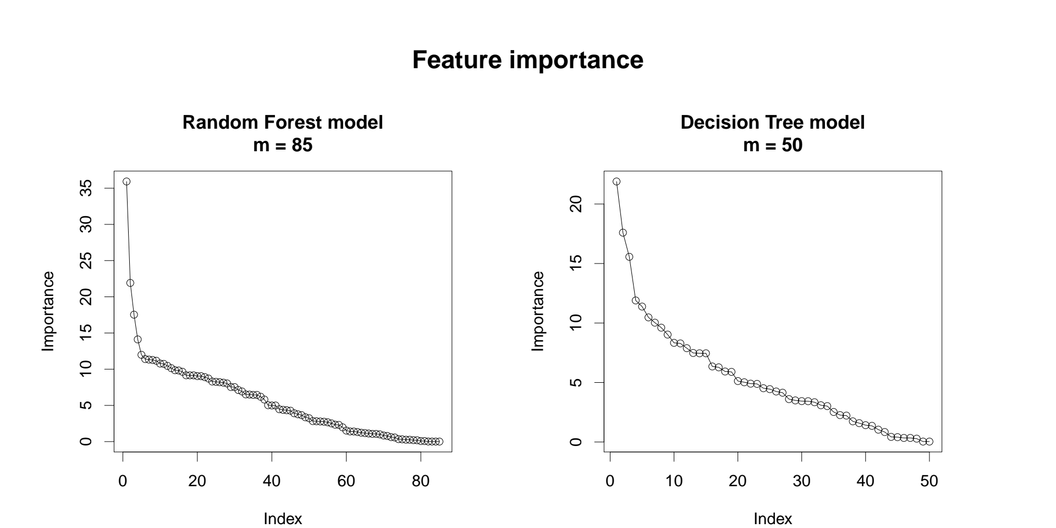
where m is the number of features used.
According to both models, the by far most important feature is the customer subgroup MOSTYPE. The difference is that the Random Forest prioritized MOSTYPE a lot more than the Decision Tree. This can be easilly seen by looking at the standradized version of feature importance (Z-score standardization):
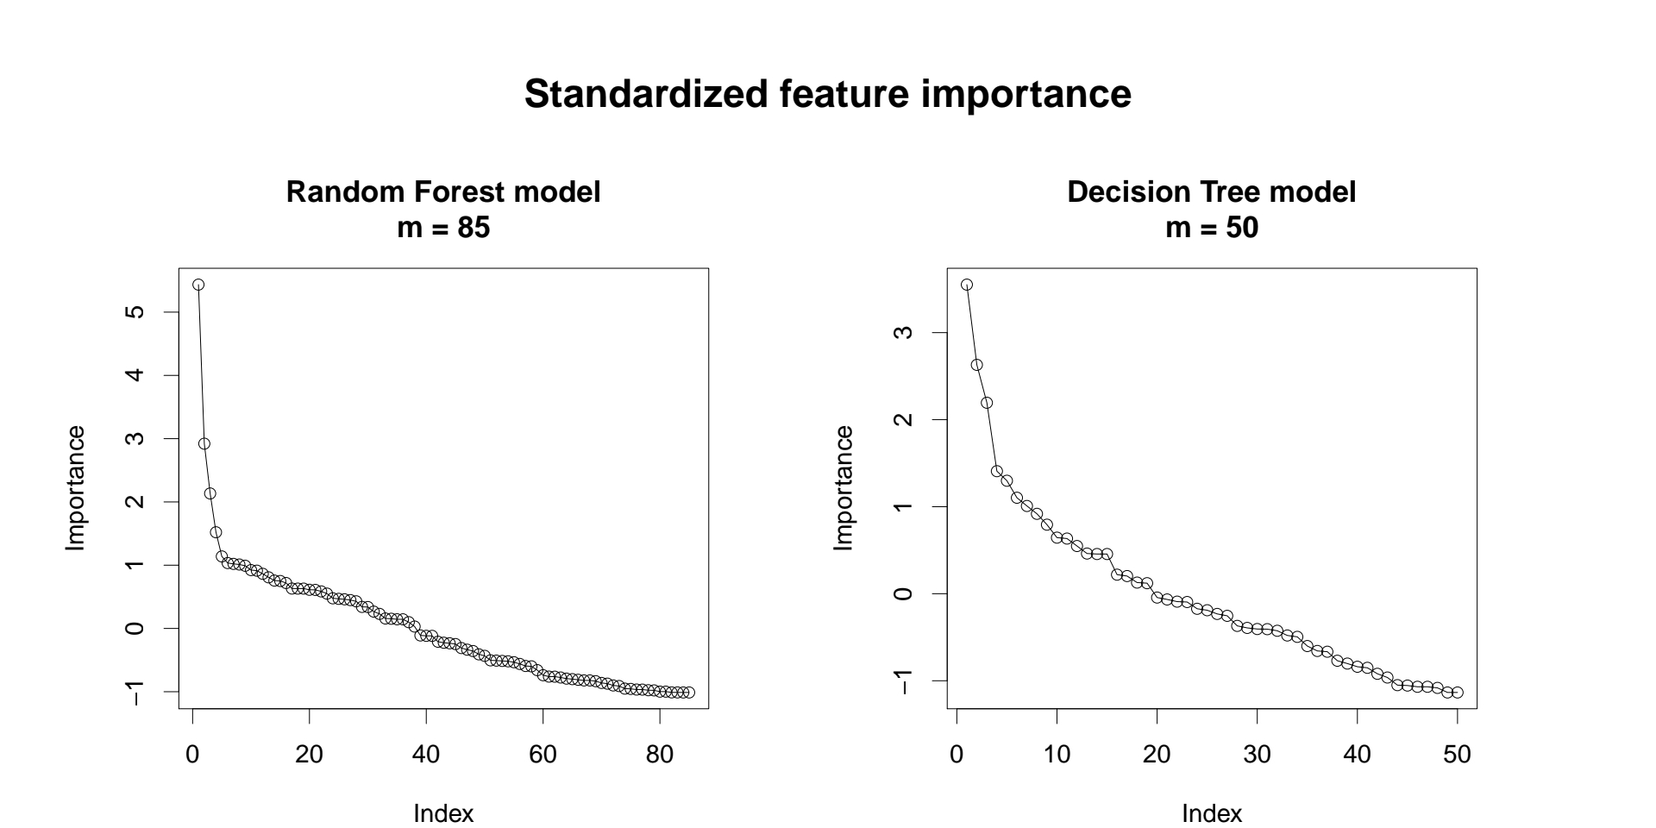
Below are listed features which are above 1 threshold:
Decision Tree | MOSTYPE, PPERSAUT, APERSAUT, PBRAND, MOSHOOFD, MINK3045, MKOOPKLA
Random Forest | MOSTYPE, PBRAND, PPERSAUT, APERSAUT, MFWEKIND, MBERMIDD, MHKOOP, MOPLLAAG

Four variables appear in both models: MOSTYPE, PPERSAUT, APERSAUT, PBRAND. These variables are the most important according to both Decision Tree model and Random Tree model but in different order:
Variable | Meaning | Decision Tree | Random Forest
MOSTYPE | Customer Subtype | 21.89 | 35.93
PPERSAUT | Contribution car policies | 17.59 | 17.53
APERSAUT | Number of car policies | 15.56 | 14.11
PBRAND | Contribution fire policies | 11.90 | 21.92

A barchart can be used to see the differences in 15 most important features based on both models:
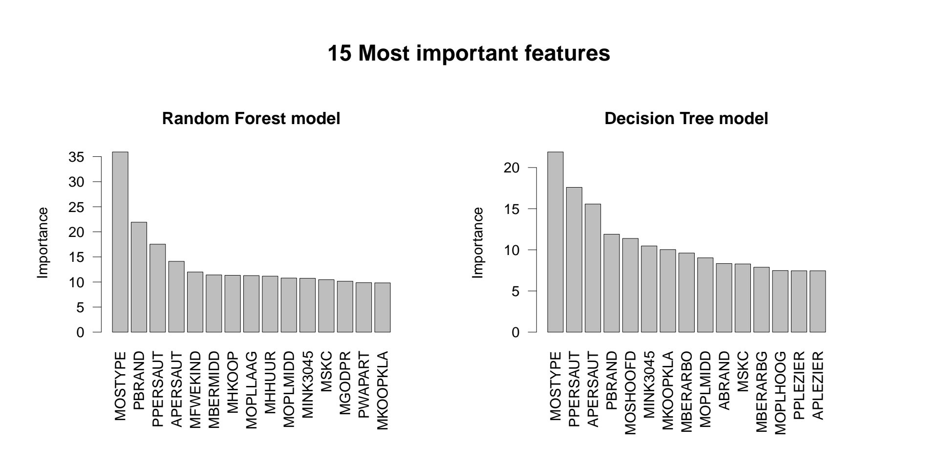
Let’s now compare the feature importance based on the Decision Tree and Random Forest models with the reduced subset of features produced by the Lasso model.

Lasso Model
Lasso regularization is controlled by the lambda parameter. The higher the lambda, the more strict the model is, meaning that there is a higher penalty. As a result, with higher values of lambda, more coefficients are shrinked to 0. This can be visuallized as follows:
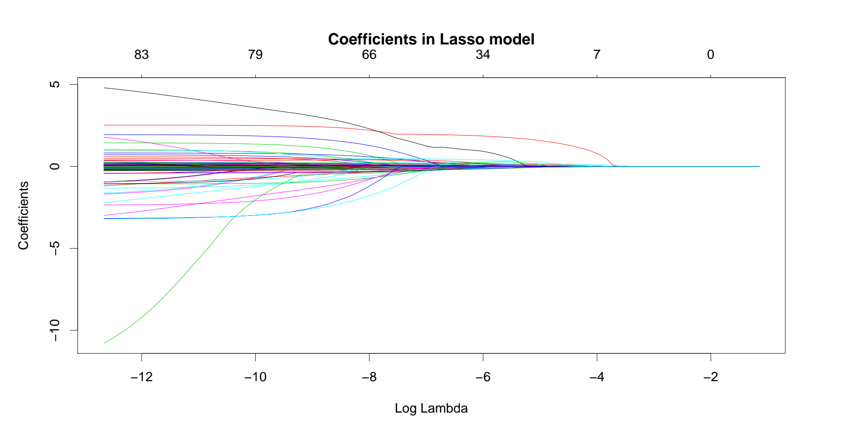
We can also observe the number of non-zero features at different values of lambda:
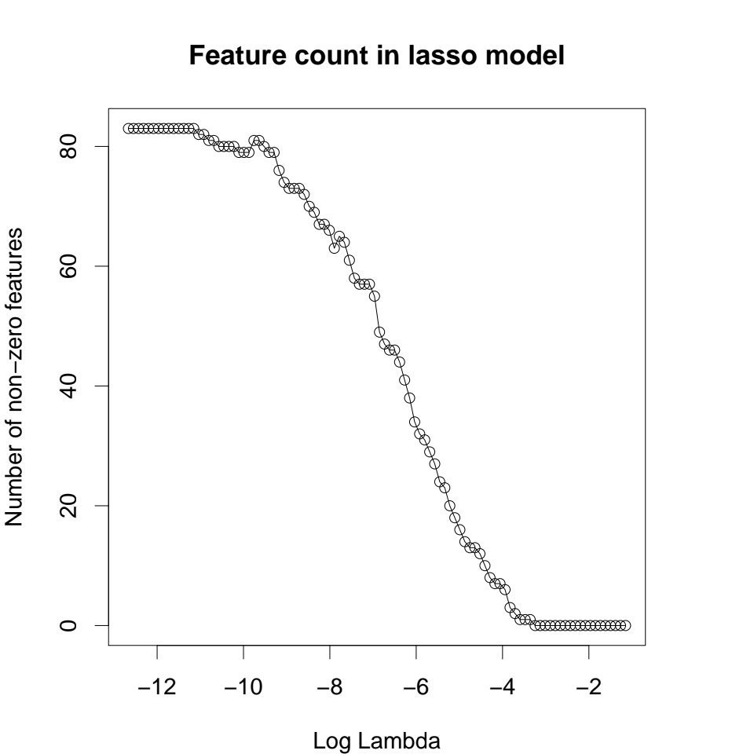
It is possible to create a subset of features by selecting a value of lamba which will shrink some coefficients to zero.
index | lambda | features
s30 | 0.00965713905296605 | 13
s31 | 0.00859693086719079 | 13
s32 | 0.00765311754650134 | 14
s33 | 0.00681292069057961 | 16
s34 | 0.0060649647746946 | 18
s35 | 0.0053991231351259 | 20
s36 | 0.00480638086306439 | 23
s37 | 0.00427871275069427 | 24
s38 | 0.00380897463695407 | 27
s39 | 0.00339080668189405 | 29
s40 | 0.00301854726004992 | 31

Let’s look at the 16 features produced by the Lasso model when setting lambda to 0.0068129. These features are: MRELGE, MOPLHOOG, MOPLLAAG, MBERBOER, MHHUUR, MAUT1, MINKGEM, MKOOPKLA, PWAPART, PPERSAUT, PBRAND, APLEZIER, AFIETS, ABYSTAND.

Task 4 – Final prediction on the blind test set
Final prediction on the blind test set was done using the best model (see Task 2e) with the best parameters. The goal is to be as precise as possible, ie. identify as many true positives as possible from 100 examples marked as positive.

