EMPLOYEE PERFORMANCE PREDICTION USING MACHINE LEARNING

INTRODUCTION

- MACHINE LEARNING APPROACH FOR EMPLOYEE PERFORMANCE PREDICTION
The Machine Learning Approach for Employee Performance Prediction with a comprehensive system designed to analyze various data points related to employees' work performance and use machine learning algorithms, leveraging ML technology stack, to predict and evaluate their future performance. By incorporating factors such as past performance metrics, training data, feedback, and external factors, the system aims to provide insights that can aid in talent management, resource allocation, and workforce optimization strategies.
Scenario 1: Talent Retention HR departments can use the machine learning predictions to identify high-performing employees at risk of attrition. By analyzing factors contributing to employee turnover and predicting performance trends, HR can implement targeted retention strategies, such as personalized career development plans or incentive programs, to retain top talent.
Scenario 2: Performance Improvement Managers and team leaders can leverage the predictions to identify areas where employees may need additional support or training. By understanding performance patterns and potential challenges, managers can provide timely coaching, resources, or skill development opportunities to enhance employee performance and productivity.
Scenario 3: Resource Allocation Organizations can optimize resource allocation by using machine learning predictions to match employees with projects or tasks that align with their strengths and capabilities. This ensures efficient utilization of talent, improves project outcomes, and enhances overall organizational performance.

TECHNICAL ARCHITECTURE:
- PRE REQUISITES
To complete this project, we require following software’s, concepts and packages
- Python
  - Python can be downloaded from the link below
  - Link : link
- Vs code
  - Install the Vs code from the link below.
  - Link : link
- Python packages:
- Open Vs code as administrator.
- Install python extension, jupyter extension from extensions in Vs code.
- From view option open terminal
- Type “pip install numpy” and click enter.
- Type “pip install pandas” and click enter.
- Type “pip install scikit-learn” and click enter.
- Type ”pip install matplotlib” and click enter.
- Type ”pip install scipy” and click enter.
- Type ”pip install pickle-mixin” and click enter.
- Type ”pip install seaborn” and click enter.
- Type “pip install Flask” and click enter.

PRIOR KNOWLEDGE
We must have prior knowledge of following topics to complete this project.
- ML Concepts
  - Supervised learning: https://www.javatpoint.com/supervised-machine-learning
  - Unsupervised learning: https://www.javatpoint.com/unsupervised-machine-learning
- Decision tree: https://www.javatpoint.com/machine-learning-decision-tree-classification-algorithm
- Random forest: https://www.javatpoint.com/machine-learning-random-forest-algorithm
- KNN: https://www.javatpoint.com/k-nearest-neighbor-algorithm-for-machine-learning
- Xgboost: https://www.analyticsvidhya.com/blog/2018/09/an-end-to-end-guide-to-understand-the-math-behind-xgboost/
- Evaluation metrics: https://www.analyticsvidhya.com/blog/2019/08/11-important-model-evaluation-error-metrics/
- Flask Basics : https://www.youtube.com/watch?v=lj4I_CvBnt0

PROJECT OBJECTIVES
By the end of this project we will:
- Know fundamental concepts and techniques used for machine learning.
- Gain a broad understanding about data.
- Have knowledge on pre-processing the data/transformation techniques and some visualization concepts.
- PROJECT FLOW
- User interacts with the UI to enter the input.
- Entered input is analyzed by the model which is integrated.
- Once model analyses the input the prediction is showcased on the UI

To accomplish this, we have to complete all the activities listed below,
- Data collection
  - Collect the dataset or create the dataset
- Visualizing and analyzing data
- Correlation analysis
- Descriptive analysis
- Data pre-processing
  - Checking for null values
  - Handling Date & department column
  - Handling categorical data
  - Splitting data into train and test
- Model building
  - Import the model building libraries
  - Initializing the model
  - Training and testing the model
  - Evaluating performance of model
  - Save the model
- Application Building
  - Create an HTML file
  - Build python code

PROJECT STRUCTURE
Create the Project folder which contains files as shown below
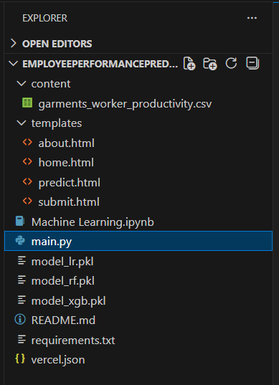

- We are building a flask application which needs HTML pages stored in the templates folder and a python script main.py for scripting.
- model_lr.pkl,model_rf.pkl,model_xgb.pkl are our saved model. Further we will use this model for flask integration.
- Machine Learning.ipynb is our model file .

DATA COLLECTION
ML depends heavily on data, It is most crucial aspect that makes algorithm training possible. So this section allows us to download the required dataset.

DOWNLOAD THE DATASET
There are many popular open sources for collecting the data. Eg: kaggle.com, UCI repository, etc.
In this project we have used garments_worker_productivity.csv data. This data is downloaded from kaggle.com. Please refer the link given below to download the dataset.
Link: link

Productivity Prediction of Garment Employees | Kaggle..
Kaggle is the world’s largest data science community with powerful tools and resources to help us achieve our data science goals...
https://www.kaggle.com/datasets/utkarshsarbahi/productivity-prediction-of-garment-employees

- VISUALIZING AND ANALYZING THE DATA
As the dataset is downloaded. Let us read and understand the data properly with the help of some visualization techniques and some analysing techniques.
Note: There is n number of techniques for understanding the data. But here we have used some of it. In an additional way, you can use multiple techniques.

IMPORTING THE LIBRARIES
Import the necessary libraries as shown in the image.

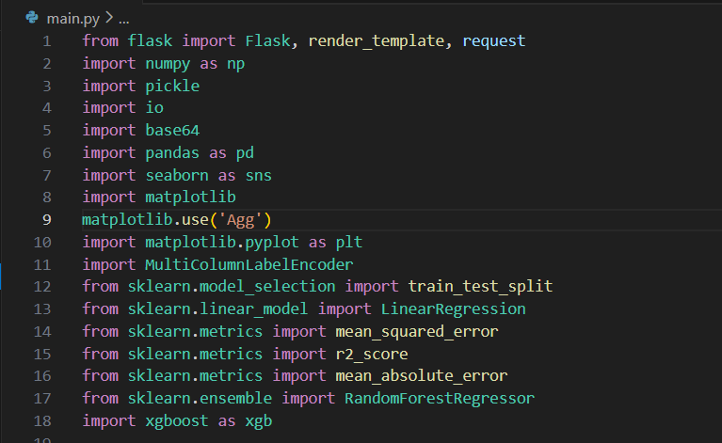

READ THE DATASET
Our dataset format might be in .csv, excel files, .txt, .json, etc. We can read the dataset with the help of pandas.
In pandas we have a function called read_csv() to read the dataset. As a parameter we have to give the directory of csv file.

CORRELATION ANALYSIS
In simple words, A correlation matrix is simply a table which displays the correlation coefficients for different variables. The matrix depicts the correlation between all the possible pairs of values in a table. It is a powerful tool to summarize a large dataset and to identify and visualize patterns in the given data.
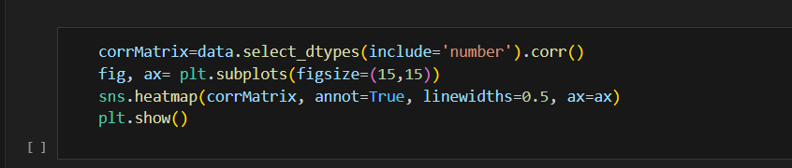
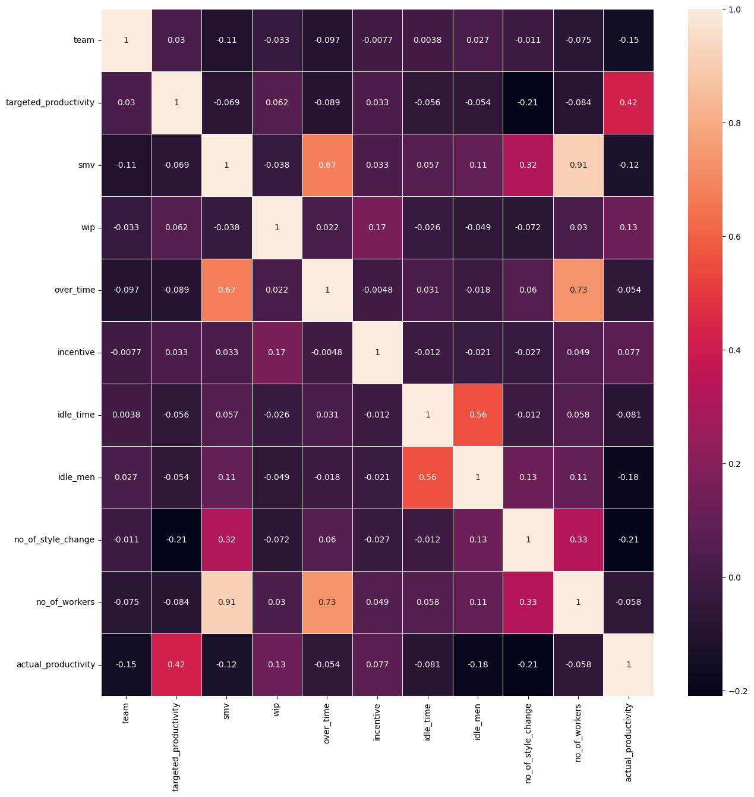

DESCRIPTIVE ANALYSIS
Descriptive analysis is to study the basic features of data with the statistical process. Here pandas has a worthy function called describe. With this describe function we can understand the unique, top and frequent values of categorical features. And we can find mean, std, min, max and percentile values of continuous features.
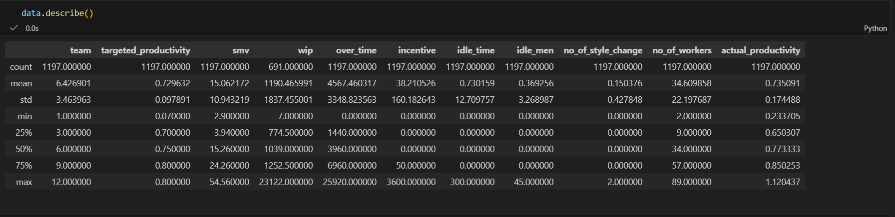
- Data Pre-processing
As we have understood how the data is lets pre-process the collected data.
The download data set is not suitable for training the machine learning model as it might have so much of randomness so we need to clean the dataset properly in order to fetch good results. This activity includes the following steps.
- Handling missing values
- Handling Date & department column
- Handling categorical data
- Splitting dataset into training and test set

Note: These are the general steps of pre-processing the data before using it for machine learning. Depending on the condition of our dataset, we may or may not have to go through all these steps.

CHECKING FOR NULL VALUES
- For checking the null values, data.isnull() function is used. To sum those null values we use .sum() function to it. From the below image we found that in our dataset there is one feature which has high number of null values. So we drop that feature.

- Let’s find the shape of our dataset first, To find the shape of our data, data.shape method is used. To find the data type, data.info() function is used.

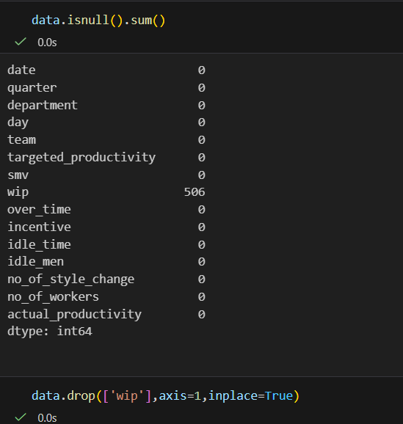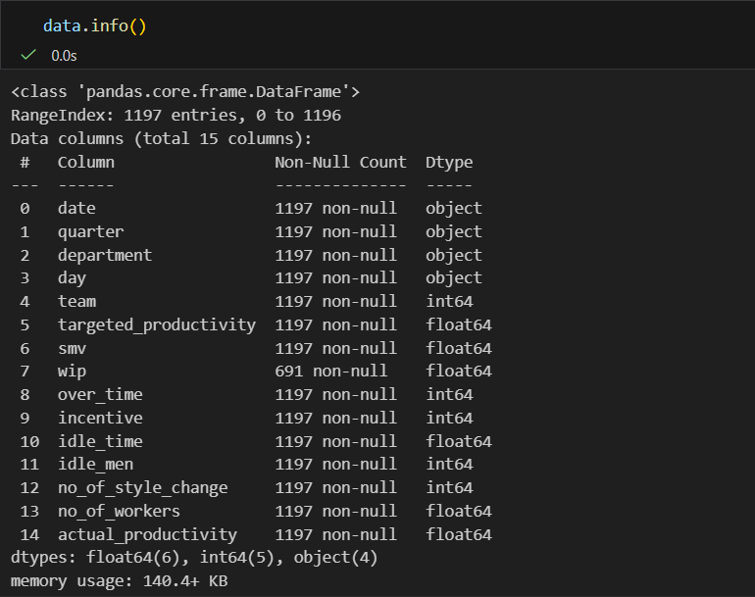

HANDLING DATE & DEPARTMENT COLUMN
- Here what we are doing is converting the date column into date time format.

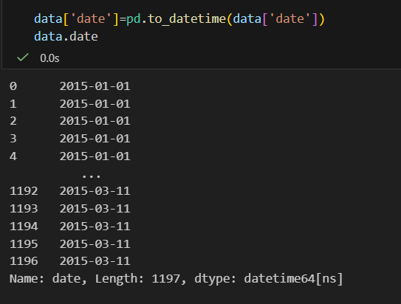

- Then converting date column to month (month index) & transferring the values into a new column called month. As we have the month column now we don’t need date, so we will drop it.
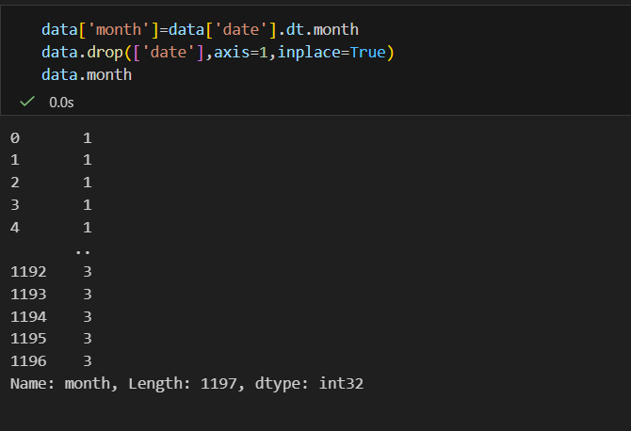
\
From below image we can see that in department column the values are slit into 3 categories Sweing, finishing, finishing. Finishing class is repeating twice, so we will merge them into 1.

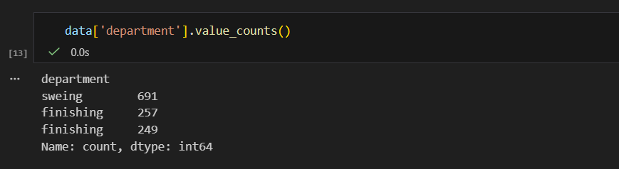
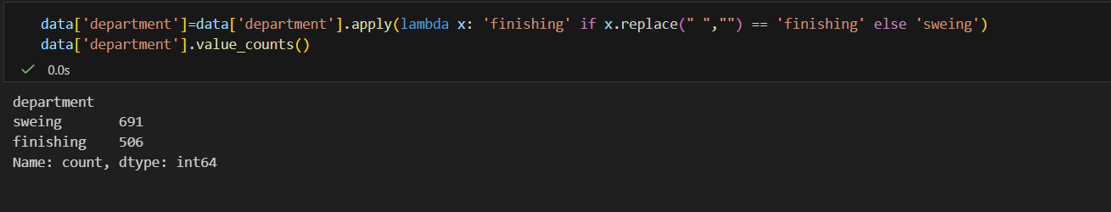

HANDLING CATEGORICAL VALUES
As we can see our dataset has categorical data we must convert the categorical data to integer encoding or binary encoding.
To convert the categorical features into numerical features we use encoding techniques. There are several techniques but in our project we are using MultiColoumnLabelEncoder.
- In our project, categorical features are quarter, department, day. With MultiColoumnLabelEncoder encoding is done.
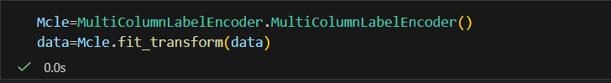

SPLITTING DATA INTO TRAIN AND TEST
Now let’s split the Dataset into train and test sets. First split the dataset into x and y and then split the data set. After that x is converted into array format then passed into a new variable called X.
Here X and y variables are created. On X variable, data is passed with dropping the target variable. And on y target variable is passed. For splitting training and testing data we are using train_test_split() function from sklearn. As parameters, we are passing X, y, test_size, random_state.
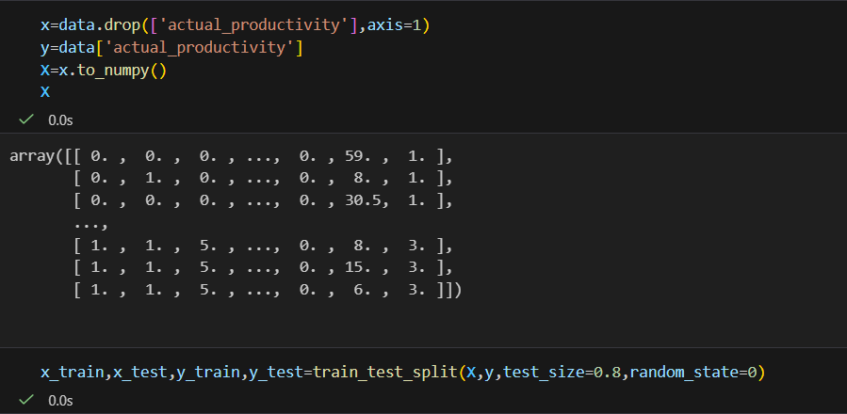
- MODEL BUILDING
Now our data is cleaned and it’s time to build the model. We can train our data on different algorithms. For this project we are applying three Regression algorithms. The best model is saved based on its performance.

LINEAR REGRESSION MODEL
Linear Regression has been initialized with the name model_lr. Then predictions are taken from x_test given to a variable named pred_test. After that Mean absolute error, mean squared error & r2_scrores are obtained.
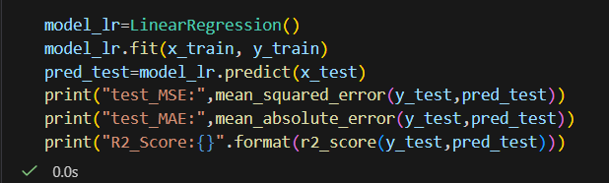

RANDOM FOREST MODEL
Random Forest has been initialized with the name model_rf. Then predictions are taken from x_test given to a variable named pred. After that Mean absolute error, mean squared error & r2_scrores are obtained.
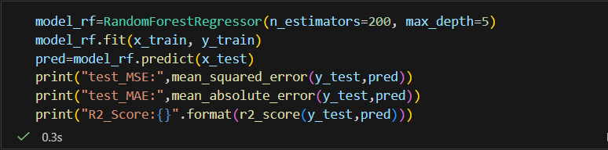

XGBOOST MODEL
XGBoost has been initialized with the name model_xgb. Then predictions are taken from x_test given to a variable named pred3. After that Mean absolute error, mean squared error & r2_scrores are obtained.
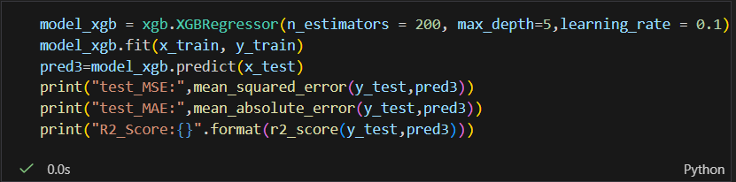

Now let’s see the performance of all the models and save the best model

COMPARE THE MODEL
For comparing the above three models MSE, MAE & r2_scroes are used.
Linear Regression:
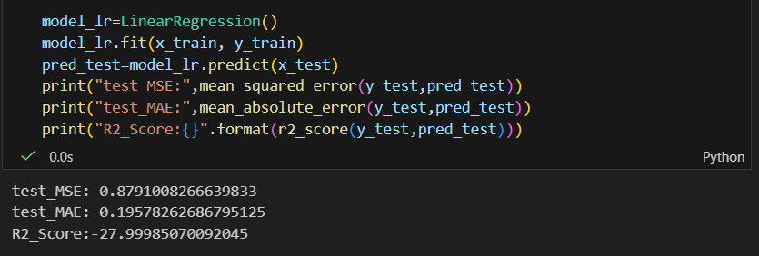

Random Forest:
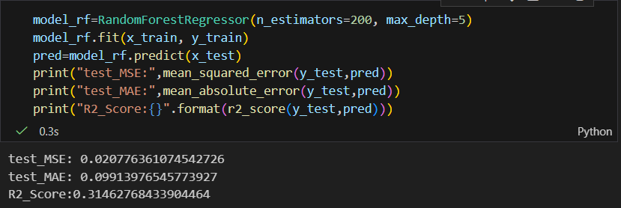
XGBoost:
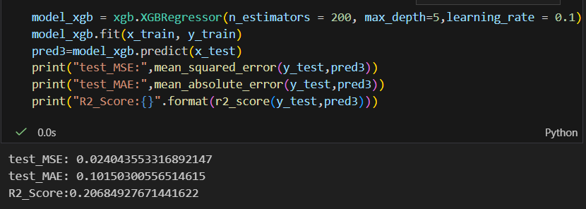
After calling the function, the results of models are displayed as output. From the three model xgboost is performing well.

EVALUATING PERFORMANCE OF THE MODEL AND SAVING THE MODEL
From sklearn, metrics r2_score is used to evaluate the score of the model. On the parameters, we have given y_test & pred3. Our model is performing well. So, we are saving the model by pickle.dump().

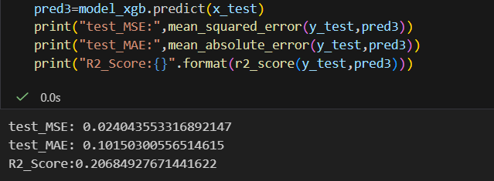

APPLICATION BUILDING
In this section, we will be building a web application that is integrated to the model we built. A UI is provided for the uses where he has to enter the values for predictions. The enter values are given to the saved model and prediction is showcased on the UI.
This section has the following tasks
- Building HTML Pages
- Building server side script

BUILDING HTML PAGES
For this project create three HTML files namely

- about.html
- home.html
- predict.html
- submit.html

and save them in templates folder.
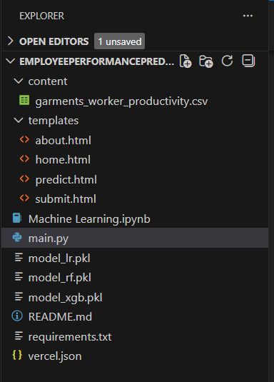
Let’s see how our home.html page looks like:
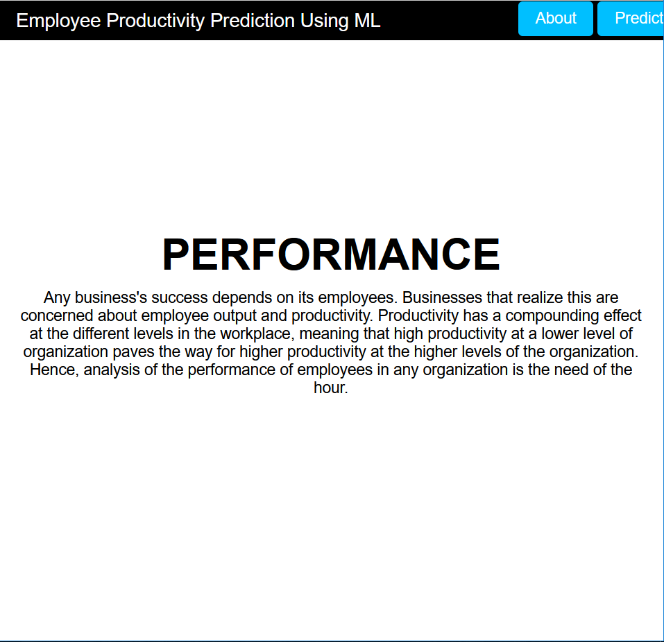

Now when we click on predict button from top right corner we will get redirected to predict.html
Let’s look how our predict.html file looks like:
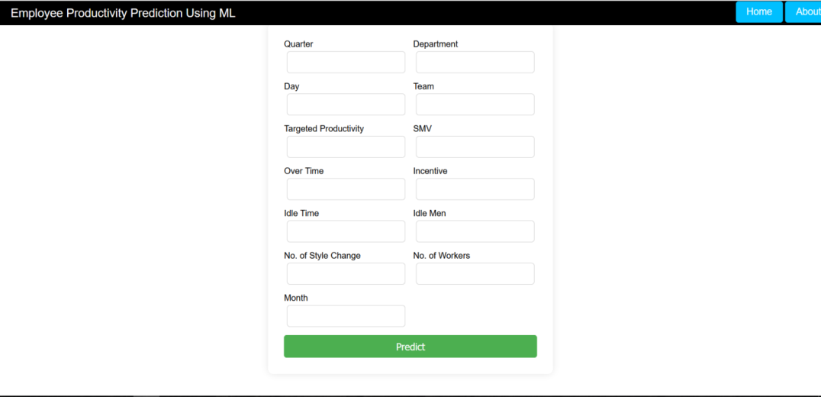
Now when we click on predict button from left bottom corner you will get redirected to submit.html
Lets look how our submit.html file looks like:
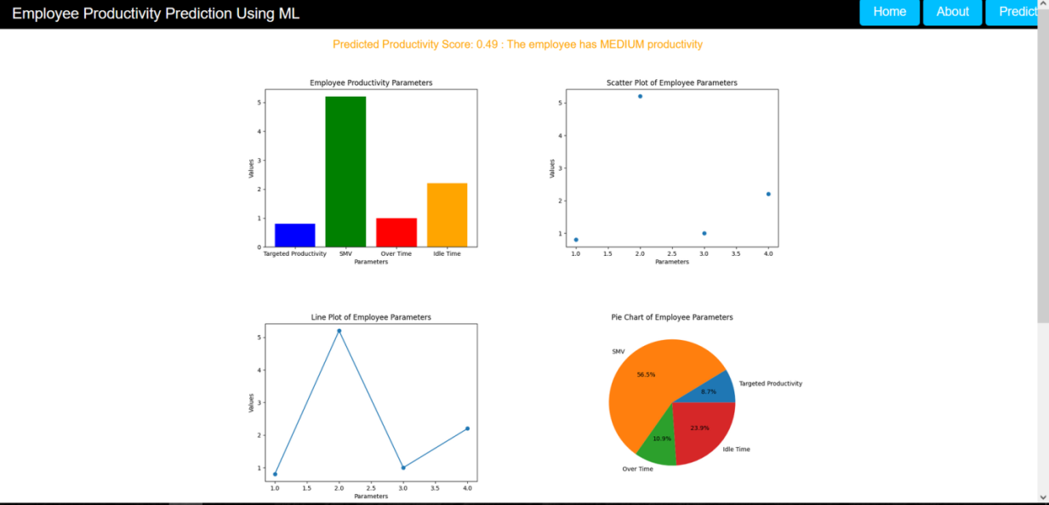

BUILD PYTHON CODE
Activity 2: Build Python code:
Import the libraries

Load the saved model. Importing flask module in the project is mandatory. An object of Flask class is our WSGI application. Flask constructor takes the name of the current module (__name__) as argument.
Render HTML page:
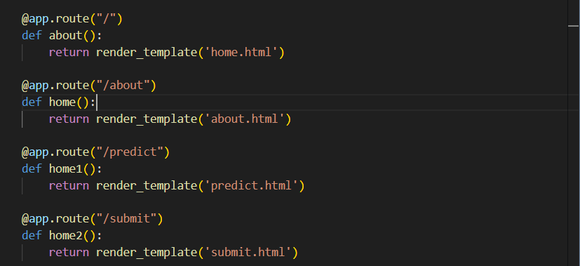
Here we will be using declared constructor to route to the HTML page which we have created earlier.

In the above example, ‘/’ URL is bound with home.html function. Hence, when the home page of the web server is opened in browser, the html page will be rendered. Whenever we enter the values from the html page the values can be retrieved using POST Method.
Retrieves the value from UI:
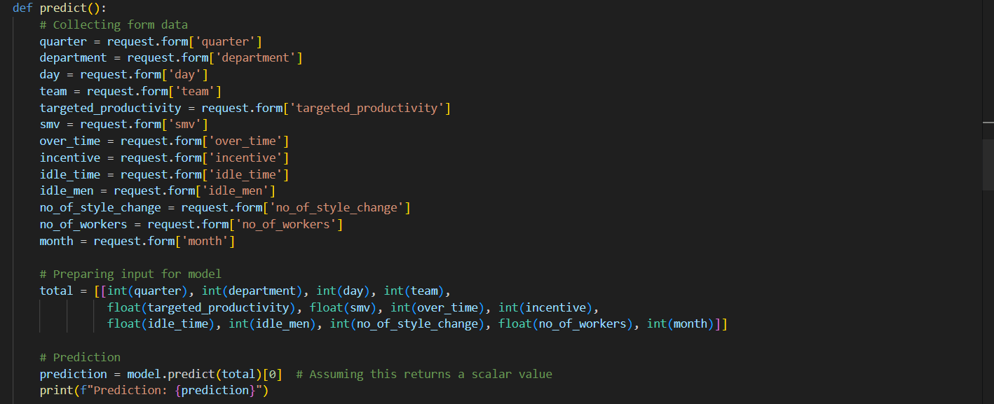
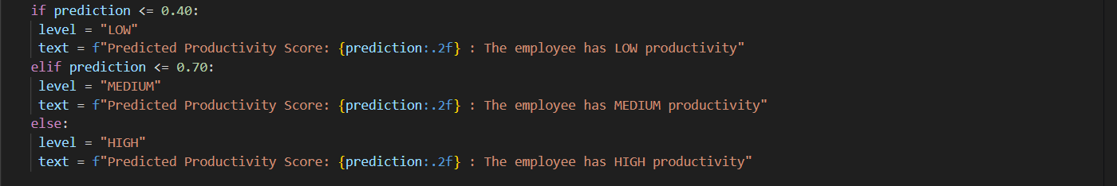
Here we are routing our app to pred () function. This function retrieves all the values from the HTML page using Post request. That is stored in an array. This array is passed to the model.predict() function. This function returns the prediction. And this prediction value will rendered to the text that we have mentioned in the home.html page earlier.
Main Function:

RUN THE APPLICATION
- Open project folder in VS code.
- Navigate to the folder where our python script is.
- Now type “python main.py” command
- Navigate to the localhost where you can view your web page.
- Click on the predict button from the top right corner, enter the inputs, click on the predict button, and see the result/prediction on the web.
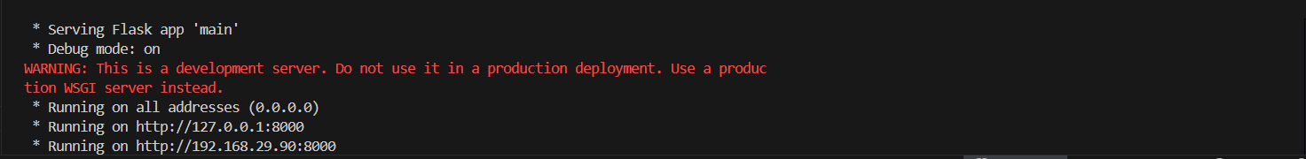

OUTPUT

Input 1:
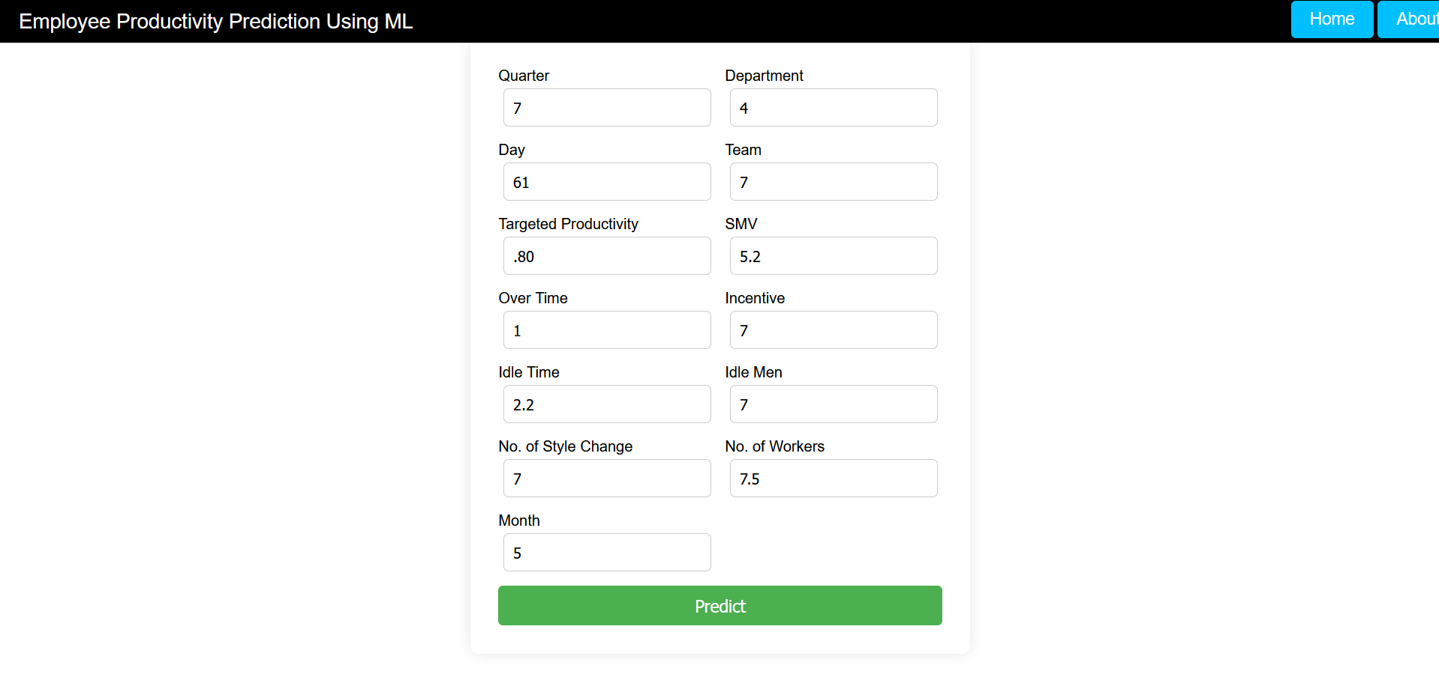

Output 1:

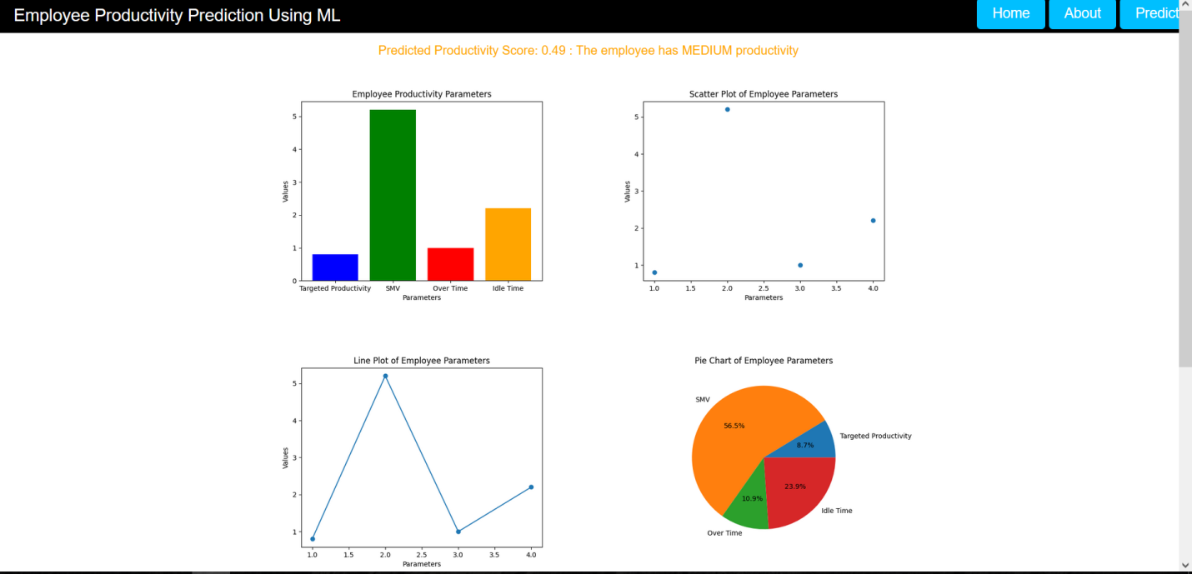

Input 2:

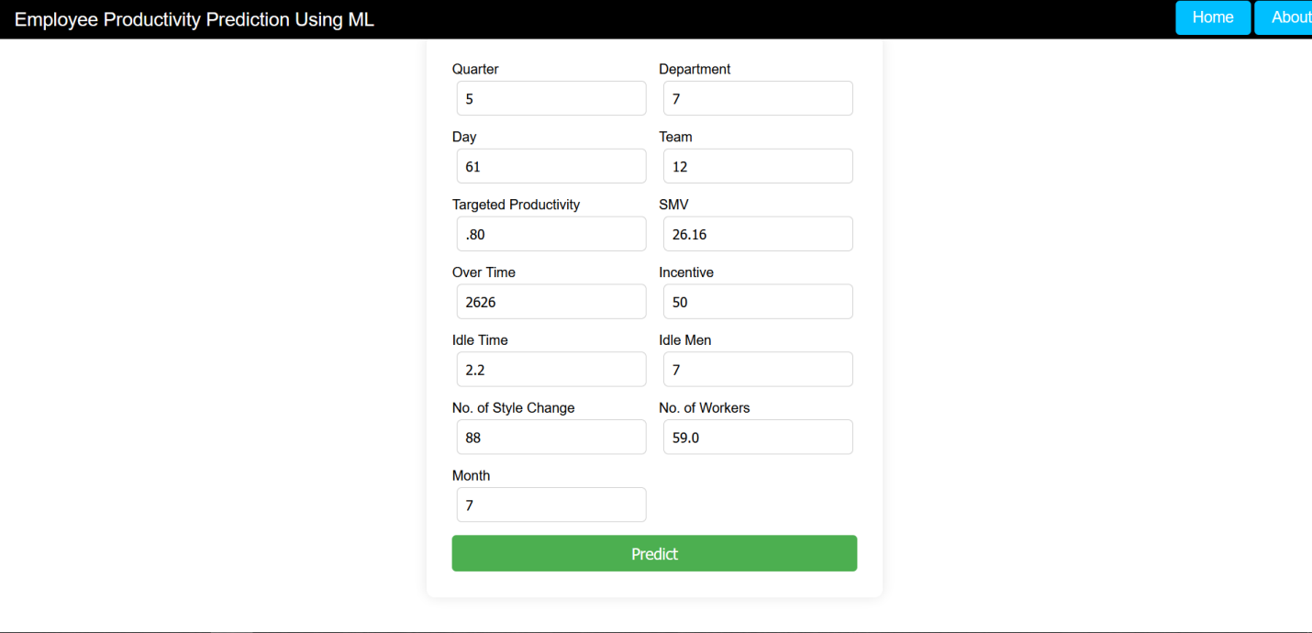

Output 2:

