Optimizing Production and Profitability at Shelby Shelving: A Linear Programming Approach

SCM 518

Final Project

**Safaa** **Almudhffer**

**Hongxi Zhang**

**Milan** **Paremajalu Suresh**

**Rutuja Patel**

**Mamidi Manish Reddy**

# Shelby Shelving

Shelby Shelving, a small manufacturer of grocery store shelves, faces a profitability challenge. Producing two models—Model S and Model LX—the company is constrained by resource availability and operational costs. This report presents a detailed analysis of the situation using a linear programming (LP) model, identifies the optimal production mix, and provides actionable recommendations to maximize profitability. Key findings suggest a focus on Model LX, which yields a $77,000 monthly profit under optimal production.

## Introduction

Shelby Shelving, a competitor in the shelf-manufacturing industry, produces Model S (standard) and Model LX (heavy-duty) shelves. Despite consistent sales, profitability concerns arise due to high fixed costs and resource constraints. Management seeks a data-driven approach to optimize operations and enhance financial performance.

## Data Collection

We collected the data from the textbook *Practical Management Science* (3rd Edition, page 127) by Wayne L. Winston and S. Christian Albright.

## Problem Statement and Data Overview

Shelby Shelving's core issues include:

1. **Resource Constraints**: Limited machine hours and assembly capacities.
2. **Profit Margins**: Model S incurs losses due to higher costs and lower sales.
3. **Fixed Costs**: Distribution across production lines exacerbates profitability challenges.

**Key Production Details**:

* **Stamping & Forming Machine**: 800 hours/month capacity.
* **Assembly Lines**:
  + Model S: 1,900 units/month.
  + Model LX: 1,400 units/month.
* **Current Production**: 400 Model S and 1,400 Model LX units.
* **Profit Margins**:
  + Model S: Revenue = $1800/unit, Costs = $1839/unit (loss).
  + Model LX: Revenue = $2100/unit, Costs = $2045/unit (profit).

* **Percentages of time spent in departments**

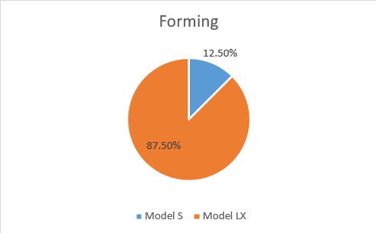 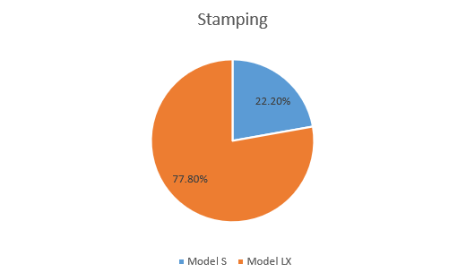

## Model Formation

**Inputs :**

i : Index of models (model S & model LX)

j : Index of steps (Stamping & Forging)

Hij : Hours required on each model for j step

Si : Selling price of each model i

Ai : Assembly capacity of each model i

Ti : Total cost of producing each unit of model i

**Decision Variables:**

Xi : No. of units of model i to produce

**Objective:**

Max Z             =  ⅀ ( Xi * Si) - Ti                              i ϵ (1,2)

**Constraints:**

1.)  Hij ≤ 800

2.)  X1 ≤  1900

3.)  X2 ≤  1400

4.)  Xi ≥ 0

## Methodology

**Linear Programming Model Setup**

The LP model was developed to maximize profits while respecting operational constraints:

* **Objective Function**:

Profit = 1800x + 2100y − Total Costs

Where x = Model S units and y = Model LX units.

* **Constraints**:
  1. Stamping Hours: 0.3x + 0.3y ≤ 800
  2. Forming Hours: 0.25x + 0.5y ≤ 800
  3. Assembly Line Capacities:
     + Model S: x ≤ 1900
     + Model LX: y ≤ 1400
  4. Non-negativity: x, y ≥ 0

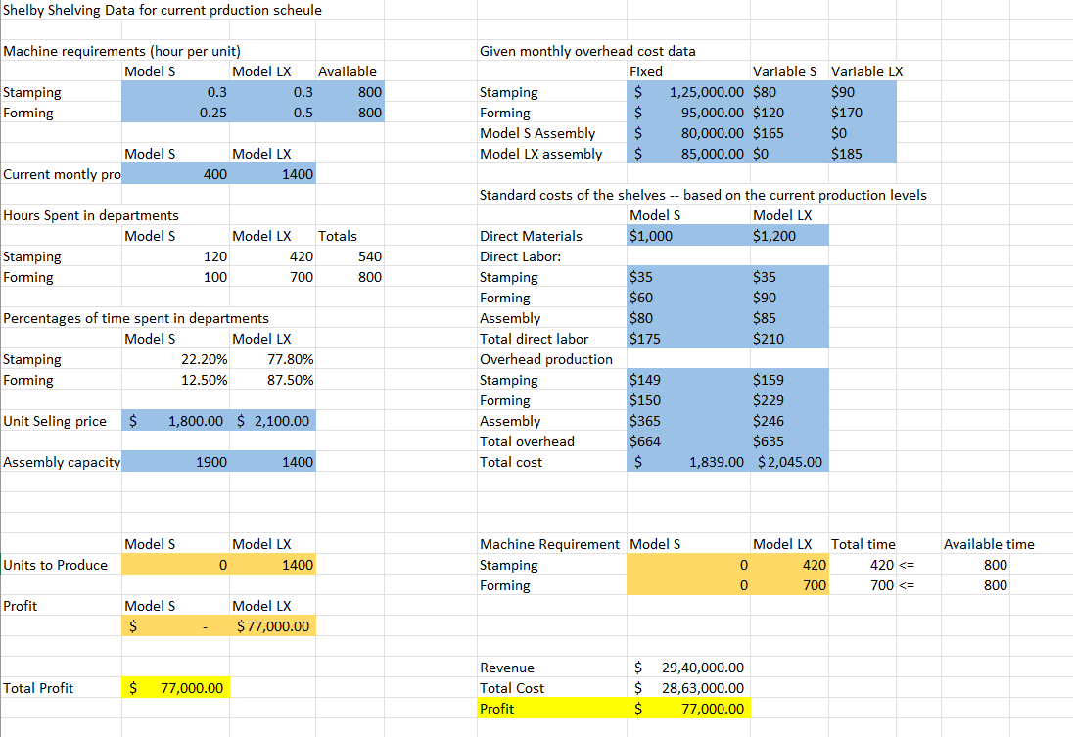

## Results and Analysis

The Solver-generated LP model provided the following outcomes:

* **Optimal Production**:
  + Model S: 0 units.
  + Model LX: 1,400 units.
* **Profit Analysis**:
  + Revenue: $2,940,000.
  + Total Costs: $2,863,000.
  + Net Profit: $77,000/month.

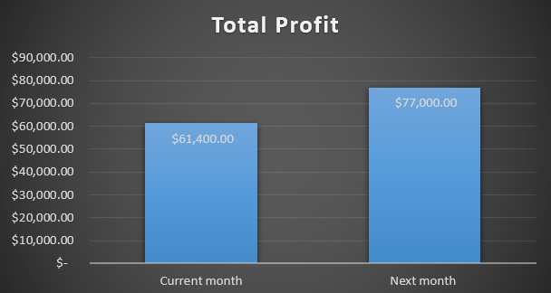

Recommendations

**Short-Term**

1. **Focus Production on Model LX**:
   * Discontinue Model S to eliminate losses and improve resource utilization.
2. **Enhance Model LX Capacity**:
   * Evaluate operational adjustments to increase Model LX output.

**Long-Term**

1. **Relaunch Model S**:
   * Redesign or reprice Model S to increase competitiveness.
2. **Invest in Efficiency**:
   * Upgrade machinery to expand production capabilities.
3. **Market Analysis**:
   * Conduct periodic market evaluations to align production with demand trends.

## Implementation Plan

**Transition Timeline**

1. Month 1:
   * Cease Model S production.
   * Scale up Model LX assembly.
2. Month 2:
   * Reallocate resources and retrain staff.
3. Month 3:
   * Monitor KPIs and refine production strategies.

**Monitoring**

Key metrics include:

* Profit Margins: Monthly financial review.
* Resource Utilization: Machine hours and assembly line usage.
* Market Response: Feedback from customers and stakeholders.

## Conclusion

The analysis concludes that focusing on Model LX production optimizes profitability. This decision is backed by clear resource advantages and financial outcomes. Shelby Shelving must act decisively to address current inefficiencies and position itself for sustainable growth.