**Why We Need Continuous Monitoring?**

Continuous Monitoring Tools resolve any system errors ( low memory, unreachable server etc. ) before they have any negative impact on your business productivity.

Important reasons to use a monitoring tool are:

* It detects any network or server problems
* It determines the root cause of any issues
* It maintains the security and availability of the service
* It monitors and troubleshoot server performance issues
* It allows us to plan for infrastructure upgrades before outdated systems cause failures
* It can respond to issues at the first sign of a problem
* It can be used to automatically fix problems when they are detected
* It ensures IT infrastructure outages have a minimal effect on your organization’s bottom line
* It can monitor your entire infrastructure and business processes

Nagios runs on a server, usually as a daemon or a service.

It periodically runs plugins residing on the same server, they contact hosts or servers on your network or on the internet. One can view the status information using the web interface. You can also receive email or SMS notifications if something happens.

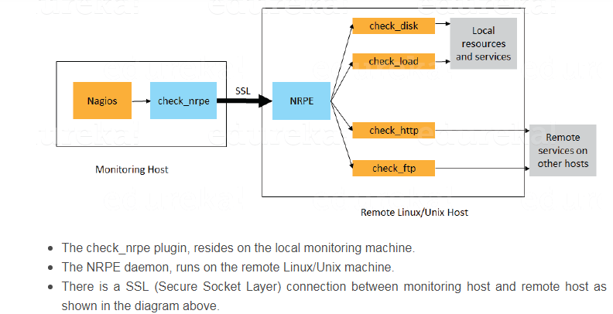

Nagios require the gcc compiler and build-essentials for the compilation, LAMP for the Nagios web interface and send mail to send alerts from the server. Use below command to install the Prerequisites.

$ sudo apt-get install -y autoconfgcc libc6 make wget unzip apache2 php libapache2-mod-php7.2 libgd-dev

For Nagios to run, you have to create a new user for Nagios. We will name the user **"nagios"** and additionally create a group named **"nagcmd"**. $useradd nagios, $groupadd nagcmd, $usermod -a -G nagcmd nagios,

$usermod -a -G nagios,nagcmd www-data

Download Nagios and extract the nagios core from nagios home page: <https://www.nagios.org/downloads/>

$ mkdir nagios, $ cd nagios

$ wget -O nagioscore.tar.gz <https://github.com/NagiosEnterprises/nagioscore/archive/nagios-4.4.3.tar.gz>

$tar xzf nagioscore.tar.gz

$cd nagioscore-nagios-4.4.3/

$./configure --with-nagios-group=nagios --with-command-group=nagcmd🡪 to configure users and group, before you build Nagios.

$make all🡪to compile the main program and CGIs.

$sudo make install

$sudo make install-commandmode

$sudo make install-init

$sudo make install-config

$/usr/bin/install -c -m 644 sample-config/httpd.conf /etc/apache2/sites-available/nagios.conf

$cp -R contrib/eventhandlers/ /usr/local/nagios/libexec/

$chown -R nagios:nagios /usr/local/nagios/libexec/eventhandlers

Download and extract the Nagios plugins in nagios folder

$cd ..

$wget <https://nagios-plugins.org/download/nagios-plugins-2.1.2.tar.gz>

$tar -xzf nagios-plugins*.tar.gz

$cd nagios-plugins-2.1.2/ 🡪 Changed to nagios plugins folder

$./configure --with-nagios-user=nagios --with-nagios-group=nagios --with-openssl 🡪 Install the Nagios plugin's

$make 🡪 install make command

$make install

/usr/local/nagios/ 🡪 to find the default configuration of Nagios

$vi /usr/local/nagios/etc/nagios.cfg 🡪uncomment line **51st line**  for the host monitor configuration.

$mkdir -p /usr/local/nagios/etc/servers 🡪 Add a new folder named servers

$vi /usr/local/nagios/etc/objects/contacts.cfg 🡪 Nagios contact can be configured in the *contact.cfg* file

**NOW configuring the Apache**

$sudo a2enmod rewrite

$sudo a2enmod cgi

$sudo htpasswd -c /usr/local/nagios/etc/htpasswd.users nagiosadmin 🡪 to configure a user *nagiosadmin* for the nagios web interface

$sudo ln -s /etc/apache2/sites-available/nagios.conf /etc/apache2/sites-enabled/ 🡪 enable the nagioshost

$service apache2 restart , $service nagios start 🡪 **Start the apache nagios**

Nagios server publicip, in my case: 35.175.253.177***/nagios***

**Add host to nagios:**

Go to Configure🡪 Start Monitoring🡪Select the wizard(Linux mechine)🡪Give ip of remote system🡪select the O/S🡪Next🡪set the host name🡪server metrics🡪set the threshold limit🡪services🡪next🡪monitoring

Settings(set for 2 min, 5min)🡪it will recheck 5 times before sending the alert

Notification settings🡪 set alert notification to individual/ Group.

-------------------

Linux host configuration:

Now Install NRPE Agent in the host/client

Yum install nrpe nagios-plugin* -y

Ls /usr/lib64/nagios/plugin🡪to check if plugin is installed

Chkconfig nrpe on

Vi /etc/nagios/nrpe.cfg🡪here search for allowed_hosts and give the IP Address of nagios server

allowed_hosts=IP of server

service nrpe start

----------------------------

Windows host configuration:

Download nsclient++🡪Install nsclient++🡪Allowed host(Give ip of nagios server)🡪Install and finish

To Remove host from nagios server:

Configure🡪monitoring🡪services🡪select the host🡪check with delete🡪go

Configure🡪Adv configuration🡪 Click on host🡪select the host🡪Checked with delete🡪 Go