**Configuration management** is a process of tracking and controlling the changes in software in terms of the requirements, design, functions and development of the product.

ChefDK is downloaded in the chef workstation, then login to chef server and then download the starter kit, then move it to chef workstation with help of winscp.

**ChefDK** includes the chef-client, an embedded version of Ruby, RubyGems, and OpenSSL.

**starter kit** will create the necessary configuration files like chef repo, knife.rb, validator.pem&user.pem files. To create connection b/w worker and chef server.

**Process of bootstrap:**

Once we apply bootstrap on node:

1. Client key is created on the server.
2. Node name is created on the server.
3. Try to connect workstation with ssh using credential.
4. Install chef client package on client.
5. Start service and expand the runlist.
6. Download cookbooks locally and execute it.

**Diff b/w validation.pem&client.pem?**

The chef-client will use the /etc/chef/validation.pem private key to authenticate itself for the initial run, because /etc/chef/client.pem doesn't exist yet. This initial run will, produce that client.pem, which is then used for all subsequent client requests.

Local mode chef cookbook execution is called **CHEFZERO**

**Ohai is installed on a node as part of the chef-client install process. Ohai is a tool that is used to detect attributes on a node, and then provide these attributes to the chef-client at the start of every chef-client run. Ohai is required by the chef-client and must be present on a node.**

**Attributes ohai collects:**

**OS,Network,memory,disk,cpu,kernel,hostnames,fully qualified domain names, virtualization,cloud provider meta data**

Chef Development Kit Version: 1.5.0

Chef: 12.21.2

cd /home/user/chef-repo

Chef-repo🡪.chef, README.md, roles,cookbooks

.chef🡪knife.rb, user.pem

Roles🡪starter.rb

Cookbook🡪metadata.rb, templates, README.md, libraries

Metadata.rb🡪to change the version of cookbook

Knife node list🡪to list the nodes in chef server

Knife cookbook list🡪list the cookbooks in chef server

Knife role list🡪 list of roles

Knife node show [node name]🡪all the details of the nodes

Knife node delete [nodename]🡪delete a node

Knife client delete [nodename]🡪while deleting node, we have to remove node related key also

knife bootstrap IP[node] --sudo –x [username] –i [pemkey]/-P [password] –N [node name] –r “recepie[demo@0.1.1]”🡪bootstrap of linux nodes

knife bootstrap windows winrm IP[node] -x Administrator -N [node name]🡪bootstrap windows node

cd /chef-repo/cookbooks🡪cookbook location

chef generate cookbook [cookbook name]🡪create cookbooks

knife cookbook upload [cookbook name]🡪to upload a cookbook to server

knife cookbook show [cookbook name]🡪 to check the version of cookbook

knife node run_list add/remove [nodename] recipe[cookbook name]🡪to add/remove cookbook from the node

knife ssh ’name:[node name]’ ‘sudo chef-client’🡪to run chef-client from workstation.

Chef-client –r “recipe [cookbookname@version]”🡪to run particular cookbook in runlist

Chef-client –r “recipe [cookbookname::recipe name]

**An attribute is a specific detail about a node.**

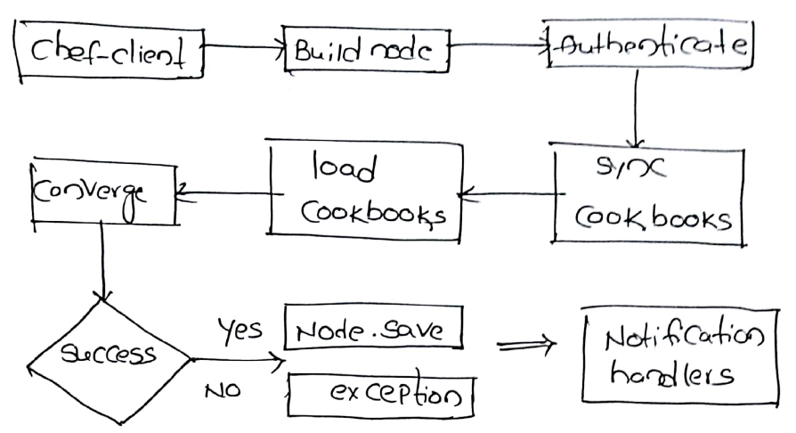

Files are static where as templates are dynamic🡪mkdir files,templates

In Files the extention should be .html, in templates extension should be .html.erb🡪vi files/index.html, vi templates/index.html.erb

An attribute is a specific detail about a node. Attributes are defined by the state of the node itself, Cookbooks (in attribute files and/or recipes), Roles & Environments. Define attributes in chef using default keyword.

1mkdir attributes🡪vi attributes/default.rb🡪here define the attributes

🡪netstat –lntp

if node[‘platform’]== “centos” || node[‘platform’]==” amazon”

execute ‘update’ do

command “yum –y update”

end

package 'httpd' do

action :install

end

service 'httpd' do

action [ :enable, :start ]

end

template '/var/www/html/index.html' do

source "index.html.erb"

end

template 'etc/httpd/conf/httpd.conf' do

source "httpd.conf.erb"

end

file ‘/root/sample.txt’ do

action : create

content : “welcome to chef”

owner : ‘root’

mode : ‘0666’

end  
directory ‘/root/test’ do

action : create

end

cookbook_file “/var/www/html/index.html” do

source “index.html”

end

include_recipe “[cookbook name]:: [recipe name]”

-------------------------------------------------------------

[‘nginx’,’tomcat’]. each do |packages|

package ‘packages’ do

action : install

end

service ‘packages’ do

action : start

end

end

----------------------------------------------------------------

recipe/default.rb

package node["package_name"] do

action :install

end

service node["service_name"] do

action [ :enable, :start ]

end

template "#{node["document_root"]}/index.html" do

source "index.html.erb"

end

attributes/default.rb

case node["platform"]

when "ubuntu"

default["package_name"] = "apache2"

default["service_name"] = "apache2"

default["document_root"] = "/var/www/html"

when "centos"||"amazon"

default["package_name"] = "httpd"

default["service_name"] = "httpd"

default["document_root"] = "/var/www/html"

end

knife role create [role name]🡪 to create role, to manage group of servers.

knife role list

knife role show [role name]

knife role edit [role name]🡪 to edit a role

export EDITOR=vi­­🡪in case recieve an error while editing a role.

knife node run_list add/remove [node name] role[role name]­­­­

knife role from file [role name]

chef-repo# mkdir databags

databags# mkdir users

users#

knife data bag create users🡪create databag

openssl passwd –l “secure_password”🡪 to generate an encrypted password

knife data bag create users jenkins🡪create data bag users ”jenkins”

or

vi data_bags/users/user.json

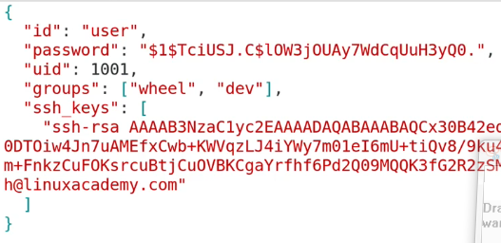

knife data bag from file users data_bags/users/user.json🡪 to create the bag items.

knife data bag lists

knife data bag show users jenkins

vi users/ram.json

vi /cookbooks/xyz/recipe/default.rb

user ‘jenkins’ do

comment ‘a user for CI/CD’

uid ‘234’

gid ‘234’

home ‘/home/test’

shell ‘/bin/bash’

password ‘$1$...’

end

take a ubuntu server🡪 t2.medium🡪download.chef.io🡪wget url🡪dpkg –i chef-server.rpm🡪chef-server-ctl🡪to operate chef server

chef-server-ctl reconfigure

chef-server-ctl status

mkdir .chef

chef-server-ctl user-create admin admin admin [admin@testorg.com](mailto:admin@testorg.com) password –f ~/.chef/admin.pem

chef-server-ctl org