Onyx Email Accelerator

System Administrator and Setup Guide


The information contained in this document represents the current view of Onyx Software on the issues discussed as of the date of this publication. Because Onyx Software must respond to changing market conditions, it should not be interpreted to be a commitment on the part of Onyx Software, and Onyx Software cannot guarantee the accuracy of any information presented after the date of publication.

This document is for informational purposes only. TO THE MAXIMUM EXTENT PERMITTED BY APPLICABLE LAW, ONYX DISCLAIMS ALL WARRANTIES, EITHER EXPRESS OR IMPLIED, INCLUDING BUT NOT LIMITED TO WARRANTIES OF MERCHANTABILITY AND FITNESS FOR A PARTICULAR PURPOSE, WITH RESPECT TO THE ATTACHED DOCUMENTATION.

© 2001 Onyx Software Corporation. All rights reserved worldwide. Onyx, Onyx Web Wizards, Onyx Customer Center, Onyx Customer Center-Unplugged, and Total Customer Management are registered trademarks of Onyx Software Corporation. Onyx Enterprise Application Server, Onyx Enterprise Database, Onyx Enterprise Studio, Onyx Employee Portal, Onyx Customer Portal, Onyx Partner Portal, Onyx Employee Portal-Outlook, Onyx Pricing Manager, Onyx Marketing Encyclopedia, Onyx Channel Connect, and Onyx KnowledgeBase are trademarks of Onyx Software Corporation. All product and company names should be considered trademarks of their respective companies and organizations.

Other company, product, and service names, may be trademarks or service marks of others.

About The Onyx Email Accelerator Documentation

This document is written for the technology professional that is going to implement the Onyx Email Accelerator. This document assumes that the reader has knowledge of Onyx Employee Portal – Web Client, Onyx Enterprise Application Server and Microsoft.NET technologies.

Providing Feedback about This Documentation

You can help the Onyx documentation team improve the Onyx Email Accelerator System Administrator Guide. Onyx is interested in hearing what you have to say about the technical documents that you received. We're especially interested in hearing your responses to the following questions, but feel free to email any type of feedback to us at help@onyx.com

- Overall, how would you rate the documentation?
- How much did the documents lend to your understanding of the product? Did it facilitate your configuration, and customization efforts?
- How could the guide be improved?
- Do you have any experiences that would be helpful to add to the documentation to avoid pitfalls?

Contacting Onyx Product Support

If you have any questions regarding Onyx Email Accelerator, please contact Onyx Product Support. You can reach Onyx Product Support as follows:
- Email: help@onyx.com
- Phone: +1 (425) 451-8043, within the United States
- Phone: +44 (0) 1344 322 370, within Europe
- Phone: +61 (0) 2 9409 4300, within Australia
- Phone: +65 (0) 332 6880, within Singapore
- The World Wide Web: http://customers.onyx.com (For the fastest response to your support needs, we encourage you to use the Product Support page on our Web site.)

We check our email continuously during normal support hours. Should you choose to email us, we will respond to you shortly after your email is received. Onyx Software Corporation strives to provide you with the easiest and most efficient methods for getting support. Please pass on any comments and suggestions that you have regarding our application.

Table of Contents

CHAPTER ONE 8
Overview 8
Onyx Email Accelerator Features 8
Onyx Email Accelerator Components 9
Database Objects 9
OEP Web Pages 9
Onyx Email Accelerator client 9
External (Tracking) Web Server 9
Onyx Email Accelerator CD Directory Structure 11
CHAPTER TWO 12
Prerequisites & System Requirements 12
Servers 12
Installation Prerequisites 12
CHAPTER THREE 13
Installation Overview 13
Part I. Database Installation 13
Installation Instructions 13
Part II. External Web Server Installation 13
TImage Installation Assumptions 14
TImage Installation Instructions 14
Unsubscribe Installation Assumptions 25
Unsubscribe Installation Instructions 25
Part III. Onyx Email Accelerator Client Installation 29
Installation Instructions 29
Part IV. Onyx Employee Portal Installation 30
Installation Instructions 31
Testing the Installation 33
Prerequisites 33
CHAPTER THREE 36
Using the Onyx Email Accelerator 36
Configuring Campaigns 36
Building the Target List 36
Building the Email 36
Sending the Email 38
Tracking Email Actions 38
CHAPTER FOUR 40
Sample HTML Templates 40
HTML Email Format and Design Tips 40
Copywriting Tips to Increase Response 41
CHAPTER 5 43
Troubleshooting 43
Problems hitting the ‘Bulk Action’ in List Manager 43
Unexpected Errors during Mass Email Process 43
APPENDIX A 45
Database Components 45
Tables Installed 45
Stored Procedures Installed 45

CHAPTER ONE

Overview
Organizations are leveraging personalized email as a preferred, cost-effective method of communicating with customers and building lasting relationships. It allows for greater personalization while providing faster feedback than traditional media such as direct mail. However, with the rise of unsolicited messages or “SPAM”, companies are struggling to get their messages delivered. The Onyx Email Accelerator, combined with the Onyx Employee Portal, provides organizations with a solution to be successful in a challenging marketing environment.

Onyx Email Accelerator Features

Onyx Email Accelerator Features | Detail
Advanced data querying and list building | - Leverage the power of List Manager to query Onyx and build targeted lists  - Exclude individuals who have chosen to opt out of mailings
Email personalization | - Send emails from any user or mailbox within the organization  - Personalize the email body with first name, last name and company name  - Add personalized unsubscribe text and opt out URL
Support for HTML formatted emails | - Create professional looking emails with full HTML support  - Use any HTML editor to author the email content
Email previewing and testing | - Single click to preview an email  - Single click to send an email to one or more test recipients prior to executing the campaign
Real-time response tracking | - Integrated with the Onyx Campaign feature  - Campaign action tracks viewed or opened email  - Campaign action tracks opt-out  - Onyx Analytics can be used to track email campaign success and statistics
Email history | - A new Onyx table maintains a history of email recipients  - Email actions can be viewed on the standard Onyx History tab with other Campaign actions  - Onyx Analytics can be used to track email campaign success and statistics
Email templates | - 5 HTML templates come pre-packaged for easier setup

Onyx Email Accelerator Components
There are four main components of the Onyx Email Accelerator. These are:

- Database objects
- OEP Web Pages
- Onyx Email Accelerator Client
- External (Tracking) Web Server

Database Objects
The Onyx Email Accelerator requires new tables and stored procedures to support processes in the Onyx Enterprise Database. These processes include the encryption and decryption of email recipient information and the capture of email history.

OEP Web Pages
The Onyx Email Accelerator is integrated with the OEP List Manager and Campaign features. List Manager is used to select a target audience and a new List Management bulk action sends the targeted list to the Onyx Email Accelerator client.

Onyx Email Accelerator client
The Onyx Email Accelerator client resides on an internal IIS/SMTP web server. The Onyx Email Accelerator receives the list of email recipients and provides a user interface for configuring the email campaign. The email Sender, Subject, action to be taken when the email is viewed, opt-out options and actual HTML email content are configured on this user interface. The Onyx Email Accelerator provides the capability to preview and test the email and executes the bulk email campaign.

External (Tracking) Web Server
The external web server tracks email recipient actions. The web server serves used in HTML emails hosts the TImage HTTP Handler which notes when a user has viewed an email, as well as Unsubscribe which handles user opt-out requests.
Onyx Email Accelerator Architecture Diagram

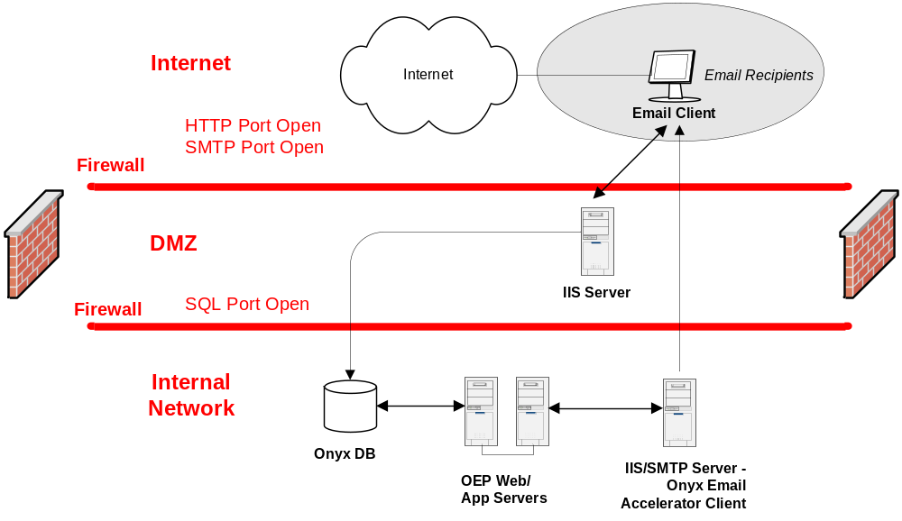

Onyx Email Accelerator CD Directory Structure
The Onyx Email Accelerator CD contains the following folder structure:

- Code:
  - OEP – Contains the new and modified OEP web files.
  - Onyx Email Accelerator – Contains the Onyx Email Accelerator client files.
  - SQL – Contains a script to install the database components.
  - TImage – Contains the TImage component and configuration file.
  - Unsubscribe – Contains the Unsubscribe component and configuration file.
- Documentation – Contains the Onyx Email Accelerator SA Guide.
- Sample Email Templates – Contains five sample HTML email templates that illustrate formatting and design considerations when authoring HTML emails.

CHAPTER TWO

Prerequisites & System Requirements
This section provides software and hardware requirements for the Onyx Email Accelerator. Please review these requirements before installing the Onyx Email Accelerator.

Servers
Onyx recommends that you set up two servers for the Onyx Email Accelerator in addition to your existing OEP servers. The two servers require the following software:

Onyx Email Accelerator Client Server
- Windows 2000 or 2003 Server
- IIS and SMTP Services
- Internet Explorer 6.0

External (Tracking) Web Server
- Windows 2000 or 2003 Server
- Microsoft .NET Framework 1.1

Installation Prerequisites
- Your external web server can connect to your Onyx database.
- You are already running Onyx Employee Portal version 5.0 English.
- You are familiar and comfortable with adding and configuring virtual directories in IIS.
- Your external web server has the Microsoft .NET Framework 1.1 installed.

TIP If the Microsoft .NET Framework has not yet been installed on your server you can download and install it here:
http://www.microsoft.com/downloads/details.aspx?FamilyID=262d25e3-f589-4842-8157-034d1e7cf3a3&DisplayLang=en

Also, careful consideration must be made when installing any additional software onto an externally accessible web server. If you are not already familiar with the Microsoft .NET Framework or need in-depth information about the implications of installing the Framework, visit this site:
http://www.microsoft.com/net/basics/framework.asp

CHAPTER THREE

This chapter contains the following information:
- How to install and configure Onyx Email Accelerator
- Testing the Onyx Email Accelerator installation

Installation Overview
The Onyx Email Accelerator installation can be divided into four sections:

- Database Installation – The database installation creates the new custom tables and stored procedures to support the Onyx Email Accelerator.
- External Web Server Installation – This installation adds the tracking and opt-out/unsubscribe web components as well as any images used in your HTML emails.
- Onyx Email Accelerator Client Installation – This installation installs the Onyx Email Accelerator client files and configures the new website in IIS.
- Onyx Employee Portal Customization Installation – This installation customizes the OEP 5.0 web files to include the Onyx Email Accelerator integration with List Management.

Part I. Database Installation

TIP The Onyx Email Accelerator Client as well as the Tracking modules residing on the External Web Server will require a database user to access the Onyx Enterprise Database. If you do not have a user in the Public Group with access to the Onyx Enterprise Database, create one. This user will be used to in the connection string set up for the Email Accelerator Client as well as the Tracking and Unsubscribe functionality described later.

Installation Instructions
- Open Query Analyzer and login to your Onyx database as ‘SA’ or other user with dbo privileges.
- Execute the following script from the CD: Code/SQL/AcceleratorBuildScript.sql
Note: Refer to Appendix A for a list of the database objects created during the installation.

Part II. External Web Server Installation
The External Web Server installation includes the activities associated with configuring a new component called TImage which is responsible for tracking opened email messages that were sent with Onyx Email Accelerator. Using an HTTP Handler written with Microsoft .NET technology, TImage is designed to receive specially encoded GIF file requests to externally accessible web servers. TImage decodes this request, records the information in your Onyx database, then sends back to the user a blank GIF file to satisfy the initial request.

Also part of the External Web Server installation is Unsubscribe which a collection of Active Server Pages written in VBScript. Unsubscribe is triggered when a user clicks on the “opt-out” link at the bottom of emails sent with the Onyx Email Accelerator. An encoded string is included in the unsubscribe request which is decoded and stored in the Onyx database. Unsubscribe also comes with a sample landing page to confirm to the user that the opt-out request was successful. Use this sample as a starting point to customize the Unsubscribe look and feel to your corporate branding standards.

TImage Installation Assumptions
The following instructions will make some assumptions about certain destination folders and virtual directory names based on commonly used defaults. Your web server configuration may vary and you should adjust these instructions accordingly. The following settings are assumed:
- The desired Virtual Directory Alias will be “TImage” and will be a virtual directory off the root directory of the web server (i.e. the final URL to access TImage will look something like http://www.YourCompany.com/TImage).
- The web server will be listed in Internet Information Services Manager as “Default Web Site.”
- The web server’s root content directory is located at C:\Inetpub\wwwroot

Note: The installation steps for Windows Server 2000 and 2003 are very similar. Where 2000 differs significantly from 2003 it will be noted in the steps below. Most screen shots will be of Windows Server 2003.

TImage Installation Instructions
- Copy the TImage folder and subfolders under the Code\ folder on the CD into the C:\Inetpub\wwwroot\ folder on the external web server. The C:\Inetpub\wwwroot\TImage\ folder should now contain the following:
- bin – Folder containing the compiled binaries for TImage.
- Images – Folder containing any images that are to be served by TImage requests.
- Web.config – File which contains the configuration information for the TImage application.

- Open the web.config file in a text editor such as Notepad to make changes to the TImage settings. By default the web.config file will look like this:

<configuration>
<system.web>
<customErrors mode="Off"/>
<httpHandlers>
<add verb="*" path="*.gif" type="ImageTrackerHandler.ImageHandler,ImageTrackerHandler"/>
</httpHandlers>
</system.web>
<appSettings>
<add key="DBCONN_STRING" value="Data Source=DATABASE_SERVER_NAME;Initial Catalog=ONYX_DATABASE_NAME;User ID=DATABASE_USER_NAME;Password=DATABASE_PASSWORD" />
<add key="GIF_FILE" value="/timage/images/space.gif" />
<add key="SITEID" value="1" />
</appSettings>
</configuration>

The bold elements between the <appSettings></appSettings> tags are the settings used to configure TImage.

- Configure the following settings:

Setting Name | Description
DBCONN_STRING | The connection string used to connect to your Onyx database server. Replace DATABASE_SERVER_NAME with the machine name of the Onyx database server. Replace ONYX_DATABASE_NAME with the name of your Onyx SQL database . Replace DATABASE_USER_NAME with the login name that will be used to access the Onyx database. Replace DATABASE_PASSWORD with the password to the above login account used to access the Onyx database.
GIF_FILE | The location of the GIF image file that is to be served as the result of a TImage request. This setting must refer to the full web path of the image file starting from the webroot (i.e. the setting must always start with the “/” character).  If you are installing TImage folder in the root if your web folder you will not need to change this setting.
SITEID | The Onyx site id to connect to. Typically this is set to 1.

- Using Internet Information Services Manager, browse to the Default Web Site and create a new virtual directory on your external web server as indicated in the screenshot below:

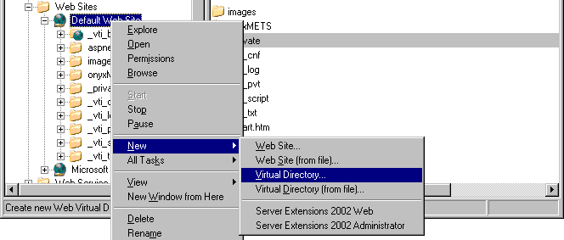

- Specify the alias name as TImage as indicated in the screenshot below. Be sure to note the Alias name chosen in this step. You will need this information to complete the Onyx Email Accelerator Client Installation (Part III, Step 3.):

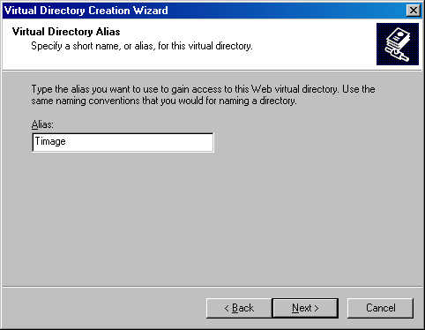

- Enter the path to where you copied the TImage folder on the web server as indicated in the screenshot below:

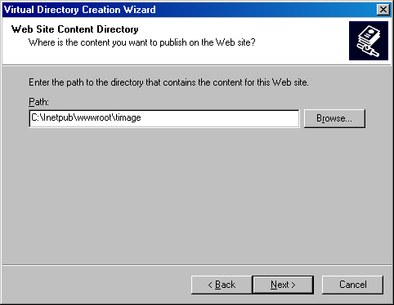

- Set the permissions for the new virtual directory as indicated in the screenshot below:

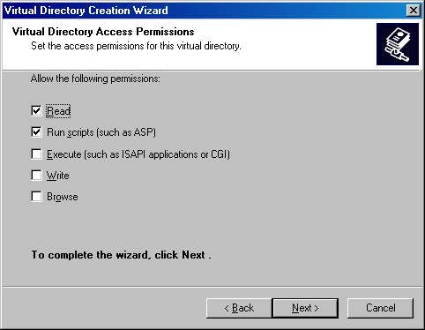

- Once the virtual directory is created, right-click on the TImage virtual directory to adjust the properties as indicated in the screenshot below:

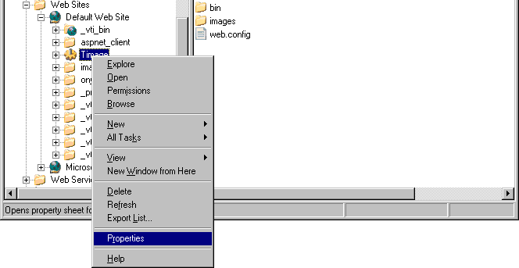

- The below image of the TImage virtual directory properties shows the recommended settings.

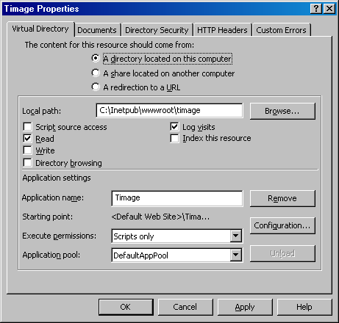

- Click on the Configuration button to set up the TImage application settings. In the Application Configuration you are going to configure TImage to execute requests for files ending with “.gif” the same way as “.aspx” files.

- On the Mappings or App Mappings tab locate “.aspx” in the list of extensions. Highlight the “.aspx” entry then click the Edit button.

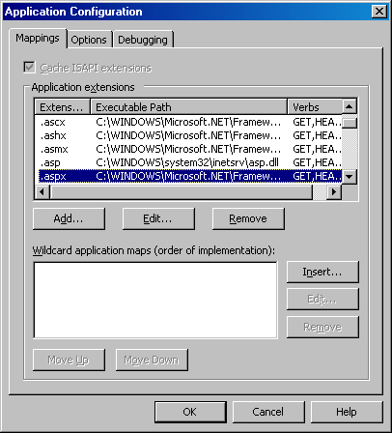

- Highlight all the text in the Executable field from beginning to end, then right-click on the highlighted text and click Copy. Click Cancel to close this window and return to Application Configuration window above. In the Application Configuration window, click the Add button.

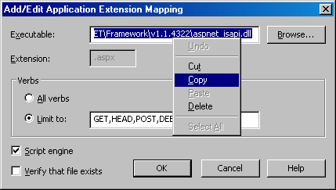

You should now see a blank Add/Edit Application Extension Mapping window.

- Right-click the empty Executable field and click Paste. The field should now contain the text you copied from the “.aspx” extension’s Executable setting.

- Enter “.gif” in the Extension field.

- In the Verbs setting, select Limit to and enter “GET,HEAD,POST,DEBUG” in the field.

- Check the Script engine box and ensure that the Verify that file exists box is unchecked.

- When you are finished click OK in the Add/Edit Application Extension Mapping window to return to the Application Configuration window.

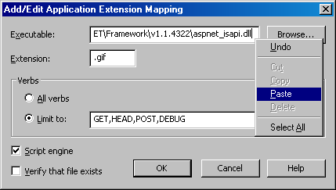

- On the Application Configuration window click the Options or App Options tab.

- Enable session state, Enable buffering, and Enable parent paths all need to be unchecked. The remaining settings can be left as-is.

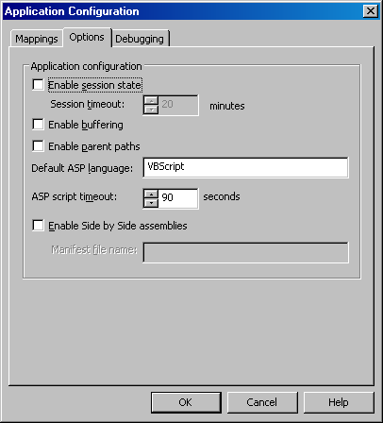

- Click on OK to return to the TImage virtual directory properties window.

- Next click on the Directory Security tab.

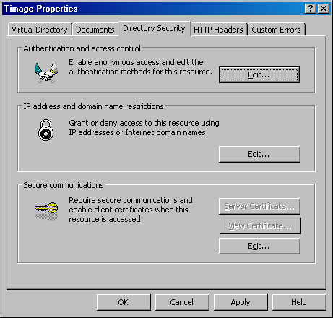

- Click the Edit button to change the Authentication and access control settings. The most common deployment of TImage on an external web server calls for unrestricted anonymous access to the TImage virtual directory.

In Windows Server 2000, anonymous access is configured as follows:

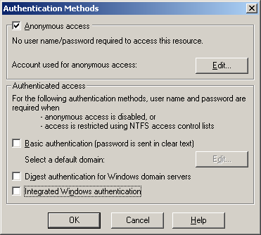

In Windows Server 2003, unrestricted anonymous access is configured differently as indicated in the screenshot below. Do not change the User name on your machine to match the one in the sample screen below.

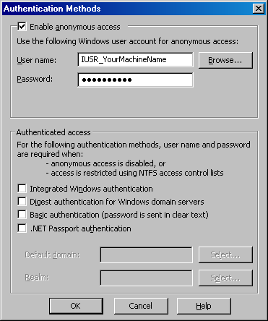

- Click on OK to return to the TImage virtual directory properties window. Click OK again to finalize all the settings and complete your TImage installation.

Unsubscribe Installation Assumptions
The following instructions will make some assumptions about certain destination folders and virtual directory names based on commonly used defaults. Your web server configuration may vary and you should adjust these instructions accordingly. The following settings are assumed:
- The desired Virtual Directory Alias will be named “Unsubscribe” and will be a virtual directory off the root directory of the web server (i.e. the final URL to access Unsubscribe will look something like http://www.YourCompany.com/Unsubscribe).
- The web server will be listed in Internet Information Services Manager as “Default Web Site.”
- The web server’s root content directory is located at “C:\Inetpub\wwwroot.”

Note: The installation steps for Windows Server 2000 and 2003 are very similar. Images of the installation process are of Windows Server 2003. The Windows Server 2000 screens look nearly identical.

Unsubscribe Installation Instructions

- Copy the Unsubscribe folder under the Code\ folder on the CD into the C:\Inetpub\wwwroot\ folder on the external web server. The C:\Inetpub\wwwroot\Unsubscribe\ folder should now contain the following:
- adovbs.inc – Standard database constants file.
- confirmation_sample.asp – File containing a fully-working sample of an unsubscribe confirmation page. Edit this file to customize the content and layout of your unsubscribe confirmations.
- default.asp – The main application portion of Unsubscribe.
- unsubscribe.config – XML file containing configuration information for the Unsubscribe application.

- Open the unsubscribe.config file in a text editor such as Notepad to make changes to the Unsubscribe settings. By default the unsubscribe.config file will look like this:

<Configuration>
<DatabaseConnectionString>
Provider=SQLOLEDB.1;Password=DATABASE_PASSWORD;Persist Security Info=True;User ID=DATABASE_USER_NAME;Initial Catalog=ONYX_DATABASE_NAME;Data Source=DATABASE_SERVER_NAME
</DatabaseConnectionString>
<ErrorReportEmailAddress>
EmailAddress@YourCompany.com
</ErrorReportEmailAddress>
<ConfirmationURL>
http://www.YourCompany.com/unsubscribe/confirmation_sample.asp
</ConfirmationURL>
<iSiteID>
1
</iSiteID>
</Configuration>

The bold elements between the various tags are the settings that should be edited to configure your installation of Unsubscribe.

- Configure the following settings:

Setting Name | Description
DatabaseConnectionString | The connection string used to connect to your Onyx database server. Replace DATABASE_SERVER_NAME with the machine name of the Onyx database server. Replace ONYX_DATABASE_NAME with the name of your Onyx SQL database . Replace DATABASE_USER_NAME with the login name that will be used to access the Onyx database. Replace DATABASE_PASSWORD with the password to the above login account used to access the Onyx database.
ErrorReportEmailAddress | While processing an unsubscribe request, if an error were to occur an email will be sent to this email address with as much information about the error and the user as possible. If this setting is left blank, no email will be sent.  It is highly recommended that this setting be completed with a valid internal email address so potential problems (i.e. loss of database connectivity) can be handled without losing unsubscribe requests.
ConfirmationURL | Full URL to the page which confirms that the user has been unsubscribed.
SITEID | The Onyx site id to connect to. Typically this is set to 1.

- Using Internet Information Services (IIS) Manager, browse to the Default Web Site and create a new virtual directory as indicated in the screenshot below:

- Specify the alias name as Unsubscribe as indicated in the screenshot below. Be sure to note the Alias name chosen in this step. You will need this information to complete the Onyx Email Accelerator Client Installation (Part III, Step 3.):

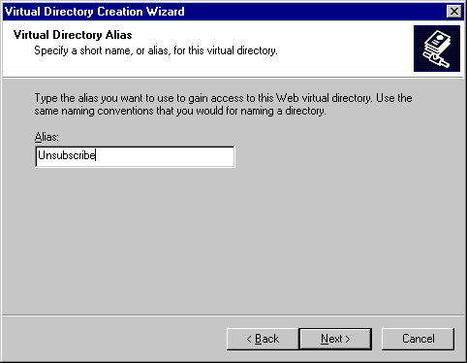

- Enter the path to where you copied the Unsubscribe folder on the web server as indicated in the screenshot below:

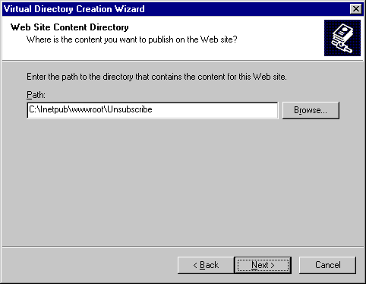

- Set the permissions for the new virtual directory as indicated in the screenshot below:

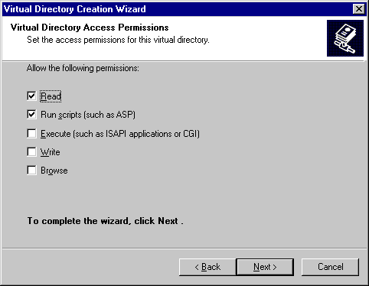

- Once the virtual directory is created, the default configuration settings should suffice for most installations.

Special Note About Internet Applications And Windows Server 2003

Windows Server 2003 requires an additional step to ensure that Onyx Email Accelerator will function properly. On the external web server hosting Unsubscribe and TImage portions of the application, ensure that Active Server Pages and ASP.NET applications are allowed to execute. These settings are located in the Internet Information Services Manager under Web Service Extensions.

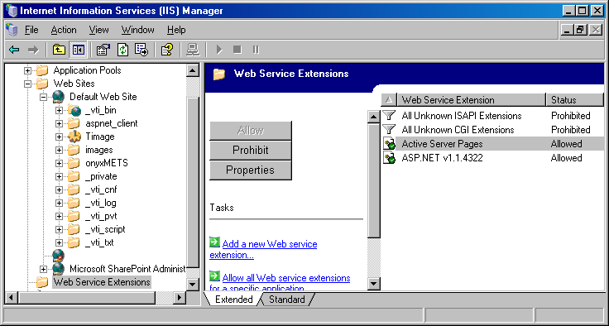

Part III. Onyx Email Accelerator Client Installation

Note: We do not recommend that you place the Onyx Email Accelerator Client on the same web server as Onyx Employee Portal.

Installation Instructions

- Copy the Code/OnyxEmailAccelerator folder from the CD to the Internal Web Server you are using for the Onyx Email Accelerator client.
- The folder OnyxEmailAccelerator should be placed in a location on your internal web server where it can be browsed via HTTP.
- For simplicity, we suggest placing the folder off the root of a web site already configured on your server---wwwroot or another virtual web site is fine.

- Make the OnyxEmailAccelerator a web application by performing the following steps:
- Open Internet Information Services (IIS) Manager and locate the OnyxEmailAccelerator folder.
- Right click on the OnyxEmailAccelerator folder and select Properties.
- On the Directory tab, click the Create button under the Application Settings to create a Web Application.
  - Select the Configuration button that becomes available after you create your application.
  - Select the App Options tab in the new window, and make sure that the Enable Session State checkbox is de-selected.
  - Select OK to exit the ‘Configuration’ dialog boxes.
- Optional: If you wish to enforce web security for the Onyx Email Accelerator Client:
  - Select the Directory Security tab
  - Click Edit under the Anonymous access and authentication control
  - De-select the Anonymous Access check box if selected
  - Select the Integrated Windows authentication check box if not already selected. Security can now be enforced using Windows Authentication. You can prohibit access to the Onyx Email Accelerator by changing the file permissions on the OnyxEmailAccelerator folder.
- Select OK to exit.

TIP: Take note of the location of the Onyx Email Accelerator Client. It will be similar to http://internalWebServer/OnyxEmailAccelerator/client.asp. This URL will need to be entered into the /ListManager/lm_results.js file during the Onyx Employee Portal Installation.

- Configure the Onyx Email Accelerator Configuration File as follows:
- Open up the \OnyxEmailAccelerator\AcceleratorClient.config file on your internal web server using Notepad or other text/XML editor.
- Set the following configurable settings in AcceleratorClient.config:

Configuration Setting | What it Does
DatabaseConnectionString | This is the connection to your OEP database. You should use a database user in the Public Group. For security reasons, do not use a DBO username/login.
OptOutTex | This is the ‘default’ text that will be inserted automatically under each of your HTML emails. You can edit this text per each email in the Accelerator Client.
OptOutURL | The Opt-Out URL is the location of the unsubscribe functionality installed on your external web server during the external web server installation. This value is required if you are planning on using the Onyx Email Accelerator’s real-time opt-out functionality. This value is derived from what was entered in the Unsubscribe Virtual Directory Alias above (Part II, Unsubscribe, Step 5).  If left blank, the Onyx Email Accelerator will assume that a different Opt-Out functionality is being used (see Opt-Out Tracking Information in the Building the Email section below)
TimageURL | The T-Image URL is the location of the Tracking Image HTTP Module installed on your external web server during the external web server installation. This is a required value for tracking real-time user views of your email. This value is derived from what was entered in the TImage Virtual Directory Alias above (Part II, TImage, Step 5).
iSiteID | The SiteID of your Onyx Installation.

Part IV. Onyx Employee Portal Installation
The integration of the Onyx Email Accelerator with OEP requires the customization of some OEP web files and some new files. If you have not made any customizations to the files listed below, you can simply overwrite the existing OEP files with the files from the CD. If you need to manually merge the customized code into your existing OEP web files, you can find the Onyx Email Accelerator code by looking for comments in the new files on the CD. All customizations are bracketed with comment text labeled: ONYX EMAIL ACCELERATOR CUSTOMIZATION. Simply place the new code, with comments, into your existing files in the same place.

Note: It is strongly recommended that you make a backup copy of all of these files prior to proceeding.

Installation Instructions

- Modify the following files on your OEP website to include the Onyx Email Accelerator customizations. On the CD these files can be found under the Code\OEP folder:

OEP File | Customization
/res/listmanager/lm_resultsres.vbi | Added string resource for friendly name that shows up in Bulk Action Drop down list
/listmanager/lm_bulkAction.xml | Defines the new bulk action and for which ‘views’ the bulk action will be available. (Individual only, value of 1)
/listmanager/lm_results.vbi | Loads the friendly name defined in /res/listmanager/lm_resultsres.vbi and the view definition from /listmanager/lm_BulkAction.xml
/listmanager/lm_results.js | Contains the code to be executed when bulk action first fires. File contains two calls to jsDoMassEmailBulkAction(); as well as actual the jsDoMassEmailBulkAction() function, for a total of three customizations.
/listmanager/lm_main.vbi | Contains new supporting function called from /listmanager/lm_results.js. This function, vbGenerateSQL(), generates SQL code from List Management Query which is executed on /listmanager/BulkAction_MassEmailQueue.asp
/listmanager/BulkAction_MassEmailQueue.asp | New file to be placed in the /listmanager/ directory.

- Customize the /listmanager/lm_results.js file
The lm_results.js file requires that you fill in the location of the Onyx Email Accelerator installation. In the previous section, the Client was placed on an internal web server with SMTP services installed. The URL to navigate to the client should look something like this: http://internalwebserver/OnyxEmailAccelerator/client.asp

Open the customized /listmanager/lm_results.js file and look for the function ‘jsDoMassEmailBulkAction()’. This function has a variable called ‘sClientLocation’. Simply place the URL of your client installation into this value between the single quotes (‘) as shown below:

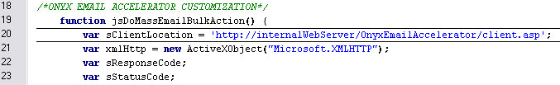

Testing the Installation

Once Onyx Email Accelerator is installed and configured it is highly recommended that you send at least one test mail to yourself before you use the application to send to your customers.

Note: If you have questions while preparing your test email, you may want to skip ahead to ‘Using the Onyx Email Accelerator’ section in Chapter 3 below before continuing with your test.

Prerequisites
- Complete the installation and configuration of all parts of the Onyx Email Accelerator.
- Ability to create new Individual Records in Onyx Employee Portal
- Ability to create a new Campaign.
- Access to an email account outside of your organization. An email account at HotMail, Yahoo Mail, or similar providers will suffice.

- Create a new Individual Record in Onyx Employee Portal and make note of the IndividualID.
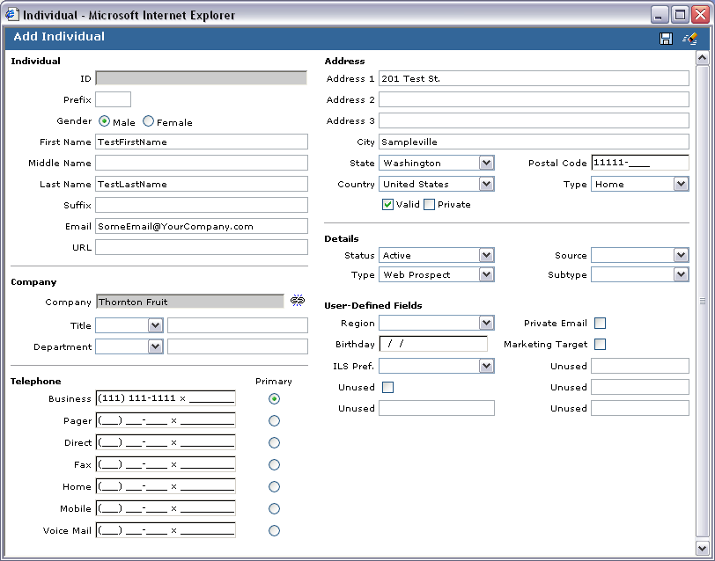

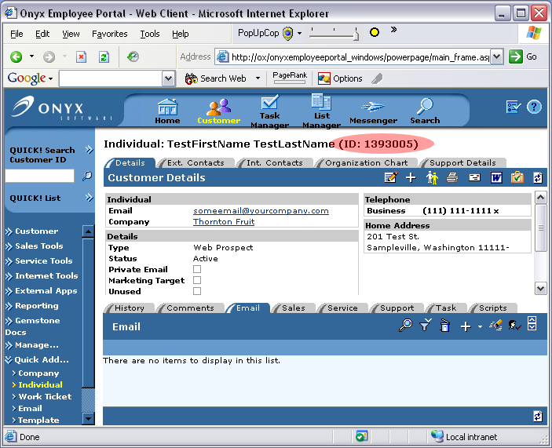

- Use the Onyx Enterprise Studio Campaign Administration tool to create or view Tracking Codes and Milestone Actions. You will need a total of 4 IDs:
  - A Tracking Code ID for a viewed email.
  - A Milestone Action ID for a viewed email.
  - A Tracking Code ID for the Unsubscribe/Opt-out.
  - A Milestone Action ID for the Unsubscribe/Opt-out.

An example of a Tracking Code ID:
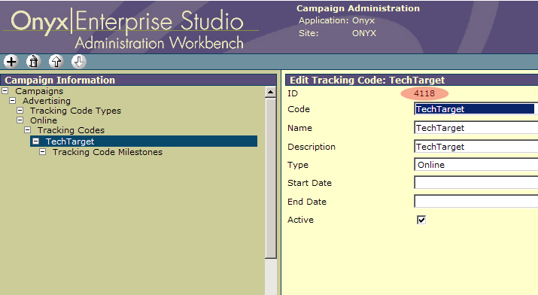

An example of a Milestone Action ID:
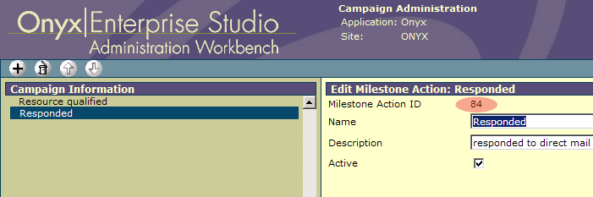

- Using Onyx Employee Portal, open List Manager and create a query that only returns the test Individual Record you created above.
- Send this one-record list to Onyx Email Accelerator using the bulk action drop down.
- Complete the fields required. Use the Tracking Code IDs and Milestone Action IDs in the View-Email and Opt-Out Tracking ID and Action ID fields.
- For email content you can create a simple HTML test or use one of the sample HTML templates included on the installation CD.
- When all fields are complete, click send.
- Log into your email client for the target email address. If your client does not automatically download the images in the HTML email, make sure to download the images manually following instructions in your email client.
- After you have opened the email, click on the unsubscribe link at the bottom. This should direct you to your web site where the Unsubscribe portion of the Onyx Email Accelerator resides. Once you see the confirmation screen, you’re ready to verify that the campaigns were marked in Onyx.
- In Onyx Employee Portal open the test Individual Record you created earlier. View this individual record’s campaign information to verify that the appropriate campaigns were set.

CHAPTER THREE

Using the Onyx Email Accelerator
This chapter describes how to use the OEP and Onyx Email Accelerator to plan, execute and track email marketing campaigns.

Configuring Campaigns
The OEP Campaign functionality is used by the Onyx Email Accelerator to track email recipient actions (view and/or unsubscribe). If you choose to leverage the tracking functionality, you will need to configure campaign tracking codes and actions for your email prior to executing the email campaign.

Building the Target List
The OEP List Manager feature is used to build a target email distribution list. To build your list, open List Manager and select the Individuals view. Choose your list criteria from the available fields and run a search to return your recipient list. Select all results and choose the Send Mass Email with Onyx Email Accelerator bulk action to launch the Onyx Email Accelerator client.

Considerations:

    - The Onyx Email Accelerator can only be used to send emails to individuals. Make sure that you build your target list using the Individuals view in List Manager. If you build a target list using another view, the Send Mass Email with Onyx Email Accelerator bulk action will not appear.

    - Your List Manager query must be designed so that you can execute the Send Mass Email with Onyx Email Accelerator bulk action again the entire result set. If you attempt to check only a subset of the list and execute the Send Mass Email with Onyx Email Accelerator bulk action, you will be prohibited from launching the Onyx Email Accelerator client.

    - Ensure that you design your List Manager query to exclude individuals who have chosen to opt-out of all or specific email communications.

Building the Email
After you’ve sent your targeted recipient list to the Onyx Email Accelerator client you are ready to set up the email. You will configure the following information for your email:

To: The To field is pre-populated with the first three individuals from your target list. A count of total email recipients is displayed beneath the third name. This count will match the count of individuals returned in your List Manager result set.

From: The From field is required and is used to indicate the sender of the email. You may specify any valid email address within your organization as the sender. The email address may be entered in either of following two formats:
- Friendly Name <Valid Email Address>
Jane Doe <janedoe@companyABC.com>
or
- Valid Email Address
janedoe@companyABC.com

Subject: The Subject field is optional and is used to specify the email subject.

Email Tracking Information: The Email Tracking Information section contains fields for tracking recipient view and opt-out email actions.

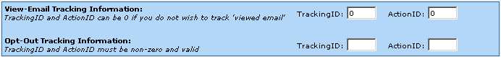

View-Email Tracking Information: If you choose to track when a recipient views the email, enter a valid OEP campaign TrackingID and ActionID for this action. It is not required that you track when a recipient views the email and a value of 0 for these fields indicates that this action will not be tracked.

Note: In order for an email to be tracked, it is required that the user downloads the images from the public web server to execute the TImage HTTP Module. Some email clients do not download images by default.

Opt-out Tracking Information: Similar to the View-Email Tracking Information fields, the Opt-out Tracking fields are used to indicate the OEP campaign TrackingID and ActionID for a recipient Opt-Out action. This may be the same TrackingID and ActionID for every email your organization sends.

By default, the Opt-Out Tracking fields are required. These fields are used in conjunction with the Opt-Out Text and Opt-Out URL fields in the Opt-Out Configuration section for handling Opt-Out management. The only time these fields are not required is when you choose not to implement the real-time Opt-Out functionality (refer to the Opt-Out Configuration section for additional information).

HTML Source / Message: The HTML Source / Message box contains the email message content and is required. You may type the HTML email content directly into this box or more typically your email will be authored using an HTML editor (such as HomeSite or Visual Studio) and then copied into this field.

Note: Chapter Four contains a list of HTML email format and design tips.

Merge Fields

Emails sent via the Onyx Email Accelerator may be personalized with a recipient’s first name, last name and/or company name. This information is pulled from the Onyx database and merged into the body of the email. To specify one of the merged fields in your email, enter the appropriate merge code according to the table below:

Field | Merge Code (must be all caps)
First Name | <@FIRSTNAME@>
Last Name | <@LASTNAME@>
Company | <@COMPANY@>

Opt-out Configuration:

By law it is required that you offer your recipients a way to opt-out of any emails that you send so they can elect to not receive them in the future and the Onyx Email Accelerator is equipped to handle opt-outs. Onyx recommends using an Opt-out campaign that can be added to your List Management queries when creating a list of target recipients. This allows for a varying level of granularity depending on how you want to implement your opt-out business rules.

Opt-Out Text: The Opt-Out text field is required and allows you to specify the text that is included at the end of the email which allows users to unsubscribe from future emails. This text may be changed on a per email basis. By default, this field will be populated with the following generic text:

We respect your privacy. If you do not wish to receive these emails in the future, please click here.

Opt-out URL: The Opt-Out URL field is a read-only field that displays the Unsubscribe URL specified in the AccleratorClient.config file (<OptOutURL>). When the Onyx Email Accelerator sends each email, the Opt-Out Text is automatically added to the bottom of your email with an encrypted URL (using the TrackingID and Action ID specified for Opt-Out Tracking) to your unsubscribe functionality on your external web server. Users will be able to opt-out in real time.

Note: We understand that there are many ways to implement an opt-out strategy. If the <OptOutURL> value in the AcceleratorClient.config file is empty or blank, the Onyx Email Accelerator will not implement the real-time opt-out functionality and the TrackingID and ActionID for the Opt-Out Tracking will not be required. The Opt-Out text field will allow you to enter HTML so that any desired Opt-Out implementation can be used.

Email Preview & Testing: The Onyx Email Accelerator provides the capability to preview and test your emails prior to campaign execution. Click on the Preview button to preview the email without sending it or enter a test email address and click on the Send Preview Email button to send the email to a test recipient.

Note: If your email contains merged fields (first name, last name or company name) the merged data will not show up when the email is previewed or tested.

Sending the Email
When you are ready to send your email, click on the Send Mass Email button. A status bar that indicates execution progress will be displayed as well as the current batch ID that is being processed (see Troubleshooting section below for explanation of iMailBatchID). When execution is complete, a count of emails sent will be displayed, as well as a count of any invalid email addresses found during the process. Instructions on how to audit the invalid emails will be displayed as well.

Tracking Email Actions
If you configure the Onyx Campaign functionality to track email actions for the email, you may track when email recipients view and/or unsubscribe from the mailing. These recipient actions will update the appropriate OEP campaign tracking codes and actions on the recipient’s OEP Individual record in real-time.

The following screenshot displays an example of how a Viewed Email recipient action would appear in OEP:

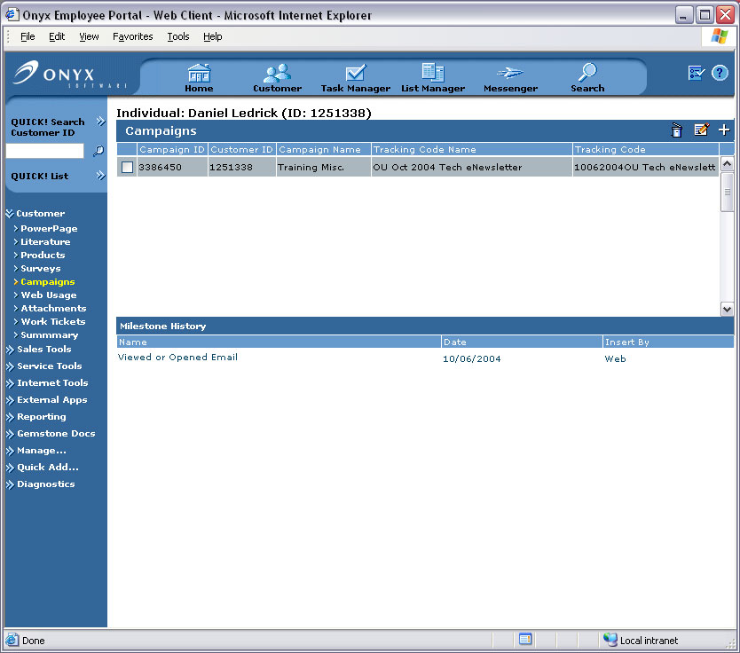

CHAPTER FOUR

Sample HTML Templates

Even if you know HTML well, sending HTML over email has its own set of limitations that a content developer should be aware of before sending messages to clients. To illustrate some of the best-practices in action, Onyx Email Accelerator includes five email templates for use as a learning tool, a starting point for your own emails, or as a working reference. Whether you use the templates or not, when you write HTML for email distribution, you always need to be aware of the differences this medium requires.

Externally Available Resources – One of the most important aspects of authoring HTML for email is to ensure that all images used in emails are on a publicly accessible web server. For example, if you open the CEO Message sample email template with a program like Notepad, you will see towards the top of the file this line:

<img src="http://www.onyx.com/images/EmailAcceleratorSamples/CEOMessage_Portrait.jpg" alt="" width="160" height="215" border="0" align="left">

This is generally how all your image references should look. The critical piece is the src portion of the <img> tag. The src must be the full URL to where the image is hosted starting with “http://”.

Cascading Style Sheets vs. In-Line Styles – Unfortunately, even if you make a cascading style sheet file available on a publicly available web server, many email clients will ignore the reference. Also, styles moved from an external .CSS file into the <head></head> portion of your HTML file also tend to be ignored by email clients. Consequently, to ensure that your email looks as good as possible on a variety of email clients you have to make heavy use of inline style attributes attached to tags like <font> <span> and <a>. All of the sample templates included use these in-line styles to format the HTML document.

Plan For Image Blocking – The best HTML layouts plan around having images blocked by some email clients and “gracefully degrade” in those circumstances by:
- Avoiding over reliance on image-heavy design.
- Not putting critical content in images.
- Checking what the design looks like both with and without images to ensure the content is still readable.

The Invite sample template includes a normal file and a version that simulates what the email would look like when viewed in an email client that blocks images.

The BRIx sample template is designed with no images whatsoever – its design will not be affected by image blocking.

HTML Email Format and Design Tips

- Avoid those fancy things your Web site designers love to do: cascading style sheets, over-reliance on images, and animation.

- Avoid those fancy things print art directors love to do: reversed type, colored type for body copy, type smaller than 10 points, body copy justified on both sides, type wrapping around a graphic, etc.

- Stick to the standard Web safe palette of 216 colors as much as possible. (See http://www.w3schools.com/html/html_colors.asp for more information about the 216 cross-platform colors)

- Your email should not be wider than 620 pixels.

- Use HTML <UL> and <OL> tags for bulleted and numbered lists.

- Keep the message size less than 40 kilobytes.

- Don’t waste precious above-the-fold HTML real estate on an enormous graphic such as a logo or product graphic. Content filters may assume that it’s a message with adult content and will reject it.

- Keep the design clean. Think postcard or billboard. Recipients may glance at your message for just a few seconds, most won't study it in detail. They are making a fast click-versus-delete decision, not a reasoned buying or other conversion decision.

- Use your design to move them toward the click -- rely on your landing page to move them to the next stage in the conversion process. If you have more than one column, make it extremely obvious which is the most important, and which merely lists "housekeeping links."

- Don't be afraid to include additional navigation links if you are a well-known brand site with many SKUs or stories. These links should not "fight" the main message, but they should be above the fold, usually on the right.

Testimonial: "Retail marketers worry that these 'housekeeping links' will distract a customer from the main 'sale' message. But we have found, overall, that response rates and conversion rates increase with these additional links."

Why? Because the main message may not be relevant to the recipient. Recipients may open the email and find that the subject isn’t interesting, but the other links serve as a reminder of all the other possibilities you have to offer.

Consider testing alternate orders of these links from message to message rather than having the order set in stone the way it may be on your site.

- Be picky about brand consistency. Use templates. Create a style guide and make sure people stick to it. This includes a standard, unchanging "from address" for all brand messages.

Copywriting Tips to Increase Response

- Be disciplined. It’s tempting for marketers to toss every single product feature and benefit into an email. That can be overwhelming to recipients.

Testing has proven the opposite approach is more effective. Pick a single theme and stick to it. Prioritize. People don’t read emails, they skim them. Your single theme should hit them over the head when they first open the email.

- Keep your copy punchy and active. Avoid flowery language. Use a lot of bullets and verbs.

- That said, avoid exclamation marks. That can be flag for spam content filters. Besides, overuse of exclamation marks can dilute your message.

- If possible, test your copy against content filters prior to see which words may get your message stopped as spam.

Your landing page is a great place to use words such as "guaranteed," "savings," "free," and "survey" that often trigger spam filters if they are used in the body of your email itself. You may have to divide your copy to conquer.

- Personalize all you can; readers will skim more slowly, paying more attention if you do.

CHAPTER 5

Troubleshooting
The Onyx Email Accelerator spans many systems and involves a few different technologies. This troubleshooting section offers a more in-depth technical discussion as to what is happening in the code.

Problems hitting the ‘Bulk Action’ in List Manager
When the bulk action is executed, the query used to generate the list is sent to /listmanager/BulkAction_MassEmailQueue.asp via the XMLHttp Object. This process is started from a custom function in /listmanager/lm_results.js. If there are errors in processing BulkAction_MassEmailQueue.asp, it is more than likely the result of the query that was passed. An IIS error will be returned to the calling function, and in response, the function will launch bulkAction_MassEmailError.htm and write out the IIS response. This can be confusing because it will appear to be an error with the Onyx Email Accelerator Client, and not the process that is occurring on the OEP web server. However, by looking at the error description, it will be explicit as to what happened and where. If errors are returned on all bulk action submittals, make sure that the installation instructions were followed correctly and that the code in /listmanager/BulkAction_MassEmailQueue.asp was not altered in any way. If an error occurs only on a particular query, please contact Onyx Support with information as to which query is causing the error.

Unexpected Errors during Mass Email Process
The Onyx Email Accelerator was constructed to ensure that recipients are not sent duplicate mail and if an error occurs in the middle of a mass email batch, that it is possible to start the process from where the error occurred.

The entire process operates like this:
- The Bulk Action in the Onyx Employee Portal creates a unique iMailBatchID and inserts all targeted recipients into table SDtMassEmailQueue.
- When the queue table is filled, the unique iMailBatchID is returned and the Onyx Email Accelerator Client is launched with the iMailBatchID as a parameter. For instance, http://internalwebserver/OnyxEmailAccelerator/client.asp?iMailBatchId=1
- When the Onyx Email Accelerator Client is submitted, a query is run to retrieve all users in table SDtMassEmailQueue with the unique iMailBatchID and NOT appearing in the SDtMassEmailHistory table for that unique iMailBatchID. This will be explained below.
- A regular expression is executed for each email address before it is sent to confirm validity of the email address. If an email address is invalid, it is skipped and left in the queue.
- After each email is sent, the user is added to the SDtMassEmailHistory table.
- When the process completes successfully, clean up is performed. This entails moving all recipients that are in SDtMassEmailQueue and NOT in SDtMassEmailHistory to table SDtMassEmailInvalids and then removing all recipients for the iMailBatchID from SDtMassEmailQueue. Table SDtMassEmailInvalids can be queried with the appropriate iMailBatchID to clean up email address data if desired.
- At the end of a successful process, all recipients for a particular batch are either in SDtMassEmailHistory OR SDtMassEmailInvalids. They will not appear in both.

If an error occurs during execution of sending the emails, you can see where the SDtMassEmailHistory table is keeping an accurate log of which recipients are sent email and which have not been processed. The ‘clean up’ job would not have been executed either. You can re-start you batch job by opening up a browser and going to http://internalwebserver/OnyxEmailAccelerator/client.asp?iMailBatchId=<YOURBATCHID>. The iMailBatchID is displayed during execution of the email, so this type of recovery is possible.

The SDtMassEmailInvalids table should be queried occasionally to ensure that the email data in the system is as valid as possible.

APPENDIX A

Database Components

Tables Installed
Table Name | Description
SDtMassEmailQueue | Table filled from /listmanager/bulkAction_MassEmailQueue.asp which is executed when the bulk action is selected in List Management.  Queue is cleared after Onyx Email Accelerator Client completes successfully. If there is a problem in the middle of execution, the Queue will contain recipient individualIDs that have not been sent emails. Executing the client again with the same iMailBatchID will continue execution (refer to Chapter 5 – Troubleshooting for additional information).
SDtMassEmailHistory | Table is filled during execution of Onyx Email Accelerator Client. Each entry in the SDtMassEmailHistory was sent an email.
SDtMassEmailInvalids | Table is filled after successful completion of the Onyx Email Accelerator Client. If any emails encountered in the process were empty, null, or invalid, they will be placed here. A warning message will be displayed in the Onyx Email Accelerator Client window disclosing how many email addresses were invalid (refer to Chapter 5 – Troubleshooting for additional information).

Stored Procedures Installed
Stored Procedure Name | Description
SDpcgValidateEmailQueue | Queries SDtMassEmailQueue to validate that passed in iMailBatchID is valid, and returns number of recipients in batch as well as first three recipient’s names to be displayed in client.
SDpcgGetEmailQueue | Returns record set of targeted recipients in SDtMassEmailQueue to the Onyx Email Accelerator Client for processing.
SDpcgEncryptEmailData | Encrypts the TrackingID, ActionID and IndividualID and returns merge data for each email.
SDpcgDecryptEmailData | Decrypts the TrackingID, ActionID and IndividualID from the past-in encoded string.
SDpcuSentEmail | Updates the SDtMassEmailHistory table when each recipient is emailed.
SDpcdProcessedEmail | Handles the completion process of the Onyx Email Accelerator by clearing out SDtMassEmailQueue and placing all invalid emails into the SDtMassEmailInvalids table.
SDpsiCampaign | Executes insertion/update of Campaign via the TrackingID and ActionID on the Individual Record. Used by both the TImage HTTP Module and Unsubscribe functionality. Procedure executes core OEP stored procedures: wbospsiCustomerCampaign and wbospsiCustomerCampaignAction.

