Navigating AwardSpring: A Guide for Donors
A step-by-step guide for donors participating in the scholarship review process
This guide walks you through accessing your account on the AwardSpring platform, and — if you're participating in reviewing or scoring applicants — using your dashboard to review applications and any awarding documents your applicants have provided.
Start by navigating to your organization's AwardSpring site. The URL will be provided to you by your organization's administrator.
You will land at the login page. (Please note that this page is customizable, so your organization's login page may look different than the example below.)
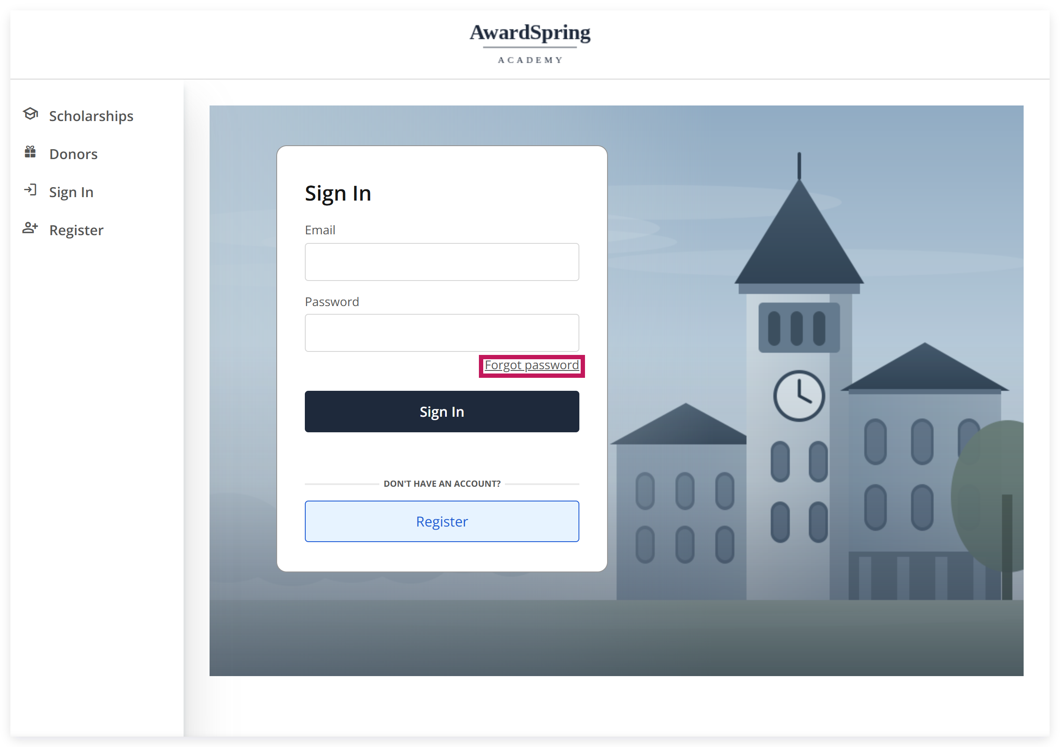
The administrator would have created your account; however, you are required to set up the password for the account. To do so, click the Forgot Password button.
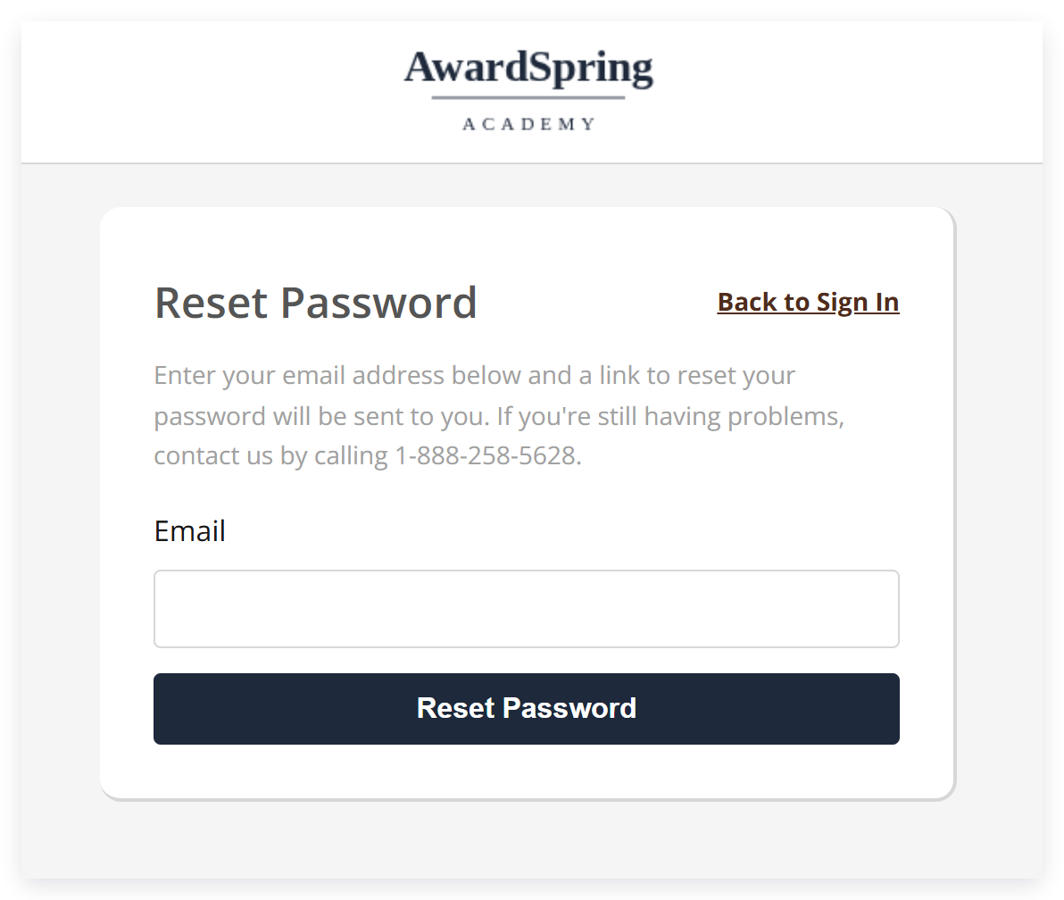
Type in your email and click the Reset Password button.
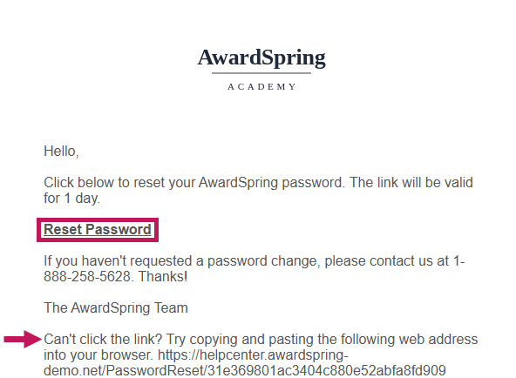
You will receive an email with a link in it, or you can click the Reset Password link, which will allow you to create a password.
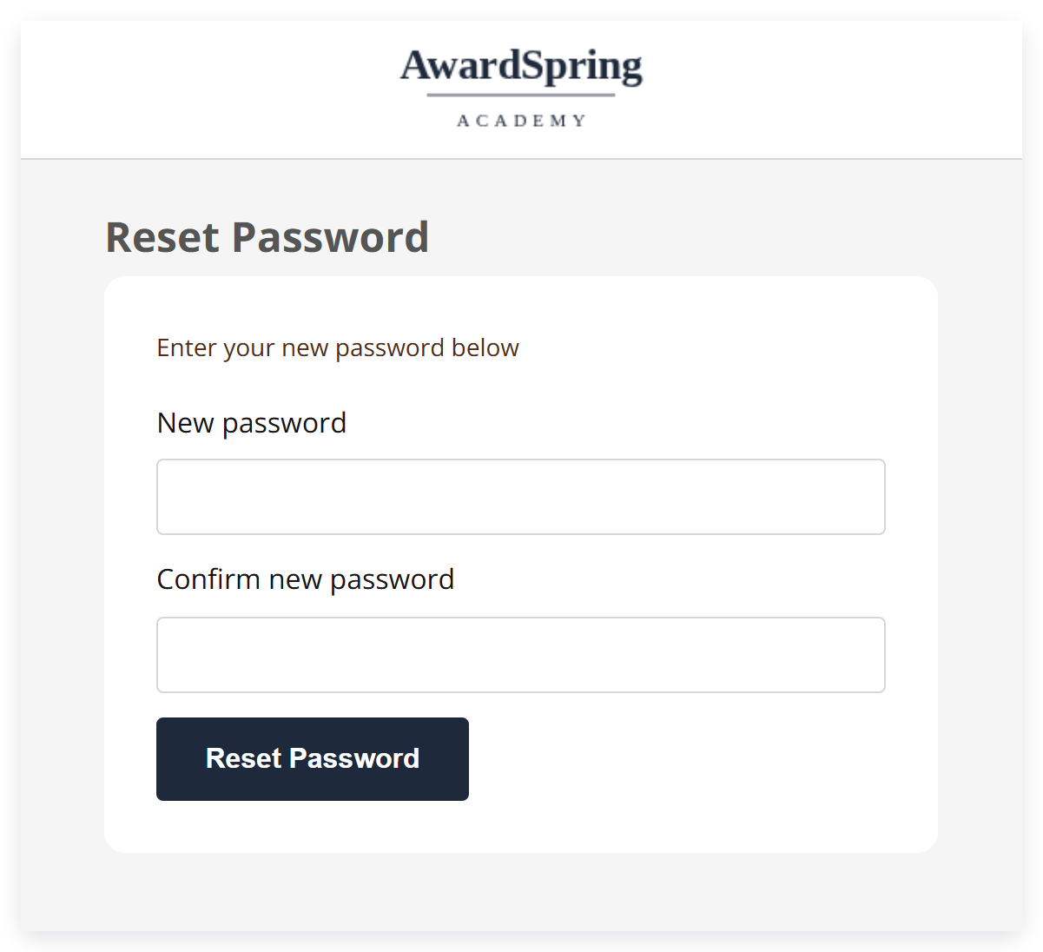
You're required to type in your password twice. When ready, click Reset Password.
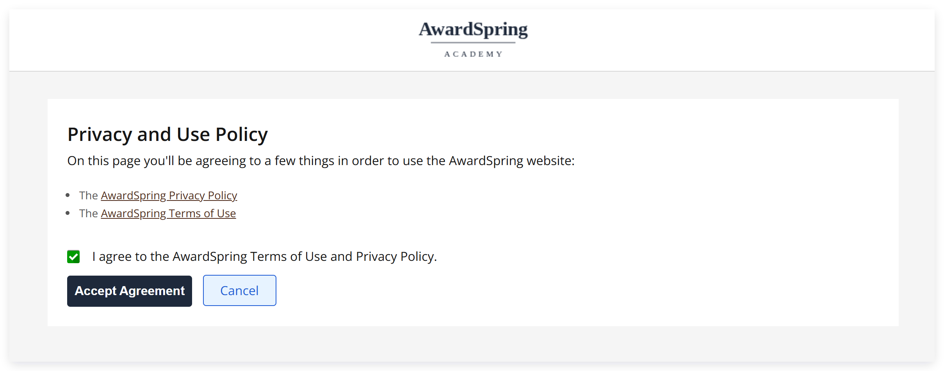
On the next screen, you'll be asked to agree to the terms of use and privacy policy.
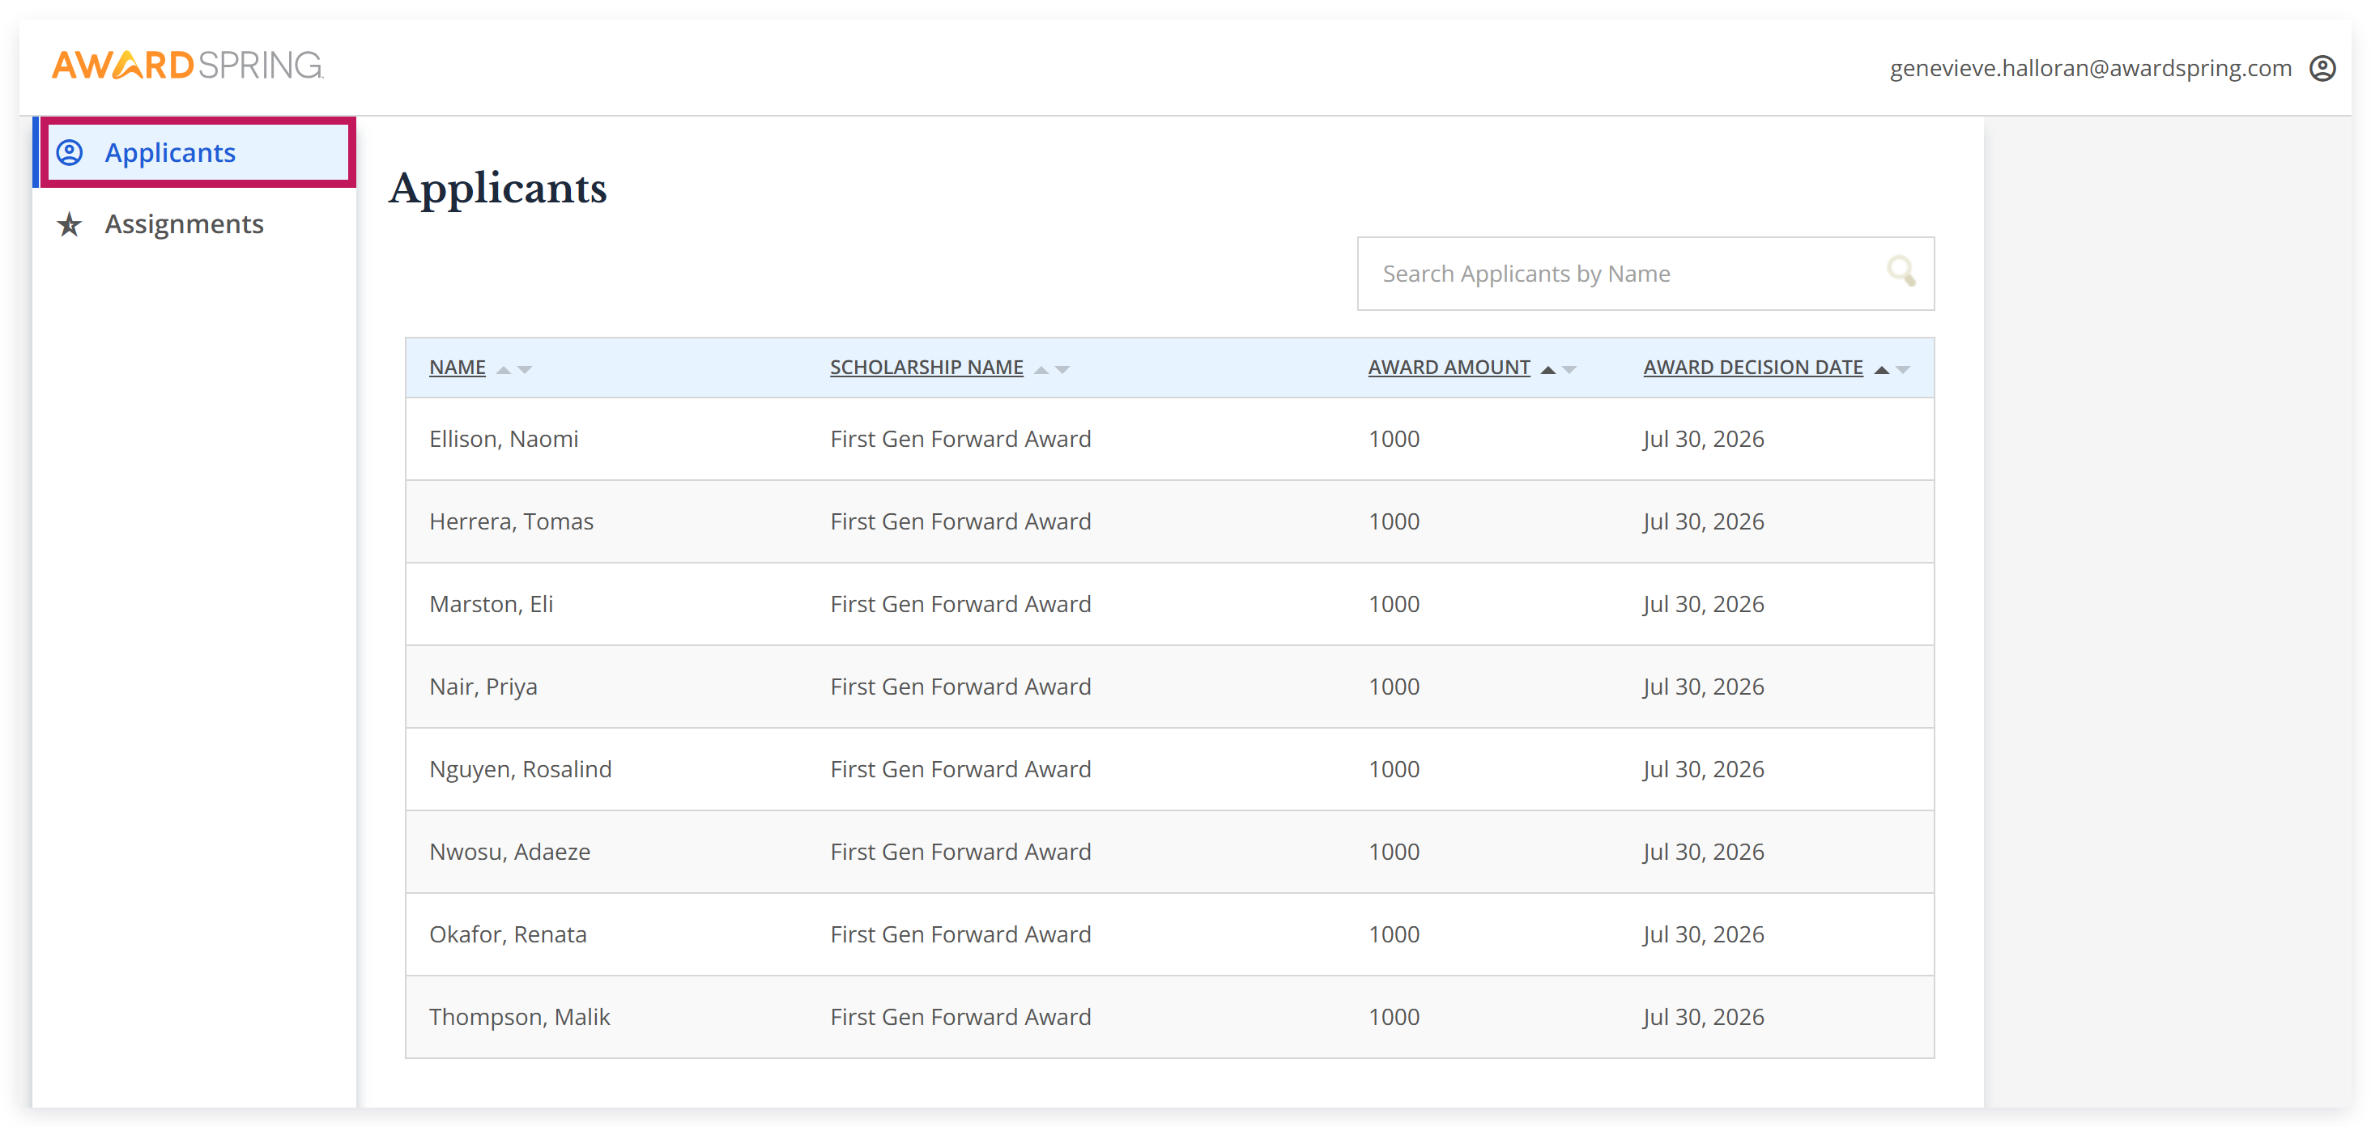
On your dashboard, under the Applicants tab, you'll find a list of applicants for scholarships that you are associated with.
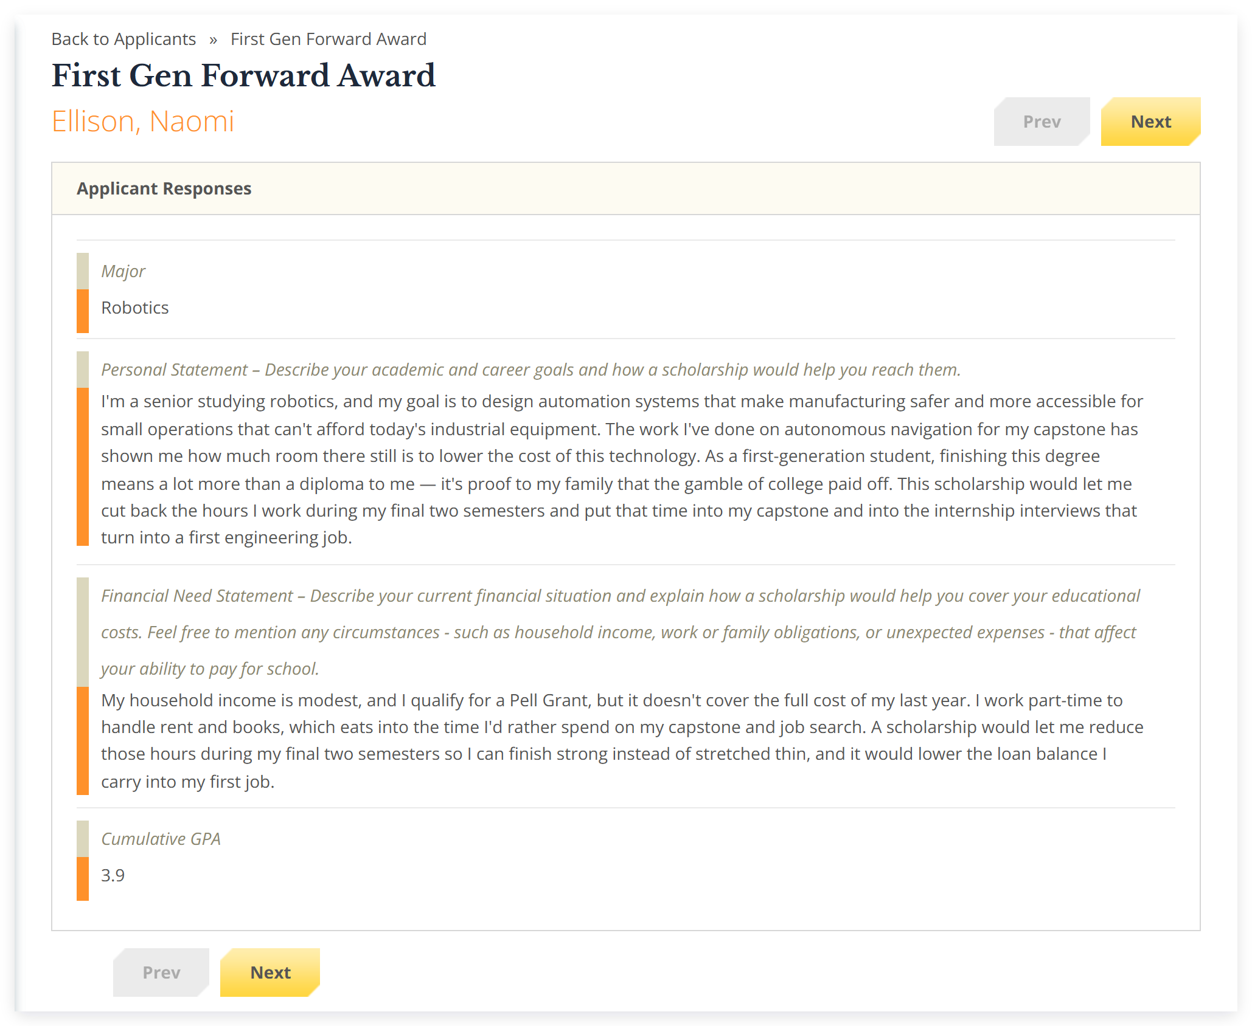
Once you select an applicant's name, you'll be able to view their application responses — their major, personal statement, financial need statement, and cumulative GPA.
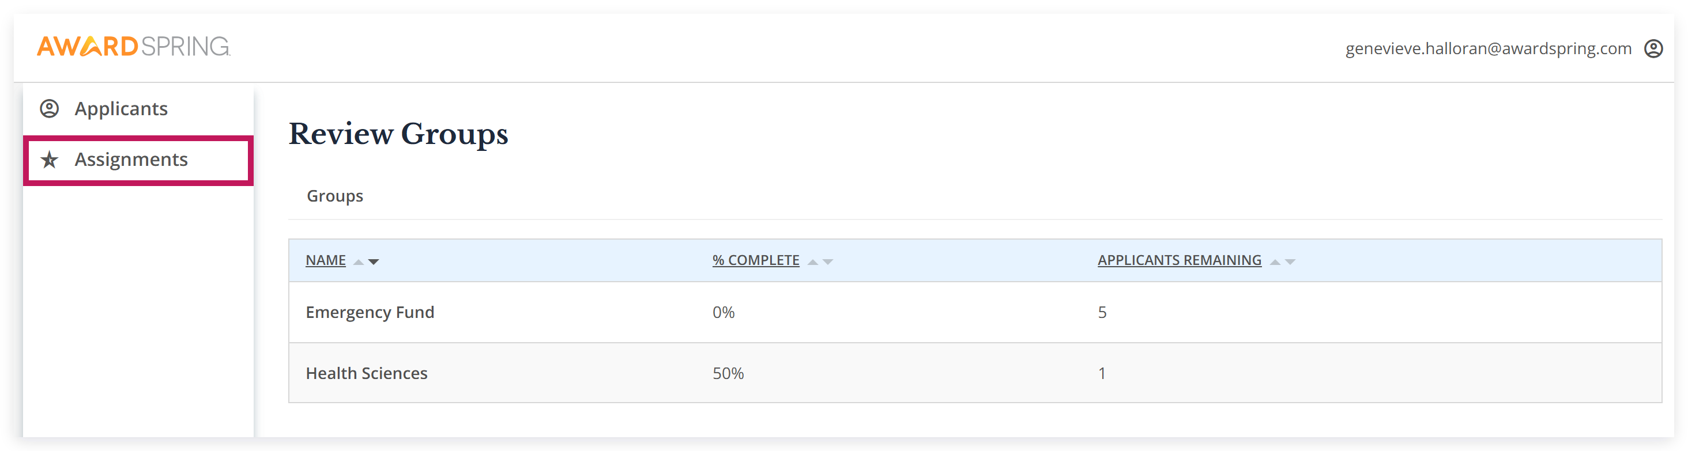
If you are participating in the process of reviewing/scoring applicants, you'll be able to complete this task under the Assignments tab on your dashboard.
Here you will find a list of review groups you were assigned in, and a list of applicants in each.
Note: If the applicant names have been blinded, you will see a number populated instead of their name.
Once you select an applicant, you will be able to view their application, score them under the Score Cards tab, and leave a comment (optional).
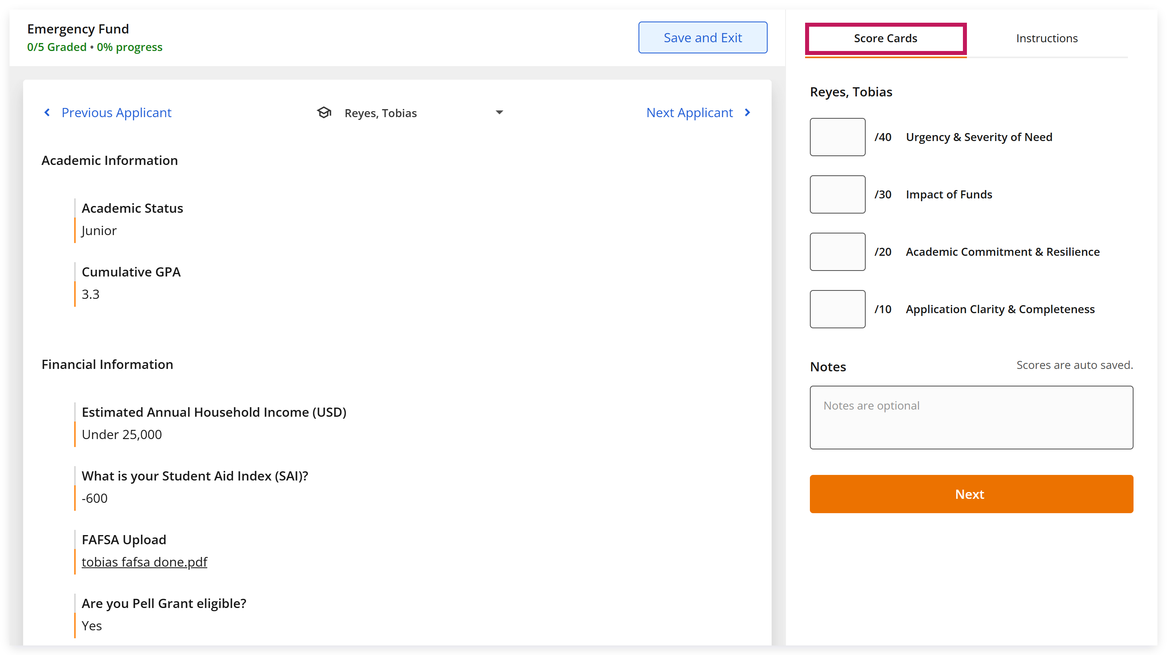
Under the Instructions tab, you'll have access to instructions that the Administrator team provided. You can easily refer to them as you are reviewing applications.
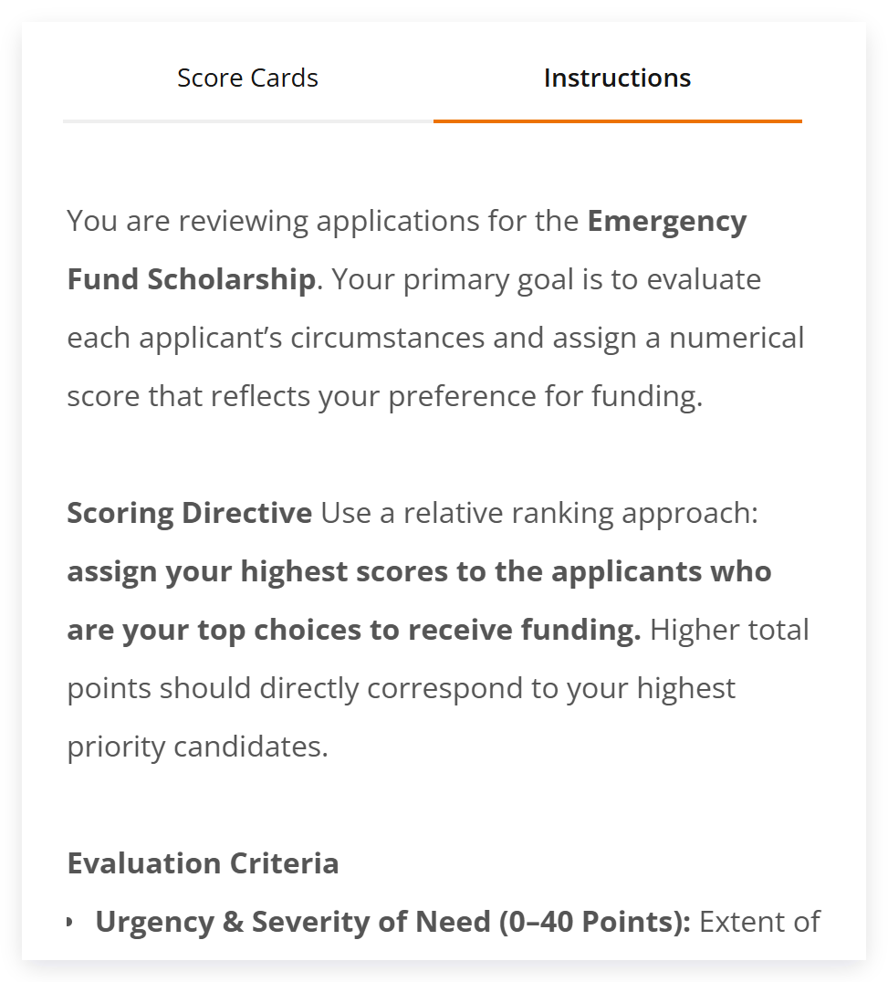
Once done, click the Next Applicant button to review the next applicant.
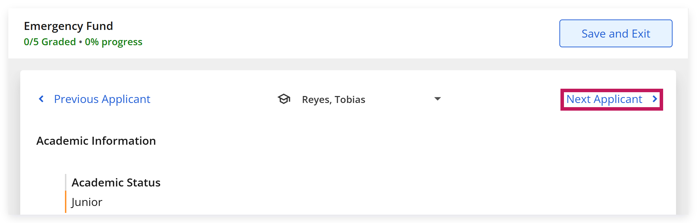
Once you have completed scoring all applicants, you can click the Save and Exit button.
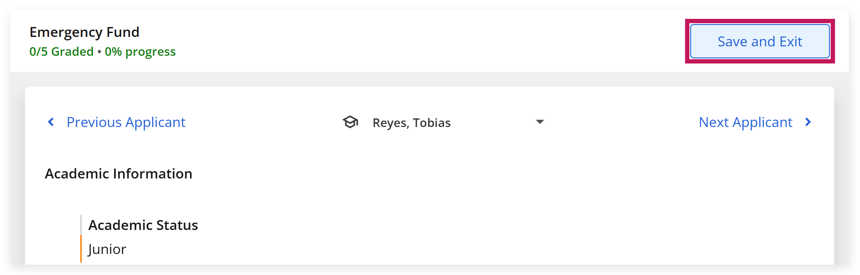
Otherwise, you can proceed to sign out of your account by clicking the profile icon in the top right corner, then click Log Out.
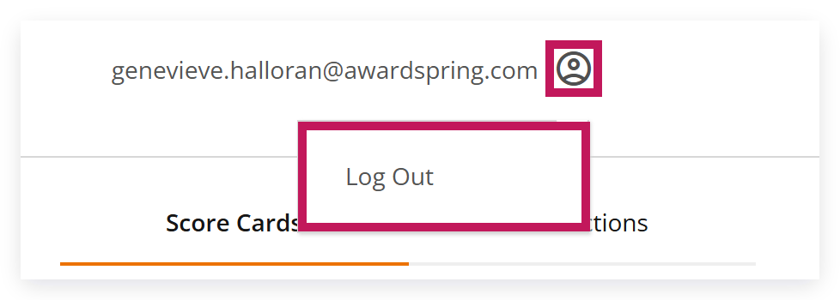
Need more help? Contact your organization's AwardSpring administrator, or visit the AwardSpring Support Help Center.

