## Cloudsearch API integration

<https://docs.aws.amazon.com/AWSJavaScriptSDK/latest/AWS/CloudSearch.html>

**Code snippet:-**

require('aws-sdk');

import * as AWS from 'aws-sdk';

import * as CloudSearch from 'aws-sdk/clients/cloudsearch';

import * as CloudSearchDomain from 'aws-sdk/clients/cloudsearchdomain';

cloudsearch_test() {

//end point :- cloudsearch.us-west-2.amazonaws.com - Oregon

var cloudsearch = new CloudSearch({apiVersion: '2013-01-01'});

var params = {

DomainNames: [

'coursera-courses'

]

};

cloudsearch.describeDomains(params, function(err, data) {

if (err) console.log(err, err.stack); // an error occurred

else console.log(data); // successful response

});

cloudsearch.listDomainNames(function(err, data) {

if (err) console.log(err, err.stack); // an error occurred

else console.log(data); // successful response

});

}

cloudsearch_domain_test() {

var csd = new CloudSearchDomain({ endpoint: 'search-coursera-courses-ttta3hjjy7jepitjpzvrt64ug4.us-west-2.cloudsearch.amazonaws.com' });

var params = {

query: 'English'

};

csd.search(params, function (err, data) {

if (err) console.log(err, err.stack); // an error occurred

else console.log(data); // successful response

});

}

# Issue:-

Cloudsearch api in AWSJavascriptSDK failed to execute.

**Screenshot (**[**http://localhost:4200/**](http://localhost:4200/) **-> browser console)**

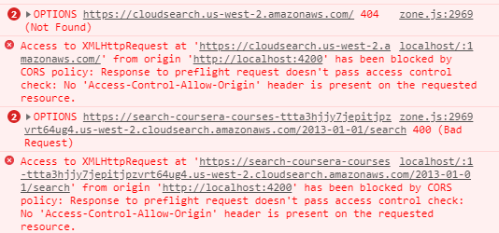

# Solution:-

<https://github.com/Rob--W/cors-anywhere/issues/144>

<https://github.com/Rob--W/cors-anywhere#client>

