Table of Contents
Markdown2-2 1
Formatted Text Examples
1
Font buttons:
1
Text Format:
1
Text Justification:
1
Useful markdown links:
1
I just have to store some code here, if you don't mind
1
I'll put it here
1
And also here
1
You know the process...
1
SameHeadingsTest 1
Heading 2
1
Heading 2 (text1)
1
Heading 2 (text2)
1
Heading 1
1
Heading 2
1
Heading 3
1
Introduction 1
References 1
test 1
test12323 1
markdown1-2.md 1
PUZZLES CLOUD MARKDOWN FILE HEADING 1 1
Welcome to the puzzles cloud md file HEADING 2 1
Let's start with stupid jokes HEADING 3 1
Let me tell you stupid joke on German: HEADING4 1
Let's switch to the Czech language HEADING 4 1
Real Czech language HEADING 5 1
Longest Serbian word he he HEADING 1 1
Serbian literature HEADING 2 1
It's enough, lets start with some smart things HEADING 1 1
markdown2-2.md 1
Formatted Text Examples 1
Font buttons: 1
Text Format: 1
Text Justification: 1
Useful markdown links: 1
I just have to store some code here, if you don't mind 1
I'll put it here 1
And also here 1
You know the process... 1
justTesting.markdown 1
PUZZLES CLOUD MARKDOWN FILE 1
Welcome to the puzzles cloud md file 1
Let's start with stupid jokes 1
Let me tell you stupid joke on German: 1
Let's switch to the Czech language 1
Real Czech language 1
Longest Serbian word he he 1
Serbian literature 1
It's enough, lets start with some smart things 1

Table of Tables
Table 1: Document references 1

Table of Figures

Table of Tables
Table 1: Document references 1

Table of Figures

testing_folder

Markdown2-2

Formatted Text Examples
Below is an illustration of the Format toolbar used to format text:

Here are some examples of the effects different options have on text:

Font buttons:
As well as the standard Font drop down box showing a list of all the fonts on your system and the Point size box that allows you to set the font size,
two shortcut buttons have been added that allow you to increase the selected text or group of text objects at the press of a button:
Will increase the font size by 2 points every time you press the button.
Will decrease the font size by 2 points every time you press the button.

Text Format:
The standard text format options are also available for text i.e. bold, italic, underline and outline:

Note:
You can combine any of these formats together, as in the last example above which is a combination of the bold, underline and outline formats.

Text Justification:
- Text can be aligned to the
  - left,
  - right,
  - centre
- or one of the three full justifications: Full Justification, Density Justification and Aspect Justification.
Note:
The Full justification spreads the words across the page but does not change the size of them. The Density Justification also spreads the words and does not change their size but puts spaces between the characters in a word. The Aspect Justification spreads the words but stretches the words to fill the space as well.
The Density and Aspect methods can provide some visually interesting effects.

Go back to the top

Useful markdown links:
- Link 1
  - This is link 1
- Link 2
  - This is link 2
- Link 3
  - This is link 3
    - Link 4
      - This is link 4 ordered under link 3

I just have to store some code here, if you don't mind

I'll put it here
LoGiC iS rEaL !!!
if(a == 0){
a = 0;
}

And also here
It's getting better
if (false == true) {
// log some message
}

You know the process...

I'll just assert and finish this...
public void justAssert(){
boolean checkTrue = true;
Assert.assertTrue(checkTrue);
}
//let me return true he he
public boolean trueStatement(){
return true;
}

testing folder

testing subFolder

no files folder

SameHeadingsTest

Heading 2

Heading 2 (text1)

Heading 2 (text2)

Heading 1

Heading 2

Heading 3

Template version: 1.0

[[doc-title]]
test

[[doc-type]]

[[doc-company]]
[[doc-company-url]]

Document Number: [[doc-id]]
Version: [[doc-version]]
Release Date: [[release-date]]

Document History

Author Name: [[doc-author]]
Author Contact: test

Document Revision
Version Number | Release Date | Status | Change Description | Author
[[doc-version]] | test | Draft | [[change-description]] | test

Intellectual Property Rights

This document is exclusive property of [[doc-company]] and all rights are reserved.

Introduction

References
Referenced documents in creation of this document are listed in the Table 1.
Document Reference | Document Title | Version | Filename
[1] | [[ reference-doc-title ]] |  | [[ reference-doc-filename ]]
[2]
[3]
[4]
[5]
[6]
[7]
[8]
Table 1: Document references

test

test12323

markdown1-2.md

PUZZLES CLOUD MARKDOWN FILE HEADING 1

Welcome to the puzzles cloud md file HEADING 2

Let's start with stupid jokes HEADING 3

Let me tell you stupid joke on German: HEADING4
- "Hey Philipp, wie war denn der Urlaub?"
- "Gräßlich! Im Hotel hatte ich Zimmernummer hundert. Und vom Türschild ist die Eins abgefallen!"

ÜÜÜÜÜÜ- that was stupid

Let's switch to the Czech language HEADING 4
- "Co rłńóobi trakłńótośźr u fśźryśźżzjera?"
- Warćękocze.
ąćęłńóśźż!!!!
Just kidding, that was Poland language u fool, let's switch to the Czech for real

Real Czech language HEADING 5
ýžáčďéěíňóřšťúů
- Jak říkáte albínskému muži z Prahy?
- Prázdný Čech.

Longest Serbian word he he HEADING 1
Here you go: АБВГДЂЕЖЗИЈКЛЉМНЊОПРСТУФХЦЧЏШ

Serbian literature HEADING 2
Весела песма
Из школе се враћа Стева
сав весео путем пева.
Уз пут среће бака Јелу:
„Ћирилицу знадем целу!"
Кући дође, па са врата:
„Ћирилицу знадем, тата!"
„Све сад, мајко, читам сам,
јер од данас и „ш" знам!"
Оком тражи и сестрицу:
„Сејо, знадем ћирилицу!"
Потом оде до икона,
па начини три поклона.
Хоће Стева да се јави
и захвали Светом Сави.
Свети Сава Стеву чује,
па се скупа с њим радује:
„Српство ми је од сад јаче
за још једно вредно ђаче!"

It's enough, lets start with some smart things HEADING 1

1.
PLAY THIS VIDEO AND THANKS ME LATER!

HIT THAT PLAY BUTTON 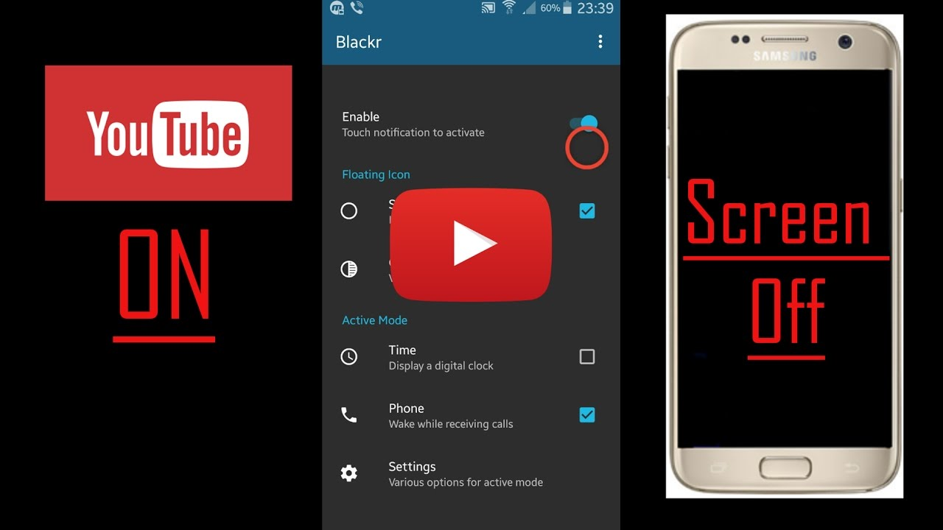
Yep, it's a picture, fool... lol
Here you go, CLICK IT:

markdown2-2.md

Formatted Text Examples
Below is an illustration of the Format toolbar used to format text:

Here are some examples of the effects different options have on text:

Font buttons:
As well as the standard Font drop down box showing a list of all the fonts on your system and the Point size box that allows you to set the font size,
two shortcut buttons have been added that allow you to increase the selected text or group of text objects at the press of a button:
Will increase the font size by 2 points every time you press the button.
Will decrease the font size by 2 points every time you press the button.

Text Format:
The standard text format options are also available for text i.e. bold, italic, underline and outline:
Note:
You can combine any of these formats together, as in the last example above which is a combination of the bold, underline and outline formats.

Text Justification:
- Text can be aligned to the
  - left,
  - right,
  - centre
- or one of the three full justifications: Full Justification, Density Justification and Aspect Justification.
Note:
The Full justification spreads the words across the page but does not change the size of them. The Density Justification also spreads the words and does not change their size but puts spaces between the characters in a word. The Aspect Justification spreads the words but stretches the words to fill the space as well.
The Density and Aspect methods can provide some visually interesting effects.

Go back to the top

Useful markdown links:
- Link 1
  - This is link 1
- Link 2
  - This is link 2
- Link 3
  - This is link 3
    - Link 4
      - This is link 4 ordered under link 3

I just have to store some code here, if you don't mind

I'll put it here
LoGiC iS rEaL !!!
if(a == 0){
a = 0;
}

And also here
It's getting better
if (false == true) {
// log some message
}

You know the process...

I'll just assert and finish this...
public void justAssert(){
boolean checkTrue = true;
Assert.assertTrue(checkTrue);
}
//let me return true he he
public boolean trueStatement(){
return true;
}

justTesting.markdown

PUZZLES CLOUD MARKDOWN FILE

Welcome to the puzzles cloud md file

Let's start with stupid jokes

Let me tell you stupid joke on German:
- "Hey Philipp, wie war denn der Urlaub?"
- "Gräßlich! Im Hotel hatte ich Zimmernummer hundert. Und vom Türschild ist die Eins abgefallen!"

ÜÜÜÜÜÜ- that was stupid

Let's switch to the Czech language
- "Co robi traktor u fryzjera?"
- Warkocze.
ąćęłńóśźż!!!!
Just kidding, that was Poland language u fool, let's switch to the Czech for real

Real Czech language
ýžáčďéěíňóřšťúů
- Jak říkáte albínskému muži z Prahy?
- Prázdný Čech.

Longest Serbian word he he
Here you go: АБВГДЂЕЖЗИЈКЛЉМНЊОПРСТУФХЦЧЏШ

Serbian literature
Весела песма
Из школе се враћа Стева
сав весео путем пева.
Уз пут среће бака Јелу:
„Ћирилицу знадем целу!"
Кући дође, па са врата:
„Ћирилицу знадем, тата!"
„Све сад, мајко, читам сам,
јер од данас и „ш" знам!"
Оком тражи и сестрицу:
„Сејо, знадем ћирилицу!"
Потом оде до икона,
па начини три поклона.
Хоће Стева да се јави
и захвали Светом Сави.
Свети Сава Стеву чује,
па се скупа с њим радује:
„Српство ми је од сад јаче
за још једно вредно ђаче!"

It's enough, lets start with some smart things

1.
PLAY THIS VIDEO AND THANKS ME LATER!

HIT THAT PLAY BUTTON
Yep, it's a picture, fool... lol
Here you go, CLICK IT:


Figure 1: Last Page

